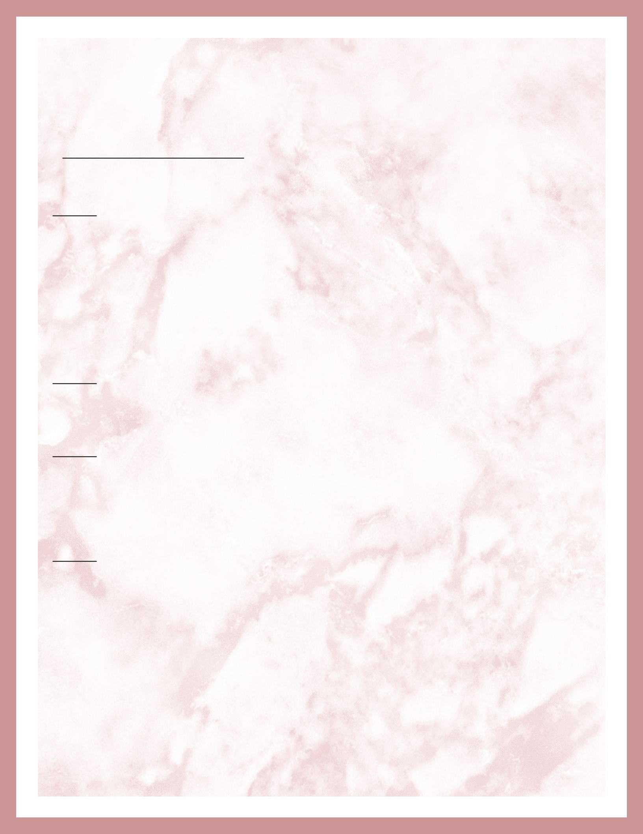
Eyelash EXTENSION CONSENT FORM

I agree to have eyelash extensions applied to my natural

eyelashes and/or removed and retouched. By signing this agreement, I consent to the placement and removal of eyelash extensions by the certified eyelash extension professional.

I understand there are risks associated with having artificial eyelashes and eyelash extensions applied to, or removed from my natural eyelashes. I further understand that as part of the procedure, eye irritation, eye pain, eye itching, discomfort, and in rare cases, eye infection or blindness can occur. I agree that if I experience any of these medical conditions with my lashes I will contact the certified eyelash extension professional and have the eyelashes removed immediately and consult a physician at my own expense. I understand that even though the certified eyelash extension professional applies or removes the eyelash extensions using the proper technique, the instruments, tapes, cleaners, eye gel pads, adhesives, and removers used may irritate my eyes or require a physician’s follow-up care and subsequent removal of the eyelash extensions.

I understand and agree to the care instructions provided by the certified eyelash extension professional for the use and care of my eyelash extensions. I realize and accept the consequences of failure to adhere to these instructions may cause the eyelash extensions to fall out, damage the extensions and/or decrease the time the lashes will last.

I understand and consent to having my eyes closed and covered for the duration of the 60-120 minute procedure. I understand that if I have lower eyelash extensions applied that I will have my eyes open and will have instruments, tapes, cleaners, eye gel pads, adhesives, and removers used that may irritate my open eyes, cause them to water and blink in excess, preventing application and/or requiring removal and a physician’s follow-up care and subsequent removal of the eyelash extensions.

I am informing the certified eyelash extension professional of the following conditions by marking with a check:

- Current use of contact lenses which I agree to remove during eyelash extension application

- Current use of eyedrops of any kind, prescription or over-the-counter

- Current use of anything such as oil-containing sunscreen or moisturizers around the eyes

- Current allergies or sensitivities to instruments, fumes, tapes, cleaners, eye gel pads, adhesives, and removers that could cause my eyes to water and blink in excess

- History of claustrophobia.

- History of recurrent eye or tear duct infections

- History of dry eyes or Sjorgen’s Syndrome

- Recent history of Chemotherapy.

- Other medical conditions which would prohibit or compromise placement and retention of eyelash extensions.

Page: 1

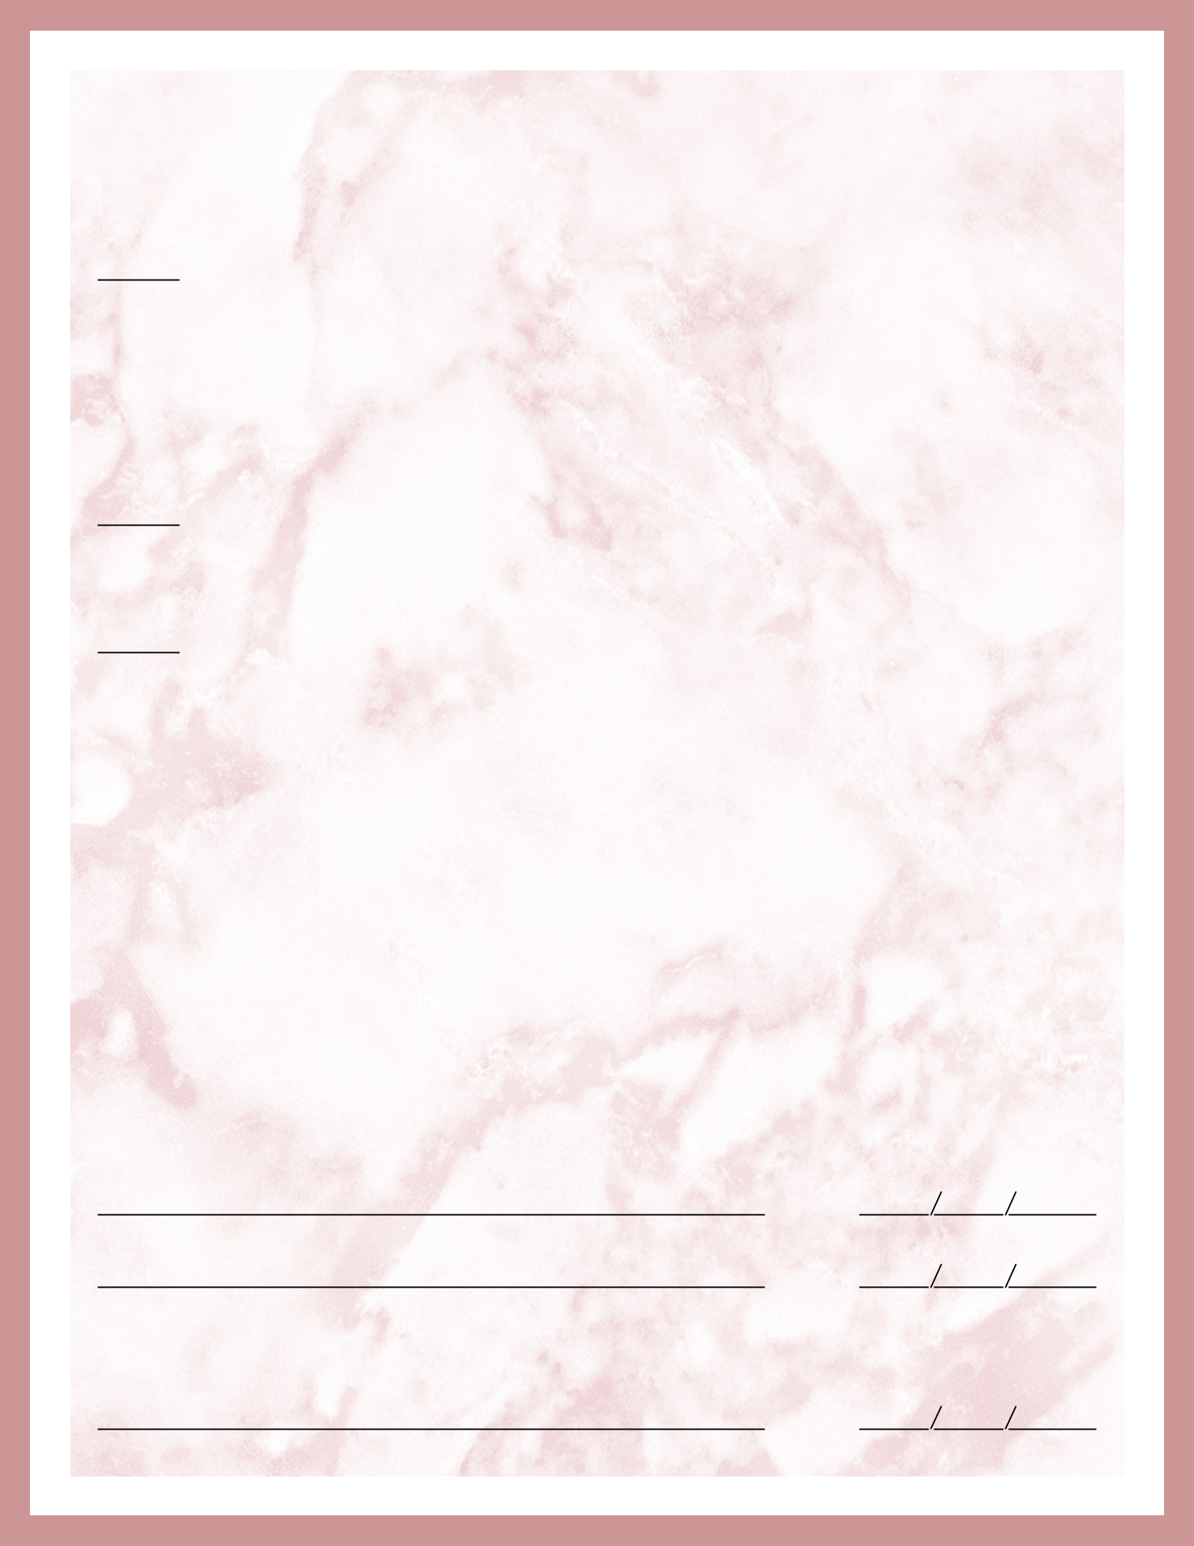
Eyelash EXTENSION CONSENT FORM

I agree to the following eyelash extension post-op and maintenance instructions:

- No waterproof mascara

- No prescription or over-the-counter eye drops

- No oil based products around the eye area

- No water can come in contact with the eye area for 24 hours of the application

- No tinting or perming of eyelash extensions

- No continuous pulling or rubbing of the synthetic lashes

This agreement will remain in effect for this procedure and all future procedures conducted by the certified eyelash extension professional. I read English and understand that this consent agreement is legal and binding. I have read and fully understand all information in this agreement. I am over 18 years of age and consent to the agreement and to treatment.

I agree to my eyelash extension professional using my photo and/or video in any online communities or forums (including but not limited to Facebook, instagram and other online media sources). My eyelash extension professional’s right of use shall include the right to publish, adapt, exhibit, reproduce, edit, distribute and display my image or likeness in connection with any product or service for any purpose (including, promotion advertising and trade) in all markets, media or technology now known or hereafter developed. I shall not have any entitlement to compensation for any content used.

I release my technician or salon from all liability associated with this procedure, which is performed with the utmost attention to safety and proper application using tools and products that the technician has been professionally trained to use. There is no guarantee for the bonding time of the eyelash extensions. This salon is not responsible for any technician errors. I understand the after care instructions and will do my part to maintain my eyelash extensions. I understand that there are many factors that may affect the life of the eyelash extensions such as water and moisture contact, weather conditions, and activities involving exposure to high temperatures.

By signing below, I verify that I have read and understand the above statements and agree to them. (An insurance release form may also need to be signed that provides coverage for this procedure.)

Date:

Signature

Date:

Technician Signature

Permission is granted to take before and after photos of my eyes / face which may be used for marketing purposes on a website, salon or class.

Date:

Signature

Page: 2

