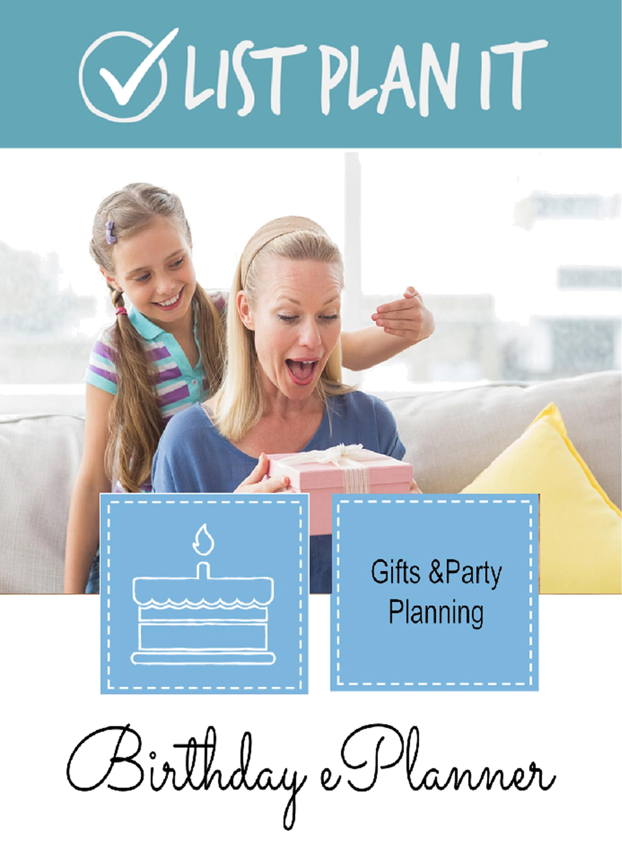


BIRTHDAY EPLANNER

GIFTS AND PARTY PLANNING

Copyright © 2015 List Plan It, LLC . All rights reserved. This ePlanner may not be reprinted or distributed in electronic, print, web, or other format without the express permission of the author. If you find this ePlanner useful, please direct your friends to http://ListPlanIt.com to obtain a copy.

BIRTHDAY EPLANNER 1

Table of Contents

FAQs

Welcome

Lists for Planning a Birthday Celebration

Create a Party Planning Checklist

Setting a Budget for a Child’s Birthday Party

Birth Month List

Birthday Gifts Given

Birthday Gifts Received

Birthday Memories

Birthday Party Planner A

Birthday Party Planner B

Birthday Party Timeline

Birthday Planner

Birthdays/Anniversaries to Remember

Cards Received

Food & Fun Worksheet

Gift Closet Inventory

Gift List A

Gift List B

Gift List C

Gift Wrap Inventory

Party Budget Planner

Party Details

Party Guest List

Party Planning Checklist

Recipes

Wish List

BIRTHDAY EPLANNER 2

FAQs

- What is an ePlanner?

An ePlanner is a packet of resources filled with tips, ideas, worksheets, and interactive lists.

- What can I do with an ePlanner?

This ePlanner is downloaded to your computer as a permanent resource to you. You can print the pages that you want or need over and over again. It is enabled for typing so you can type into the pages with your own information and save it for future reference.

- Can I use this ePlanner on a mobile device?

You can view &/or print the ePlanner from a mobile device. However, you cannot type into a PDF on your mobile device without the help of an app such as iAnnotate or Type on PDF. These apps allow you to add lots of your own information.

- What is the difference between the pages in this ePlanner and those found in a membership to ListPlanIt.com?

There is no difference in the quality of the pages, only in the delivery. A membership allows you to have access to all of ListPlanIt’s lists (including any new lists). . .one at a time. Our ePlanners are segments of lists, downloaded at one time and are updated every 2 years.

- Are there any more ePlanners like this one?

ListPlanIt.com currently has 17 ePlanners, all geared toward helping you living a more organized life. See here for a full list of our ePlanners.

BIRTHDAY EPLANNER 3

Welcome

Once a year, everyone gets a chance to feel unique. Birthdays are an excellent opportunity to celebrate the people in our lives. Treating your loved one(s) to a special gift, an outing, or a party requires plenty of thought and planning. Work out as many details as possible before the big day to ensure that everyone experiences a day that is full of laughter and love!

Members to ListPlanIt have access to hundreds of lists, checklists, inventories, schedules, and worksheets that will not only help you live a more organized life, but will also save you time and money when you use them to guide you. Not yet a member? Join today and take control of your home and family management with hundreds of mobile and printable lists, all geared toward helping you get organized. Save 20% on a Basic or Pro Annual Membership when you use the following coupon code in the checkout: LISTSRUS20
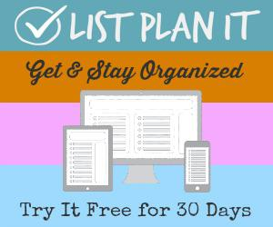

BIRTHDAY EPLANNER 4

Lists for Planning a Birthday Celebration

Whether you prefer a massive party or a small get-‐together, whether you’ll prepare lots of food or have it catered, whether you’ll have lawn games or crafts, there is plenty to consider. It helps to organize your thoughts and then create a plan of attack to get it all done.
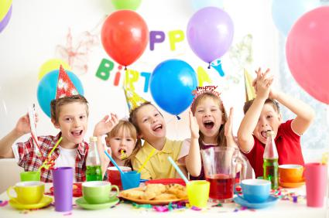

Here are some lists to get you started with your birthday celebration planning.

- Friends Quick List (Contact Info) – Keep a list of each member of your family’s friends plus their contact info for easy addressing of invitations.

- Wish List (Holidays & Occasions) – Before you buy your gift(s), be sure to know what they want. Have the birthday boy or girl fill out a wish list before you head to the store or mall.

BIRTHDAY EPLANNER 5

- Gift List (Holidays & Occasions) – Plan out the perfect gifts and keep track of what you’ve already purchased. Never buy two of the same things or overbuy again.

- Birthday Planner (Holidays & Occasions) – Get a general feel for the mood of the celebration. Will there be a party? A cake? A venue?

- Party Guest List (Holidays & Occasions) – Keep track of invitees, method of contact, and RSVPs.

- Party Fun Worksheet (Holidays & Occasions) – Just gathering people together does not always a party make. You need to provide some type of entertainment to encourage the fun. Music, crafts, activities, games are all what give a party life.

- Party Menu (Holidays & Occasions) – No party is complete without something to eat. A party will surely sink without something to drink. Plan out the food and beverages for your celebration.

- Birthday Party Timeline (Holidays & Occasions) – Make the most of the day of the party by setting up a timeline that is easy to follow and flows nicely from activity to activity.

- Birthday Gifts Received (Holidays & Occasions) – Keep track of gifts received as a record and to make thank you cards a snap.

- Goals for This Year (Holidays & Occasions) – Who said it has to be new year to set goals? I think a great birthday tradition is to set personal goals for your next year of life.

BIRTHDAY EPLANNER 6

Create a Party Planning Checklist

Whether you are celebrating a birthday, Halloween or harvest, Christmas, or New Year, a party is a great way to celebrate. However, parties are quite a bit of work for the person planning them. By creating a checklist of things to accomplish and a timeline in which to accomplish them, you’ll save yourself lots of time and frustration.
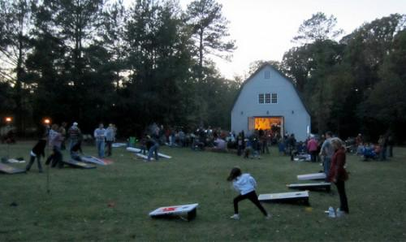

Here are some ideas for your party-‐planning checklist.

One Month Before

___ Create a Party Budget

___ Choose a theme

___ Make the guest list

___ Make or buy invitations

___ Create menu

___ Choose activities/games

___ Order supplies & favors

___ Book entertainment

BIRTHDAY EPLANNER

7

Three Weeks Before

One Day Before

___ Send invitations

___ Rent any equipment

___ Make shopping list

___ Order food/catering

Two Weeks Before

___ Order cake

___ Buy pinata & fillers

___ Clean party area

___ Charge camera/video camera

___ Decorate for party

___ Set up games/activities

___ Set out party favors

___ Prepare food that can refrigerate well

___ Bake cake

___ Clean bathrooms

___ Order flowers

Party Day

One Week Before ___ Do major cleaning ___ Buy food & beverages ___ Buy candles/matches ___ Buy thank you cards ___ Contact non-‐RSVP guests ___ Make a party timeline

___ Pick up cake, ice, balloons

___ Frost homemade cake

___ Prepare food

___ Finish decorating

___ Prepare cake table

___ If presents, set up receiving area & get

gifts received list ready

___ Don’t forget to smile

Two Days Before

___ Order balloons

Day After Party

___ Buy garbage bags

___ Arrange party favors/bags

___ Confirm entertainment

___ Choose party music/playlist

___ Return rented/borrowed equipment

___ Put reusable items in a bin/box

___ Throw away whatever you don’t

intend to use again

___ Download photos

___ Vacuum floors

___ Break out those thank you cards

BIRTHDAY EPLANNER 8

Setting a Budget for a Child’s Birthday Party

Planning your child’s birthday party can be stressful and pricey. There are so many different aspects to consider; food, decorations, games, and gifts are all common you’re putting together your party budget. However, there are ways to make your money go further. The point of a party is to have fun!
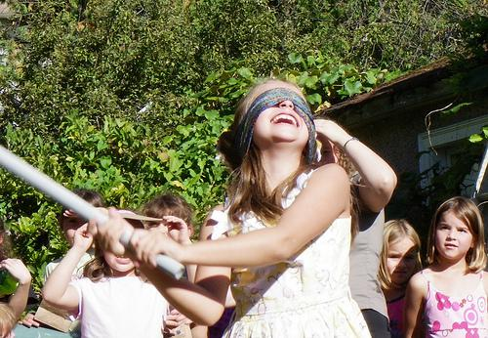

Here are some birthday budgeting steps to help make the most of your child’s big day.

- Make a list. Before you head out, take a look at the birthday and party planning lists that are available at ListPlanIt in Holidays & Occasions. Create and manage your lists right in your account. Share your lists on Facebook or via email to delegate responsibilities or give hints at gift lists. Then pull up your lists while you’re out shopping for the things that you need. Be sure to jot down everything you will need before you step

BIRTHDAY EPLANNER 9

foot in a store, and figure out just how much you’re expecting to spend. This will help you stay in a good price range and will ensure that you don’t forget anything.

- Get the best value for your money. You don’t have to shop at the most expensive store in town. Check out the local dollar store for a change. There you can find all kinds of fun, colorful decorations at great prices. Most of these products are a quality that will suit your party needs.

- Buy in bulk. Check out stores that sell snacks and drinks in bulk. If you’re doing a fairly large party with friends and family joining in, it’s better to buy large quantities all in one package than pay extra money buying each bag or box of snacks separately.

- Don’t be afraid to ask for help. Talk to friends and family and see if they have anything they could pitch in. Whether it’s old decorations or their favorite dish, they just might have something to bring to the table.

A child’s birthday is a joyous and exciting milestone. It means that wonderful bundle of joy you brought into the world is another year older and wiser. So why stress over it? With the right preparation and state of mind it can be a wonderful memory that neither you nor your child will forget.

BIRTHDAY EPLANNER 10
 |  | birthday
BIRTH MONTH LIST
Month | Gemstone | Flowers
January | Garnet | Carnations, Snowdrop
February | Amethyst | Violet, Primrose
March | Aquamarine | Daffodil, Jonquil
April | Diamond, White Sapphire | Daylily, Sweet Pea
May | Emerald | Lily of the Valley, Hawthorn
June | Pearl | Rose, Honeysuckle
July | Ruby | Larkspur, Water Lily
August | Peridot | Gladiolas, Poppy
September | Sapphire | Aster, Morning Glory
October | Opal, Tourmaline | Calendula, Cosmos
November | Topaz | Chrysanthemum
December | Turquoise, Blue Topaz | Narcissus, Holly


http://ListPlanIt.com
©2007-2015 List Plan It, LLC
birthday

BIRTHDAY GIFTS GIVEN

Name Gift(s) this Year Response


http://ListPlanIt.com
©2007-2015 List Plan It, LLC
 |  |  | birthday
BIRTHDAY GIFTS RECEIVED |  | NAME ______________
Gift | From | Store Bought | Thank You Card
Gift | From | (just in case) | Sent


http://ListPlanIt.com
©2007-2015 List Plan It, LLC

BIRTHDAY MEMORIES

Birthday Boy / Girl: Age:
Theme of Birthday:

How We Celebrated:

Special Meal:

Funny Moments:

Family & Friends Who Shared This Day:

What I Want to Remember Most:

Accomplishments Made This Year:

Comments:
birthday

DATE _______________

http://ListPlanIt.com
©2007-2015 List Plan It, LLC

 |  | birthday
BIRTHDAY PARTY PLANNER A |  | OCCASION ____________
Guests to Invite
1. |  | 11.
2. |  | 12.
3. |  | 13.
4. |  | 14.
5. |  | 15.
6. |  | 16.
7. |  | 17.
8. |  | 18.
9. |  | 19.
10. |  | 20.
Foods / Drinks to be Served
1. |  | 6.
2. |  | 7.
3. |  | 8.
4. |  | 9.
5. |  | 10.
Done | Party Prep | Instructions / Notes
 | Choose Date & Location
 | Formal | Informal | Potluck | Buffet
 | Make/Buy & Send Invitations


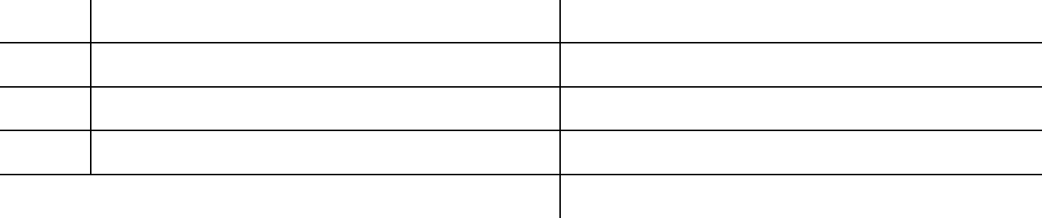

Choose Entertainment (Games, Music)
Clean House
Decorate House
Make Shopping List
Go Shopping
Prepare Food

http://ListPlanIt.com
©2007-2015 List Plan It, LLC
 |  |  | birthday
BIRTHDAY PARTY PLANNER B |  | OCCASION _______________
ONE MONTH | THREE WEEKS |  | TWO WEEKS
BEFORE | BEFORE |  | BEFORE
___ Create a Party Budget | ___ Send Invitations |  | ___ Order Cake
___ Choose Theme | ___ Rent any Equipment |  | ___ Buy Film, Batteries, &
___ Make the Guest List | ___ Buy Pinata & Fillers |  | Video Tape
___ Make or Buy Invitations | ___ Order Food |  | ___ Buy Pinata & Fillers
___ Create Menu |  |  | ___ Order Flowers
___ Make Shopping List
___ Choose
Activities/Games
___ Order Supplies & Favors
___ Book Entertainment
ONE WEEK | TWO DAYS |  | ONE DAY
BEFORE | BEFORE |  | BEFORE
___ Do Major Cleaning | ___ Order Balloons |  | ___ Clean Party Area
___ Buy Food & Beverages | ___ Buy Garbage Bags |  | ___ Charge Video Camera
___ Buy Candles / Matches | ___ Arrange Party Favors / |  | ___ Decorate for Party
___ Buy Thank You Cards | Bags |  | ___ Set up Games /
___ Call Non RSVP guests | ___ Confirm Entertainment |  | Activities
___ Make Party Timeline | ___ Choose Party Music |  | ___ Set Out Party Favors
 |  |  | ___ Prepare Food that can
 |  |  | refrigerate well
 |  |  | ___ Bake Cake
 |  |  | ___ Clean Bathrooms
PARTY DAY! | DAY AFTER PARTY |  | NOTES
___ Pick up Cake, Ice, | ___ Return Rented /
Balloons | Borrowed Equipment
___ Frost Homemade Cake | ___ Put Reusable Items in a
___ Prepare Food | “Birthday” Bin / Box
___ Finish Decorating | ___ Throw Away Whatever
___ Prepare Cake Table | you Don’t intend to use
___ Set up Presents Area & | Again
Get Gifts Rec’d List Ready | ___ Download / Develop
___ Get Camera Ready | Photos
___ Don’t forget to Smile | ___ Vacuum Floors
___ Remember, This is a | ___ Break Out those Thank
Party! | You Cards




http://ListPlanIt.com
©2007-2015 List Plan It, LLC
birthday

BIRTHDAY PARTY TIMELINE

OCCASION _______________

Time


Day of Party Plan

Notes


:00

:30

:00

:30

:00

:30

:00

:30

:00

:30

:00

:30

:00

:30

:00

:30

:00

:30

:00

:30

:00

:30

:00

:30

:00

:30

:00

http://ListPlanIt.com
©2007-2015 List Plan It, LLC

birthday

BIRTHDAY PLANNER

Birthday: Child:

Family Traditions to Include: Possible New Family Traditions:


Meal Plan:

Breakfast –

Lunch –

Dinner –

Cake Plan:


Gift Ideas:


Gifts Bought:


Activities/Events Ideas: Activities/Events Plan:

Notes:


http://ListPlanIt.com
©2007-2015 List Plan It, LLC

birthday

BIRTHDAYS / ANNIVERSARIES TO REMEMBER

January July


February August

March September

April October

May November

June December
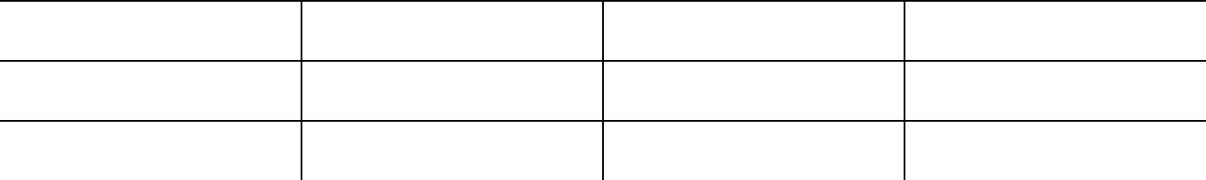

http://ListPlanIt.com
©2007-2015 List Plan It, LLC
 | birthday
CARDS RECEIVED | OCCASION ______________
1. | 26
2. | 27.
3. | 28.
4. | 29.
5. | 30.
6. | 31.
7. | 32.
8. | 33.
9. | 34.
10. | 35.
11. | 36.
12. | 37.
13. | 38.
14. | 39.
15. | 40.
16. | 41.
17. | 42.
18. | 43.
19. | 44.
20. | 45.
21. | 46.
22. | 47.
23. | 48.
24. | 49.
25. | 50.
 | http://ListPlanIt.com
 | ©2007-2015 List Plan It, LLC

birthday

FOOD & FUN WORKSHEET

Food / Beverages Ingredients Needed Instructions


Games / Activities Supplies Needed Instructions

http://ListPlanIt.com
©2007-2015 List Plan It, LLC
birthday

GIFT CLOSET INVENTORY

Boy


Girl

Baby


Wedding

Anniversary

Christmas


http://ListPlanIt.com
©2007-2015 List Plan It, LLC
birthday

GIFT LIST A

OCCASION _______________

Recipient
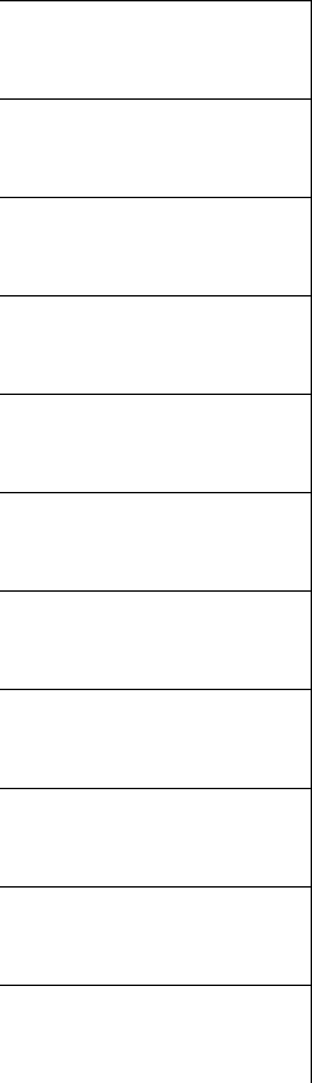

Gift Ideas
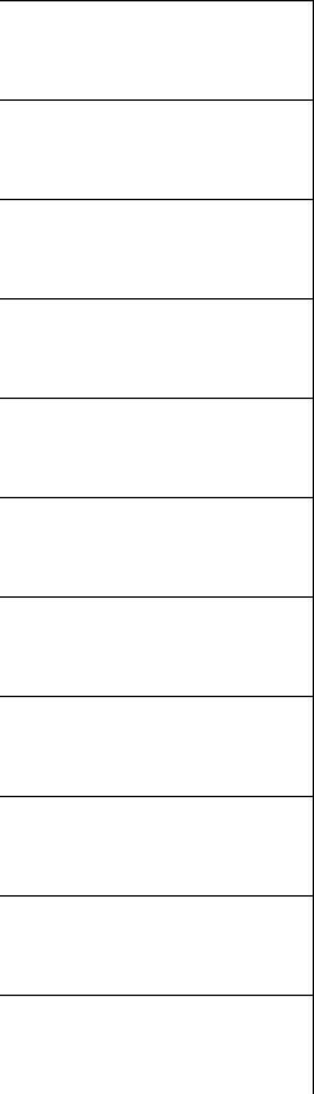

Final Gifts

http://ListPlanIt.com
©2007-2015 List Plan It, LLC

 |  |  | birthday
GIFT LIST B |  |  | OCCASION _______________
Recipient | Projected | Gift Ideas | Final Gifts
Recipient | Spending | Gift Ideas | Final Gifts
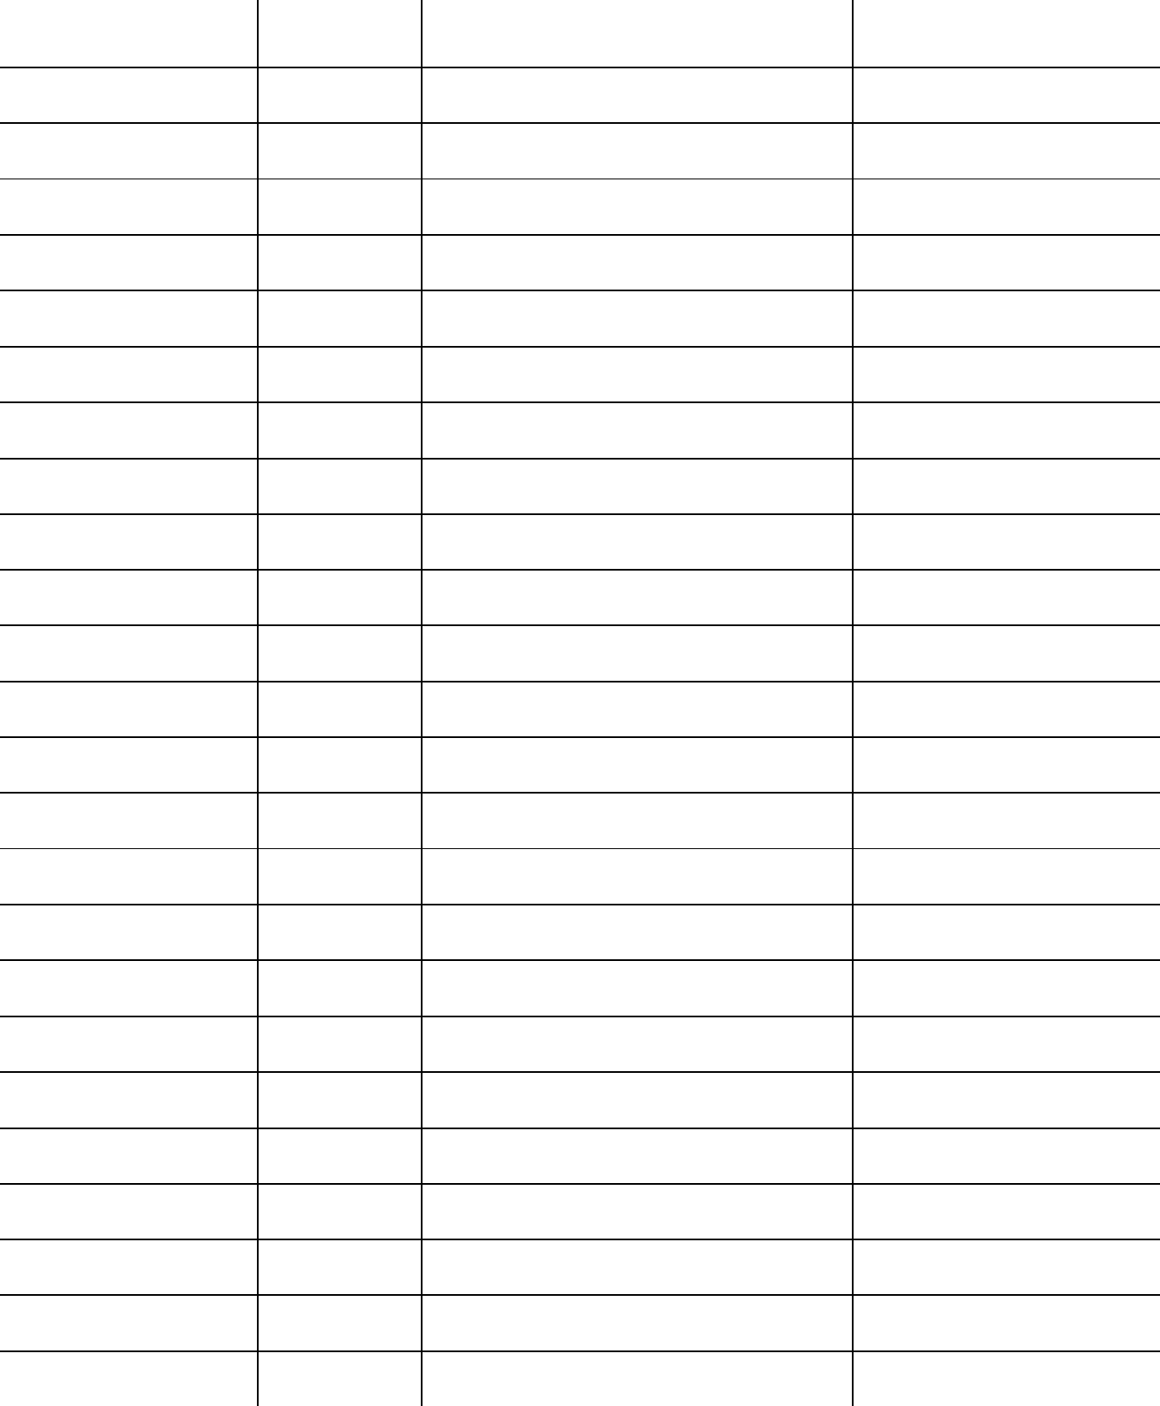

http://ListPlanIt.com
©2007-2015 List Plan It, LLC

GIFT LIST C

Recipient

Something You Want

Something You Need

Something to Wear

Something to Read

Recipient

Something You Want

Something You Need

Something to Wear

Something to Read

Recipient

Something You Want

Something You Need

Something to Wear

Something to Read

Recipient

Something You Want

Something You Need

Something to Wear

Something to Read

Recipient

Something You Want

Something You Need

Something to Wear

Something to Read
birthday


OCCASION _______________

Gift Ideas Gifts Bought
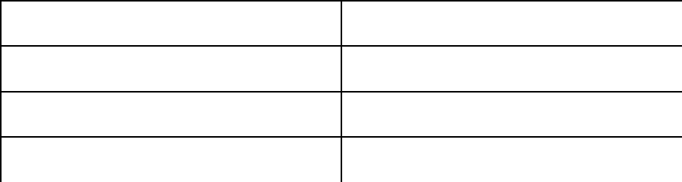

Gift Ideas Gifts Bought
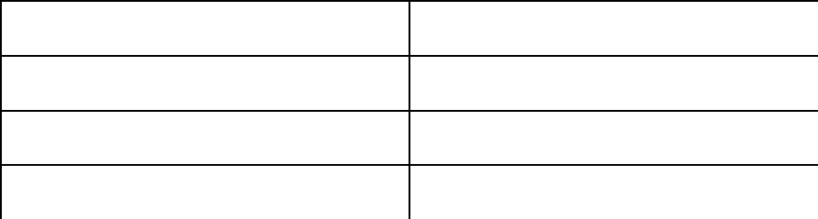

Gift Ideas Gifts Bought
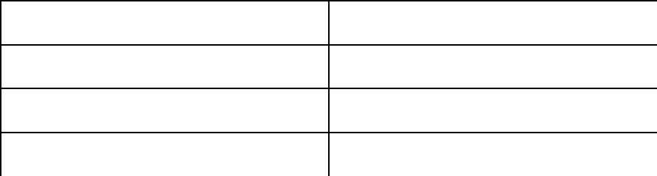

Gift Ideas Gifts Bought

Gift Ideas Gifts Bought

http://ListPlanIt.com
©2007-2015 List Plan It, LLC
birthday

GIFT WRAP INVENTORY

Wrapping Paper Gift Bags/Boxes


Tissue Paper Labels/Gift Tags


Ribbons/Bows Gift Cards


http://ListPlanIt.com
©2007-2015 List Plan It, LLC
birthday

PARTY BUDGET PLANNER


OCCASION _______________

Drinks / Food:

Description of Expenses
Appetizers, Meal, Cake, Caterer, Etc


Projected
Costs

Actual
Costs

Party Goods:

Description of Expenses
Invitations, Plates, Napkins, Decorations, Etc

Projected
Costs

Actual
Costs

Entertainment:

Description of Expenses
Music, Games, Prizes/Goody Bags,

Etc

Projected
Costs

Actual
Costs

Rental:

Description of Expenses
Hall, Restaurant, Inflatables, Etc

Projected
Costs

Actual
Costs

http://ListPlanIt.com
©2007-2015 List Plan It, LLC

birthday

PARTY DETAILS

OCCASION ________________

Food / Beverages

Ingredients Needed


Instructions

Games / Activities Supplies Needed Instructions


http://ListPlanIt.com
©2007-2015 List Plan It, LLC

PARTY GUEST LIST

Name # in Family 1. 2. 3. 4. 5. 6. 7. 8. 9. 10. 11. 12. 13. 14. 15. 16. 17. 18. 19. 20. 21. 22. 23. 24. 25.


 |  | birthday
 | OCCASION _______________
RSVP | Gift Received | Thank You
Y / N | Gift Received | Sent
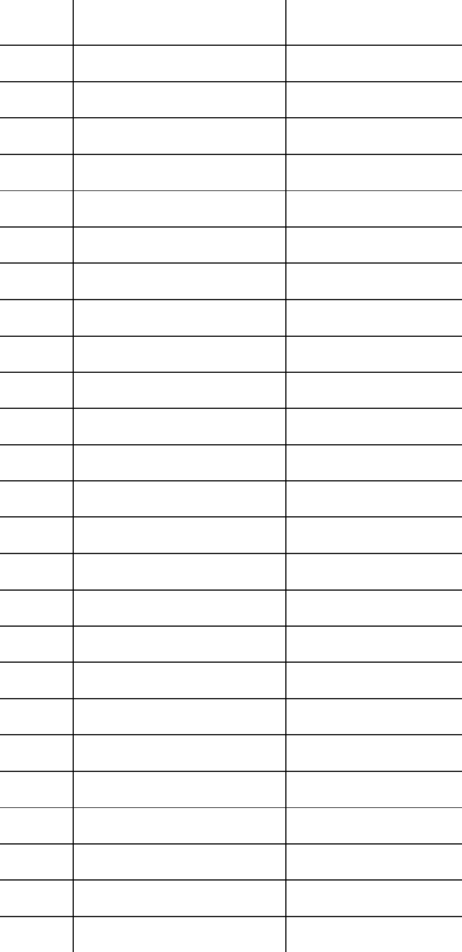

http://ListPlanIt.com
©2007-2015 List Plan It, LLC

 |  | birthday
PARTY PLANNING CHECKLIST |  | OCCASION _______________
ONE MONTH | THREE WEEKS | TWO WEEKS
BEFORE | BEFORE | BEFORE
___ Create a party budget | ___ Send invitations | ___ Order c
___ Choose Theme | ___ Rent any equipment | ___ Buy pinata & fillers
___ Make the Guest List | ___ Make shopping list | ___ Order flowers
___ Make or Buy Invitations | ___ Order food/catering
___ Create Menu
___ Choose Activities
/Games
___ Order Supplies & Favors
___ Book Entertainment
ONE WEEK | TWO DAYS | ONE DAY
BEFORE | BEFORE | BEFORE
___ Do major cleaning | ___ Clean party area | ___ Charge camera /video
___ Buy food & beverages | ___ Clean bathrooms | camera
___ Buy candles / matches | ___ Buy garbage bags | ___ Decorate for party
___ Buy thank you cards | ___ Arrange party favors / | ___ Set up games /
___ Order balloons | bags | activities
___ Call non-RSVP guests | ___ Confirm Entertainment___ Set out party favors
___ Make party timeline | ___ Choose party music / | ___ Prepare food that can
 | playlist | refrigerate well
 |  | ___ Bake cake


PARTY DAY! | DAY AFTER PARTY | NOTES
___ Pick up cake, ice, | ___ Return rented /
balloons | borrowed equipment
___ Frost homemade cake | ___ Put reusable items
___ Prepare food | away
___ Finish decorating | ___ Throw away whatever
___ Prepare cake table | you don’t intend to use
___ If presents, set up | again
receiving area | ___ Download photos
___ Prepare a gifts rec’d list | ___ Vacuum floors
___ Get camera Ready | ___ Break out those thank
___ Don’t forget to smile | you cards


http://ListPlanIt.com
©2007-2015 List Plan It, LLC

RECIPES


Recipe:

Ingredients:

Directions:

Recipe:

Ingredients:

Directions:

http://ListPlanIt.com
©2007-2015 List Plan It, LLC
birthday

Remarks:

Remarks:
birthday

WISH LIST

NAME _______________

I Would Like. . .

Where I Found It


Rank


http://ListPlanIt.com
©2007-2015 List Plan It, LLC

Related Resources

Did you like this ePlanner? Try some of our other ePlanners:
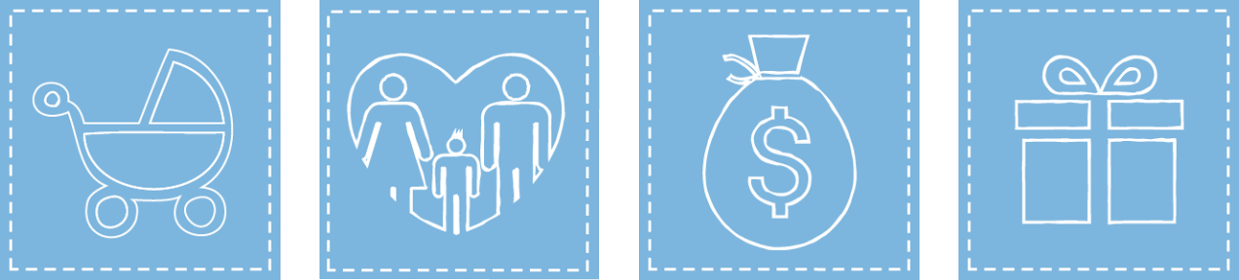

Baby ePlanner Family ePlanner Finance ePlanner Holiday ePlanner


Homemaking ePlanner Meals ePlanner Moving ePlanner Personal ePlanner


Planning

Retreat

Planner ePlanner


Student ePlanner

Travel ePlanner

Planning Retreat ePlanner


http://ListPlanIt.com

©2015 List Plan It, LLC

