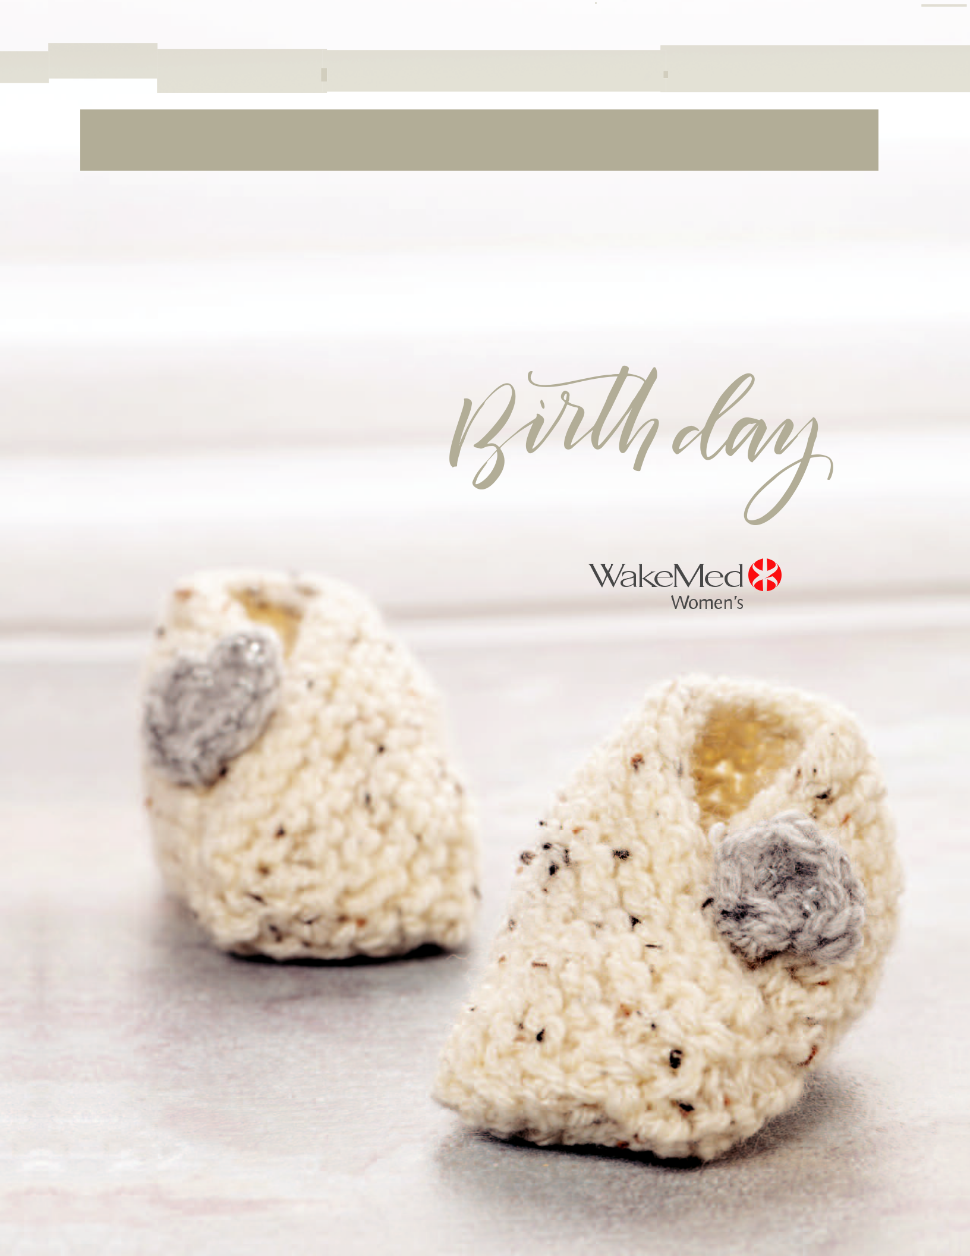
PATIENT NAME

When it comes to giving birth your way, putting it in writing can help. A Birth Plan is an optional wish list that allows you to outline your goals, hopes, indicate any concerns and tell us your preferences for when the time comes to labor and give birth. It’s a way to keep all your birth day care providers informed about what is most important to you.

A birth plan, or wish list, is a communication tool summarizing your “birth day” preferences. It is important to understand there is more than one way to do things, and every birth is unique and can be unpredictable. Try to remain flexible, positive, realistic, and limit it to what matters most to you.

WISH LIST

WakeMed supports your wishes and desires when it

comes to welcoming a new baby, and have created

this wish list format to capture this important

information. It is our ultimate goal for both mom

and baby to emerge happy and healthy after each

and every birth.

We are here to answer any questions you may have

about the labor and birth process.

getting started

We recommend:

- Take childbirth preparation classes. For a list of classes offered at WakeMed, visit www.wakemed.org and click on Classes & Events > Childbirth & Family.
- Read reputable books and/or websites about labor and birth

WISH LIST



- Spend time reflecting on your own preferences and discuss your thoughts with your support person/team.

- Share your draft with your health care provider at your next appointment and discuss it with him/her.

- Revise your “Birth Day Wish List” as needed.

- Pack several copies in your hospital bag and bring to the hospital when it’s time to deliver. Snap a photo, too, in case you misplace or forget your paper copies.

about you

NAME BABY’S ESTIMATED BIRTH DATE

BEST WAY TO CONTACT YOU AFTER YOU GO HOME JPHONE/EMAILK

YOUR DOCTORJSK

BABY’S NAME JIF DECIDEDK

PEDIATRICIAN: JCONTACT PEDIATRICIAN AHEAD OF TIME TO VERIFY IF THEY ARE ACCEPTING NEW PATIENTSK

MAIN SUPPORT PERSON’S NAME RELATIONSHIP TO YOU

IMPORTANT PEOPLE JOTHER THAN MAIN SUPPORT PERSONK YOU WOULD LIKE TO BE PRESENT DURING YOUR BABY’S BIRTH.

(See visitation policy)

DOULA: (IF APPLICABLE PLEASE PROVIDE YOUR DOULA’S NAME)

NOTE: Doulas are welcomed, but they count as a support person as outlined in the visitation policy.

What can we do to help you reach your “birth day” goals? List your top three desires for this birth.

1.

2.

3.

❑ Breastfeeding ❑ Bottle Feeding

(The American Academy of Pediatrics recommends exclusive breastfeeding for the first year of life.)

pain medication/anesthesia

Pain is an individual experience. The discomforts of labor and birth vary from woman to woman. We are here to help you effectively cope with these discomforts through the use of coping mechanisms such as movement, massage, position changes, breathing techniques and relaxation. When well-supported and continuously encouraged, many women are able to give birth with few, if any, medications.

Should medications be requested, you and your health care provider can discuss available options to reduce your discomfort. Keep in mind, pain medications can ease discomfort, but they are not designed to eliminate all sensations.

Throughout labor, you will be asked about your level of pain. We use a

0-10 scale with “0” being no pain and “10” being the very worst pain you can imagine. We encourage you to think about your pain tolerance level and use all available coping and comfort measures throughout labor and birth to help you to have a more satisfying birthing experience.

“P.A.I.N.” is…

Purposeful – alerts and causes labor progress

Anticipated – we expect some pain in labor

Intermittent – it comes and goes, giving you a break

Normal – nothing is more normal than labor pain

wish list for labor

(Check your wishes)

Labor Induction/Augmentation

If I go past my estimated due date and there are no health risks for me or my baby, I would prefer:

❑ Not to be induced ❑ To be induced

So that we may better serve you, please indicate your preferences below.

Pain Management/Anesthesia

Remember you can change your mind at any point throughout labor.

❑ I prefer to labor and give birth without pain medication. I am aware of pain medications available. I will ask if I would like something for pain. Please do not ask me.

❑ I would like to have pain medications offered to me via IV before trying an epidural.

❑ I would like an epidural as soon as possible. (Keep in mind, getting an epidural requires a team effort that takes 60-90 minutes to accomplish. We strongly encourage you to learn, practice and use all available coping and comfort measures while we work to place your epidural.)

first stage labor (0-10 cm dilated)

I prefer…

Lighting: ❑ Dim ❑ Bright ❑ Open curtains

Television: ❑ On ❑ Off

Quiet: ❑ During contractions ❑ All the time

❑ Music (bring your own music & player)

❑ Aromatherapy/essential oils (bring your own; no lit candles in the hospital)

❑ To wear a hospital provided gown ❑ To wear my own clothes

❑ Encouragement/positive reinforcement ❑ Massage/touch

❑ Movement/Position changes ❑ Shower

❑ Tub

❑ Heat/Cold therapy

❑ Guided imagery/visualization ❑ Breathing patterns

❑ Relaxation/meditation ❑ Birthing ball

❑ Other:

c o n t i n u e d

The following are my preferences (I understand these items are subject to approval by my health care provider according to the safety of me and my baby.)
❑ I prefer no IV unless absolutely necessary.

❑ If I need an IV, I would like to use a saline lock. A saline lock is a port that allows immediate access to the vein for IV fluids and/or medications if needed. The advantage is that you don’t have to be continuously connected to the tubing and IV bag with the pole.

❑ Intermittent (off and on) fetal monitoring if the baby is not in distress.

❑ Continuous fetal monitoring. I understand this may limit some mobility.

after birth

❑ To have my baby placed skin-to-skin immediately and to remain there long as baby is not having difficulty adjusting.

❑ To have the baby dried and swaddled, by the nurse, before being brought to me.

❑ To have cut the cord.

❑ To allow the cord to stop pulsating before clamping and/or cutting. ❑ To bank the baby’s umbilical cord blood (bring your own collection

kit from a cord blood banking company) ❑ Other:

second stage labor (pushing)

I would like…

❑ A mirror present (to help with pushing and to view birth) ❑ To touch the baby’s head as it crowns

❑ My coach or designated person to support my legs when I push ❑ To use a squat bar during pushing

❑ To try different positions during pushing

❑ To delay pushing until I feel the urge, even if I am fully dilated (Labor down)

❑ Counting to help me push ❑ No counting to help me push ❑ Other:


newborn care

WakeMed offers family-centered care that creates an environment to foster a relationship between mom, baby and family. As part of our family-centered approach, we encourage rooming-in, where your baby is kept in the room with you, rather than the nursery. This is special time for you to get to know your newborn and learn how to care for him/her and for yourself, and is especially helpful for those who are breastfeeding. If you should need our newborn nursery, it is available to you at any time during your stay.



© 2019 WakeMed

