O - 9/13/13 | Christmas Gift Tags | #FR-039
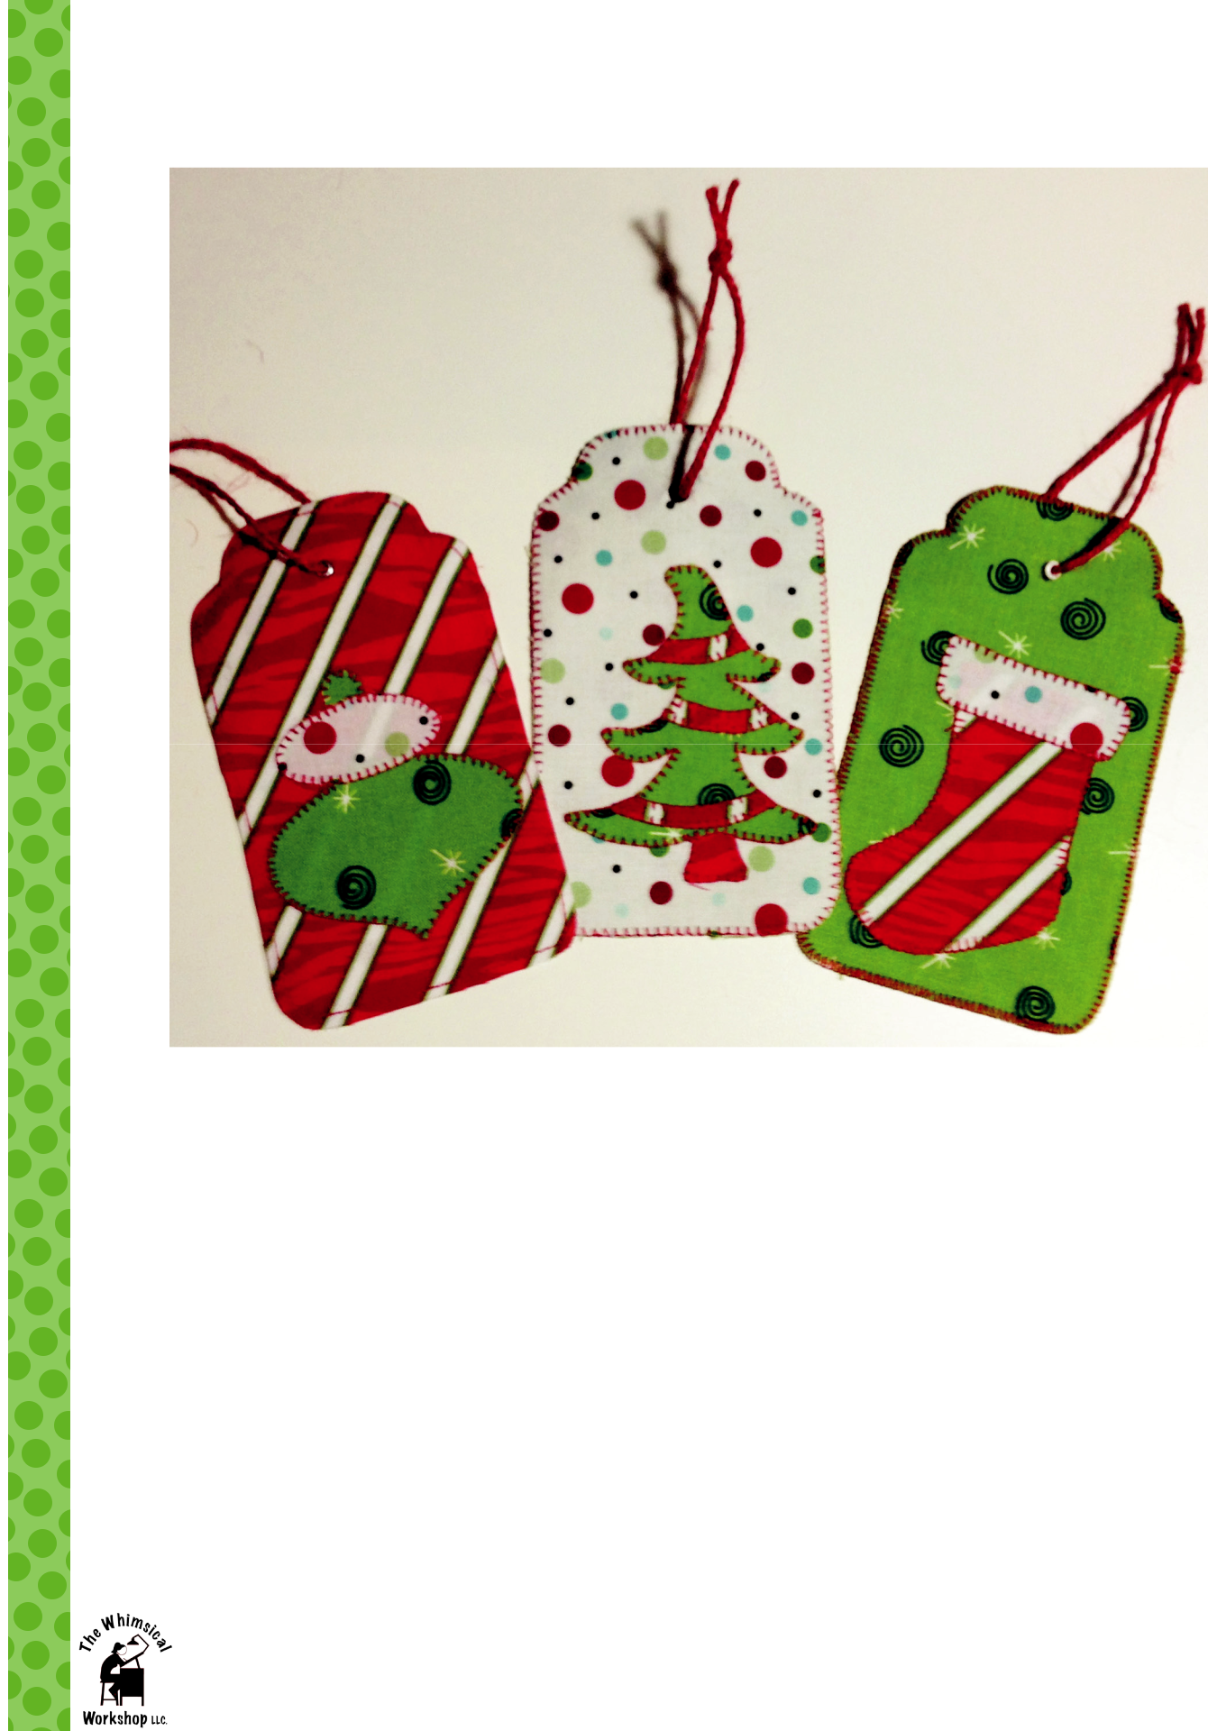

Designed by Heidi Pridemore

Fabric Requirements (makes 9 tags) : | You will also need:
• 1/4 yard of White Dots | • 1 1/2 yards of Fusible Web
• 1/4 yard of Red Stripe | • | 2 yards of cord or ribbon
• 1/4 yard of Green Swirls | • | OPTIONAL- (9) 1/4” Eyelets

©2013 All Rights Reserved The Whimsical Workshop Page 1

O - 9/13/13 | Christmas Gift Tags | #FR-039

3" x 5 1/2"
Designed by Heidi Pridemore

Please read all instructions before starting. Measurement on borders are approximate, measure your quilt top before cutting.

Cutting Instructions:

White Dots • Cut six 4" x 6" rectangles (3 for label fronts and 3 for label backs)

• See instructions to cut stocking and ornament parts

Red Stripe • Cut six 4" x 6" rectangles (3 for label fronts and 3 for label backs)

• See instructions to cut stocking and tree parts

Green Swirls • Cut six 4" x 6" rectangles (3 for label fronts and 3 for label backs)

• See instructions to cut tree and ornament parts

Assembly Instructions

1.

2.

3.

Refer to the manufacturer's instructions to trace the tree, stocking and ornament templates onto the paper side of the fusible web.

Press each template onto the wrong side of the fabrics as listed on the templates. Cut out each tem-plate on the drawn lines.

Using the placement drawing and an applique pressing sheet to assemble the tree, stocking and ornament. NOTE: if you do not have an applique pressing sheet, assemble each item onto the center of a 4" x 6" rectangle of your choice.

4. Press the assembled tree, stocking or tree onto the center of one 4" x 6" rectangle of your choice to make the gift tag front. Finish the raw edges of each shape with a decorative stitch such as a button-hole or satin stitch.

5. Press fusible web to the wrong side of the gift tag front. Place one plain 4" x 6" rectangle (label back) on top of the fused label front, wrong sides together (with the fusible web sandwiched between the two fabrics). Press the layers together to make one label.

6.

7.

8.


Place the Gift Tag Template on top of the layered label and trace around the template. Make sure to mark the hole for the cord onto the tag as well. Cut out the gift tag and the hole.

Stitch around the gift tag edge using a decorative stitch such as a satin or buttonhole stitch or use a straight stitch an 1/8" around the edges

For the hole, either stitch around the hole or use a 1/4" eyelet to finish the hole. Cut a 7" piece of cord and slide it through the finished hole. Use the cord to tie the label the gift. Use a permanent pen to write To: and From: on the back of the label.

Page 2

©2013 All Rights Reserved The Whimsical Workshop • Do not reproduce without written permission of The Whimsical Workshop.

Happy Holiday Gift Tags

Templates

Red Stripe

Templates

Placement Drawing
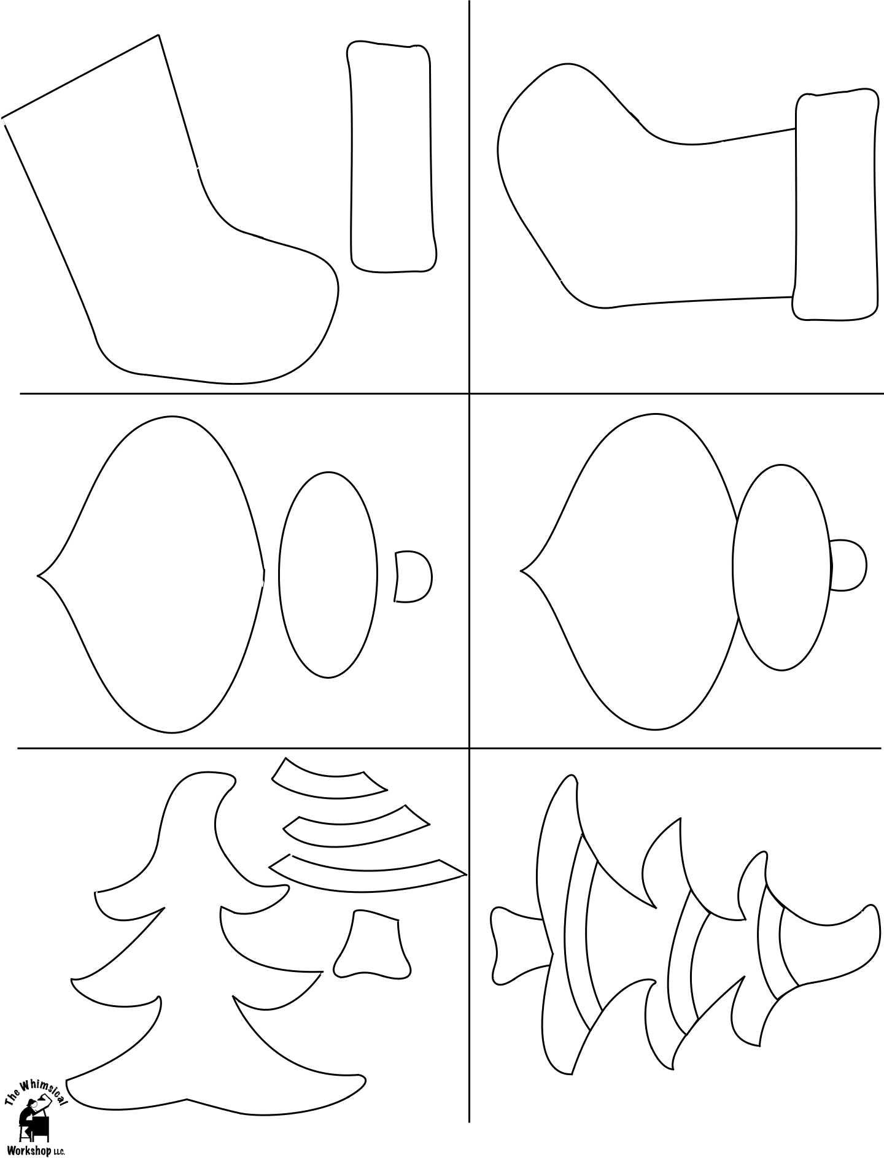

White Dots

Placement Drawing

SwirlsGreen | DotsWhite | SwirlsGreen

Templates

Red Stripe

Placement Drawing

Green Swirls

Red Stripe

Red Stripe

Red

Stripe

Page 3

©2013 All Rights Reserved The Whimsical Workshop • Do not reproduce without written permission of The Whimsical Workshop.

O - 9/13/13 | Christmas Gift Tags | #FR-039

3" x 5 1/2"
Designed by Heidi Pridemore
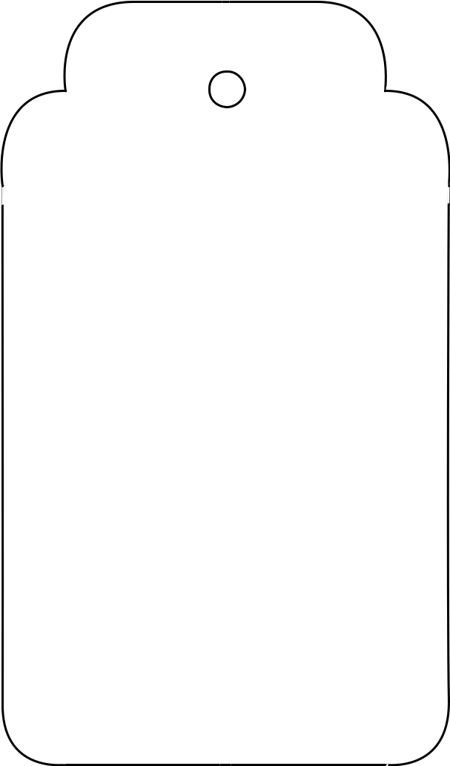

Gift Tag Template

Page 4

©2013 All Rights Reserved The Whimsical Workshop • Do not reproduce without written permission of The Whimsical Workshop.

