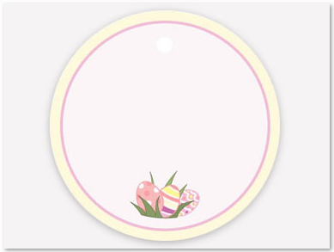

Thinking of you always

To

From



Thinking of you always

To

From