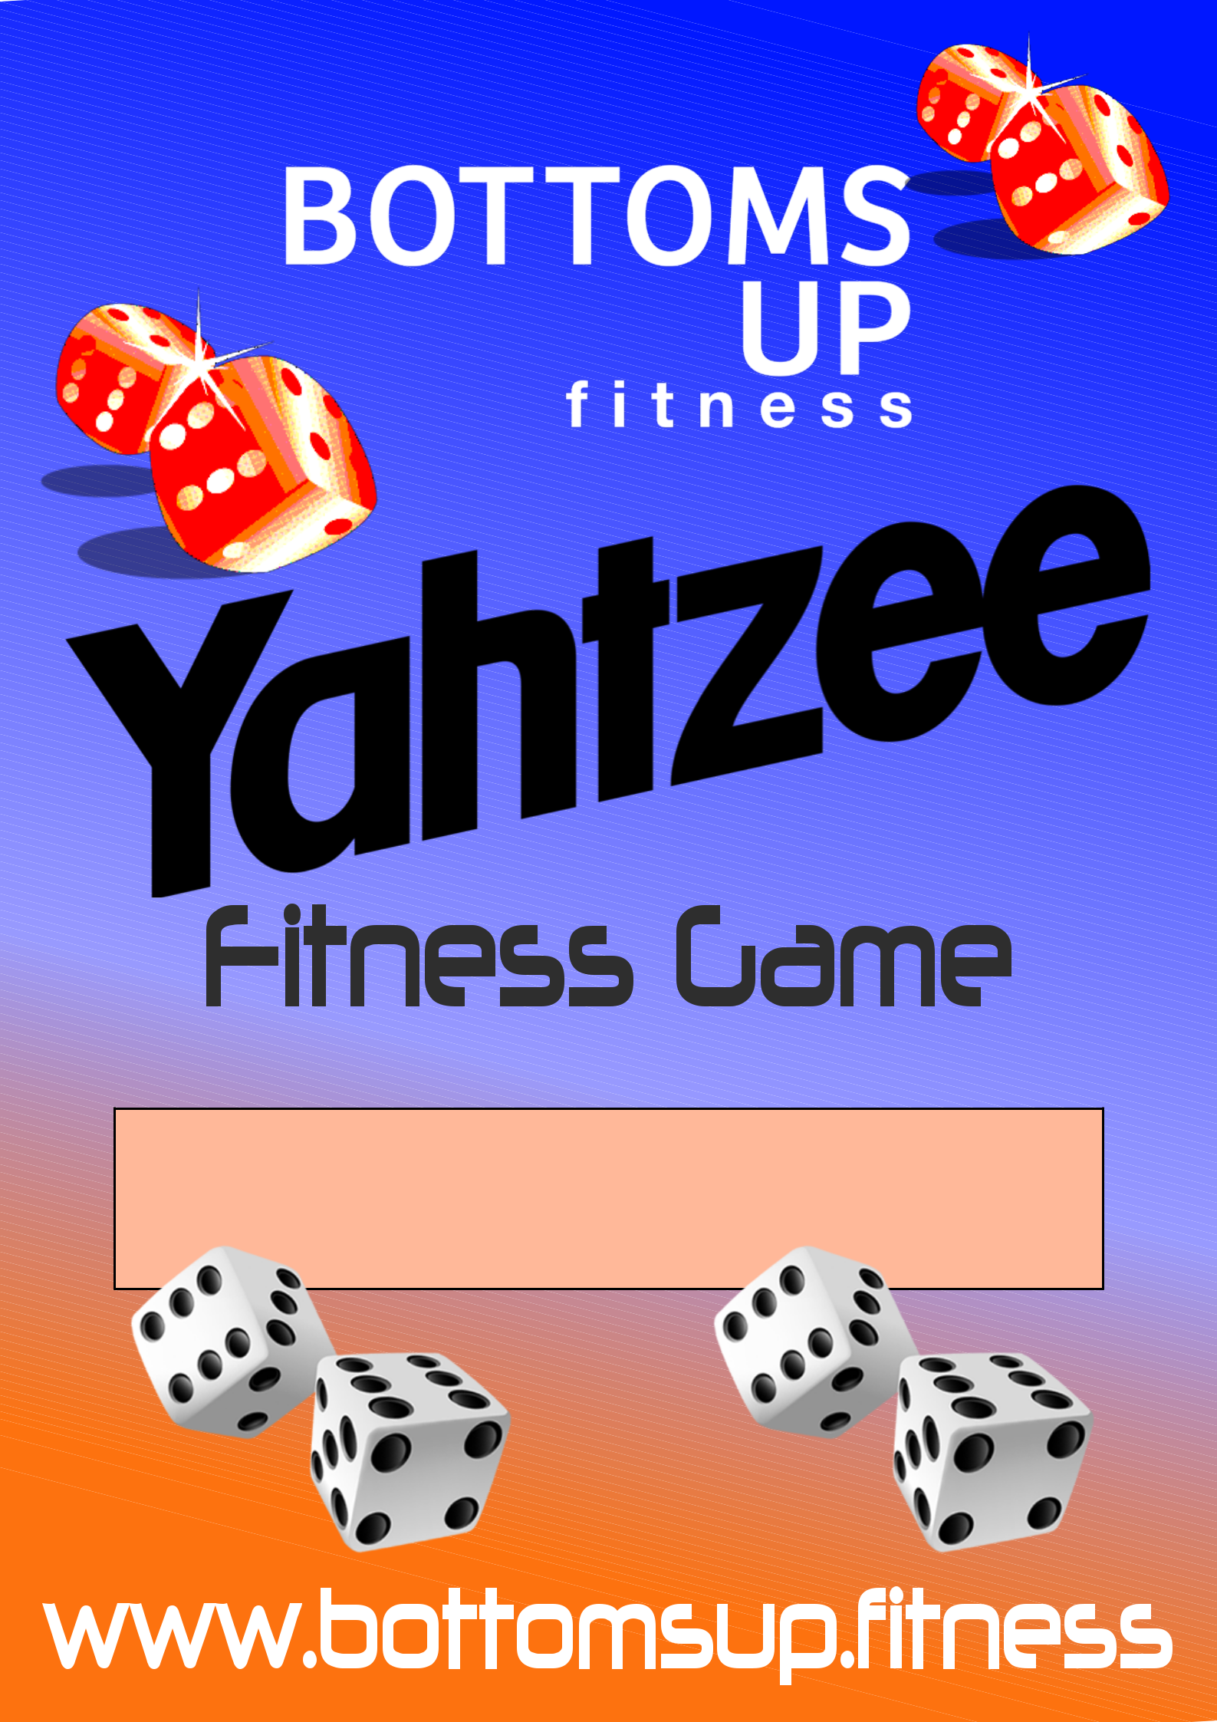

Inside are all the rules and instructions for you to play Yahtzee fitness. This is a team game suited for group fitness sessions and physical education classes.
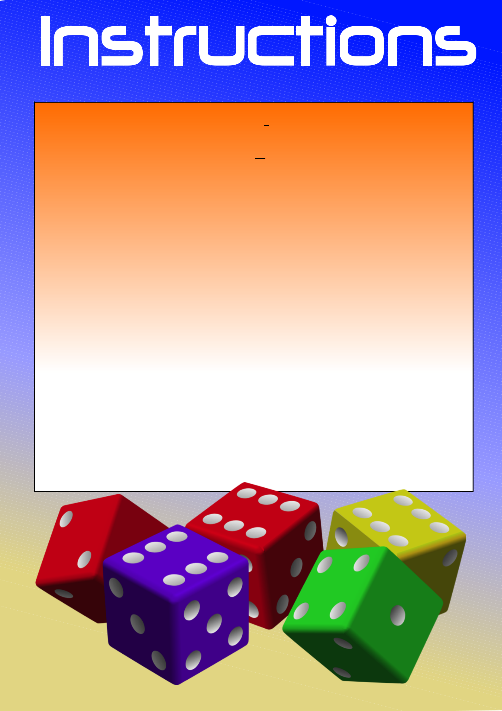

Time
15 - 30 minutes

How to play
A shortened fitness take on the classic game Yahtzee, this fitness session should create fun and excitement. Get the participants into teams of 4 or any number that suits your group size. As per the traditional game of Yahtzee, the participants roll 5 dice and try to get the highest score they can. Once they have rolled the dice they can either reroll some or all of the dice up to a total of 3 times.

After 3 rolls they need to choose a category to score in the table below eg. They may have 3 ones and therefore choose to pick the ‘ones’ category. In this instance they would put their total of 3 into their score and then complete the required exercise attached to this. Then they would come back and roll again to try and obtain another category and complete the exercise assigned to it.

Once there are only 1-2 categories left they may not be able to match a category eg. They may need to obtain a small straight and are not able to achieve it in their 3 rolls. In this instance they would get a zero for that score and as punishment they would complete double the reps of the exercise for that category. The game continues until the teams complete their scorecard.

The winning team is the team that gets the highest score. Between rolls and exercises, get the group to perform a 100m or 200m run as a team.

Print out a game card for each team and provide them with five dice for the game to start.





Ones

Twos

Threes

Fours

Fives

Sixes

Three of a kind

Four of a kind

Small straight

Large Straight

Yahtzee

Chance


count & add ones



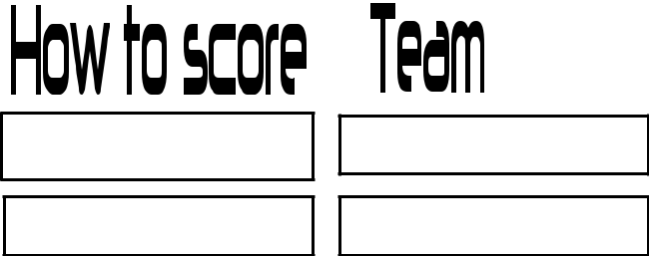

count & add twos

count & add threes

count & add fours

count & add fives

count & add sixes

add total of all
dice

add total of all
dice


sequence of four
numbers (score 30)

sequence of five
numbers (score 40)

five of a kind
(score 50)

Add total of dice
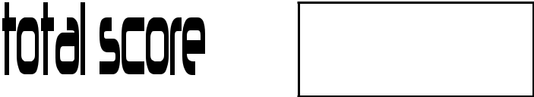

15 Kettle Bell


swings

15 slam balls

10 kettle bell
squats

10 knee slam balls

10 kettle bell
deadlift jumps

10 kettle bell
thrusters

10 side to side slam
balls

15 kettle bell pull
ups

15 kettle bell
shoulder presses

20 kettle bell
lunges


20 kettle bell
single arm swings

15 kettle bell
deadlifts

Ones |  | count & add ones |  |  |  | 15 Kettle Bell
 |  |  |  |  |  | swings
Twos |  | count & add twos |  |  |  | 15 slam balls
Threes |  | count & add threes |  |  |  | 10 kettle bell
 |  |  |  |  |  | squats
Fours |  | count & add fours |  |  |  | 10 knee slam balls
Fives |  | count & add fives |  |  |  | 10 Squat Thrusters
Sixes |  | count & add sixes |  |  |  | 10 Push Ups
Three of a kind |  | add total of all |  |  |  | 15 Dips
 |  | dice
Four of a kind |  | add total of all |  |  |  | 15 kettle bell pull
 |  | dice |  |  |  | ups
Small straight |  | sequence of four |  |  |  | 30 Lunges
 |  | numbers (score 30)
Large Straight |  | sequence of five |  |  |  | 15 Commandoes
 |  | numbers (score 40)
Yahtzee |  | five of a kind |  |  |  | 20 kettle bell
 |  | (score 50) |  |  |  | single arm swings
Chance |  | Add total of dice |  |  |  | 15 kettle bell
 |  |  |  |  |  | deadlifts


Ones

Twos

Threes

Fours

Fives

Sixes

Three of a kind

Four of a kind

Small straight

Large Straight

Yahtzee

Chance

count & add ones

count & add twos

count & add threes

count & add fours

count & add fives

count & add sixes

add total of all
dice

add total of all
dice

sequence of four
numbers (score 30)

sequence of five
numbers (score 40)

five of a kind
(score 50)

Add total of dice

10 push ups

10 squat thrusters

15 squat jumps

- lunges
(alternating legs)

10 V-Sits

- Commandoes 10 Burpees

15 Sit Ups

15 Sumo squats

10 Dips

10 tuck jumps or
box jumps

15 star jump
squats

