PLAYERS NAME_________________________________
SCORE CARD

If total score
Is 63 or over
UPPER SECTION | HOW  TO SCORE | GAME  #1 | GAME  #2 | GAME  #3 | GAME  #4 | GAME  #5 | GAME  #6
Aces = 1 | COUNT AND  ADD ONLY  ACES
Twos = 2 | COUNT AND  ADD ONLY  TWOS
Threes 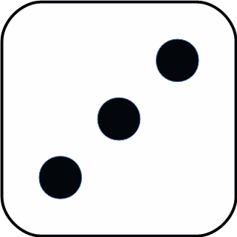 = 3 | COUNT AND  ADD ONLY  THREES
Fours 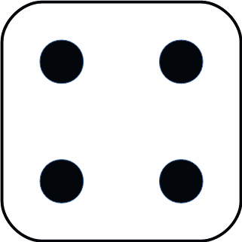 = 4 | COUNT AND  ADD ONLY  FOURS
Fives 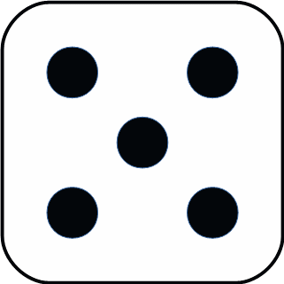 = 5 | COUNT AND  ADD ONLY  FIVES
Sixes 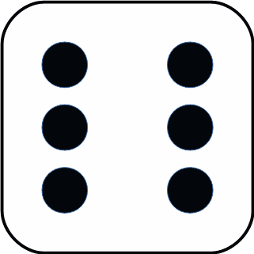 = 6 | COUNT AND  ADD ONLY  SIXES
TOTAL SCORE
BONUS | SCORE 35
TOTAL
Of Upper
Section
LOWER SECTION | HOW  TO SCORE
3 of a kind | Add Total  Of All Dice
4 of a kind | Add Total  Of All Dice
Full House | SCORE  25
Sm. Straight  (Sequence)  Of 4  (Sequence)  Of 5  5 of  A kind  Of Lower  Section  Of Upper  Section | SCORE  25
Lg. Straight | SCORE  40
YAHTZEE | SCORE  50
Chance | Score Total  Of All 5 Dice
TOTAL
TOTAL
GRAND TOTAL

Duplicated by Linear Concepts, 2017
4A72 - BE SURE TO WISH THE STONECIPHERS A HAPPY 50TH WEDDING ANNIVERSARY. MAY 28 1967

