

make bed


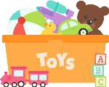tidy room


help with
dishes


clean
washroom


set table


take out garbage

- s CHORE CHART


SUN MON TUE WED THU FRI SAT


AWESOME BAM!


I DID IT! AWESOME


I DID IT! BAM!


GOT IT! ROCKSTAR


^{ROCKSTAR} GOT IT!
 |  |  |  |  |  |  |  | Cop
SWEET |  |  |  |  |  |  |  | SWEET

- s CHORE CHART

SUN MON TUE WED THU FRI SAT



make bed


tidy room


help with
dishes


clean
washroom


set table


take out
garbage

Copyright 2019 www.mindfulmazing.com


- s CHORE CHART

SUN MON TUE WED THU FRI SAT



Copyright 2019 www.mindfulmazing.com

Cut

out

and

tape

and

glue to

your

blank chore chart OR cut out and put in your chores to do jar.

do

homework

make bed

tidy room

help with
dishes


clean
washroom


set table

take out
garbage

sweep
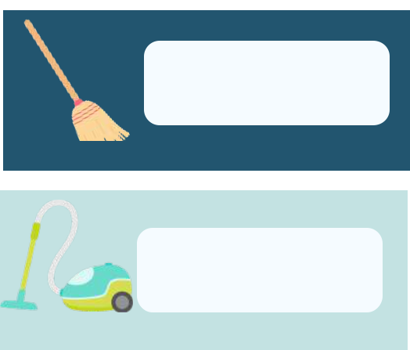

vacumn


brush teeth


dust


water
plants


feed pets


walk dog

wipe

counters


yard work


put away
clothes


help with
dinner prep


mow grass


pack lunch


bring in
mail

C
A
S
H

C
A
R
D

S

O
R

G
L
U
E

O
N

C
H
A
R

T

Copyright 2019 www.mindfulmazing.com

M

A
K
E


Y
O
U
R


O
W
N


C
H
O

R
E

S
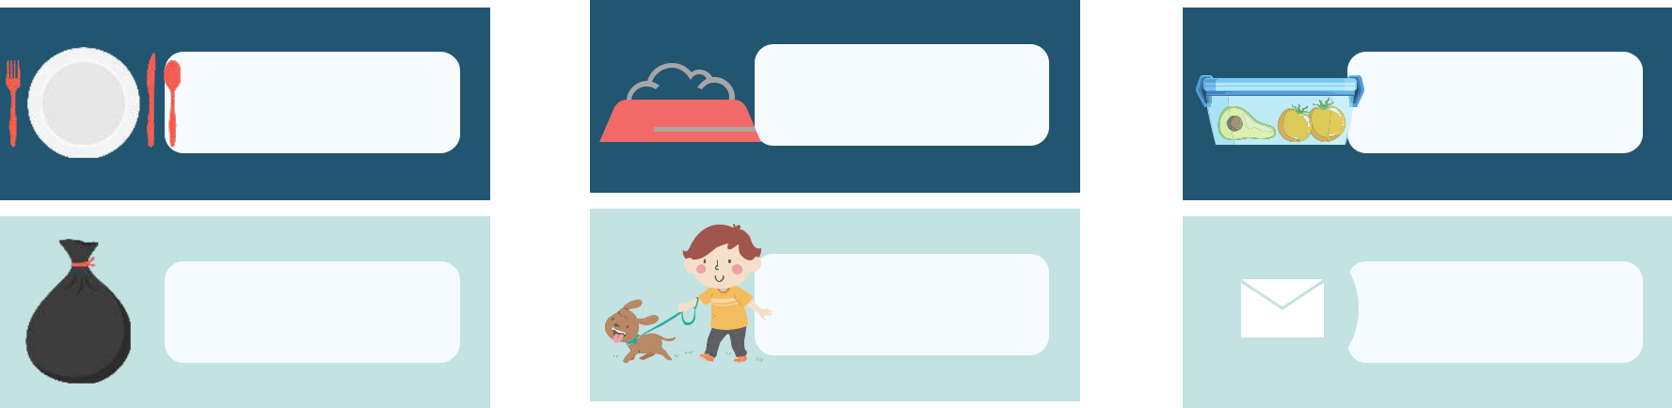

Copyright 2019 www.mindfulmazing.com


AWESOME AWESOME AWESOME AWESOME AWESOME AWESOME AWESOME


ROCKSTAR ROCKSTAR ROCKSTAR ROCKSTAR ROCKSTAR ROCKSTAR ROCKSTAR


I DID IT! I DID IT! I DID IT! I DID IT! I DID IT! I DID IT! I DID IT!


GOT IT! GOT IT! GOT IT! GOT IT! GOT IT! GOT IT! GOT IT!


BAM! BAM! BAM! BAM! BAM! BAM! BAM!


SWEET SWEET SWEET SWEET SWEET SWEET SWEET



Jar Labels SPENDING


CHORES TO DO SAVING

 | CHORES I'VE
 | CHORES I'VE |  |  |  | GIVING
 | DONE |  |  |  | GIVING

PLACE YOUR CASH CARDS IN JARS SPLIT YOUR WEEKLY ALLOWANCE

Copyright 2019 www.mindfulmazing.com


- s CHORE CHART

SUN MON TUE WED THU FRI SAT


make bed


tidy room


help with
dishes


clean
washroom


set table


take out
garbage

Copyright 2019 www.mindfulmazing.com


- s CHORE CHART

SUN MON TUE WED THU FRI SAT


Copyright 2019 www.mindfulmazing.com

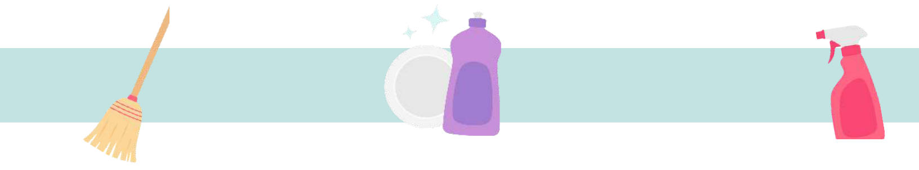
Age Appropriate Chores for Kids

AGES 2-3

Put cup in sink Pick up toys

Dust Put clothes in hamper

AGES 4-6
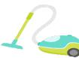

Any previous chores |  | Help fold clothes
Make bed |  | Help put clothes in laundry
Set the table |  |  | Wipe table
Water the plants |  |  | Help feed pets
 | AGES 7-11
All prior chores |  | Meal Prep | Take out garbage
Vacumn and sweep | Fold majority of laundry Wipe washroom vanities
Help with yardwork | Help make lunches |  | Get mail
 | AGES 12+
Wash dishes |  | Mow yard | Supervise siblings
Empty dishwasher | Pack lunches |  | Help clean out fridge
Mop floors | Clean washroom |  | Wash windows
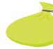


WWW.SWEETTHINGS.COM

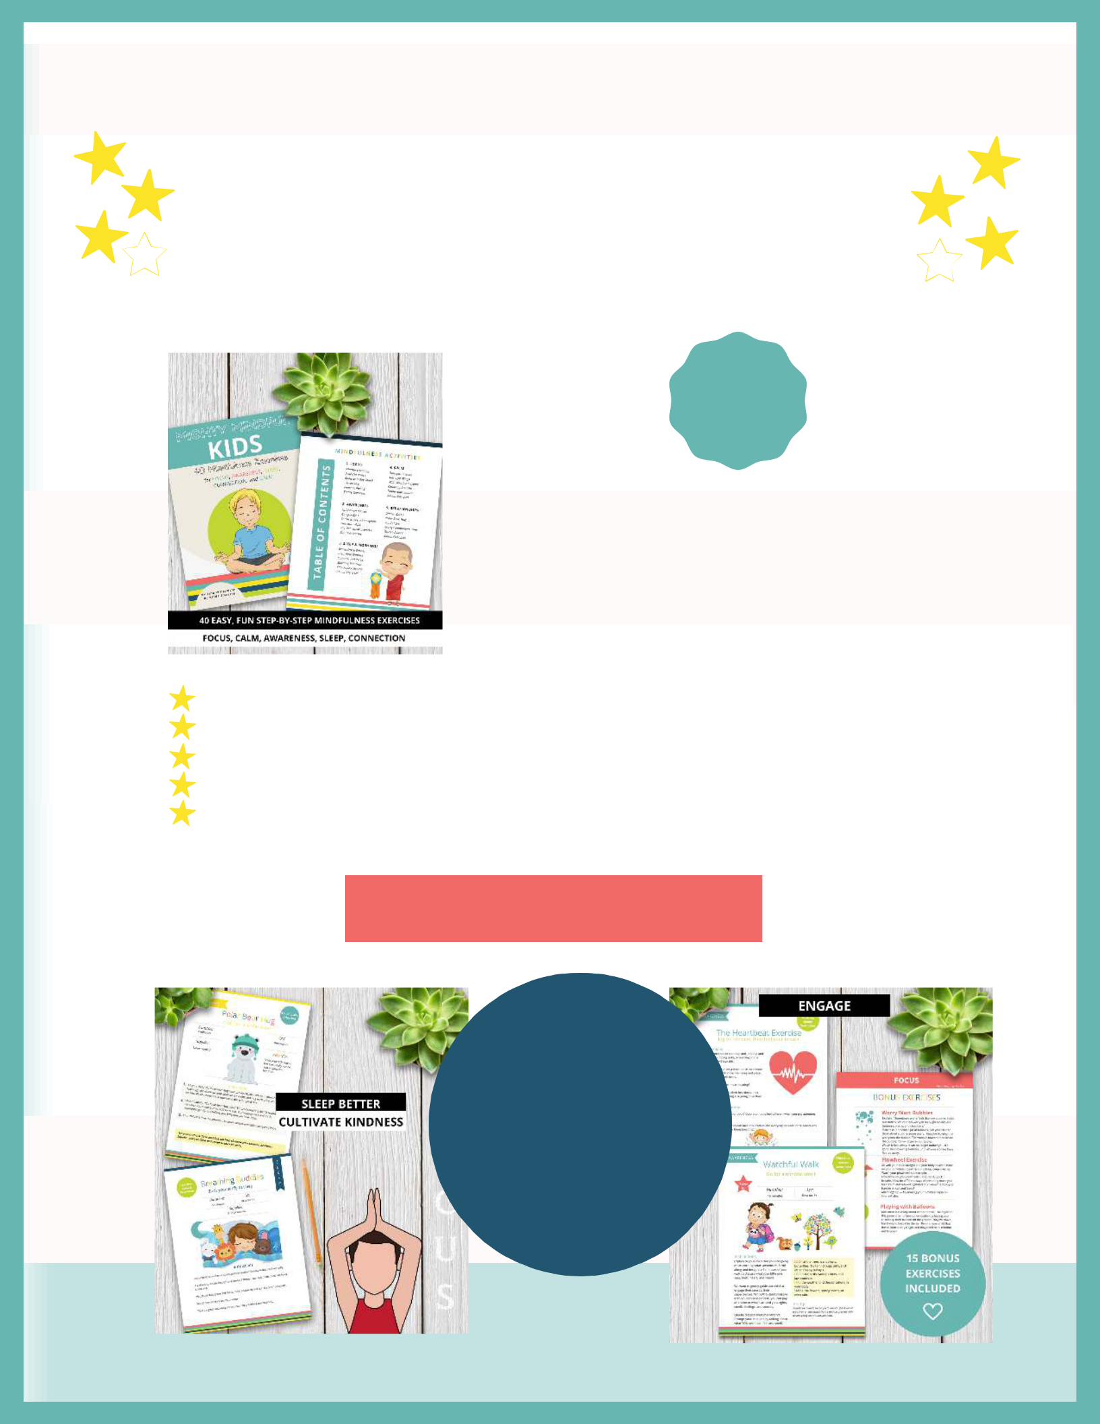

40 FUN MINDFULNESS EXERCISES

Focus, Calm, Awareness, Sleep,
Relationships

START

HERE

Now that you've dipped your toes into

mindfulness for kids, why not take your practice to the next level with 40 fun, easy, step-by-step mindfulness activities for kids?

8 exercises for focus (think improved grades and sports abilities)

8 exercises for calm (think less tantrums and less stress and anxiety)

8 exercises for awareness (think living in the moment and less screen time)

8 exercises for relationships (think deeper friendships and more meaning)

8 exercises for kindness and gratitude (think awesome character building and kids who aren't entited)

