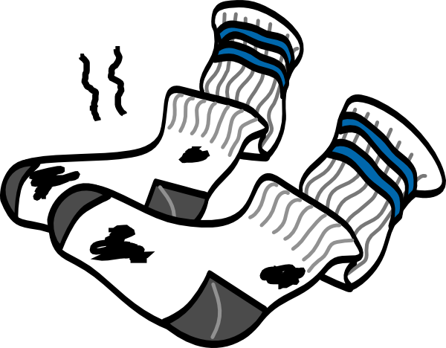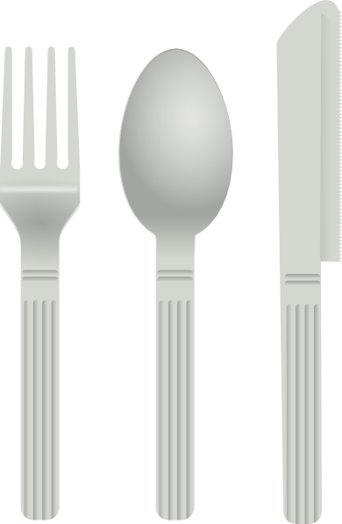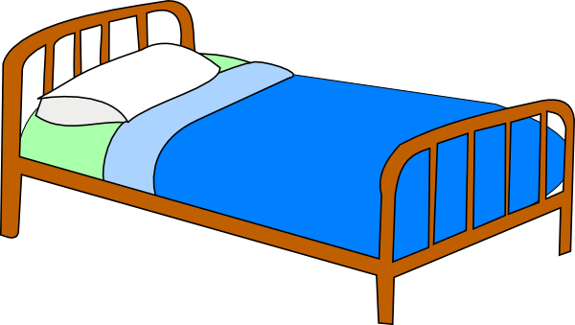

PUT DIRTY CLOTHES DOWN THE CHUTE

PUT DIRTY DISHES IN THE SINK

PUT AWAY TOYS

BE KIND

GO TO BED WITHOUT COMPLAINING

_______________’S CHORE CHART



GET DRESSED

PICK UP TOYS

WASH

HANDS

SHARE

BE KIND

__________________’S CHORE CHART

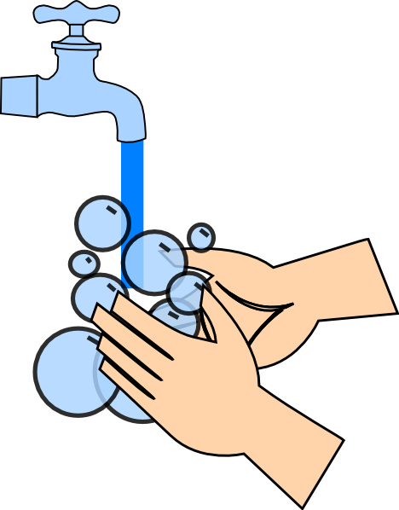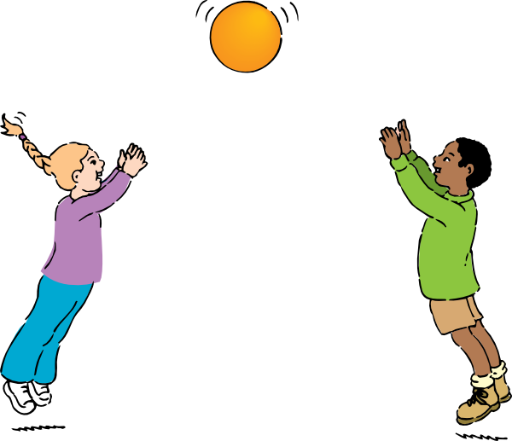

__________________’S CHORE CHART

DONE

DONE

DONE

DONE

DONE

DONE

DONE

DONE

DONE