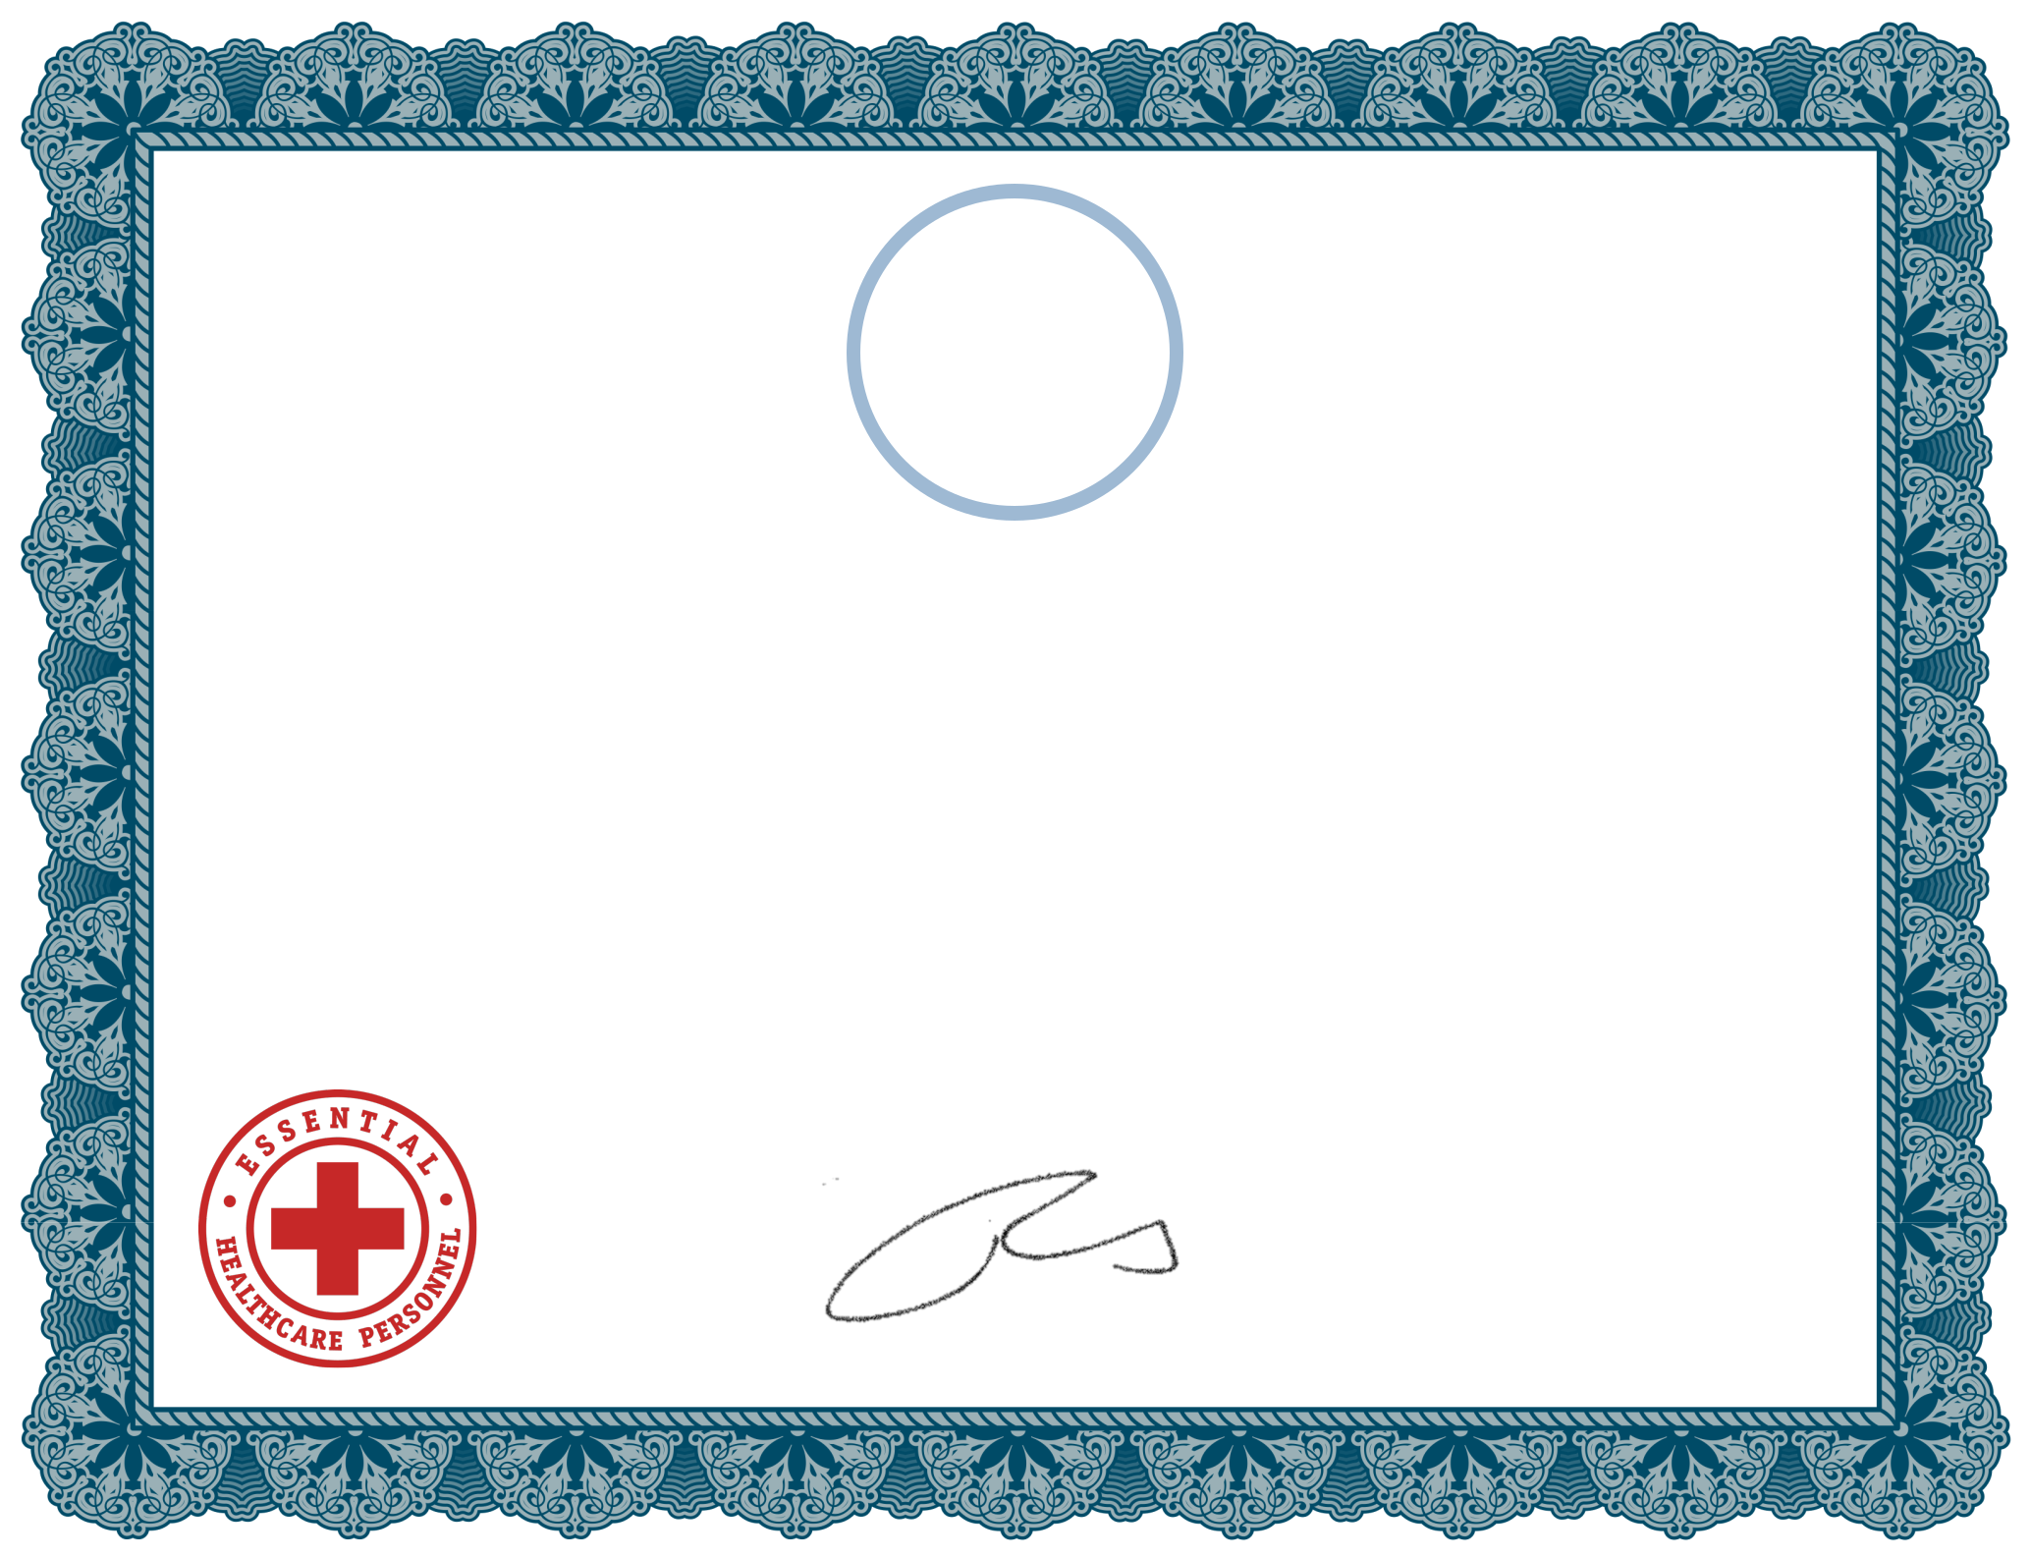
W

Wound Care Specialists, LLC

Certificate of Appreciation

Presented to All Facility

Nurses, LPNs and CNAs

For their unwavering commitment and attention to patient-focused wound care needs during these trying times. We thank you!

_______________________________________
Robert A. Brenes, MD, CWSP, WCC, FACCWS | COVID-19 Certificate
Chief Executive Officer of Wound Care Specialists, LLC | Awarded in 2020

