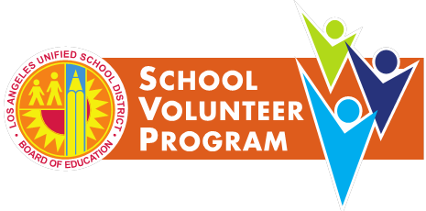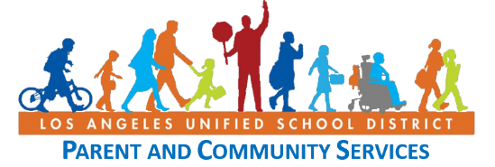 

awarded to

## (Name of Recipient)

In recognition and appreciation of your commitment

To strengthening our schools and for making a difference

To the students of the Los Angeles Unified School District at

## (School Site)

## Awarded this (Date)

**Principal (Signature)**

# certificate of Appreciation