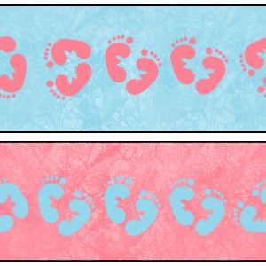

Birth Certificate Template

Baby Name Here: ____________________________________________

**Birth certificate**

Date: ________________________________

Congratulations on the birth of your baby