

|  |
| --- |
|  |

|  |
| --- |
|  |

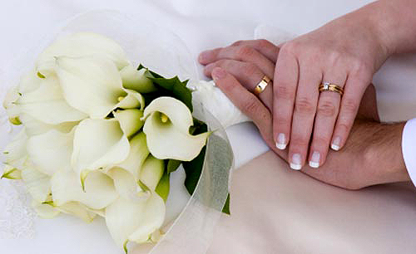

Marriage Certificate

This is to certify that

_________________________And ___________________________

Were Wed on the ________ Day of__________ In the year ___________

By: ________________________________________________________

At: ________________________________________________________

_______________ _______________

Bride Groom

Marriage Certificate