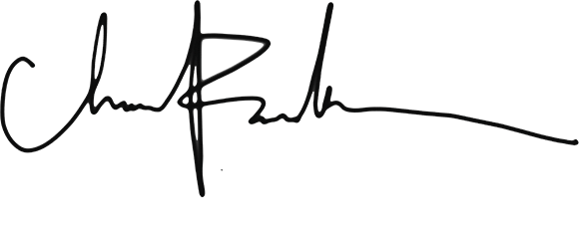

&

Groom

Bride

Were Wed on the_____________________Day of _________________________In the yearAt__________________________________________________________________________________

Anne

Paul

THIS CERTIFY THAT

Certificate Of Marriage