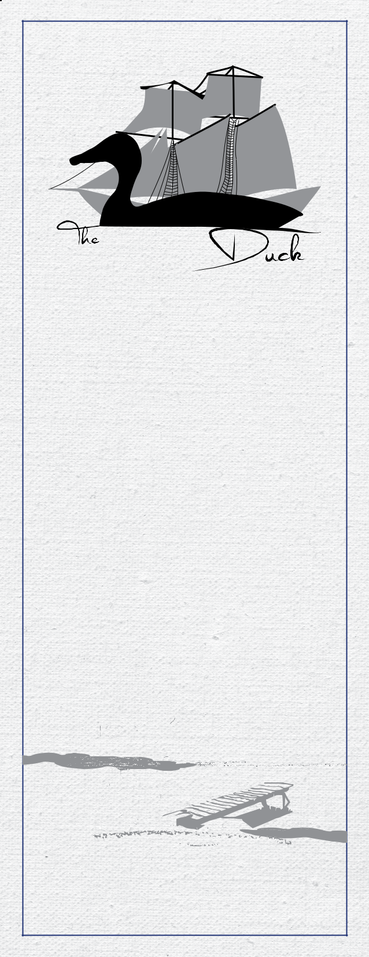

DRINK
MENU

WINES

WHITES | 6oz | 1/2L | Bottle
Riesling VQA | $8.5 | $23 | $32
Sandbanks Estate Winery
Prince Edward County, Canada
Pinot Grigio | $9 | $25 | $34
Gabbiano Promessa
Val do Pesa FI, Italy
Sauvignon Blanc | $9.25 | $26 | $35
Silver Point
Marlborough, New Zealand
House WHITE
Benchmark Chardonnay | $8 | $23 | $32/litre
Niagara on the Lake, Canada
SPARKLING
Mimosa | $9
Spumante Bambino | $8
Rosé
White Zinfandel | $8.5 | $23 | $32
Woodbridge by Robert Mondavi
Acampo, California
Reds
Baco Noir/Pinot Noir VQA | $9.25 | $26 | $35
Sandbanks Estate Winery
Prince Edward County, Canada
Cabernet Sauvignon | $9.75 | $28 | $37
Wolf Blass Yellow Label
Nuriootpa South Australia, Australia
Cabernet-Shiraz | $9 | $25 | $34
Cliff 79 Meritus Wines PTY Ltd
South Australia, Australia
Malbec | $8.75 | $24 | $33
Trivento Fair Trade
Mendoza, Argentina
House RED
Cabernet/Merlot | $8 | $23 | $32/litre
Benchmark
Niagara on the Lake, Canada

WINE BY THE BOTTLE
Our bottles can be corked and taken home if not finished with your meal!

WHITES | Bottle
Verdejo | $30
Honoro Vera Blanco
Rueda, Spain
Riesling | $32.5
Deinhard
Rheinhessen, Germany
Pinot Grigio | $50
Santa Margherita
Alto Adige/Trentino, Italy
Chardonnay | $50
J.Lohr Riverstone
Monterey California, USA
Sauvignon Blanc | $50
Kim Crawford
Marlborough, New Zealand
Sauvignon Blanc | $50
Oyster Bay
Marlborough, New Zealand
REDS
Merlot | $32
Donini, Lamberti S.P.A.
Friuli, Italy
Shiraz/Syrah | $30
Rosemount Estate
South Australia, Australia
Ripasso | $41
Folonari Valpolicella Ripasso Classico Superiore
Veneto, Italy
Sangiovese | $47.5
Rocca Della Macìe Chianti Classico
Tuscany, Italy
Foch-Baco Noir VQA | $49
Sleeping Giant, Sandbanks Estate Winery
Prince Edward County, Canada
Pinot Noir | $54
Kim Crawford
Marlborough, New Zealand
Cabernet Sauvignon | $57.5
Liberty School, Hope Family Wines
California, USA
Cabernet Sauvignon | $60
J Lohr Seven Oaks
Paso Robles California, USA
Tempranillo Blend Rioja | $67.5
Muga Reserva
Rioja, Spain

COCKTAILS 1.25oz
Duck it up to make it a Double! 2oz

Substitute house liquor for premium for an additional $2.5.

Classic Caesar
With house vodka, Mott’s Clamato juice, Worcestershire & Tabasco!

All Caesars are topped with a house made rim, celery, pickle, citrus,

pepper & a spicy bean.

$9

Duck size $11.5

Electric Lemonade
Gin, Hpnotiq and lemonade.

$8

Duck size $10.5

Singapore Sling
Sloe gin, cherry brandy, bitters, grenadine, lemon, orange juice and pineapple, shaken over ice, garnished with an orange wedge. $8.5

Duck size $11

Long Island Iced Tea
Equal parts vodka, gin, white rum, triple sec, tequila, topped with

Coca-Cola & lemon.

$8

Duck size $10.5

Shaken Lime Margarita
Pink Himalayan salt rim, tequila, triple sec, shake with lime over ice. $8

Duck size $10.5

Dockside Sangria
Seasonal fruit, white Zinfandel, triple sec, peach schnapps,

finished with Sprite.

$8.5

Pitcher $24

Ask your server about your favourite cocktail and

we will do our best to accommodate you!

Coolers AND MORE

$6.75 each

Palm Bay

Twisted Tea

Smirnoff Ice Moosehead Radler

Beer
Bottles
Domestic | $5.25 | Import | $7
Premium | $6.25 | Empire Cider | $7.5 (local)

From Our Taps
Domestic

12oz $4.25 / Pint 20oz $6.5 / Pitcher 60oz $18.5

Premium

12oz $5 / Pint 20oz $7 / Pitcher 60oz $20

Import

12oz $5.5 / Pint 20oz $7.5

MARTINIS 2oz
Substitute house liquor for premium liquor (Grey Goose, Stolichnaya,Tanqueray or Bombay Sapphire) for an additional $2.5.

Classic Gin or Vodka
Dry vermouth, served with a twist of lemon, olives or onions.

Smirnoff vodka

Beefeater gin

$10

The Whistling Martini
Pineapple juice, blue curaçao, passion fruit liqueur and peach schnapps. $10.5

Lemon Drop Martini
Refreshing real lemon, simple syrup, house vodka with a sugar rim. $10.5

M&M Martini
Creme de cacao and Frangelico.

$10.5

Classic Cosmopolitan
Cranberry, lime, vodka & triple sec.

$10.5

The Caramel Appletini
Vodka, Sour Puss and caramel schnapps.

$10.5

The Manhattan
Rye, sweet red vermouth, dash of bitters with a maraschino cherry

served on the rocks or neat.

$10.5

All martinis come shaken or stirred and served in a

chilled martini glass or on the rocks.

Whiskey, Scotch AND Cognac 1.25oz

Johnnie Walker Red | $7.5
Johnnie Walker Black | $8.5
Glenlivit | $8
Glenfiddich | $8
Glenmorangie | $8.75
Oban | $12.5
Jameson Irish Whiskey | $6.75
Jack Daniel’s Tennessee Whiskey | $6.75
Jim Beam Bourbon | $7
Courvoisier VS | $8

Liquid Desserts

Specialty Coffees (1.25oz) $7.5

All of our special coffees are served with fresh premium coffee, a sugar rim & topped with whip cream.

Irish Coffee Bushmills Irish whiskey & brown sugar

Irish Cream Coffee Bailey’s Irish cream

Spanish Coffee Brandy & Kahlúa

B-52 Coffee Bailey’s Irish cream, Kahlúa & Grand Marnier

Monte Cristo Kahlúa & Grand Marnier

Scottie Coffee Bailey’s Irish cream, Kahlúa & banana liqueur

Crispy Crunch Frangelico & cream de cacao

Liqueurs (1.25oz) $7.25

Limoncello

Frangelico

Bailey’s

Amaretto

Grand Marnier

Sambuca

NON-ALCOHOLIC SELECTIONS

Coca-Cola products with free refills $3

Coca-Cola Diet Coca-Cola Orange Fanta

Nestea Iced Tea Sprite Canada Dry Gingerale Soda Water

Number E Sparkling Tea (local)

Arroyo (hibiscus, cranberry & apple) $3.75

Pop By the Bottle $3

Dad’s Root Beer Jones Cream Soda

Juices (16oz) $3

Apple Juice Orange Juice Cranberry Juice

Pineapple Juice

Tomato Juice

Clamato

Lemonade

Milk & Chocolate Milk

Large 16oz 3.75 Small 12oz 2.75

Bottled Water $3.25

Perrier 330mL Eska 355mL

Mocktails $4.25

Virgin Caesar | Shirley Temple
Becks Non-Alcoholic Beer $3.75
Hot Beverages
Coffee | $2.5
Red Rose Tea | $2.25
Green Tea | $2.75
Mint Tea | $2.75
Earl Grey Tea | $2.75
Cranberry Tea | $2.75
Hot Chocolate | $3


Little Ducklings

Drinks

$3
(free refills on fountain pops)

Coca-Cola

Diet Coca-Cola

Orange Fanta

Nestea

Canada Dry Gingerale

Sprite

$2

Milk

Chocolate Milk

Apple Juice

Orange Juice

Cranberry Juice

Pineapple Juice

Lemonade

