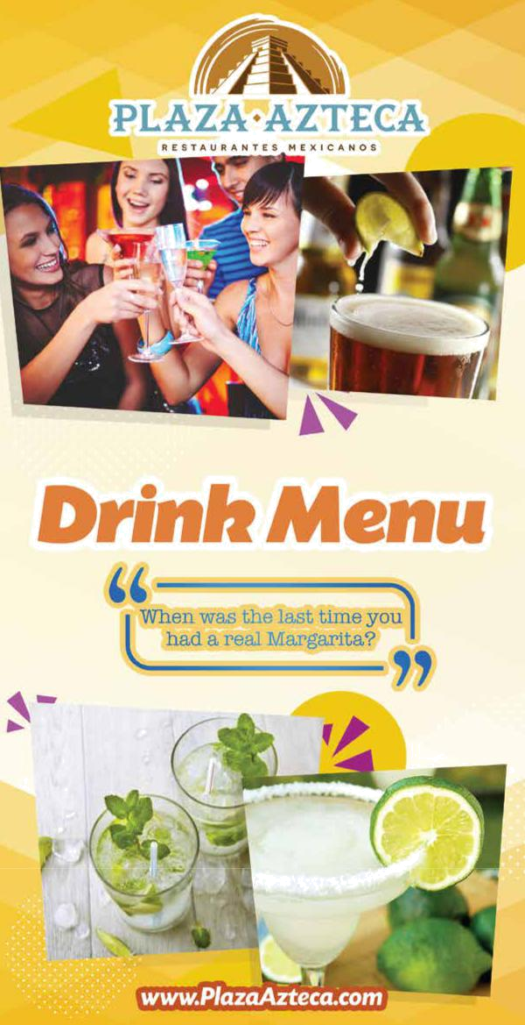
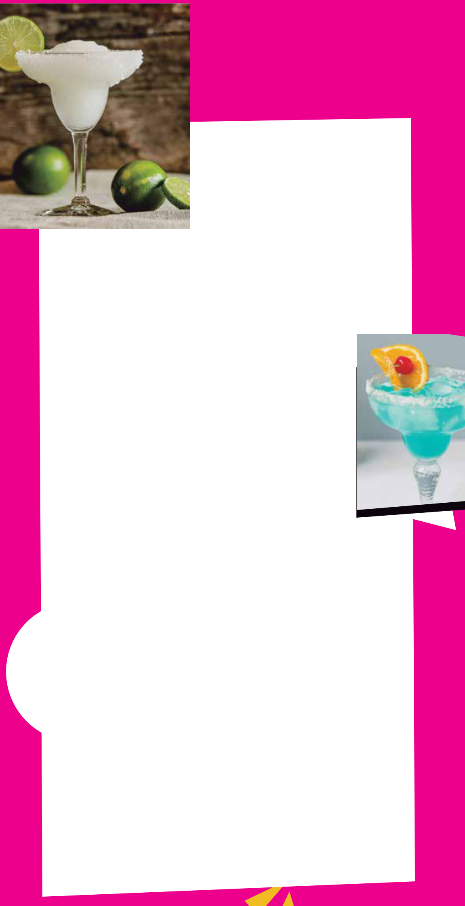
Margaritas 

REGULAR / JUMBO

SKINNY MARGARITA · 15
Roca Patrón Silver Tequila, agave nectar,

lime juice, topped with club soda

ULTIMATE · 12 / 22
Patrón Barrel Select Reposado Tequila,

Gran Gala, agave nectar and lime juice.

SMOKED PINEAPPLE · 12 / 22
Patrón Barrel Select Reposado Tequila,

smoked pineapple puree, agave nectar and lime juice.

MARGARITA SAMPLER · 13
Lime, Strawberry, Chile Mango and Piña Colada served on a ight.

HOUSE · 7 / 10

BEER RITA · 14
A jumbo house margarita with your

choice of Mexican/Domestic beer in one.

PERFECT · 10 / 18
José Cuervo, Presidente Brandy and Gran Gala.

TROPICAL · 10 / 18
Mango Silver Tequila, melon liqueur,

pineapple juice with sweet & sour mix.

PRICKLY PEAR · 8 / 14
Hornitos Plata Tequila, pricly pear puree,

agave nectar and fresh lime juice.

JAMAIZCAL · 9 / 16
Mezcal, hibiscus, jalapeño syrup and fresh lime juice.

CUCUMBER JALAPEÑO · 8 / 14
Sauza Cucumber Chili Tequila, cucumber &

jalapeño juice, agave and lime.

COCO LOCO · 9 / 16
1800 Coconut Tequila, coconut milk and sweet condensed milk.

POMEGRANATE · 12 / 22
Don Julio Blanco Tequila, pomegranate juice and lime.

WATERMELON JALAPEÑO · 10 / 18
Agave Loco Pepper Cured Tequila, watermelon juice and

jalapeño smoked sea salt.

CHILE MANGO · 11 / 20
Agave Loco Pepper Cured Tequila, mango puree, lime juice, agave nectar and chamoy sauce.

TIRA CHONES · 10 / 18
Mango Silver Tequila mango puree, pasion fruit puree,

habanero syrup, lime juice and hibiscus ower salted rim.

JALAPEÑO PINEAPPLE MARGARITA · 9
Cazadores Blanco Tequila, muddled jalapeño, pineapple juice and lime juice.

TEXAS STYLE MARGARITA · 8
Sauza Gold Tequila, Gran Gala and home made margarita mix.
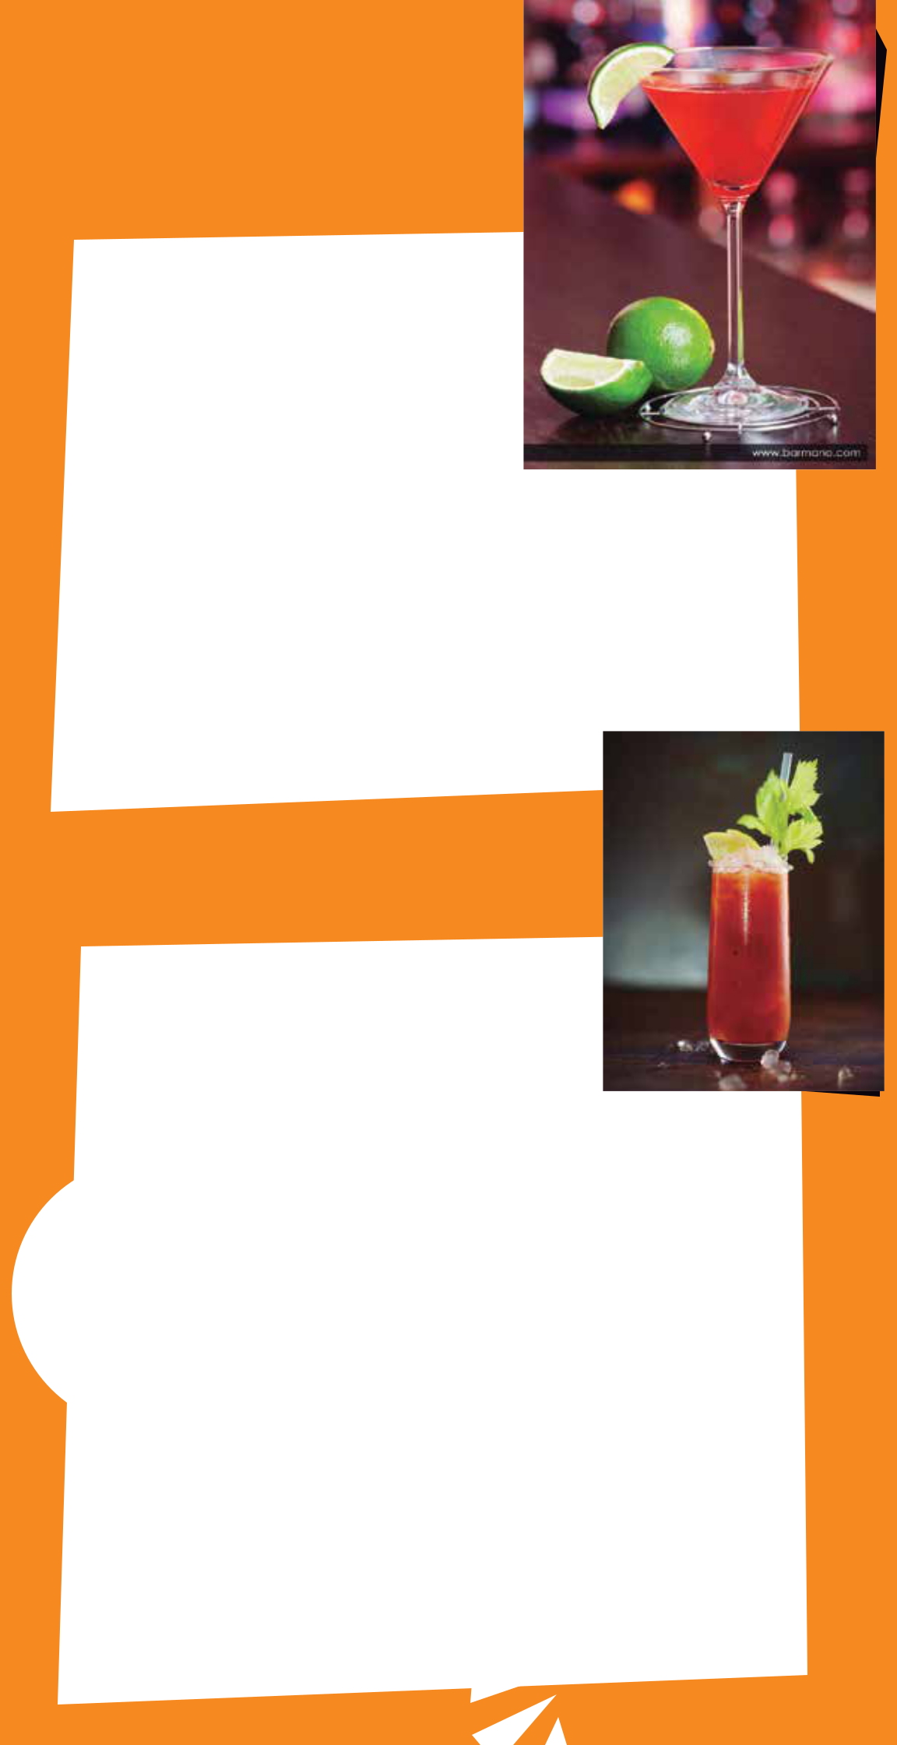
Martinis

MEXICANTINI · 15
Barrel Select Patrón Reposado,

lime and sweet vermouth.

HAWAIIANTINI · 9
Ciroc Coconut, Pineapple juice and grenadine.

CUCUMBERTINI · 9
Pearl Cucumber, muddled with cucumbers.

CHOCOLATE & STRAWBERRY · 9
Strawberry Vodka, crème de cocoa and simple syrup.

APPLETINI · 9
Green Vodka and apple schnapps.

ESPRESSO · 9
Double Shot Espresso Vodka, hazelnut liqueur and cream.

BESO DE ÁNGEL CON TEQUILA ROSE · 15 Tequila Rose and Barrel Select Patrón Reposado.

Cocktails

ARROS CON LECHE · 10
Patron XO Incendio with coconut milk, sweetened milk & cinnamon.

PALOMA · 8
Altos Plata, Grapefruit Soda, fresh lime and smoked

EL PATRÓN (THE BOSS) · 10
Barrel Select PAtrón Reposado, Agave Nectar and fresh lime juice.

CHARRO NEGRO · 8
Exotico Blanco, Cola and lime wedge.

MICHELADA · 7
Mexican Beer with a splash of tapatío, Clamato, pepper and lime juice over ice.

VIVA EL CHE · 8
Leblon Cachaca, lime, mint, agave, cucumber and club soda.

EL VIEJO · 11
Tres Generaciones Añejo, Agave, orange and lime

with chocolate bitters.

STRONG ISLAND ICED TEA
You know what it is.

CANTARITO · 10
Exotico Blanco, grapefruit, lime and orange juice, a splash of grapefruit soda served in a cantarito souvenir cup to take home.
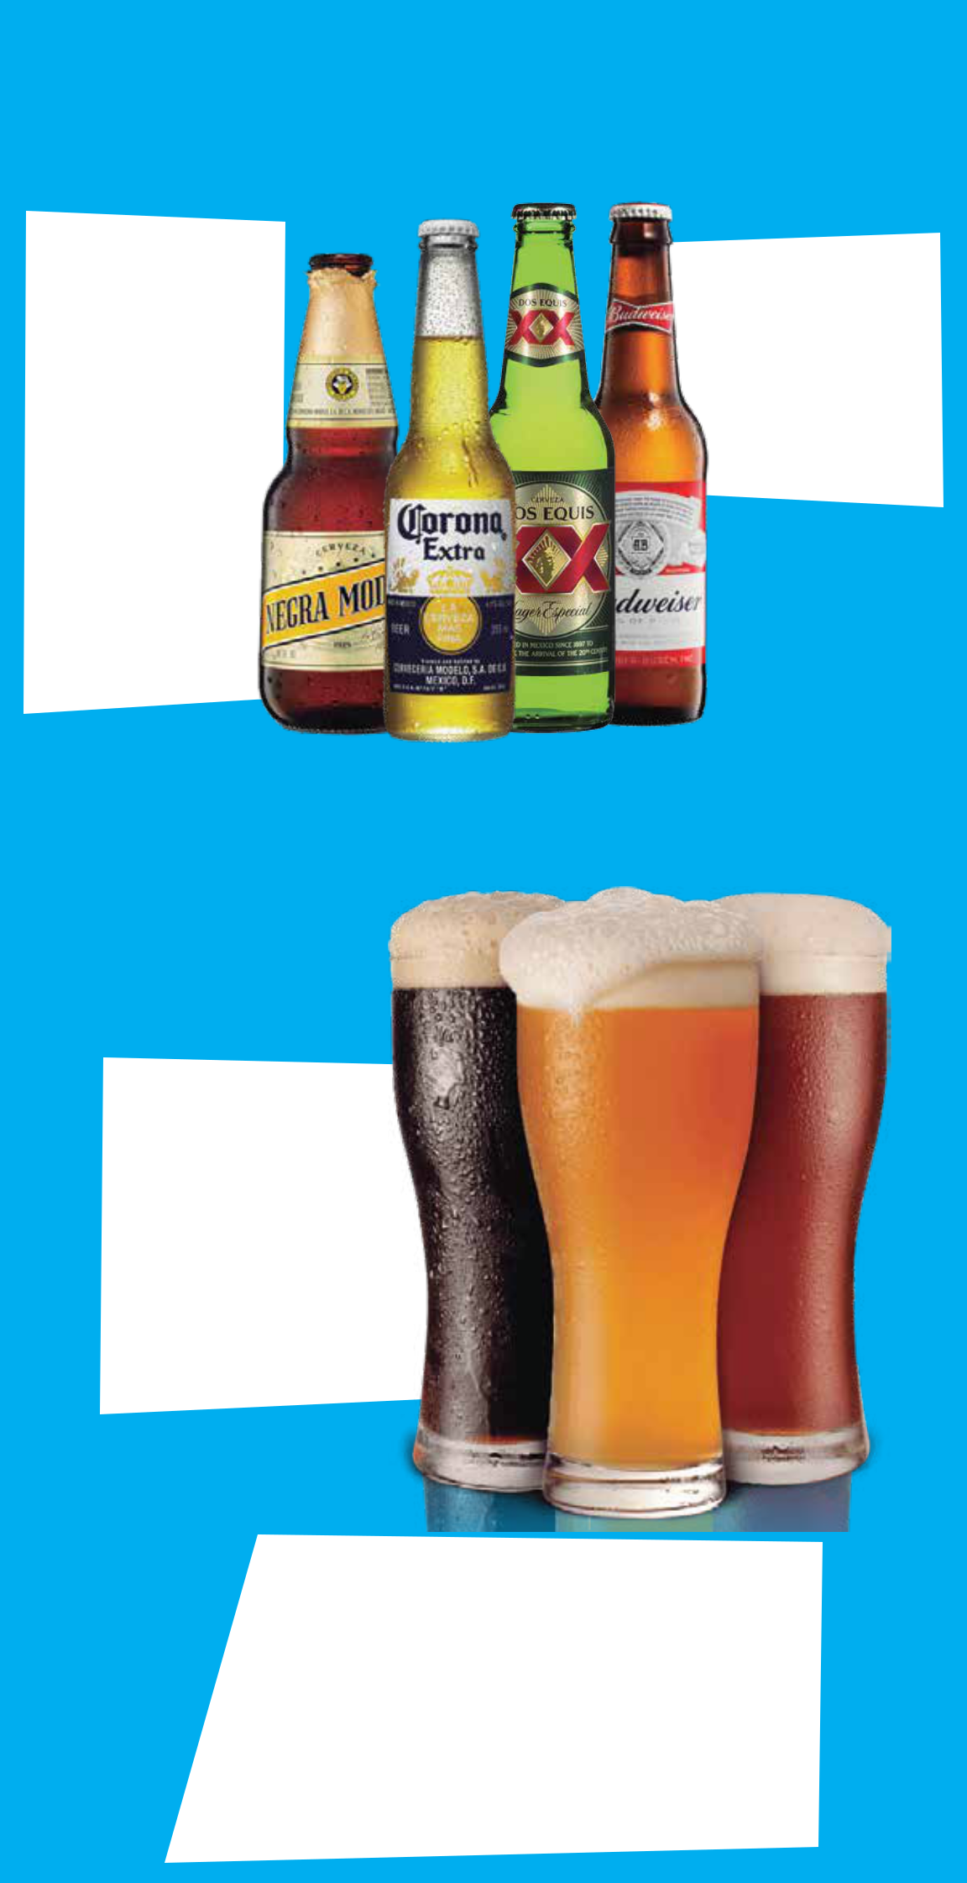
Bottled Beers

IMPORTED · 5

Corona
Corona Premier
Corona Light
Negra Modelo
Modelo Especial
XX Amber
XX Lager
Pací co
Victoria
Tecate
Bohemia
Sol
Heineken
Heineken Light
Stella Artois
Angry Orchad (4.50)

Draft Beers

IMPORTED

12oz · 4.50
22oz · 7

32oz · 8.50

Corona Light Modelo Especial Negra Modelo XX Lager XX Amber Pací co

DOMESTIC · 3.50

Coors Light Miller Lite Michelob Ultra Budweiser Bud Light Yuengling Lager

O’Douls (Non-alcoholic)

DOMESTIC
12oz · 22oz · 32oz
Miller Lite | 3.50 |  | / | 5.50 / 7
Yuengling Lager | 3.50 |  | / | 5.50 / 7
Blue Moon | 5.50 |  | / | 7/10
Sam Adams Seasonal | 5.50 |  | / | 7/10
Dog sh Head 60 Min IPA | 6 | /8/11
Sweetwater IPA | 6 | / 10
Victory Golden Monkey 12oz ONLY | 6
Deschutes Fresh Squeezed IPA | 5.50 |  | / | 7.50

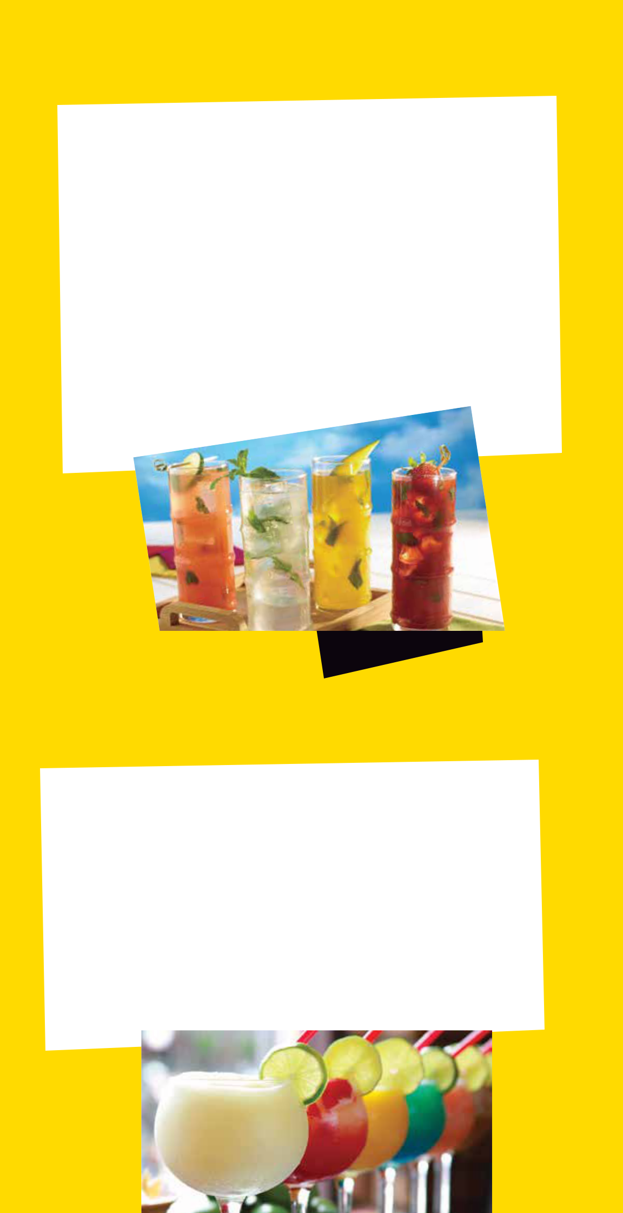
Mojitos

CLÁSICO · 7
Bacardi Superior Rum, fresh mint, lime, sugar and club soda.

TEJITO · 12
Patrón Citronge Pineapple, Patrón Barrel Select Tequila, muddled pineapple & mint and club soda.

FLAVORED · 8
Yourchoice of strawberry, raspberry, mango, peach or pineapple.

PERFECT · 9
Leblon Cachaca, mint, lime and sugra.

AZTEC STYLE · 8
Altos Plata Tequila, mint, lime and sugar.

PLUM MOJITO · 9
Plush Plum Vodka, mint, symple syrup,

plum juice and club soda.

Frozen Drinks

REGULAR / JUMBO

RUM DAIQUIRI · 7 / 12
Natural Flavored Smoothie with Bacardi Superior Rum.

BLANCA COLADA · 9 / 17
1800 Coconut Tequila in your Piña Colada.

MIAMI VICE · 7 / 12
Layered Strawberry Daiquiri and Piña Colada.

NON-ALCOHOLIC SMOOTHIES · 5 / 9
Strawberry, Raspberry, Mango, Peach or Piña Colada

Desserts

CHOCOLATE CAKE · 6.99
A warm, decadent chocolate cake.

CHURROS · 5.50
3 apple- lled churros, fried and covered in cinnamon

and sugar, served with vanilla ice cream.

FLAN · 5.50
Baked custard with a caramelized top, nished with

whip cream and a cherry.

FRIED ICE CREAM· 5.99
A scoop of vanilla ice cream with a fried coating, served in a cinnamon-sugar coated tortilla bowl and nished with honey, chocolate and raspberry syrup, whip cream and a cherry.

MANGO RASPBERRY CHEESECAKE · 6.99
A tart and delicious twist on a classic.

SOPAPILLAS · 5.50
3 fried pastries, covered in cinnamon-sugar and nished with honey, caramel and chocolate syrup, served with vanilla ice cream.

PASTEL DE TRES LECHES · 6.99
A vanilla cake, soaked in “Tres Leches” (evaporated milk, condensed milk and heavy cream), nished with vanilla and chocolate frosting, garnished with chocolate and raspberry syrup.

XANGO · 5.99
A fried our tortilla with a cheesecake lling, covered in cinnamon-sugar and nished with caramel and chocolate syrup, served with vanilla ice cream.
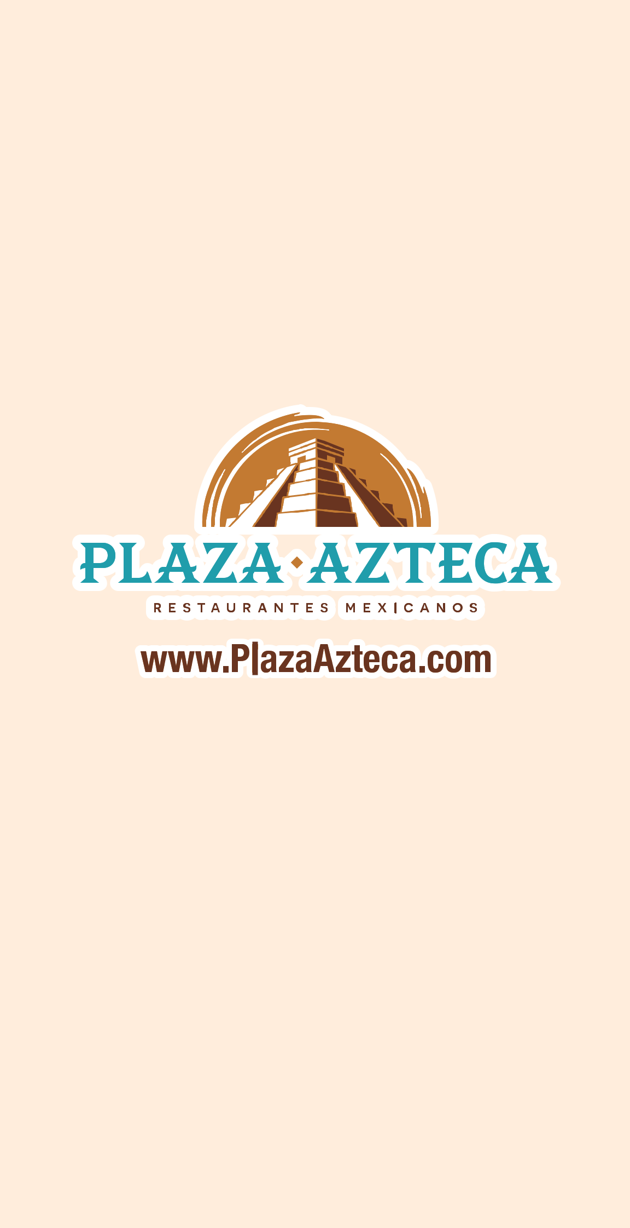

PLAZA AZTECA PLYMOUTH MEETING 351 Plymouth Road, Plymouth Meeting, Pennsylvania, 19462 (610) 940-3906

