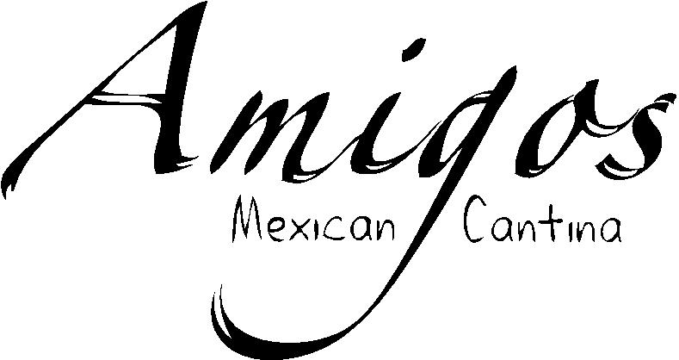

Not Your Typical Mexican Restaurant
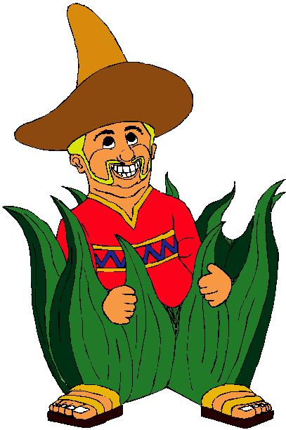

DRINK MENU

“Amigos Famed Margaritas”

CASA
Our house margarita made with Sauza Gold, triple sec, splash of sour & Jamaican Lime Juice

BLUE HAWAIIAN
Say Aloha with Sauza Gold Tequila and Blue Curacao blended with pineapple & Jamaican Lime Juice

SOUTH STREET “ESPECIAL”
A step up from our house margarita. Made with Jose Cuervo Especial Tequila

BIKE SHOP MARGARITA
After your ride, sit back and relax with Herradura Reposado Tequila, Cointreau & Jamaican Lime Juice

PARROTHEAD
It’s like taking a trip to Key West. Made with Jimmy’s Gold Margaritaville Tequila, triple sec, Jamaican Lime Juice & a splash of sour mix

cadillac
This ain’t your father’s Oldsmobile! 1800 Silver Tequila, Cointreau, Grand Marnier & Jamaican Lime Juice

PATRÓN CITRON
Smoothest of the smooth - Patrón Silver Tequila, Patrón Citrónge Orange Liquer & Jamaican Lime Juice

THE SKINNY MARG
Our guilt free margarita of Hornitos Reposado, soda water, and fresh squeezed lime

COCONUT TELEGRAPH
An island favorite featuring Margaritaville Calypso Coconut Tequila, amaretto & Jamaican Lime Juice

1800 GRAND GOLD
1800 Reposado Tequila & Grand Marnier & Jamaican Lime Juice. No need to say more...

POMEGRANATE MARGARITA
Sauza Gold Tequila, Pomegranate Liqueur, triple sec, Jamaican Lime Juice & sour mix

WILD BERRY MARGARITA
A delicious concoction of blended berries, 1800 Silver Tequila & Jamaican Lime Juice served in a sugar rimmed glass on the rocks

MILLIONAIRE MARGARITA
Feel like a million bucks with 1800 Anejo Tequila, Grand Marnier & Jamaican Lime Juice

DR. DAVE’S MARGARITA
The slight adjustment of adding Cointreau to Patrón Silver Tequila & Jamaican Lime Juice will leave you feeling much better. No Co-pay with this one!

MI AMIGO
A top notch margarita made with Cuervo Traditional Tequila, Cointreau & Jamaican Lime Juice, straight up

THE GIGGLING MARLEY
Sure to put a smile on your face. Cazadores Reposado Tequila, Cointreau, Jamaican Lime Juice & a splash of orange juice
Jamaican Me Crazy
Hornitos Plata tequila, Malibu rum, Crème de Banana, pineapple and cranberry juice

Espresso Margarita
Patron XO Café liqueur, Crème de Cacao, Stoli Vanilla, and a splash of espresso coffee served straight up

Pineapple Express
Jose Cuervo Silver tequila, triple sec, lime juice & pineapple juice

Anejo Gimlet
Choose from Don Julio, 3G’s, Hornitos, or 1800 Anejo tequila and enjoy it on the rocks with a splash of lime juice

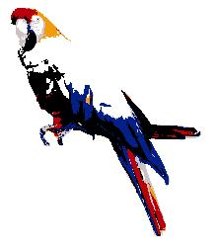 Tequila

1800 Reposado | Herradura Silver | Patron XO
1800 Silver | Jose Cuervo Especial | Sauza Extra Gold
1800 Anejo | Jose Cuervo Silver | Sauza Hornitos Anejo
Cabo Wabo Reposado | Jose Cuervo Tradicional | Sauza Hornitos Reposado
Cazadores Reposado | Margaritaville Coconut | Sauza Hornitos Plata
Don Julio Anejo | Margaritaville Gold | Tres Generaciones Anejo
Herradura Reposado | Milagro Reposado | Tres Generaciones Reposado
Herradura Seleccion Suprema | Patron Silver | Tres Generaciones Plata

Wine

If you prefer grapes to tequila, perhaps one of the following is up your alley

Served by the glass or bottle

SYCAMORE LANE | YELLOW TAIL | House
Merlot | Pinot Noir | Amigos Own Sangria
Cabernet Sauvignon | Shiraz
White Zinfandel
Pinot Grigio
Chardonnay

Beer
Amstel Light | Negra Modelo | DRAFT
Bud | O’Douls (Non Alcoholic) | BBC Coffeehouse Porter
Bud Light | Sam Adams Lager | Bud Light
Bud Light Lime | Sam Adams Seasonal | Dos Equis Amber
Coors Light | Stella Artois | Landshark Lager
Corona |  | Redhook Longhammer IPA
Corona Light |  | Redhook Seasonal
Guinness | GLUTEN FREE | Sam Summer
Heineken | Redbridge | Shocktop
Long Trail Double Bag
L/Trail Blackberry Wheat
Michelob Light | MALTERNATIVES
Michelob Ultra | Margaritaville Spiked Tea
Miller Lite | Margaritaville Spiked Lemonade
Modelo Especial

Boat Drinks

ISLAND PUNCH
How about a nice island punch?....

Sure...Malibu mango, amaretto, and cranberry juice.

Goombay Smash
A classic in the making at Amigos. Jack Daniels, Malibu rum,

Crème de Banana, and pineapple juice

Coyote Killer
The name says it all! Bacardi, Captain Morgan, Malibu, Myers,

Peach Schnapps, cranberry and pineapple juice

Bahama Papa
Make ya feel like ya on da island!! Rum, apricot brandy, amaretto, pineapple juice, OJ, ands a splash of grenadine

Yellow Bird
Dis drink help ya find dat island rhythm wit rum, pineapple and orange juice, Crème de banana, apricot brandy and a dash of Galliano

Tiki Hut
The tiki bar is open! Pear vodka, Malibu mango rum, cranberry and pineapple juice

Cazacran
Cazadores reposado tequila and cranberry juice

MANGO MAI TAI
Amaretto, Malibu Mango Rum, Myers Dark Rum & pineapple juice are perfectly sinful together

VOO DOO JUICE
Be careful with this one!! Pineapple rum, Banana rum,

Citrus rum, and Coconut rum, fruit juices, and a dark rum floater

MOJITO
Bring a little Caribbean flair to your table.

Made with fresh mint leaves & Bacardi Silver Rum
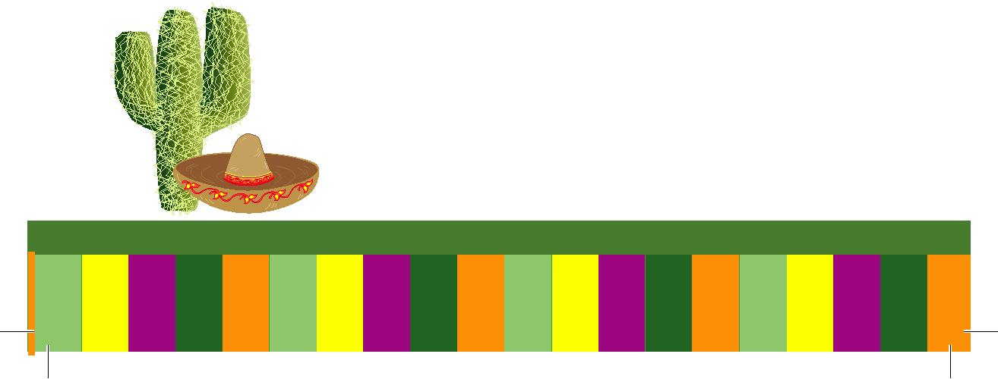

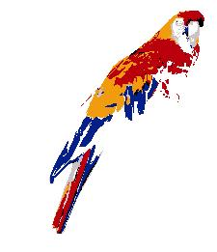 Frozen Concoctions

That Help You Hang On

FROZEN AMIGOS MARGARITAS
Sauza gold tequila, triple sec, and your choice strawberry, mango, peach, raspberry, or wildberry

Shortcake
Strawberry or raspberry with ice cream and amaretto

Snickers Bar
Not going anywhere for a while? Chill out with this delightful blend of ice cream, dark Crème de Cacao, and Frangelico

COUSIN IN MIAMI
Don’t get “wasted away” with this creation of Margaritaville Calypso Coconut tequila, triple sec, and pineapple juice

BANANA SPLIT
All the flavor and half the calories!! Banana rum,

Crème de Cacao, blended with strawberry and pina colada

PASSIONCOLADA
Malibu Passion Fruit & Coconut Rums blended with Pina Colada Mix makes this spectacular any time of year

MANGO AND CREAM
Maui ice cream, mango and Captain Morgan

Desserts

HOMEMADE FLAN
(GLUTEN FREE)

A sweet homemade custard

served with caramel sauce and whipped cream

5.95

HOMEMADE CARROT CAKE
(GLUTEN FREE)

With cream cheese & coconut frosting

5.95

NEW YORK STYLE CHEESECAKE
A classic topped with strawberries, chocolate sauce, or caramel sauce

4.50

AMIGOS FRIED CHEESECAKE
New York Style Cheesecake wrapped in a flour tortilla, fried crisp, and topped with sliced strawberries, caramel sauce, or chocolate sauce
4.95

FRIED ICE CREAM
Vanilla or chocolate ice cream rolled in a crunchy coating and deep fried, topped with sliced strawberries, caramel sauce, or chocolate sauce
4.95

CHOCOLATE INFUSION CAKE
Chocolate cake with a warm liquid chocolate center

4.95

CHOCOLATE OR VANILLA ICE CREAM
1.95

Fried Ice Cream Sampler
5 mini fried ice creams featuring vanilla, chocolate, strawberry, mint chocolate chip, and cookies and cream
5.95

