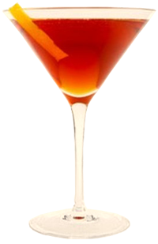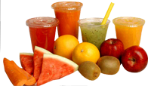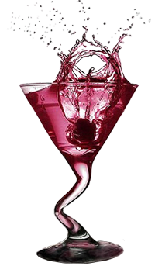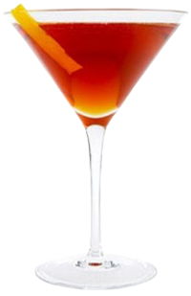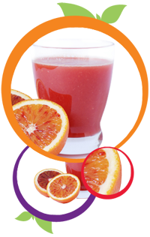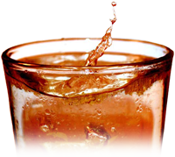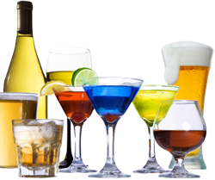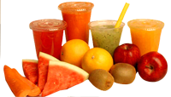

**Hot Drinks**

Brandy

Vodka

Gin

Raki

Turkish Liqueur

Vodka – Redbull

Cider

**Local Spirits**

**Wine BY the Glass**

Red

White

Rose

Medium White

Sweet White

Banana

Strawberry

Cherry

Vanilla

Chocolate

Mixed (Your Choice)

Coke

Fanta (Lemon or Orange)

Sprite

Soda

Water

Tonic Water

Fruit Juice

Ayran

Ice Tea

Energy Drink

Fresh Orange

**Soft Drinks**

**Milk Shakes**

Drinks Menu

**For Contact:**

**555-555-5555**

**email@example.com**

**Location: [Write Location of Your Restaurant Here]**

_____

_____

_____

_____

_____

_____

_____

_____

_____

_____

_____

_____

Efes

Efes Light/Dark

Tuborg

Miller/Becks

Fosters/Carlsberg

John Smiths

Guinness

Cider

Budweiser/ Corona

_____

_____

_____

_____

_____

_____

_____

_____

_____

Bacardi

Malibu

Rum

Whisky

Bailesy

Tia Maria

Kahlua

Archers

Tequila

Safari

Martini

Gordon Gin

Amaretto

Smirnoff Vodka

Jack Daniels

Jim Bean

Southern Comfort

**Beers**

_____

_____

_____

_____

_____

_____

_____

_____

_____

_____

_____

_____

Bailey’s Coffee

Tia Maria Coffee

Irish Coffee

Brandy Coffee

Kahlua Coffee

Cointreau Coffee

Hot Chocolate

Nescafe

Tea

Apple Tea

Green Tea

Cappuccino

_____

_____

_____

_____

_____

_____

_____

_____

_____

_____

_____

_____

_____

_____

_____

_____

_____

**Import Drinks**

_____

_____

_____

_____

_____

_____

_____

_____

_____

_____

_____

_____

_____

_____

_____

_____

_____