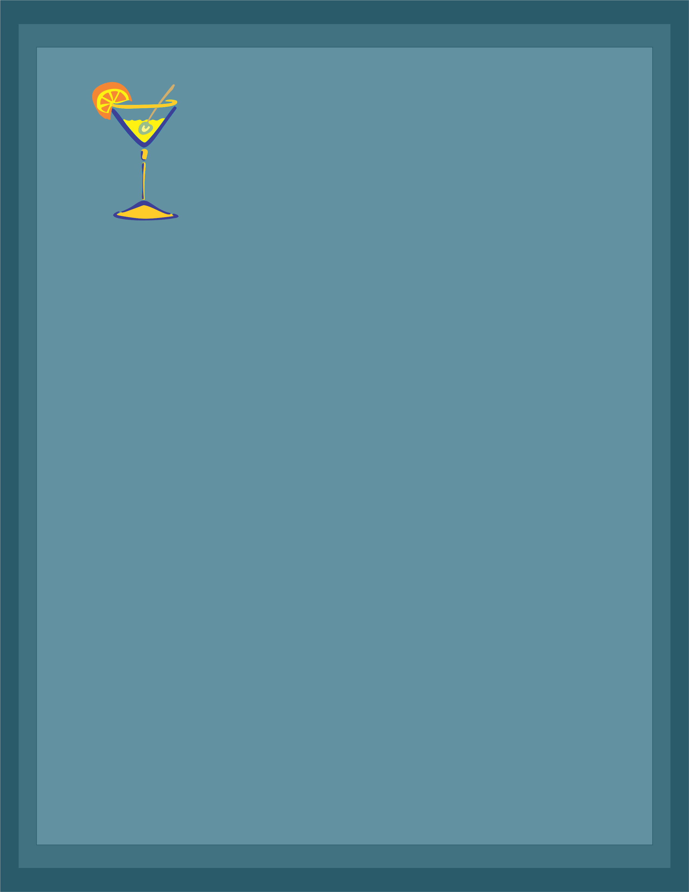

Drink Menu

Your Bar Tagline Here – (Contact Info)

***ISLAND PUNCH***

How about a nice island punch?....

Sure...Malibu mango, amaretto, and cranberry juice.

***Goombay Smash***

A classic in the making at Amigos. Jack Daniels, Malibu rum,

Crème de Banana, and pineapple juice

***Coyote Killer***

The name says it all! Bacardi, Captain Morgan, Malibu, Myers,

Peach Schnapps, cranberry and pineapple juice

***ISLAND PUNCH***

How about a nice island punch?....

Sure...Malibu mango, amaretto, and cranberry juice.

***Goombay Smash***

A classic in the making at Amigos. Jack Daniels, Malibu rum,

Crème de Banana, and pineapple juice

***Coyote Killer***

The name says it all! Bacardi, Captain Morgan, Malibu, Myers,

Peach Schnapps, cranberry and pineapple juice

***ISLAND PUNCH***

How about a nice island punch?....

Sure...Malibu mango, amaretto, and cranberry juice.

***Goombay Smash***

A classic in the making at Amigos. Jack Daniels, Malibu rum,

Crème de Banana, and pineapple juice

***ISLAND PUNCH***

How about a nice island punch?....

Sure...Malibu mango, amaretto, and cranberry juice.

***Goombay Smash***

A classic in the making at Amigos. Jack Daniels, Malibu rum,

Crème de Banana, and pineapple juice

***Coyote Killer***

The name says it all! Bacardi, Captain Morgan, Malibu, Myers,

Peach Schnapps, cranberry and pineapple juice

***ISLAND PUNCH***

How about a nice island punch?....

Sure...Malibu mango, amaretto, and cranberry juice.

***Goombay Smash***

A classic in the making at Amigos. Jack Daniels, Malibu rum,

Crème de Banana, and pineapple juice

***Coyote Killer***

The name says it all! Bacardi, Captain Morgan, Malibu, Myers,

Peach Schnapps, cranberry and pineapple juice

***ISLAND PUNCH***

How about a nice island punch?....

Sure...Malibu mango, amaretto, and cranberry juice.

***Goombay Smash***

A classic in the making at Amigos. Jack Daniels, Malibu rum,

Crème de Banana, and pineapple juice