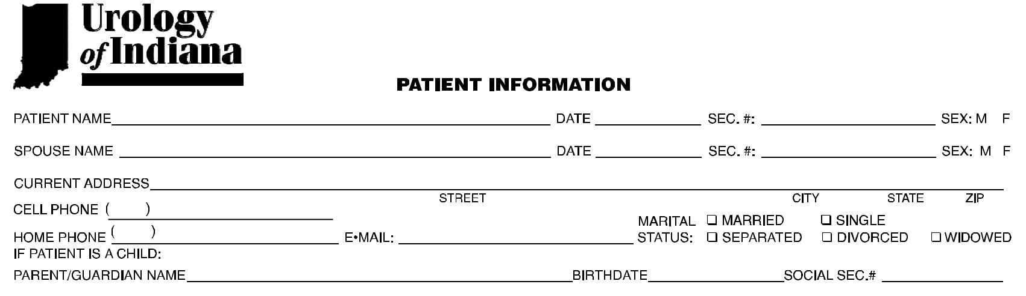
PATIENT REGISTRATION FORM

Please answer all questions to the best of your ability

BIRTH SOCIAL

BIRTH SOCIAL

ADDRESS_______________________________________________________________________________________ PHONE______________________________

ADDRESS (IF DIFFERENT)_________________________________________________________________________ PHONE (IF DIFFERENT)________________

NAME:___________________________ PHONE:________________

3.__________________________________ BIRTH DATE__________ SEX:___
4.__________________________________ BIRTH DATE__________ SEX:___
