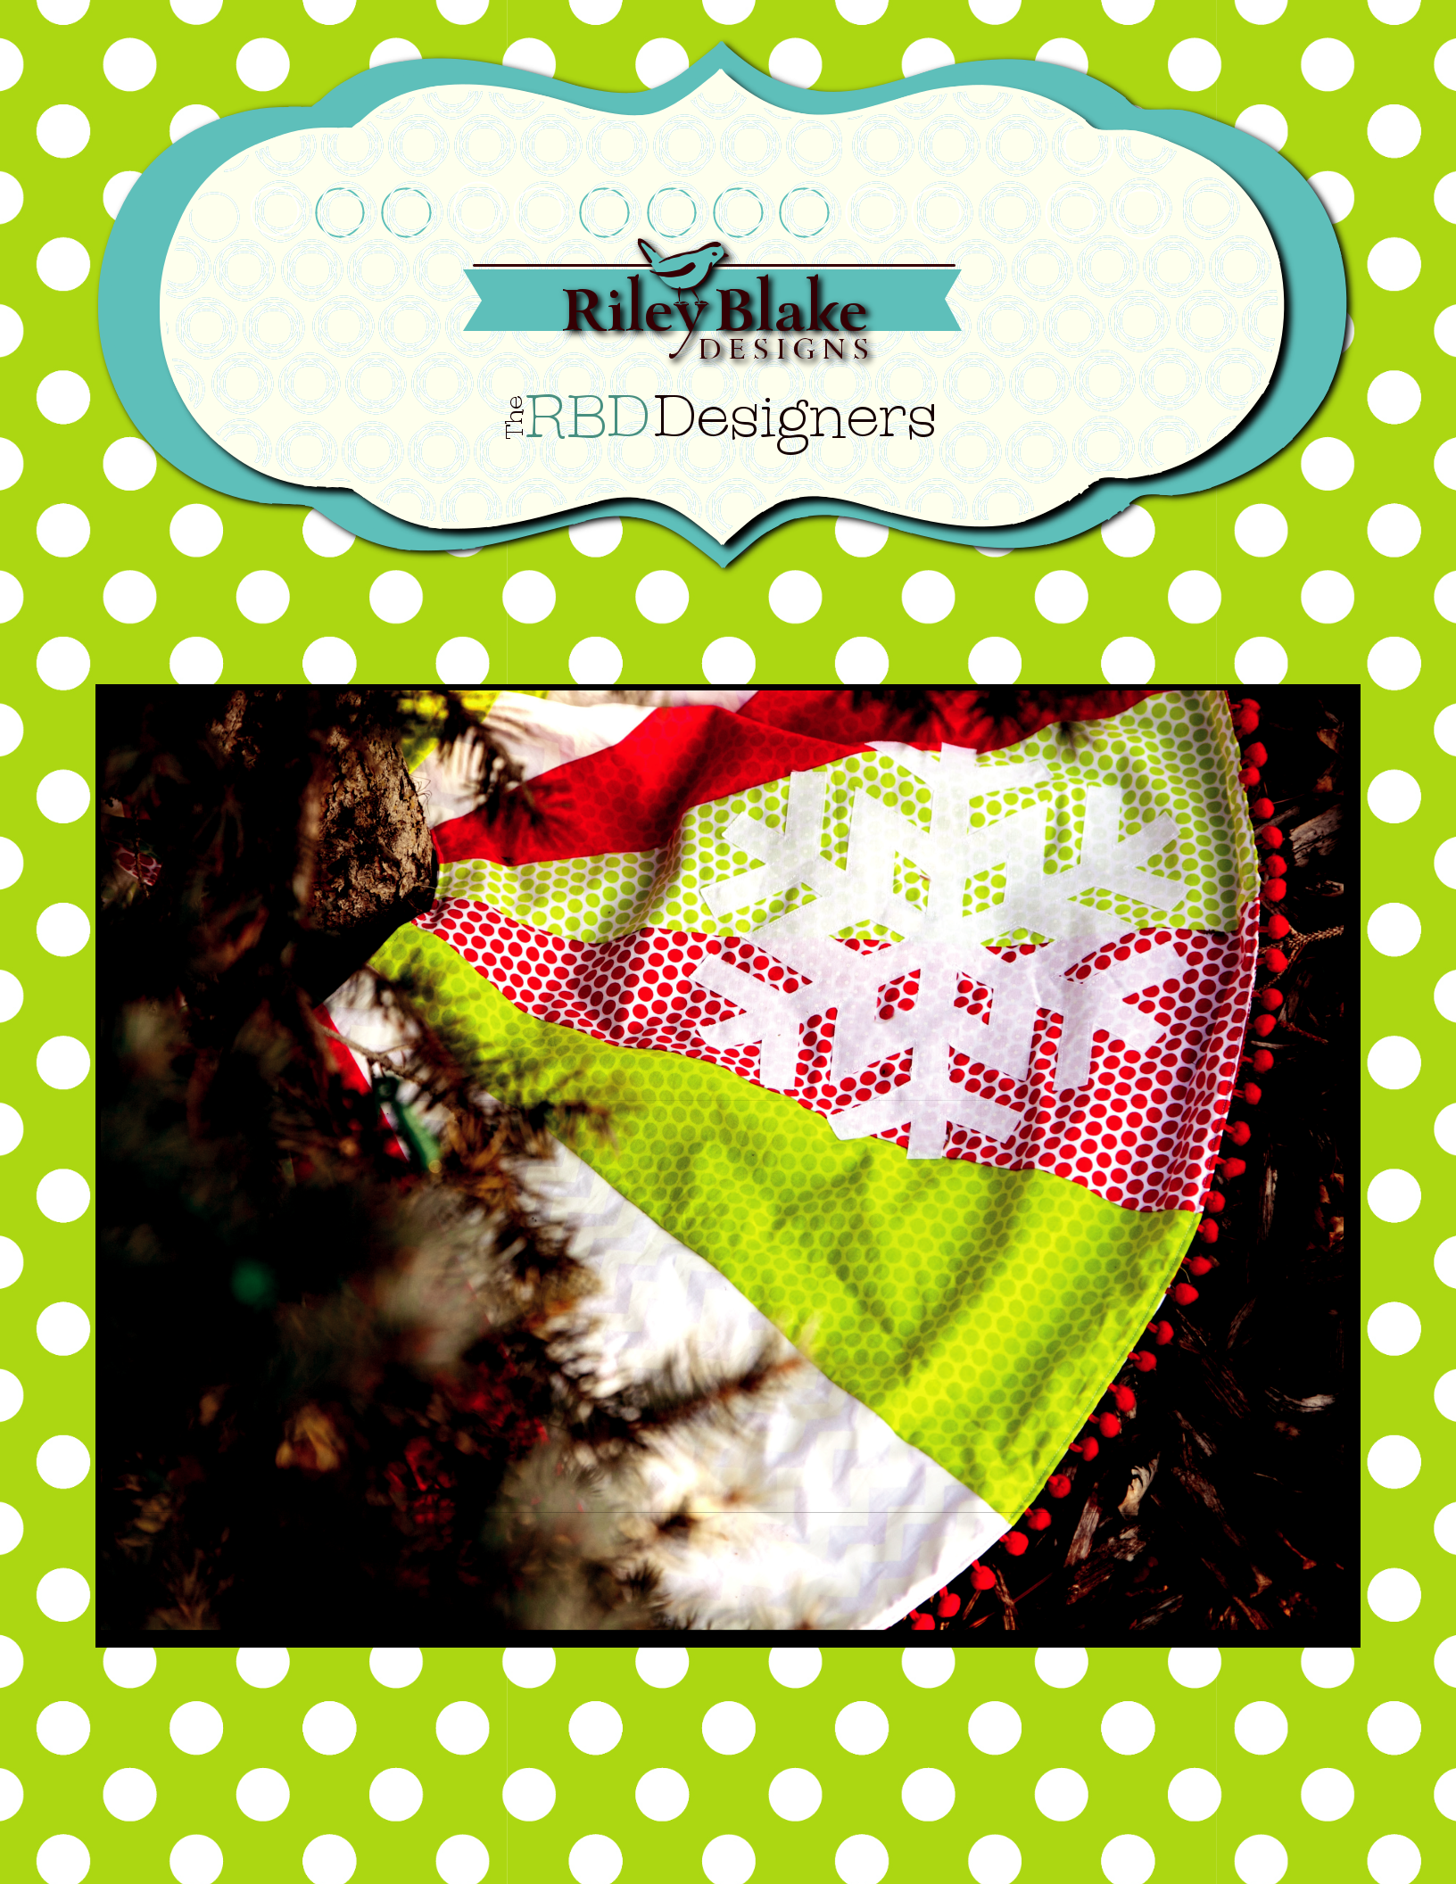
Merry Christmas Tree Skirt

Merry Christmas Tree Skirt

FINISHED SIZE: 48” X 48”
Measurements include ¼” seam allowance.
Sew with right sides together unless otherwise stated.

Please check our website www.rileyblakedesigns.com for any revisions before starting this project.

FABRIC REQUIREMENTS:
Wedges – 1/2 yard of 5 fabrics
Snowflakes – 2/3 yard
Pom Poms –4 1/2 yards
Fusible web – 1 1/3 yards
Back – 2 1/2 yards

CUTTING REQUIREMENTS:

Make template of wedge piece using three wedge pieces provided.

Cut 4 wedges from each of 5 fabrics.

ASSEMBLY INSTRUCTIONS:

- Skirt Front
  - Stitch 5 wedges (one of each fabric) together in desired order to create a quarter of the skirt circle.
  - Repeat to make 4 quarters with 5 wedges each.
  - Stitch quarters together leaving last seam open.
- Skirt Back
  - Stitch back fabric together to be at least 54” x 54”.
  - Lay skirt top on back and carefully cut to same size.
  - Lay back aside for later.
- Pom Poms
  - Pin pom poms to outside edge of skirt front.
  - Using zipper foot, baste pom poms in place.
- Skirt Assembly
  - With right sides together, pin back and front together and stitch all the way around leaving a 6” opening on the inside edge between wedges.
  - Turn skirt right side out through opening.
  - Top stitch making sure to stitch opening shut.
- Snowflakes
  - Make template of snowflake.
  - Draw 4 snowflakes on smooth side of fusible web.
  - Iron to wrong side of snowflake fabric.
Cut out on marked lines.
- Remove paper and press onto desired locations.
- Stitch around snowflakes through both top and back of skirt.

Leave 6” opening here for turning
x x

©2013 Riley Blake Designs and RBD Designers.

Merry Christmas Tree Skirt

Wedge Piece #1
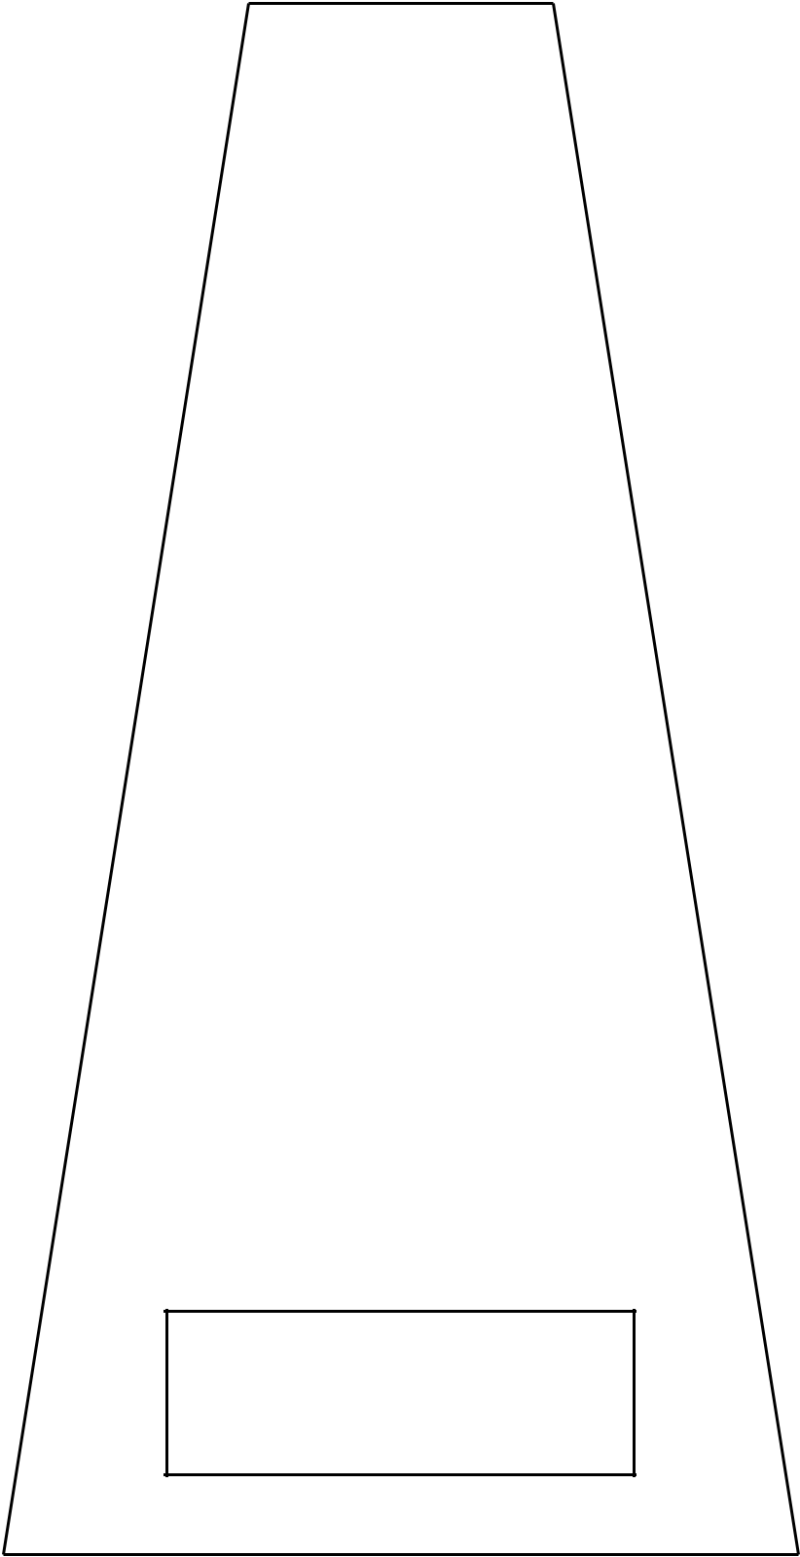

Match to Top Box on Wedge Piece #2

Measure
1 Inch

©2013 Riley Blake Designs and RBD Designers.

Merry Christmas Tree Skirt

Wedge Piece #2
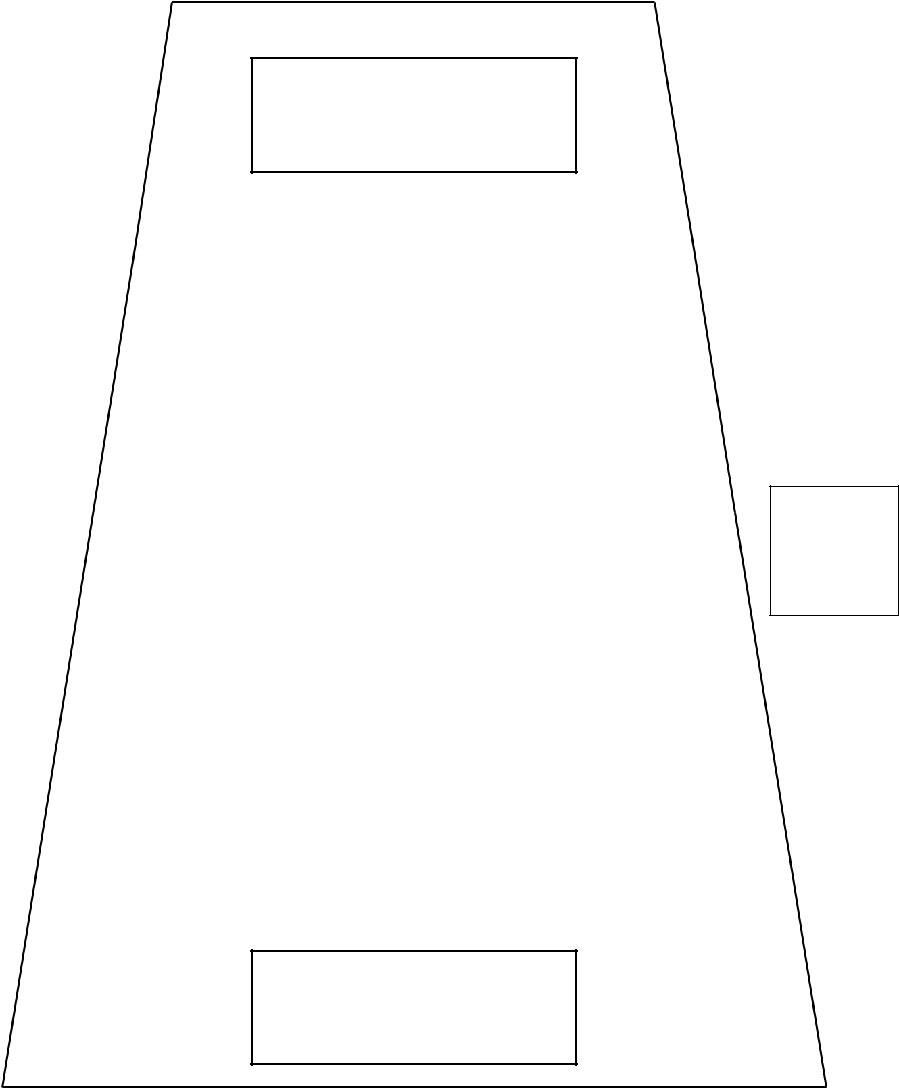

Match to Box on Wedge Piece #1

Measure
1 Inch

Match to Box on Wedge Piece #3

©2013 Riley Blake Designs and RBD Designers.

Merry Christmas Tree Skirt

Wedge Piece #3
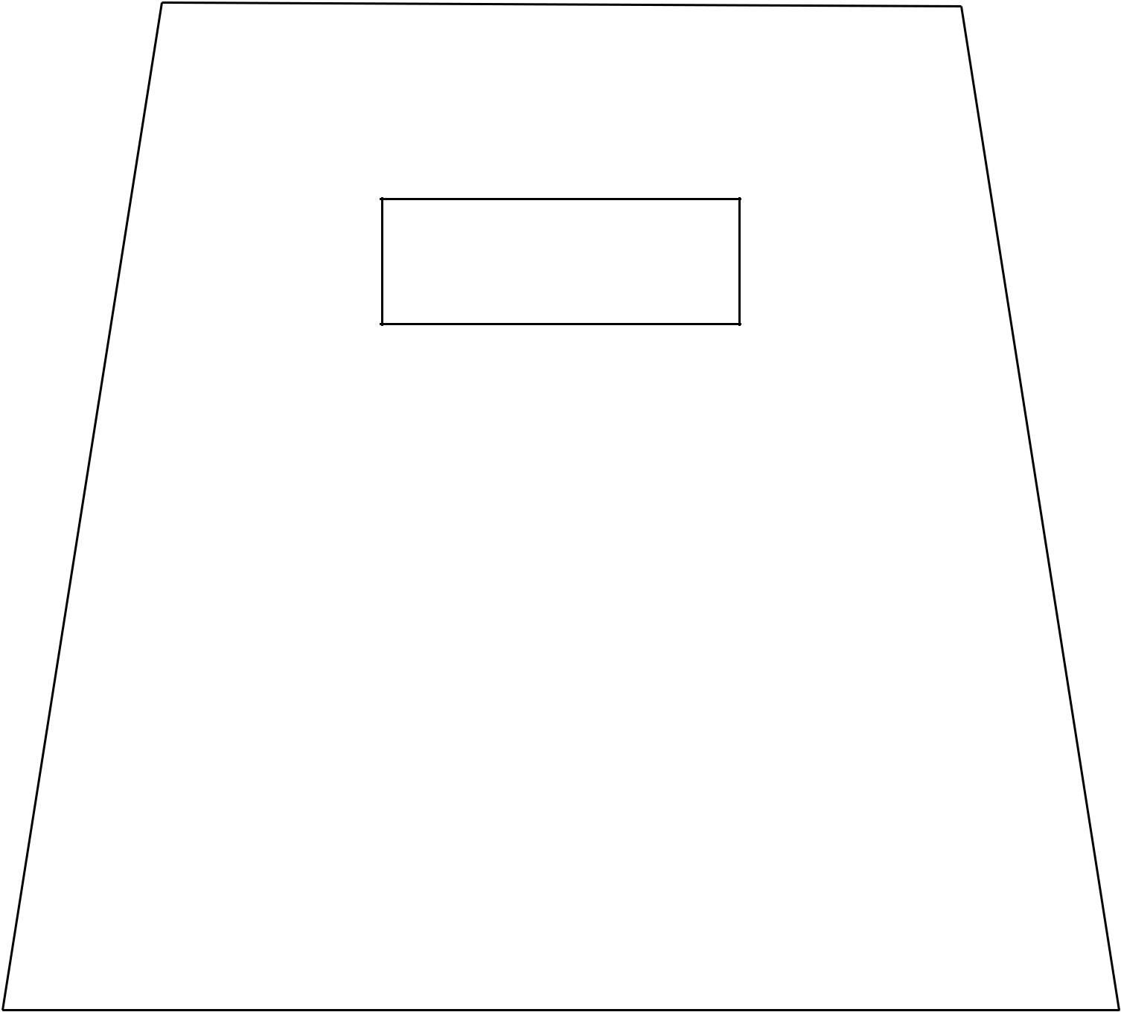

Match to Bottom Box on Wedge Piece #2

Measure
1 Inch

©2013 Riley Blake Designs and RBD Designers.

Merry Christmas Tree Skirt

Snowflake


Place on Fold

Place on Fold

Measure
1 Inch

©2013 Riley Blake Designs and RBD Designers.

