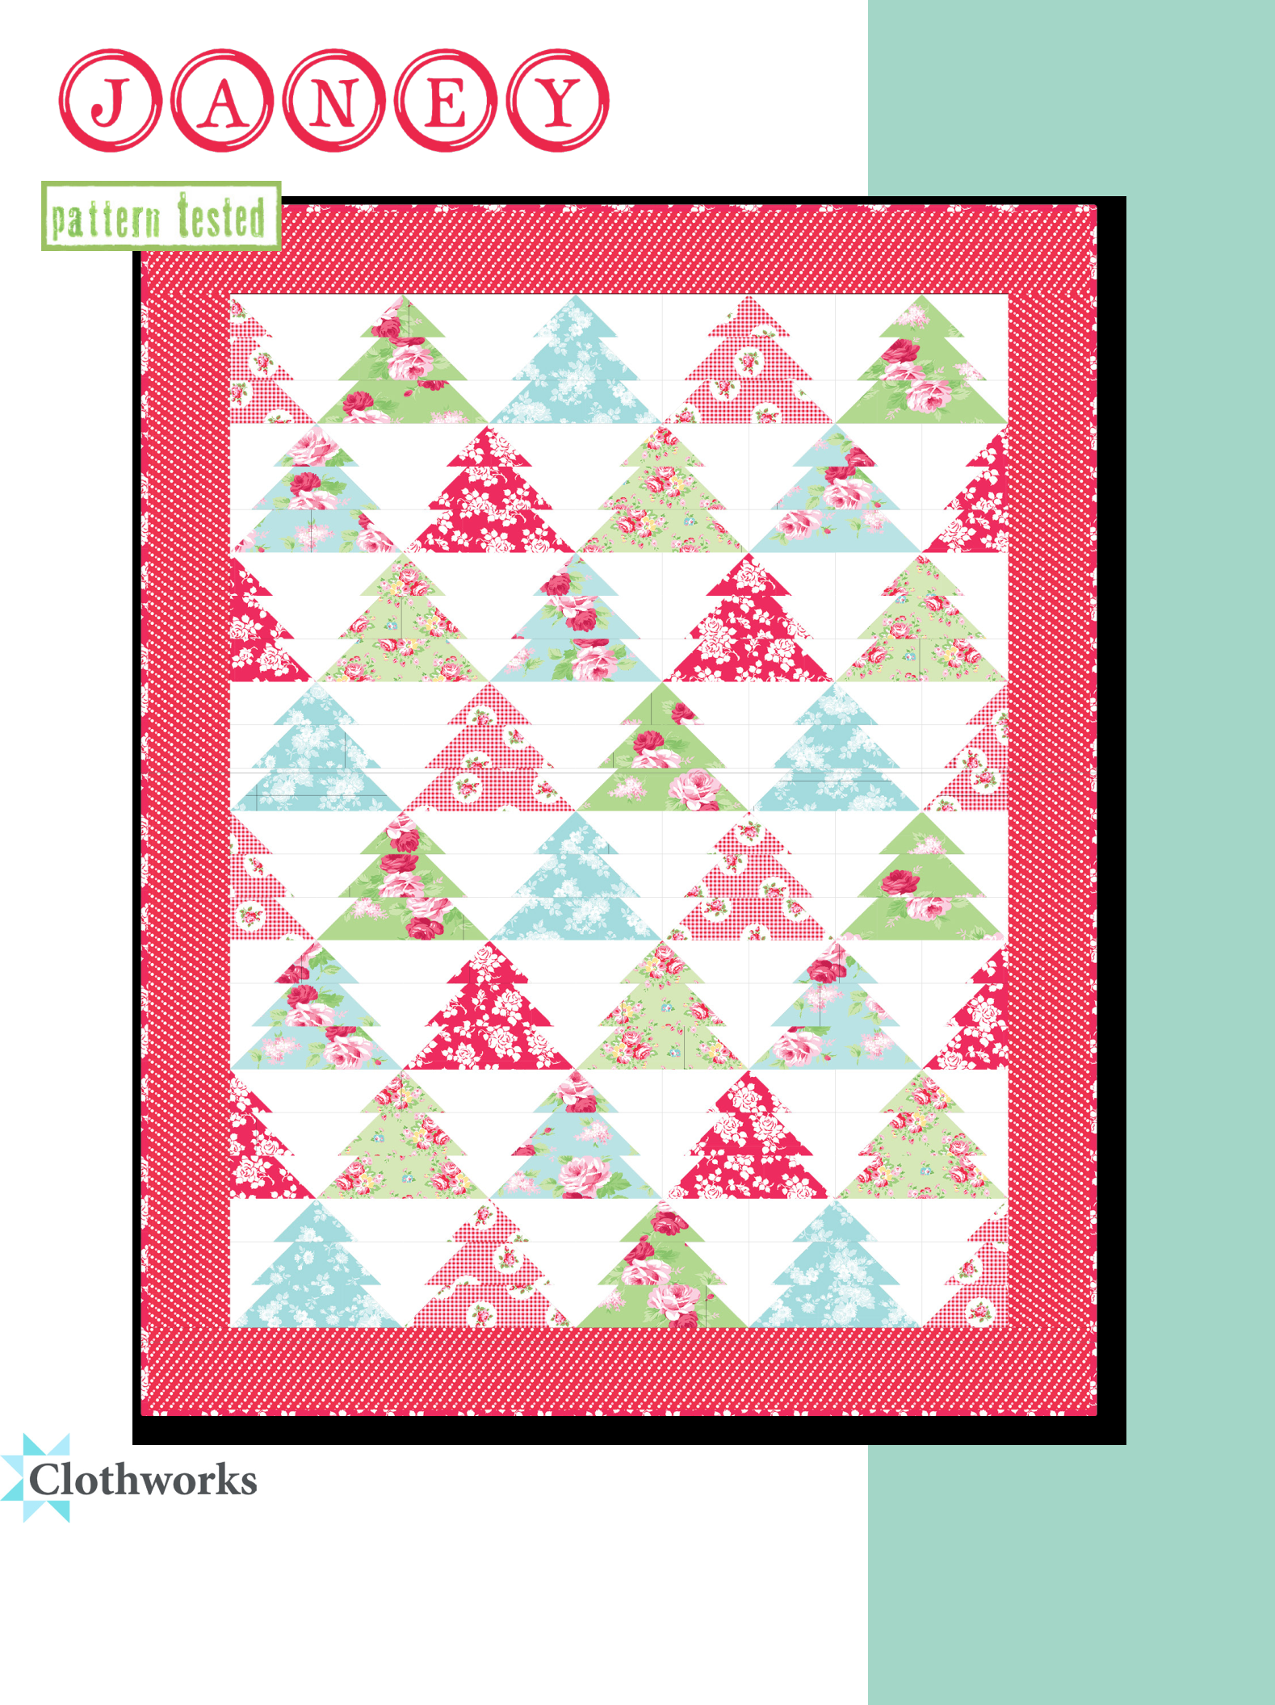
Fabrics by Tanya Whelan

Janey Christmas Tree

Designed by Tanya Whelan

Instructions by Gayle Noyes

Finished Size: 44 ½” x 56 ½”

www.clothworks.com info@clothworks.com

Janey Christmas Tree

Materials

Trees:
(A) Lt Green Satin Rose Y2701-20 | ⅜ yd
(B) Lt Aqua Satin Rose Y2701-32 | ⅜ yd
(C) Lt Mint Meghan Floral Y2701-109 | ⅜ yd
(D) Aqua Tonal Bouquet Y2706-33 | ⅜ yd
(E) Lt Red Rosie Check Y2704-4 | ⅜ yd
(F) Lt Red Falling Rose Y2705-4 | ⅜ yd
Background: White Solid AMB-1 | 1 ½ yds
Border: Lt Red Dots Y2703-4 | ¾ yd
Binding: Lt Red Falling Rose Y2705-4 | ½ yd
Backing: Lt Blue Janey Floral Y2700-29 | 3 yds
Cut the Fabrics

Please read before cutting: When cutting templates- cut 2 ½” strips, then cut your templates. Take a scant ¼ inch seam or add a little to the width of each template. (Sometimes the shape is distorted from copying.)

When cutting reverse templates, put right sides together, then cut. This provides a right & left side.

From the Trees:

Fabric (A):

Cut (2) 5 ¼” squares. Cut each square in half diagonally twice to yield 8 triangles. 5 triangles will be used

Cut (5) template #3 & 2 ½” x 8 ½” rectangles

Fabrics (B, C, D) for each fabric:

Cut (2) 5 ¼” squares. Cut each square in half diagonally twice to yield 8 triangles. 6 triangles will be used

Cut (6) template #3 & 2 ½” x 8 ½” rectangles

Fabrics (E,F) for each fabric:

Cut (1) 5 ¼” square. Cut it in half diagonally twice to yield 4 triangles.

Fabrics: Janey collection by Tanya Whelan for Clothworks Not For Resale

Prior to starting this project, please check our web site for any pattern updates: www.clothworks.com
Instructions

Tree Block construction:

One Tree Block consists of the following: From fabric (A), select the following: (1) triangle cut from a 5 ¼” square; (1) Template #3 shape; and (1) 2 ½” x 8 ½” rectangle. From the Background fabric, select the following: (1) each Template #1 and #1 reversed; (1) each Template #2 and #2 reversed; and (2) 2 ½” squares.

Choose triangle. Join template #1 shape sewing the diagonal edge on the left edge of the triangle. Press. Attach Template #1 reversed shape to the right diagonal edge. Press. This makes the upper strip of the tree block.

Select template #3 shape. Sew the Template #2 background piece to the left side joining diagonal edge. Repeat sewing Template #2 reversed background shape to the right diagonal edge. Press. This makes the center tree strip.

Choose the 2 ½” x 8 ½” strip of tree fabric. Select the (2) 2 ½” squares of background and on wrong side lightly mark a diagonal line from corner to corner. Align the square with the end of the larger strip and sew along the marked line. Refer to picture of the tree block and repeat with the remaining 2 ½” background square. Trim away excess fabric after pressing.

Stitch these three strips together to make the tree block. Press. The block will now be 6 ½” x 8 ½” and will finish at 6”x 8” when sewn into the quilt. Repeat this process with fabrics (B, C, D, E, & F) to create the thirty-two (32) tree blocks needed.

Make the Half Tree blocks:

When reversing the half trees, but sure to sew on the left and right squares as shown below: Select a 2 ½” square of tree print and as before draw on a diagonal line. Select a 2 ½” x 4 ½” background strip. Place print square on right end of background. Stitch on diagonal line. Press and trim. (Fig. 1) Select one of each print and background template #2 shape. Join on diagonal edge. Press. Select 2 ½” x 4 ½” print and a 2 ½” square. As before, mark and stitch. Press and trim. Join these three strips together to make right facing Half tree block. Repeat to make (4) of these. Referring to the photo, construct the remaining four left facing Half Tree blocks in similar manner. (Fig. 2)
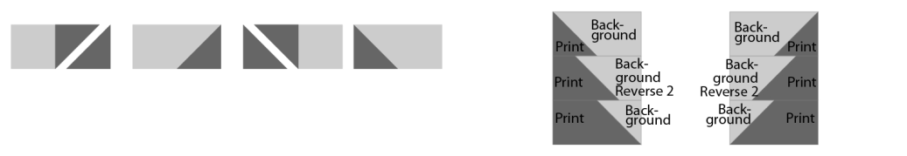

Fig. 1 Fig. 2

Putting it all together:

Referring to the photo, lay out the blocks. Join the trees in rows.
Sew the rows together. Press.

Borders: Sew the strips of border fabric together to make one long strip. Cut side borders 48 ½”. Sew onto the sides of the quilt top. Press. Cut top and bottom borders 44 ½”. Sew and press.

Seam binding strips together using a diagonal seam. Press seams open. Matching raw edges press in a fold the length of the binding strip.

Finishing the quilt:

Cut and seam the backing fabric to make a large enough backing for the project. Layer backing, batting, and quilt top. Pin or baste and quilt as desired. Attach binding to finished quilt and hand or machine stitch to finish.

Templates
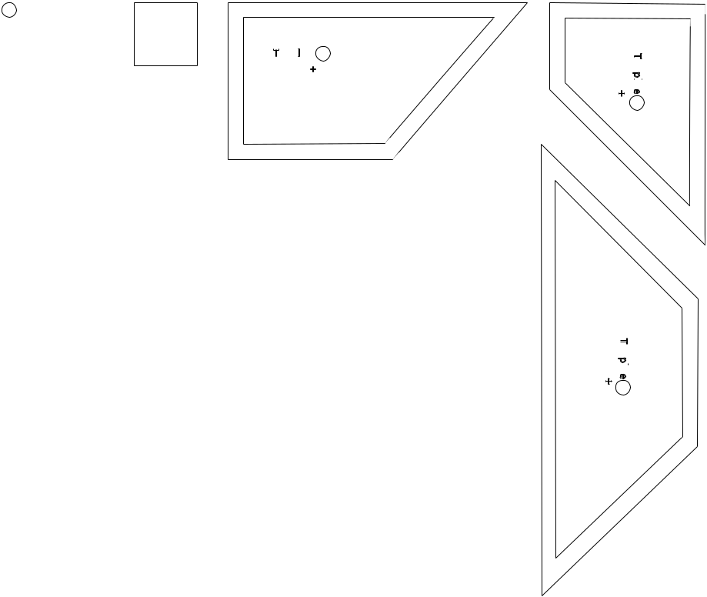

Cut (4) of: template #2; template #2 reversed; template #3; 2 ½” x 8 ½” rectangles; 2 ½” squares; and 2 ½” x 4 ½” rectangles

From the White Solid Background:

Cut (32) each of template #1 & template #1 reversed

Cut (36) each of template #2 and template #2 reversed

Cut (80) 2 ½” squares

Cut (8) 2 ½” x 4 ½ rectangles

From the Lt Red Dots for the Border:

Cut (5) strips 4 ½” x WOF

From the Lt Red Falling Rose for binding:

Cut (6) strips 2 ½” x WOF

Things to Know

WOF = Width of Fabric; LOF = Length of Fabric Sew all seams at ¼”

Always press seams toward darker fabric

While every attempt has been made to give accurate measurements, yardage requirements, and construction directions, this does not allow for personal variations in measuring, cutting and/or sewing. Clothworks is not responsible for printing errors.

1 | - template
2 | - | template | 1”
2 | - | template | square
3 | - | template | Template 1
3 | - | template | + 1R
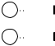

- - 5 ⁄ ” square

- - 8 ½” x 2 ½” rectangle

- - 2 ½” square

- - 2 ½” x 4 ½” rectangle
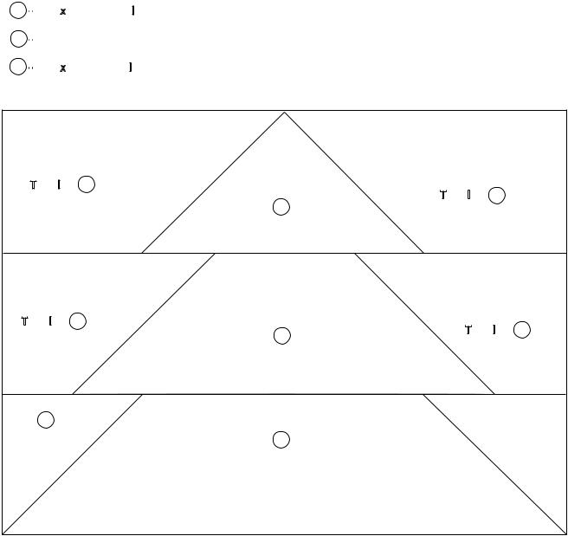

Template |  | 1 | Template 1R
 |  | 4 | Template 1R
Template | 2 |  | Template 2R
 |  | 3 | Template 2R
6
 |  | 5 | 6

Template2
+ 2R

Template
3 +3R

Increase templates
230% for full size.
Measure the 1”
square to ensure final

templates are correct.

