

Gingerbread House + Christmas Tree Potholder Duo

By Faith Essenburg

It’s that time of year again when we celebrate family and friends, eat all the yummy treats and actually get excited about snow! This season flys by, and this year I just want to savor every minute, count all my blessings, and take every special moment in. And as a maker, I suppose it goes without saying that I also want to make ALL THE THINGS!!! I dug deep into my creativity and pulled out all the cuteness I could find for this fun, easy Gingerbread House and Christmas Tree Potholder Duo. I hope you will enjoy making them as gifts for friends or just to add a bit of holiday spirit to your own home.
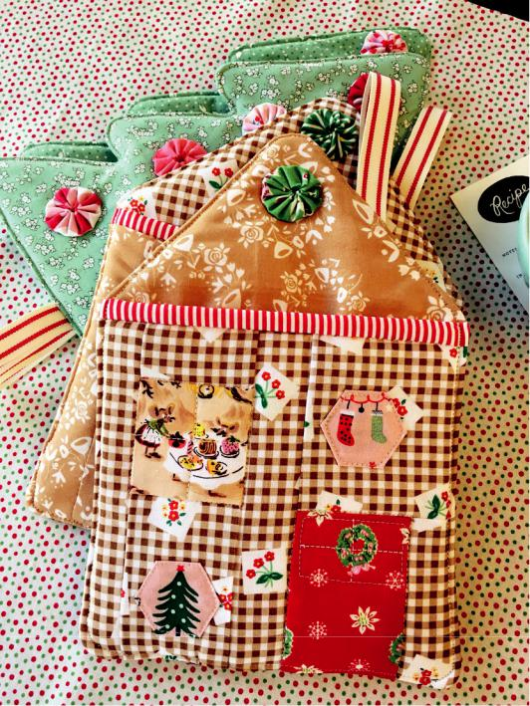

Skill Level: Beginner

Sewing Time: 2-3 Hours

Finished size: Approx 8”

Janome Supplies Required:

Janome Sewing Machine

Janome Feet A, O, and F

Purple Tip Needle

Fabrics/Notions Required:

-Half yard Insul-Bright

-Batting scrap 8 inch square

-1-2 fat quarters fabric for front and back of gingerbread house -1 fat quarter fabric for Christmas tree -Stripe fabric 7.5x7.5

-Assorted scrap fabrics for making yo-yo’s (a yo-yo maker is also helpful) -Fussy cut fabrics for window, door and hexagons -Ribbon 12-14 inches long
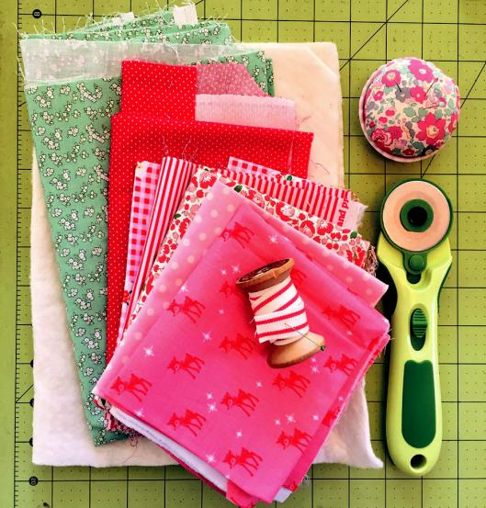

Supplies Required:

-Marking pen

-Wonder clips

-Turning tool like a chopstick

-Iron

-Scissors

-Glue stick

www.janome.com

Page 1



Gingerbread House + Christmas Tree Potholder Duo


To make Christmas Tree Potholder:

Print out Tree template and cut out tree shape. Take two green fabrics 8x10 inches and place together right sides facing, pin to hold in place, using a pen or marker trace the template onto your fabric. Your pen marking will be your sew line, do not cut on this line! Use a scissors to cut ¼ inch around your sew line. Follow these steps using two sheets of Insul-Bright to cut your lining.
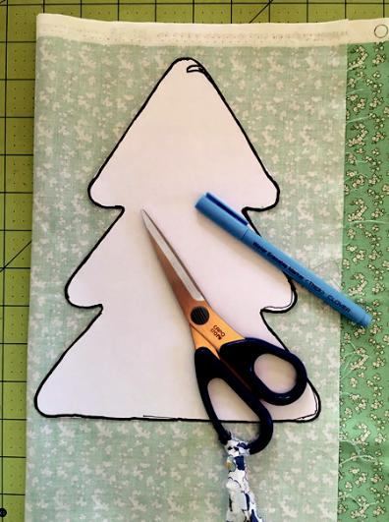

Use sewing foot O to get that ¼ inch seam and a 2.0 stitch length so your corners will be smooth when turned right side out. Start at bottom of tree just on top of ribbon and sew around tree shape. Leave about 2 inches for turning at the bottom. Use a scissors to cut little darts into each part that darts in, this will give you smoother edges. Turn right side out using a chopstick to poke

out corners. Using a hot iron, press around edge of tree making sure to flatten the corners and dart areas. Using a 1/8”, top stitch around tree, starting with your opening. Next make 8 small yo-yo’s, arrange onto your tree and glue into place to hold while sewing.
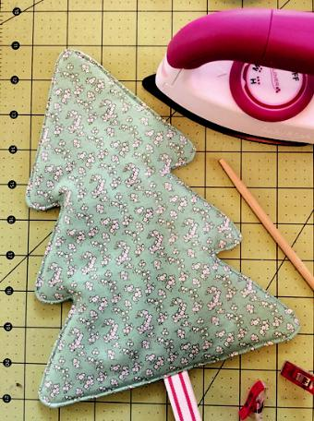

With right sides still facing, place green fabric on top of your Insul-Bright to make a sandwich. Fold 6 inches of ribbon in half, place between your two green fabrics with the edges aligned, use clips around edges to hold in place.
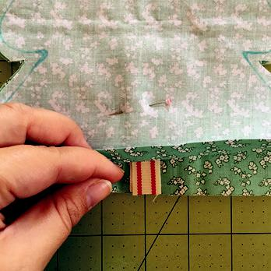

Using sewing foot F, sew a small line into the center of each yo-yo to attach to tree. Trim threads, and your potholder tree is all trimmed! You can also decorate tree using small hexies or pompoms.



www.janome.com

Page 2

Gingerbread House + Christmas Tree Potholder Duo

To make Gingerbread House Potholder:

-Insul-Bright 2 pieces 7.5x10.5 and one 7.5x6.5

-For front pocket cut:

-Door 2.5x3.5

-Window 2.5 square

-Gingerbread pieces 1.5x3.5, 3.5 square, 2.5x1.5, -2.5x3.5, and two 1.5x6.5

-Red stripe binding/pocket backing 7.5 square -Two pieces 7.5x10.5 for front and back of base -6 inch ribbon for “chimney”

To assemble the house front sew door fabric to 1.5x3.5 house fabric using your ¼ inch (O) sewing foot, press seams to door fabric. Next sew this piece to the 3.5 inch square house piece also pressing seams towards the door. Add the long 1.5x6.5 house strip to the left of the door piece, press seams to door and set aside. Sew your 1.5x2.5 house piece to the top of the window and press seams to window side, sew 2.5x3.5 house piece to bottom of window pressing seams to window. Add 1.5x6.5 house strip to left of window, press seams to window and join door section to window section pressing all seams flat.

Place your house front pocket on top of your 7.5x6.5 Insul-bright, place your striped fabric on top of house with right sides facing. Using your O sewing foot sew a ¼ inch seam along the top. Fold striped fabric over to cover back of house pocket, sew along the edge of striped fabric to make binding edge using your F foot.

Next make two hexagons using the template, remove paper and iron flat. Use a bit of glue to hold hexie in place while you sew around shape attaching to house front. Sew just around the outside of window and door and add quilting to make window panes, set front pocket aside.

Layer your two pieces of Insul-bright and front and back fabric for the house base, place house front pocket on top for measuring.
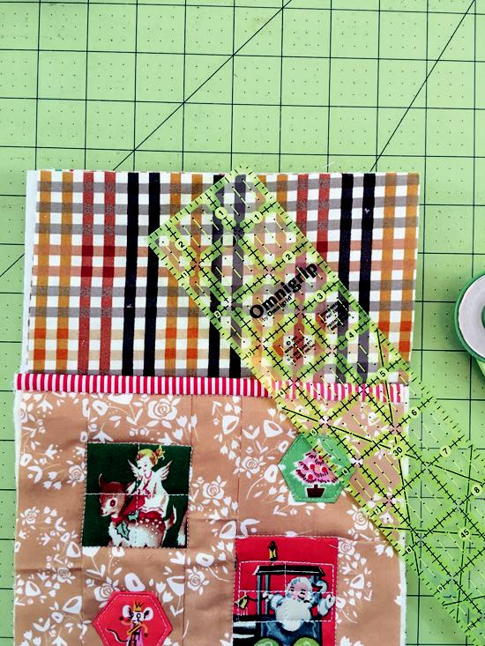

Using a ruler, measure ¼ inch from top edge of house pocket to ¼ inch off of top center (this ¼ inch off of top center leaves room for your seam allowance), use a rotary cutter to cut, repeat on other side to make your roof shape.


www.janome.com

Page 3

Gingerbread House + Christmas Tree Potholder Duo

To sew together, layer Insul-Bright, roof fabric, house front pocket (both right sides up), and lastly place house backing fabric right side down on top, use clips to hold in place.
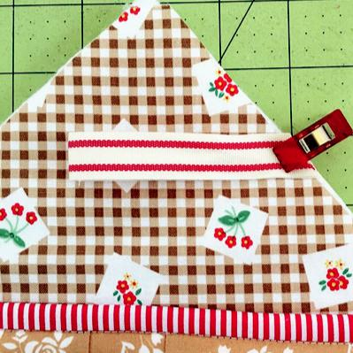

To finish off your gingerbread house, make one small yo-yo and sew to roof of house using the method from the Christmas tree.
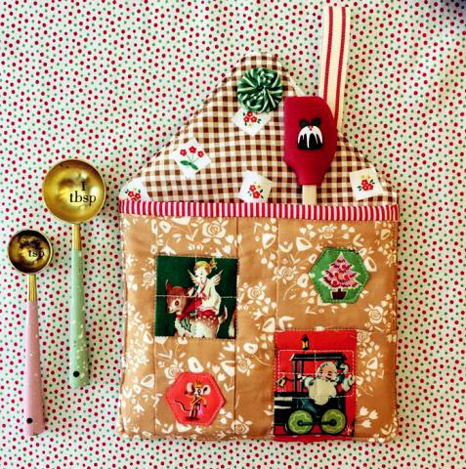

All the cute details and fussy cut fabrics make for the sweetest touches and handmade charm.

Starting at the bottom sew using your O foot, leave a two inch opening for turning. Turn right side out using a chopstick to poke out corners. Turn opening seams in and stitch closed using a 1/8” seam, top stitch around house.
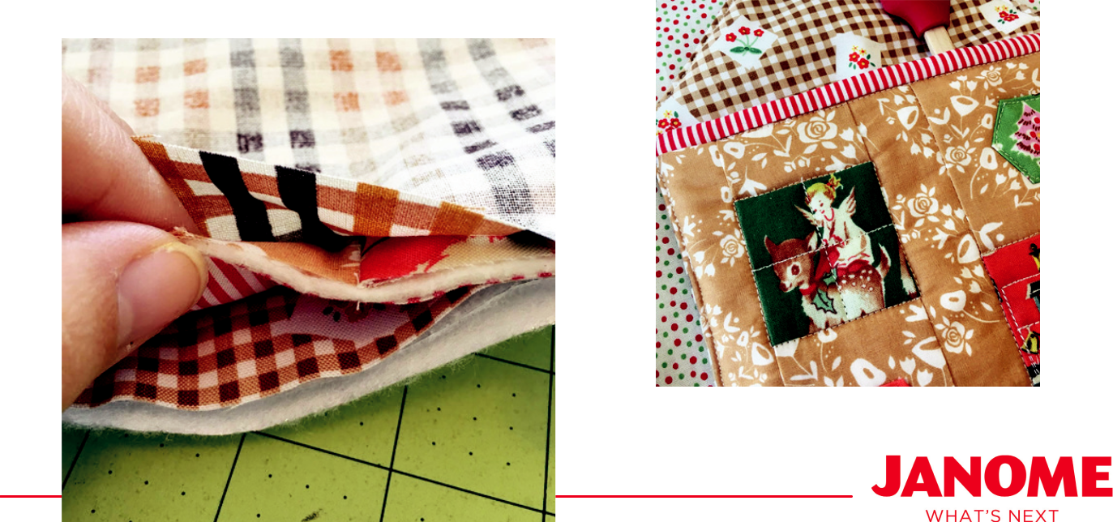

www.janome.com

Page 4

Gingerbread House + Christmas Tree Potholder Duo

Make a couple sets with your favorite Christmas movie on and a cup of hot chocolate. Add a recipe card and you’ll have the perfect hostess gift!
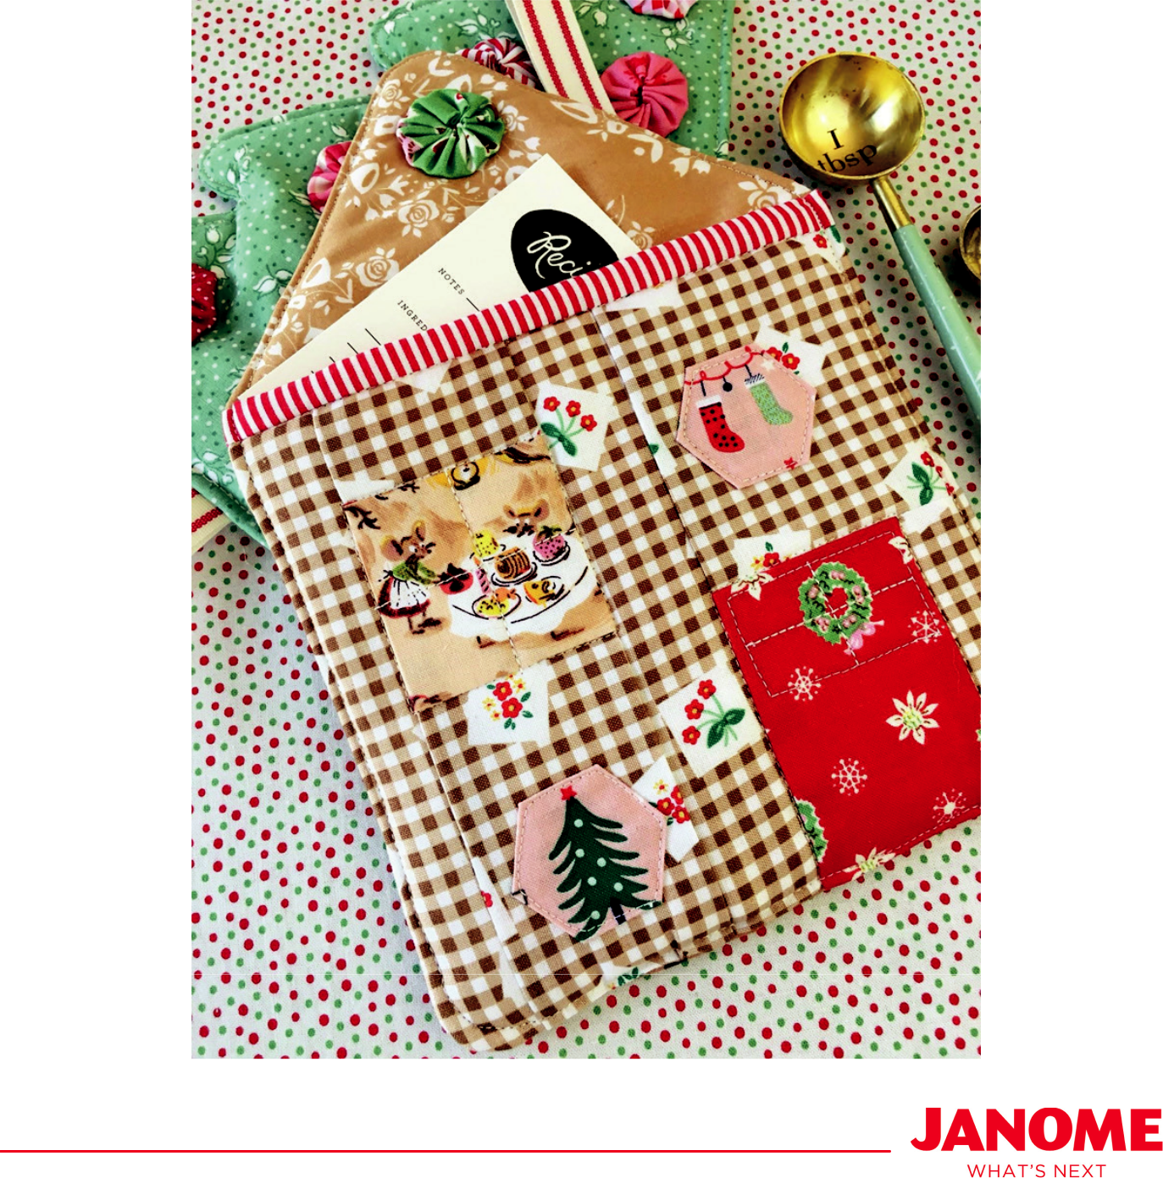

www.janome.com

Page 5

Gingerbread House + Christmas Tree Pattern Page
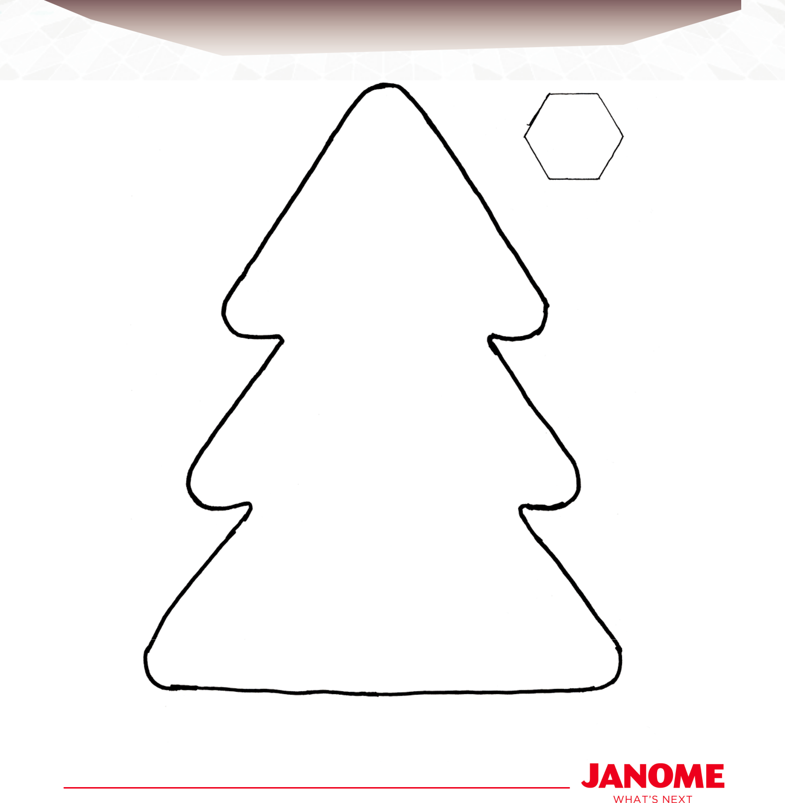

www.janome.com

Page 6

