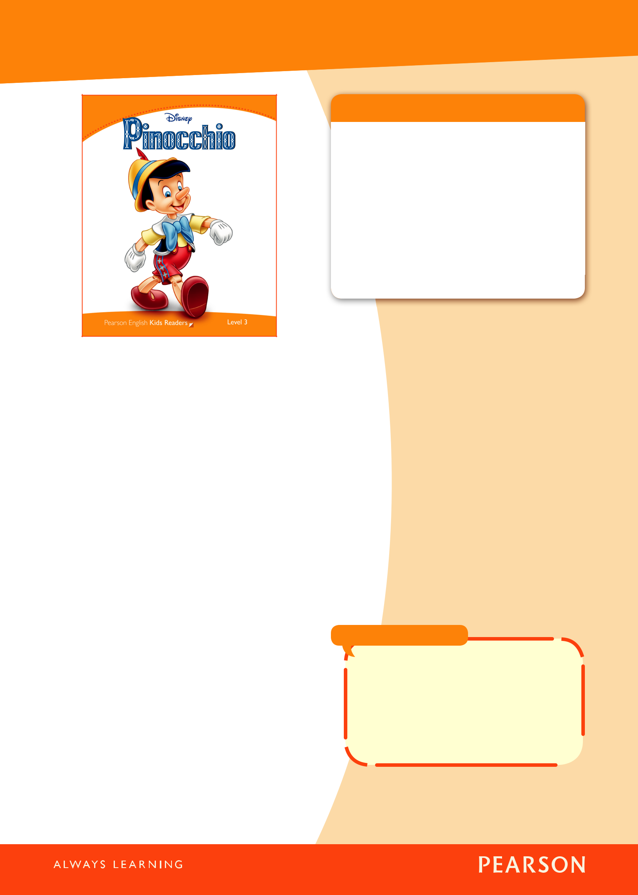
Pearson English Kids Readers
Teacher’s Notes

Summary of the story

Pinocchio is a puppet made by a woodcarver called Geppetto. Geppetto likes Pinocchio and wants him to be a real boy. The Blue Fairy comes to Geppetto’s house in the night and brings the puppet to life. Jiminy Cricket promises to look after Pinocchio.

On his way to school, Pinocchio meets two villains, Honest John and Giddy. They sell the puppet to a man called Stromboli, who has a Marionette Show. Stromboli puts Pinocchio in a cage and he is very unhappy. The Blue Fairy comes to help Pinocchio, and asks what happened. Pinocchio does not tell the truth and his nose gets longer. When he tells the truth, his nose goes back to normal and the Blue Fairy lets him out of the cage.

Jiminy wants to take Pinocchio home, but Honest John and Giddy trick Pinocchio a second time. They want to take him to Pleasure Island with lots of other boys. Pinocchio thinks it is for a vacation, but it is not. When the boys arrive they are all changed into donkeys. With Jiminy’s help, Pinocchio escapes but when he gets back home, his father is not there.

Geppetto had gone to the ocean to look for Pinocchio, but a whale swallowed him! Pinocchio finds the whale and is also swallowed. He then manages to get the whale to sneeze them out of

 | Level 3
Suitable for: |  | young learners who have
 |  | completed up to 150 hours
 |  | of study in English
Type of English: |  | American
Headwords: |  | 600
Key words: |  | 15 (see pages 2 and 5 of
 |  | these Teacher’s Notes)
Key grammar: |  | present simple, past
 |  | simple, would like, Let’s …,
 |  | Have to (obligation),
 |  | comparative adjectives

its mouth. Pinocchio saves Geppetto’s life, but dies himself. In the end, the Blue Fairy comes to Geppetto’s house and, because Pinocchio was brave, changes him into a real boy.

Background information

Pinocchio is an animated movie created by Walt Disney Productions. It was first released in 1940 and was the second feature-length animated movie from Disney. (Snow White and the Seven Dwarfs was the first.)

The story was based on a novel by the Italian writer, Carlo Collodi (1826–1890). It was called The Adventures of Pinocchio and was first published as a weekly serial in a magazine (1881–1883).

The film won two Academy Awards®, one for Best Original Score and one for Best Original Song, When You Wish Upon a Star.

Did you know … ?

When You Wish Upon a Star became the fanfare of the Disney Company. You can hear it when the logo appears at the beginning of Disney movies.

Although Pinocchio is famous for his nose growing when he lies, this only happens in one scene in the movie. 

1 www.pearsonenglishkidsreaders.com PINOCCHIO LEVEL 3


Pearson English Kids Readers
Teacher’s Notes

The characters

Pinocchio is a wooden puppet who comes to life.

Geppetto is a woodcarver who makes Pinocchio.

Jiminy Cricket is a cricket who promises to look after Pinocchio.

Figaro is Geppetto’s cat.

Cleo is Geppetto’s goldfish.

The Blue Fairy brings Pinocchio to life and helps him when he is in trouble.

Honest John is a fox who tricks Pinocchio and sells him to Stromboli.

Giddy is a cat. He works with Honest John.

Stromboli is the owner of a puppet show.

Topics and themes

Art and craft Geppetto is a skilled woodcarver. He makes a marionette (a puppet with strings) that looks like a real boy. Ask students what other kinds of puppets they know of, e.g. finger puppets, stick puppets, glove puppets, shadow puppets, etc. Find out if any students have puppets, or if they have been to a performance with puppets. (See also Activity 2 on page 3 of these Teacher’s Notes.)

Science and Technology Pinocchio is made from wood carved by Gepetto. Ask the students what other materials are used to make puppets and toys. Do they know how other materials are shaped, e.g. plastic, metal, fabric, papier-maché? (See also Activity 1 on page 3 of these Teacher’s Notes.)

History The ancient Egyptians made and used string puppets 4,000 years ago. In the distant past puppets were used for story-telling, not as toys for children. Talk with the students about how puppets make stories more involving and memorable.

(See also Activity 1 on page 3 of these Teacher’s Notes.)

Friendship Jiminy Cricket is Pinocchio’s friend and he helps him when he is in trouble. Talk with the students about the value of friendship and what makes a true friend.

Key words

(see page 5 of these Teacher’s Notes for the Key words in context)

cage (n) real (adj)

coach (n) save (v)

dead (adj) sell (v)

donkey (n) sneeze (v)

fairy (n) string (n)

fire (n) too (adv)

monster (n) whale (n)

puppet (n)

Family Pinocchio is not really Geppetto’s son, but he calls him ‘Father’ and Geppetto calls Pinocchio ‘Son’. Talk with students about the importance of family and how people who live alone can sometimes be lonely.

Avoiding temptation Pinocchio was going to school when he met Honest John and Giddy. He went with them and got into trouble. Discuss with students why it is important to do what the adults you trust tell you, and not go off with people you don’t know.

Telling the truth When Pinocchio tells the Blue Fairy a lie, his nose gets longer and longer. Talk with the students about why it is important to tell the truth. What can happen to us in real life if we lie?

Making wishes Geppetto wishes for Pinocchio to be a real boy and, in the end, the Blue Fairy makes his wish come true. Ask students if they make wishes. What kinds of things do they wish for?

Bravery The Blue Fairy changes Pinocchio into a real boy at the end because he was very brave and cared more about Gepetto’s safety than his own. Ask students to think of examples when they have been brave. Can they think of other examples of bravery in real life or in stories?

2 www.pearsonenglishkidsreaders.com PINOCCHIO LEVEL 3

Pearson English Kids Readers
Teacher’s Notes

Class Activities (After Reading)

Here are some activities to do with your class after reading Pinocchio.

1. Puppets from the past

Materials: pictures of puppets from history in reference books or from the internet; large sheets of paper; colored pens

- Show students some pictures of puppets from the past. (Include a variety of types of puppet.)

- Talk about each puppet in turn. Use language that students can use as a model for their writing, e.g. This puppet is … years old. It comes from … . It is made from … . It is big / small. People used it to (tell stories).

- Write a model text on the board.

- In pairs, students choose one of the puppets. Give each pair of students a sheet of paper and some colored pens.

- Students draw and colour in their puppet on their sheet of paper.

- Students write a short text about their puppet in their notebooks. They can ask you questions to check the information they need to write the text, e.g. How old is the puppet? Where does it come from?

- Students copy their texts on their posters.

- Display the finished posters.

2. Make a puppet

Materials: wooden spoons; colored pens; pipe cleaners / chenille stems; wool; glue; pieces of fabric; scissors; buttons and sequins for decoration

- Before the session, make a puppet using a wooden spoon. Paint a face on the spoon and stick wool around the face for hair. Bend pipe cleaners / chenille stems around the handle to make arms. Cut the fabric to make clothing and glue it to the ‘body’.

- Put all the materials in separate boxes at the front of the class (e.g. spoons in one box, pipe cleaners in another).

- Use your puppet to talk to the class, e.g. Hello, my name is … How are you today?

- Tell students to come and collect the materials they need to make their own puppets. (Stage this process so that students do not all come at once.)

- Go around the class as students are making their puppets to help them, or make suggestions.

- When all the puppets are finished, students use their puppets to ‘talk’ to each other in pairs or small groups.

- Ask for volunteers to come to the front of the class to ‘talk’ with your puppet.

  - Materials display table (over several sessions)

- Brainstorm with students the different materials that are used to make puppets and toys, e.g. metal, paper, plastic, rubber, wood.

- Make a display table in one part of the classroom. Tell students to bring examples of puppets or small toys made from these materials from home.

- In subsequent classes, allow five minutes at the end of the session for students to put their items on the display table and to talk about the materials with the class.

- Ensure that all the items are returned to students at the end of each session.

3 www.pearsonenglishkidsreaders.com PINOCCHIO LEVEL 3

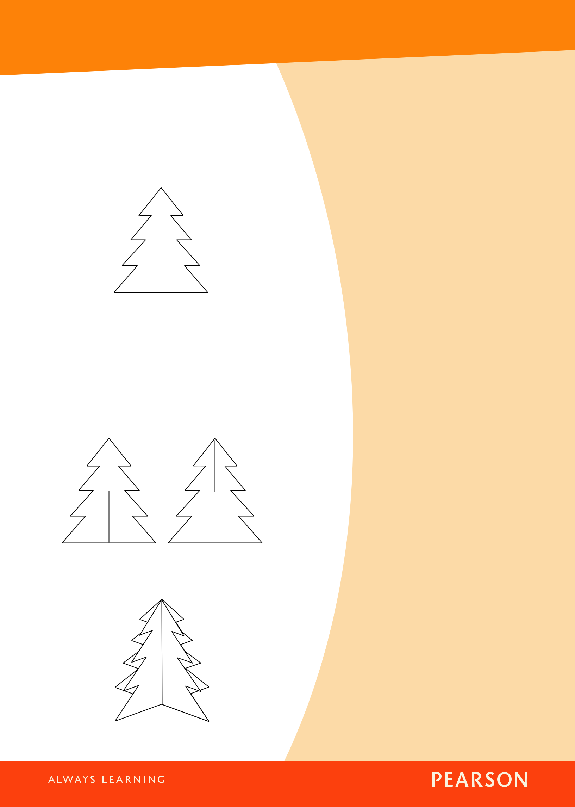
Pearson English Kids Readers
Teacher’s Notes

4. Make a wishing tree

Materials: two large pieces of thick green card; scissors; small pieces of paper; scotch tape

- Before the session, draw the same simple Christmas tree outline like the one below on both pieces of card.

- Cut out both outlines so you have two tree-shaped pieces of card.

- Take one of the tree shapes and make a vertical cut from the center of the base to exactly halfway up the height.

- Take the other tree shape and make a vertical cut from the point of the tree to exactly halfway down the center of the shape.



- Show students the wishing tree. Hand out the small pieces of paper.

- Students write or draw wishes on the pieces of paper.

- Students walk around the classroom. Clap your hands. Students stop and ask and answer about their wishes with another student, e.g. What’s your wish? It’s …. Repeat this process about six times.

- Students use scotch tape to attach their wishes to the wishing tree.



• Slot the two pieces together to make a tree.

It should stand up like the ‘tree’ below.

4 www.pearsonenglishkidsreaders.com PINOCCHIO LEVEL 3


Pearson English Kids Readers
Teacher’s Notes

Key words

cage ................ But Stromboli is not a kind man. He puts Pinocchio in a cage. (p. 8)

coach .............. “This is the coach for Pleasure Island,” says Honest John. (p. 11)

dead ............... “You saved my life and now you are dead.” (p. 21)

donkey ........... “You have a donkey’s ears, a donkey’s legs ... you are a donkey!” (p. 13)

fairy ................ The fairy makes his nose smaller. (p. 9)

fire .................. “Let’s make a fire,” says Pinocchio. (p. 19)

monster ......... “There were two big monsters ...,” says Pinocchio. (p. 9)

puppet ............ Geppetto makes puppets. (p. 1)

real ................. “I’d like you to be a real boy,” Geppetto says. (p. 4)

save ................ He saves Geppetto’s life. (p. 20)

sell .................. “Let’s sell him to Stromboli. We can make a lot of money!” (p. 7)

sneeze ............ “We want to make the whale sneeze.” (p. 19)

string .............. “Look,” says Honest John. “That puppet doesn’t have strings!” (p. 7)

too ................... “I’m here too,” says the Blue Fairy. (p. 9)

whale .............. Geppetto tried to find Pinocchio and now he is inside a whale! (p. 15)

5 PHOTOCOPIABLE Text copyright © Pearson Education. Disney material © Disney.

PINOCCHIO LEVEL 3

Pearson English Kids Readers
Teacher’s Notes

While-Reading activities

Activity 1 (pages 3–5)

Circle the right words.

- Jiminy Cricket looks in the door / in the window / under the door.

- Jiminy and Geppetto / Pinocchio and Geppetto / Jiminy and Pinocchio are wearing hats.
- Geppetto has three pets / two pets / one pet.

- The fairy is yellow / pink / blue.

Activity 2 (pages 6–9)

Order the sentences.

a Honest John and Giddy see Pinocchio.

b Pinocchio tells the real story.

c Pinocchio does not tell the real story.

d Pinocchio’s nose gets smaller.

e The Blue Fairy arrives.

f Pinocchio runs to school.

g Pinocchio’s nose gets longer.

h Stromboli puts Pinocchio in a cage.

6 PHOTOCOPIABLE Text copyright © Pearson Education. Disney material © Disney.

PINOCCHIO LEVEL 3

Pearson English Kids Readers
Teacher’s Notes

Activity 3 (pages 10–14)

Match the two parts of the sentences.

1 | Honest John and Giddy want | a | to go and play.
2 | There are a lot of | b | run away from Pleasure
 |  |  | Island.
3 | On Pleasure Island Pinocchio wants | c | children on the coach to
 |  |  | Pleasure Island.
4 | Pinocchio grows | d | Pinocchio to go to Pleasure
 |  |  | Island.
5 | Jiminy and Pinocchio | e | a donkey’s tail and two ears.

Activity 4 (pages 15–19)

Write T (True) or F (False).

1 Geppetto is on vacation.

2 Pinocchio reads a letter.

3 Pinocchio and Jiminy look for Geppetto in the town.

4 Geppetto is sleeping inside the whale.

5 The whale eats Pinocchio with the fish.

6 Pinocchio sneezes and the whale opens its mouth.

7 PHOTOCOPIABLE Text copyright © Pearson Education. Disney material © Disney.

PINOCCHIO LEVEL 3

Pearson English Kids Readers
Teacher’s Notes

Activity 5 (pages 20–22)

Copy the correct sentence next to the picture.

- “Pinocchio, you were good,” the Blue Fairy says.

- “Father, I’m a real boy,” says Pinocchio. “Look!”

- Pinocchio saves Geppetto’s life.
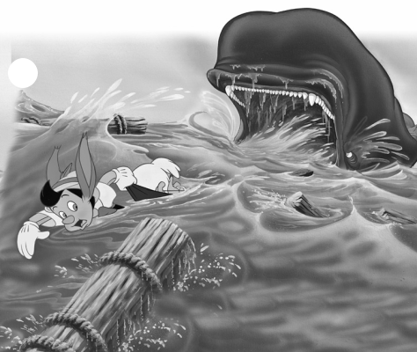

1

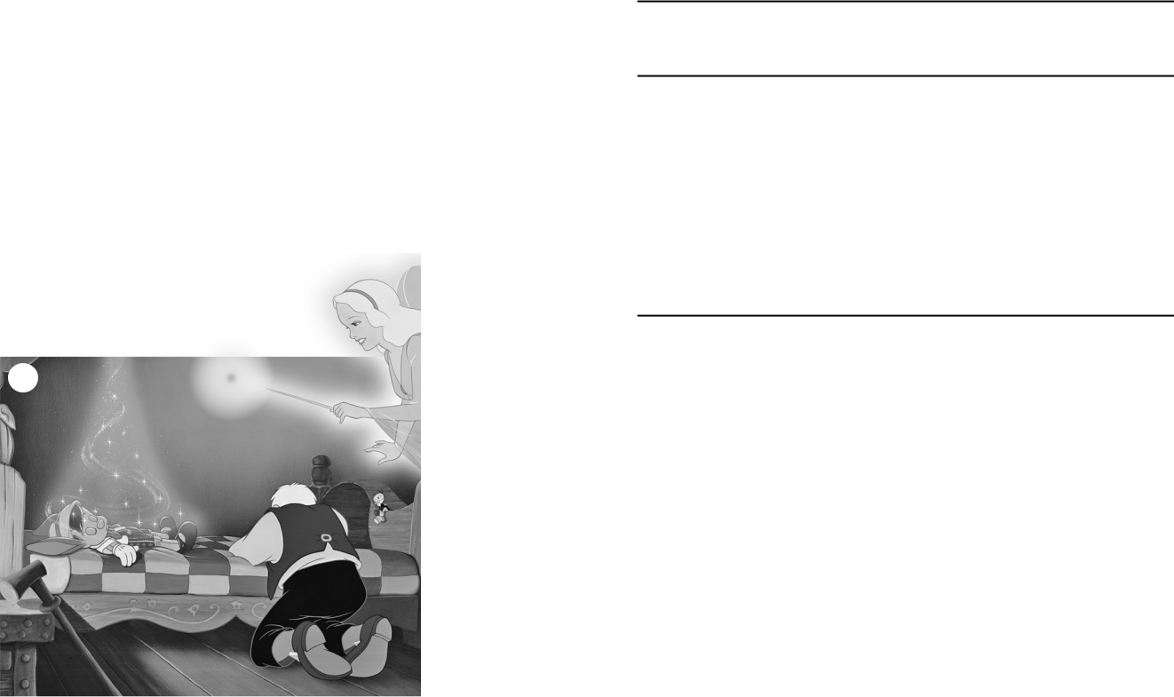

2
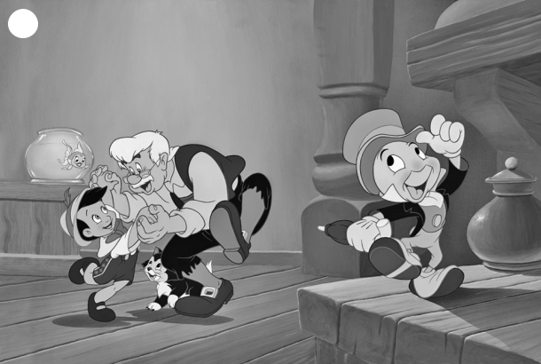

3

8 PHOTOCOPIABLE Text copyright © Pearson Education. Disney material © Disney.

PINOCCHIO LEVEL 3

Pearson English Kids Readers
Teacher’s Notes

After-Reading activities

Activity 1

Write the names under the pictures.


Cleo Figaro Stromboli Geppetto Honest John

Giddy Jiminy Cricket The Blue Fairy Pinocchio
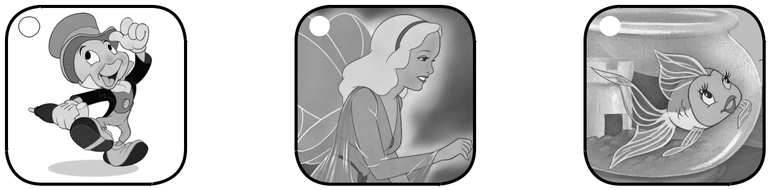

a b c
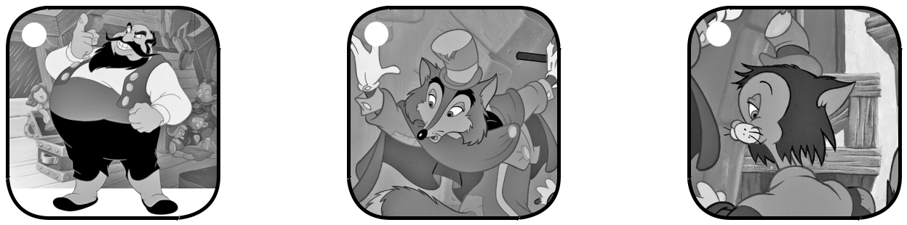

d e f
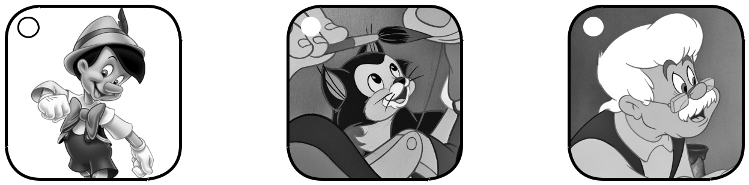

g h i

9 PHOTOCOPIABLE Text copyright © Pearson Education. Disney material © Disney.

PINOCCHIO LEVEL 3

Pearson English Kids Readers
Teacher’s Notes

Activity 2

Who says these things in the story? Cut and stick the sentences next to the pictures in Activity 1.
✁ ✁

1 Wake up, Pinocchio! 2 There were two big monsters.

✁ ✁

3 We can make a lot of money! 4 Wait for me!

✁

- How can we get out?

Who doesn’t speak?

Activity 3

Find fifteen words from the story.

p

u

p

p e t f a i r
y
v
i
l
l
a
g
e
d
a
r
k
s
c
h
o o l m o n

s

t

e

d o
h
c
a
o
c
d
i n
k
r t r u e

n

k

e

y

o c e a n

l e f i

w h a

r

e

r

e

d anc

a l

e

10 PHOTOCOPIABLE Text copyright © Pearson Education. Disney material © Disney. PINOCCHIO LEVEL 3


Pearson English Kids Readers
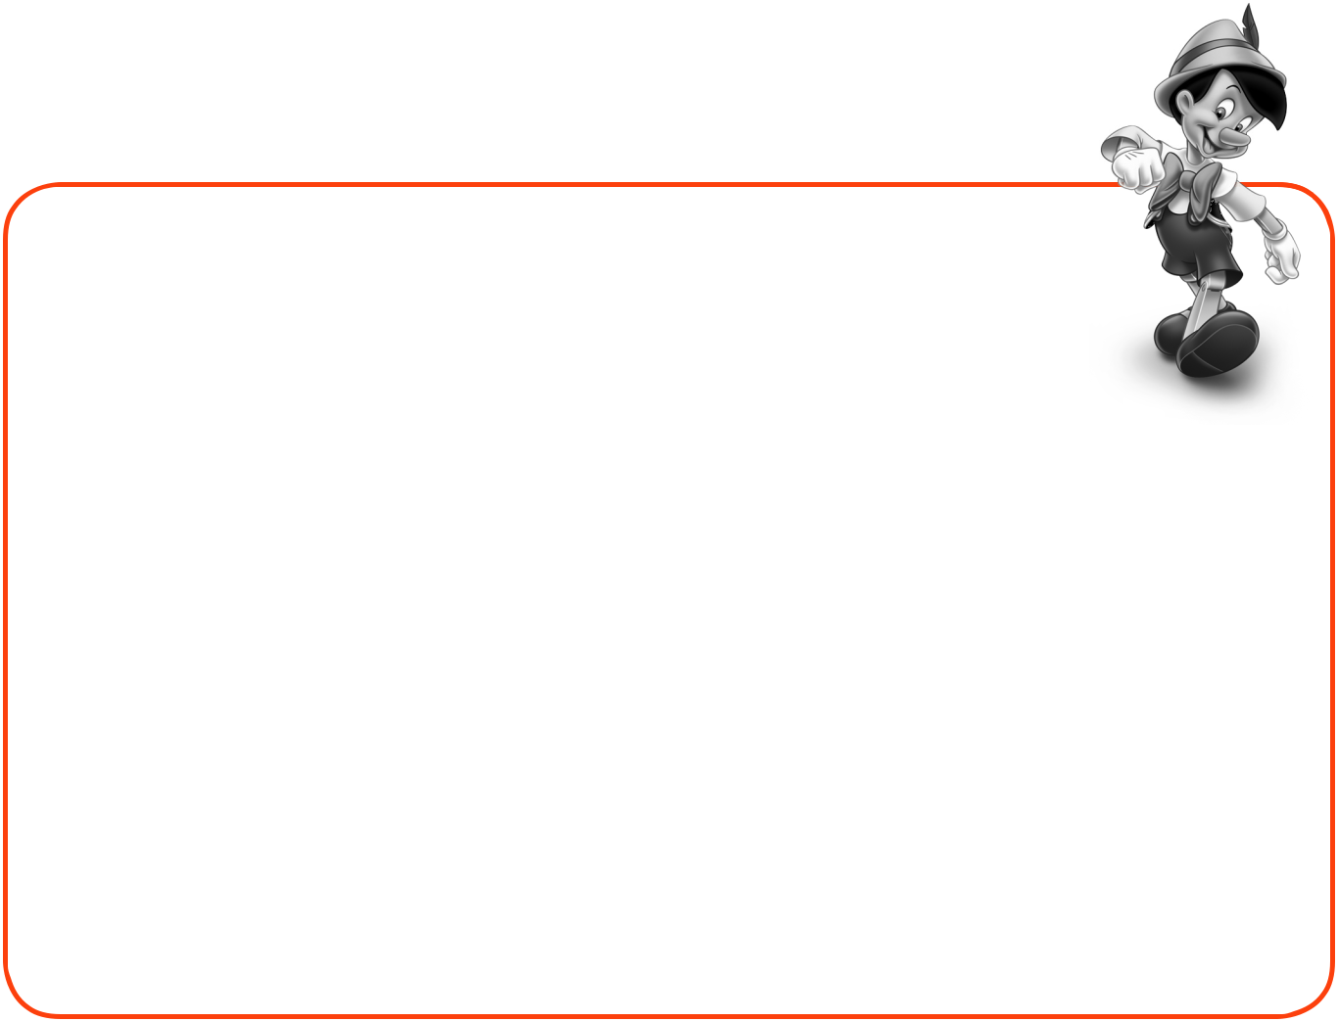
Teacher’s Notes

Activity 4

Draw a puppet friend for Pinocchio here.

Now answer the questions about your puppet.

- What is your puppet’s name?

My puppet’s name is .

- What is your puppet wearing?

.

- What can your puppet do?

.

11 PHOTOCOPIABLE Text copyright © Pearson Education. Disney material © Disney. PINOCCHIO LEVEL 3

Pearson English Kids Readers
Teacher’s Notes

Answer Key

In the back of the Reader

Before You Read

1 1 b 2 d 3 c 4 a

- Pinocchio

After You Read

- c and d are not his friends.

- 1T 2F 3T 4T 5F 6F 7T 8T 9T

Activity 3

puppet fairy village dark school monster true kind coach donkey ocean whale fire real dance

Activity 4

Open answers

In these Teacher’s Notes

While-Reading activities

Activity 1

- in the window

- Jiminy and Pinocchio

- two pets

- blue

Activity 2

f, a, h, e, c, g, b, d

Activity 3

1 d 2 c 3 a 4 e 5 b

Activity 4

1F 2T 3F 4F 5T 6F

Activity 5

1 c 2 a 3 b

After-Reading activities

Activity 1

a Jiminy Cricket b The Blue Fairy c Cleo

d Stromboli e Honest John f Giddy

g Pinocchio h Figaro i Geppetto

Activity 2

1 | The Blue Fairy 2 Pinocchio 3 Honest John
4 | Jiminy 5 Geppetto

Who doesn’t speak?

Stromboli, Figaro, Cleo, Giddy

12 www.pearsonenglishkidsreaders.com PINOCCHIO LEVEL 3

