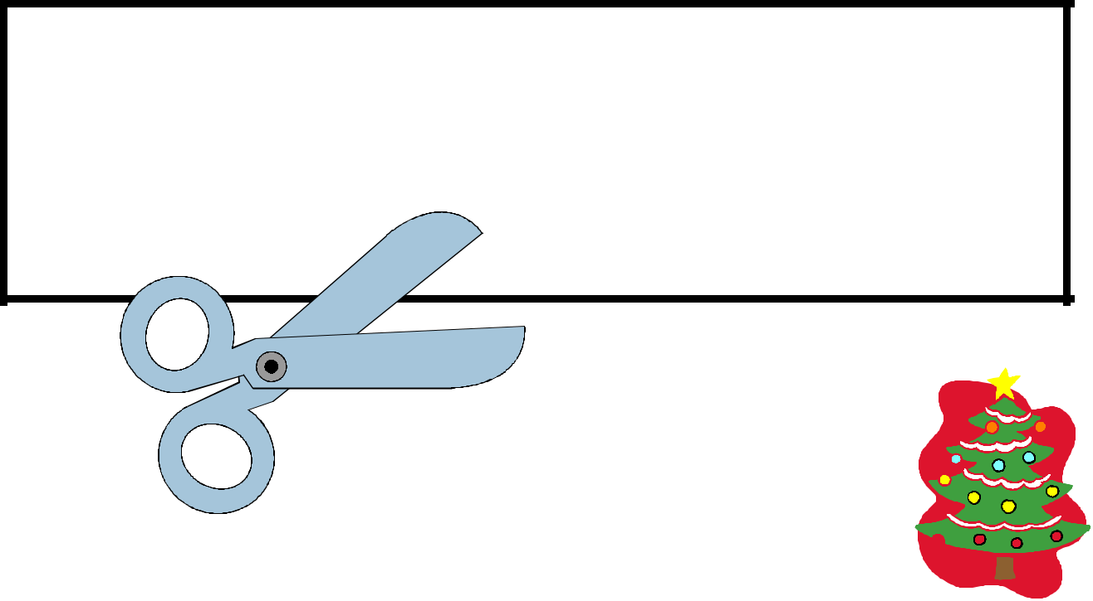

Cut It Out! Pack

Christmas Theme

Level 1: Straight Lines

Level 2: Curved Lines

Level 3: Zig-Zag Lines

Level 4: Shapes

Terms of Use: This free printable pack was created for you to use at home with your child/students or with multiple children in a classroom/tutoring setting. Please do not sell, host, reproduce, giveaway, or store on any other site (including a blog, Facebook, 4Shared, Dropbox, etc.). Thank you!

©2013 All Rights Reserved.
www.thisreadingmama.com


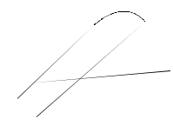 Cut it Out! Pack 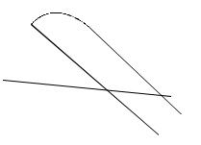
Intro and Instructions

Per my daughter’s request (3 years old), I am making some Cut

it Out! Packs. You will find four levels: straight lines, curved lines, zig-zag lines, and shape puzzles. My hope is that this pack will grow with her and your child as cutting skills mature.

I desired to create ideas in this pack that had extension activities beyond just cutting practice. Here are some ideas for extending the activities:

- Cut It Out! Strips- After the child cuts out all the strips, use the cards as counting cards or create patterns together.

- Cut it Out! Cutting Cards- After the child cuts them up, mix them up to create picture puzzles. The pictures help to make the activity self-correcting. Once matched up, the child can glue the pictures down on paper.

- Cut it Out Shapes- Once cut out, the child can glue them down to the template to create a picture.

©2013 All Rights Reserved.
www.thisreadingmama.com

Cut it Out! Strips Level 1 - Cut on horizontal black lines to create cutting strips for child.
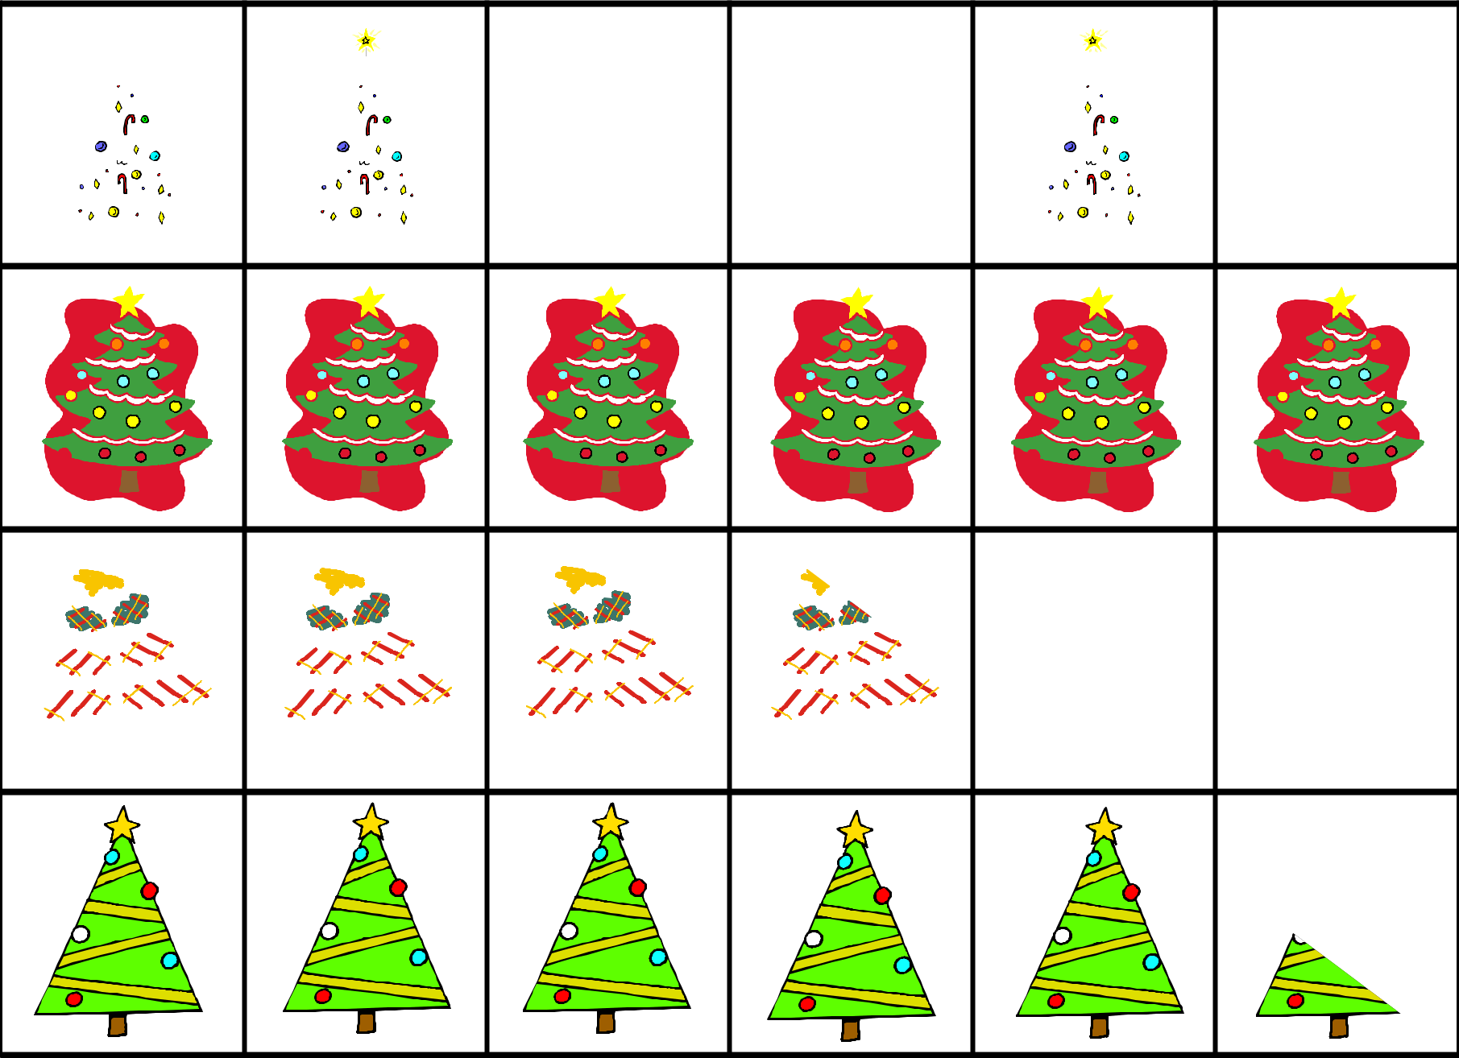

 | LinesStraight
©2013 All Rights Reserved. | www.thisreadingmama.com

Cut it Out! Level 1- Cutting Cards Straight Lines

After pictures have been cut out, the child can use them as puzzles. Pictures can be glued down onto paper once matched up again.
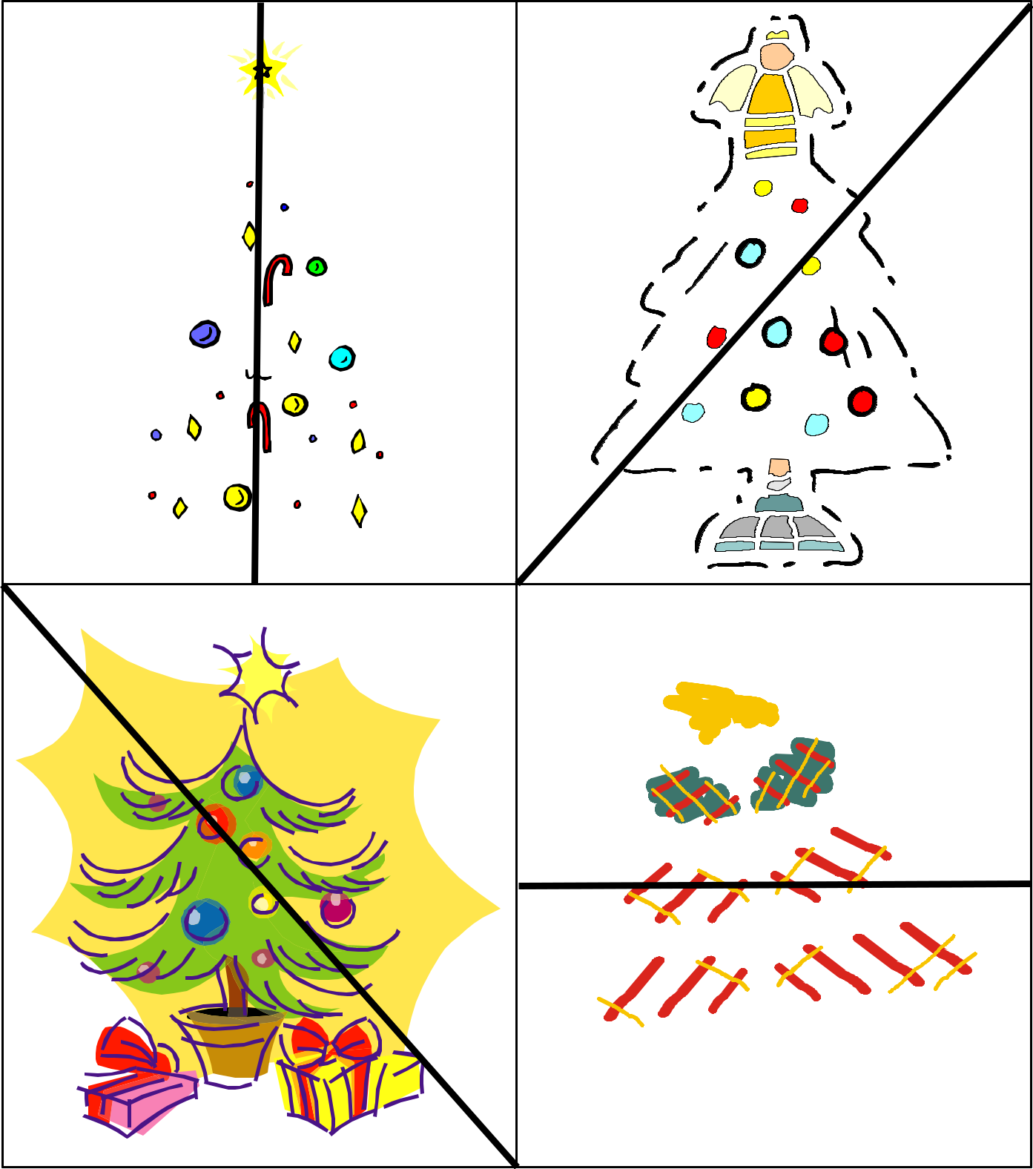

©2013 All Rights Reserved.
www.thisreadingmama.com

Cut it Out! Level 1- Cutting Cards Straight Lines
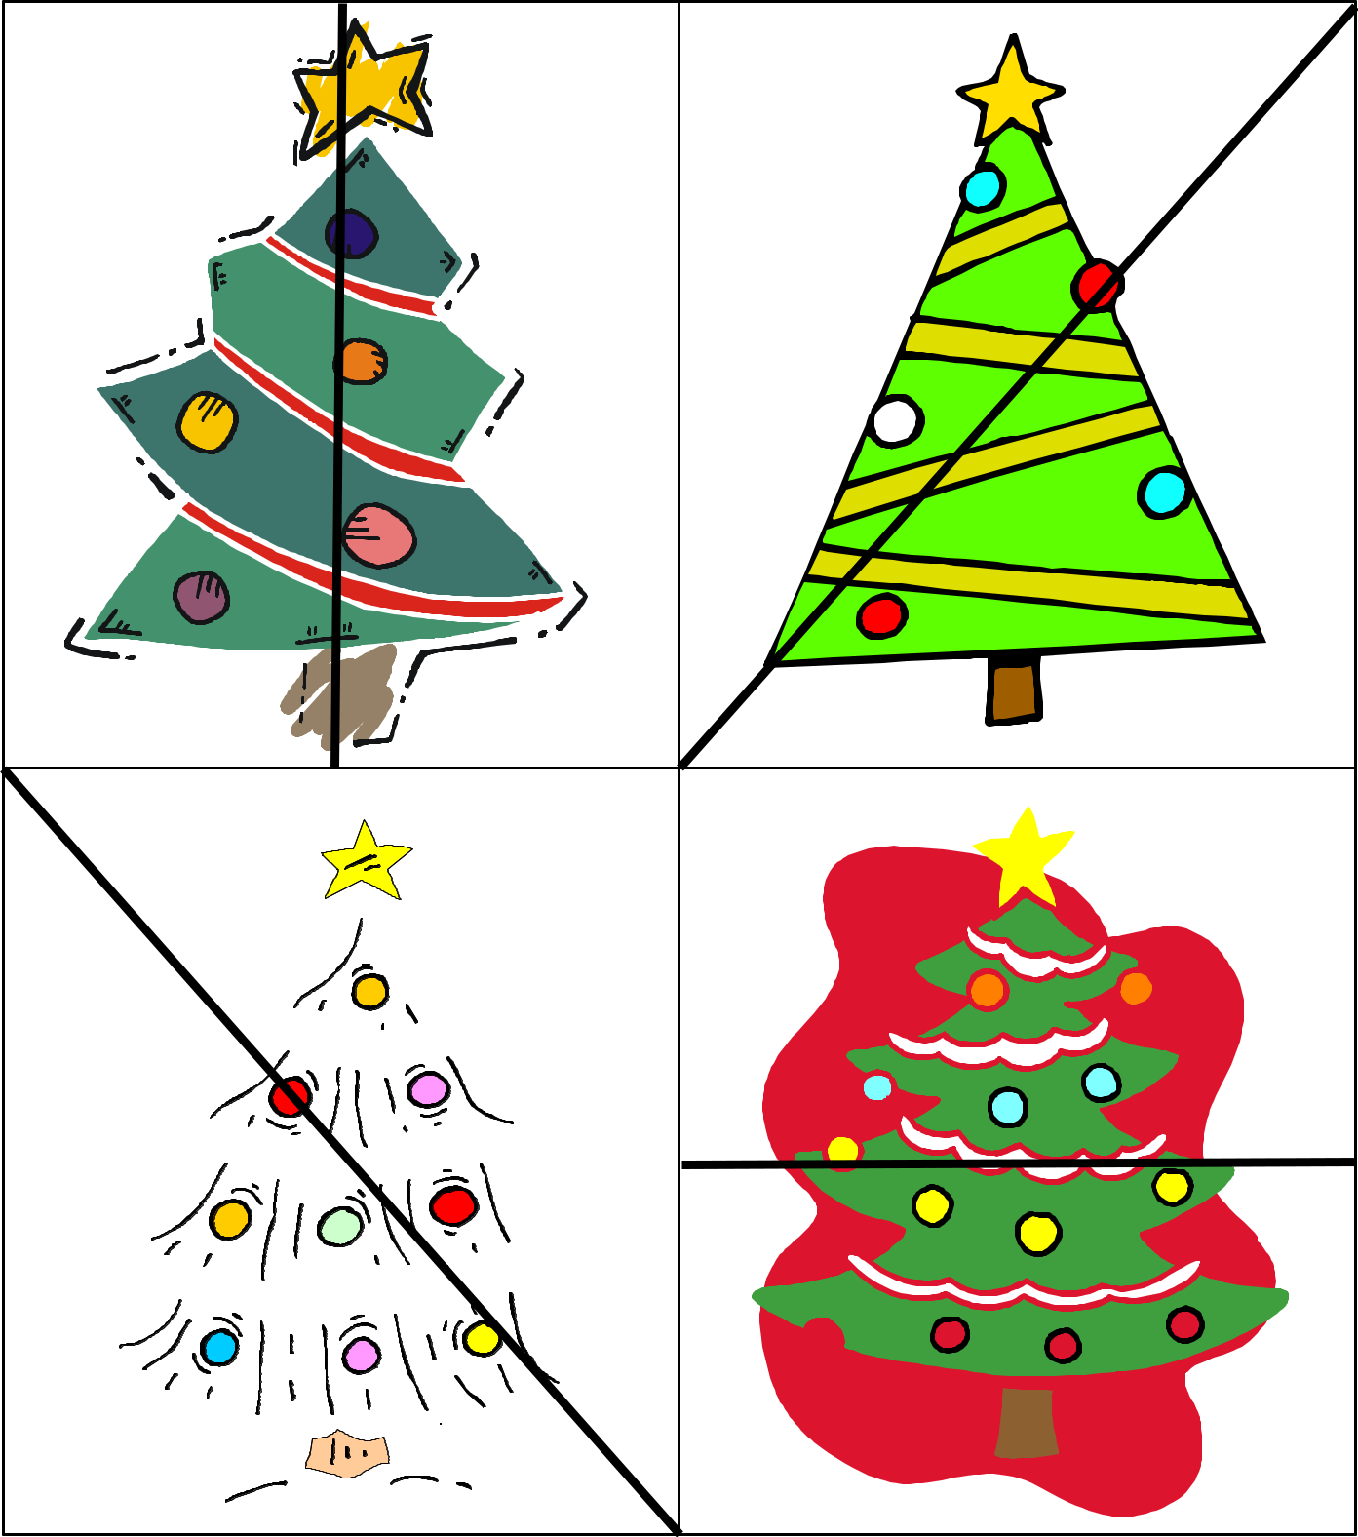

©2013 All Rights Reserved.
www.thisreadingmama.com

Cut it Out! Strips Level 2 - Cut on horizontal black lines to create cutting strips for child.
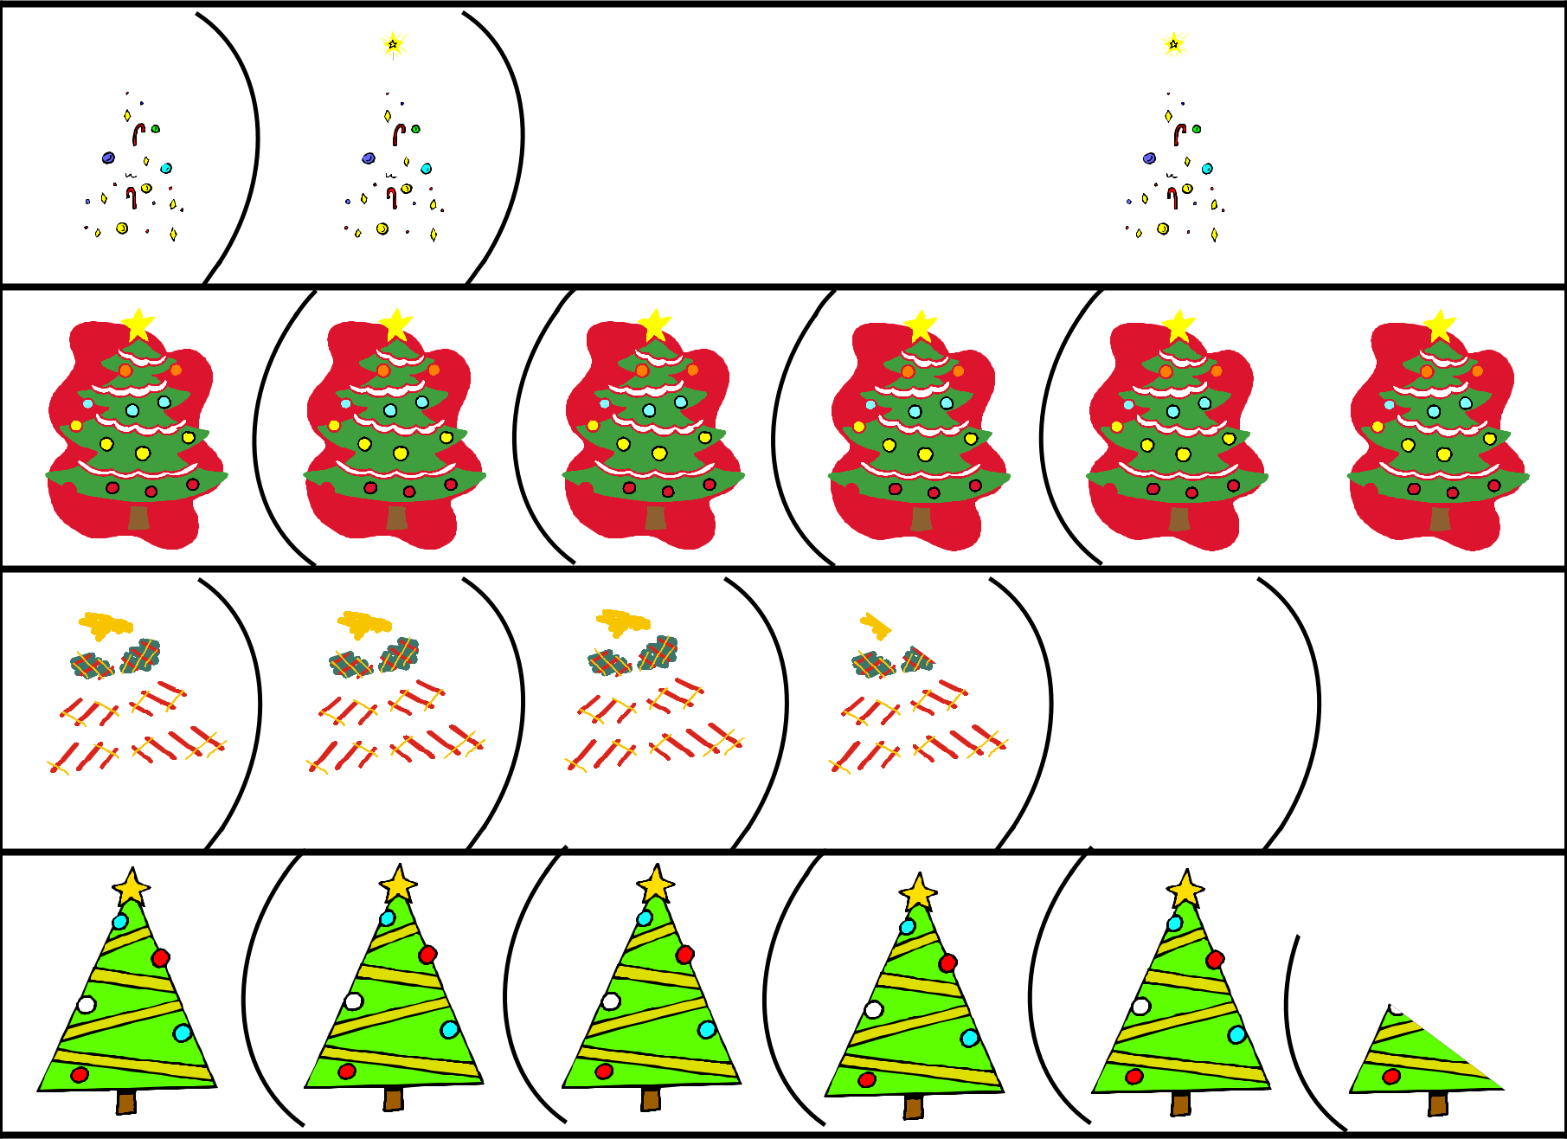

 | LinesCurvy
©2013 All Rights Reserved. | www.thisreadingmama.com

Cut it Out! Level 2- Cutting Cards Curved Lines

After pictures have been cut out, the child can use them as puzzles. Pictures can be glued down onto paper once matched up again.
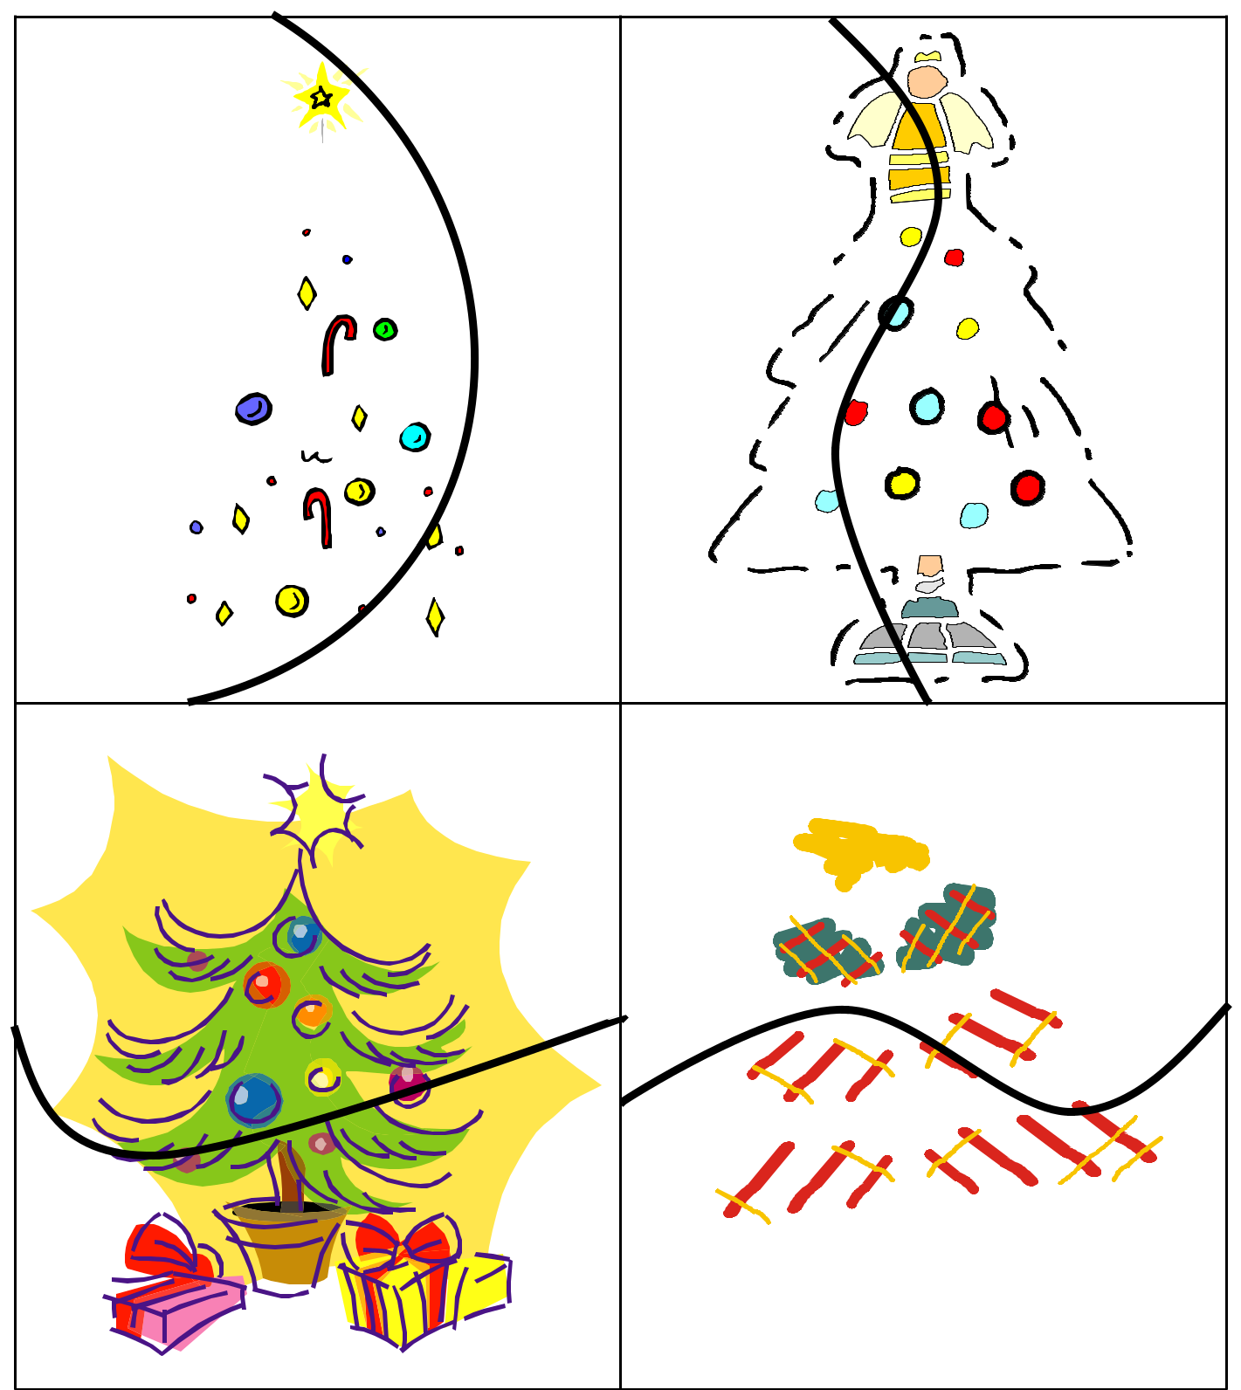

©2013 All Rights Reserved.
www.thisreadingmama.com

Cut it Out! Level 2- Cutting Cards Curved Lines
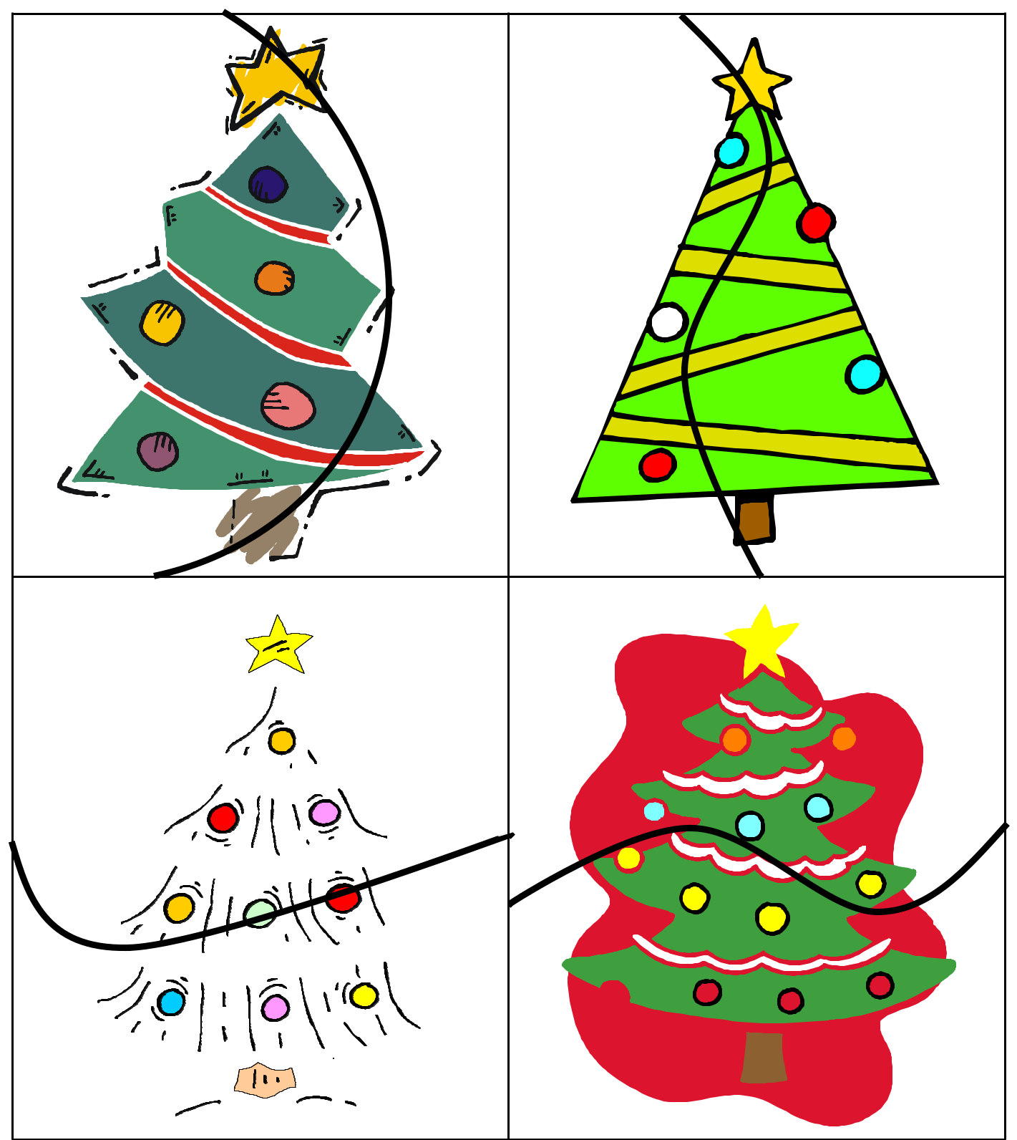

©2013 All Rights Reserved.
www.thisreadingmama.com

Cut it Out! Strips Level 3 - Cut on horizontal black lines to create cutting strips for child.
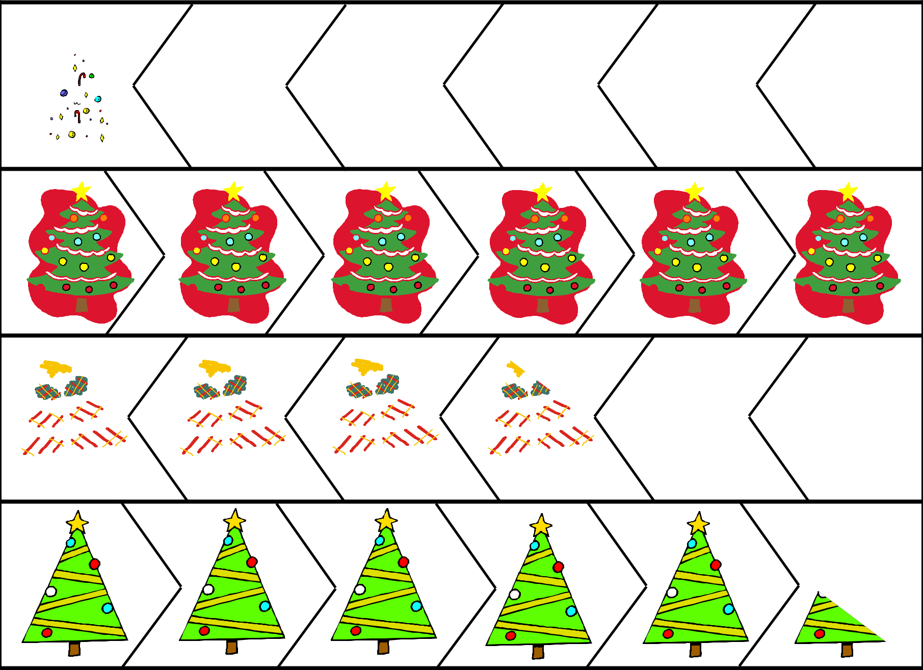

 | LinesZag-Zig
©2013 All Rights Reserved. | www.thisreadingmama.com

Cut it Out! Level 3- Cutting Cards Zig-Zag Lines

After pictures have been cut out, the child can use them as puzzles. Pictures can be glued down onto paper once matched up again.
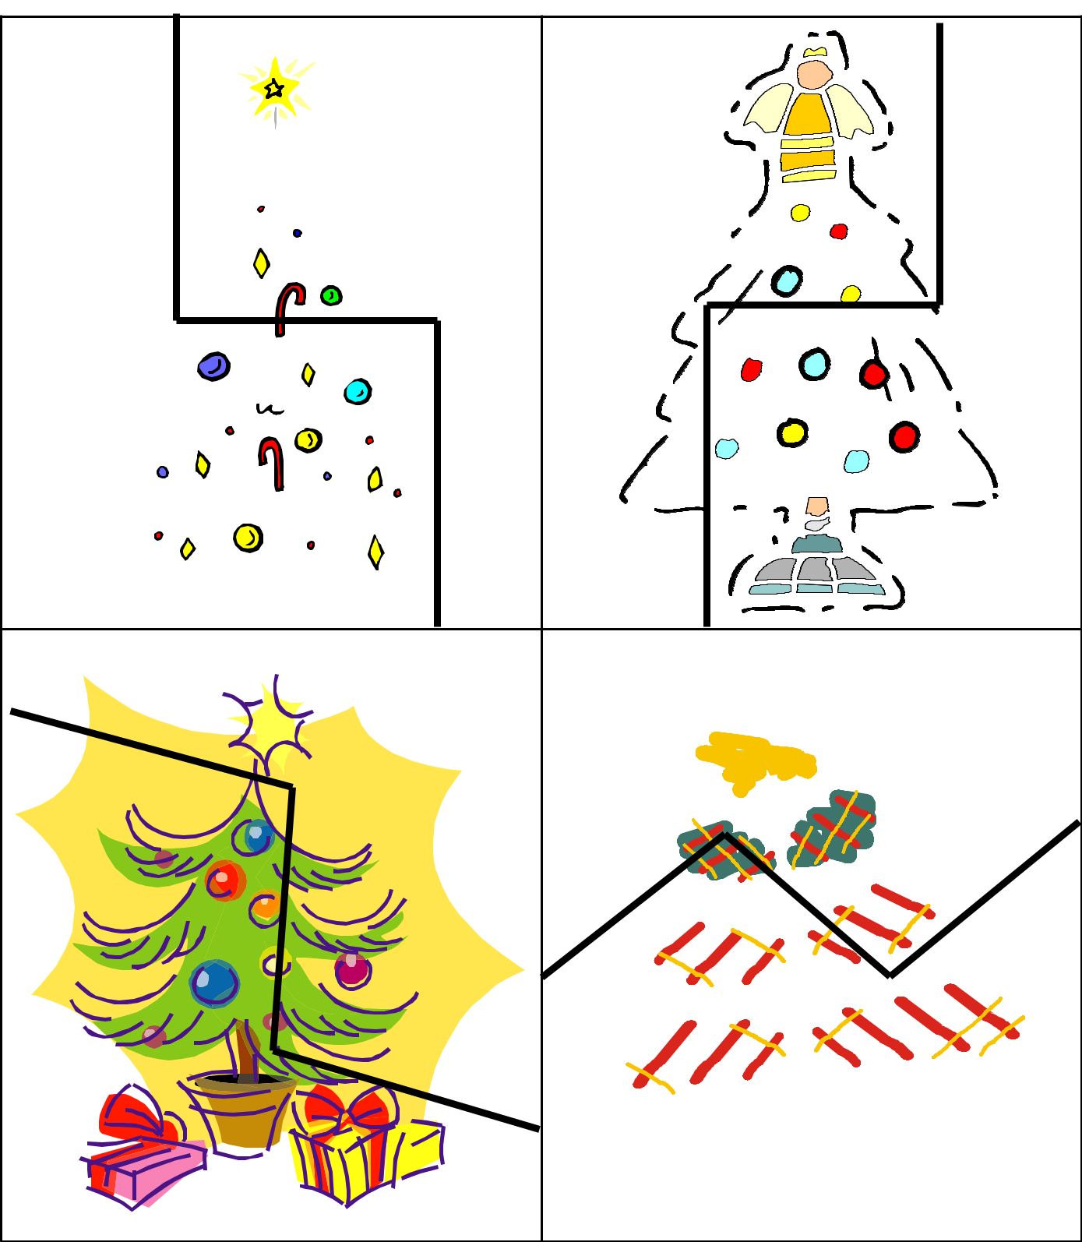

©2013 All Rights Reserved.
www.thisreadingmama.com

Cut it Out! Level 3- Cutting Cards Zig-Zag Lines
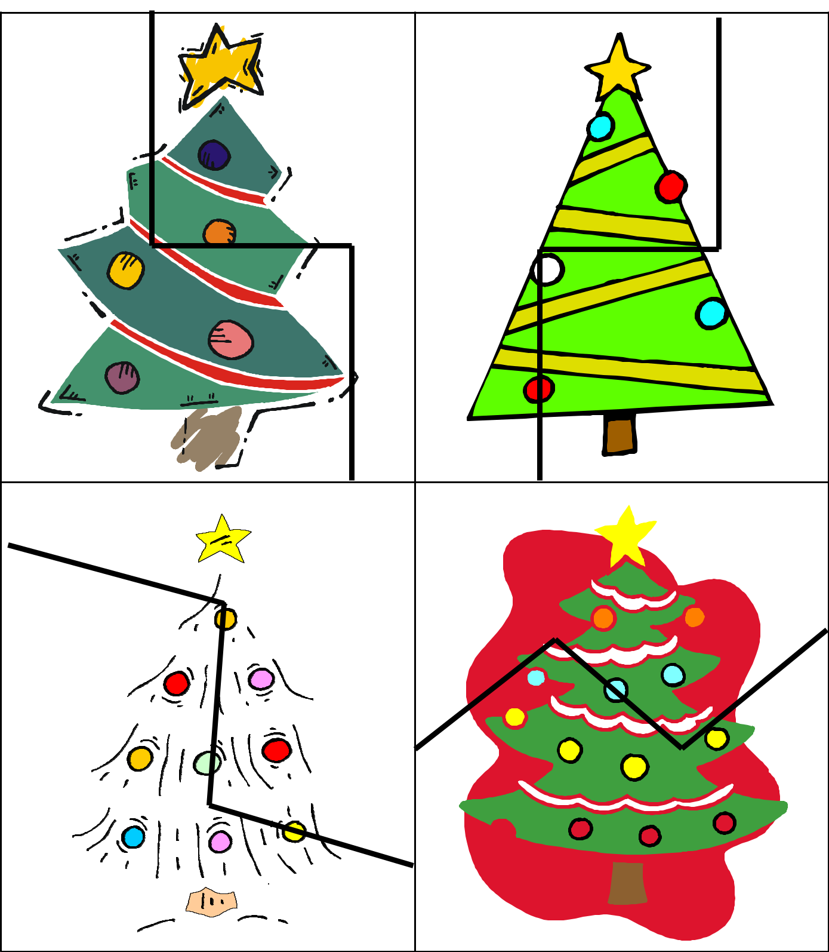

©2013 All Rights Reserved.
www.thisreadingmama.com

Cut it Out! Level 4- Shapes
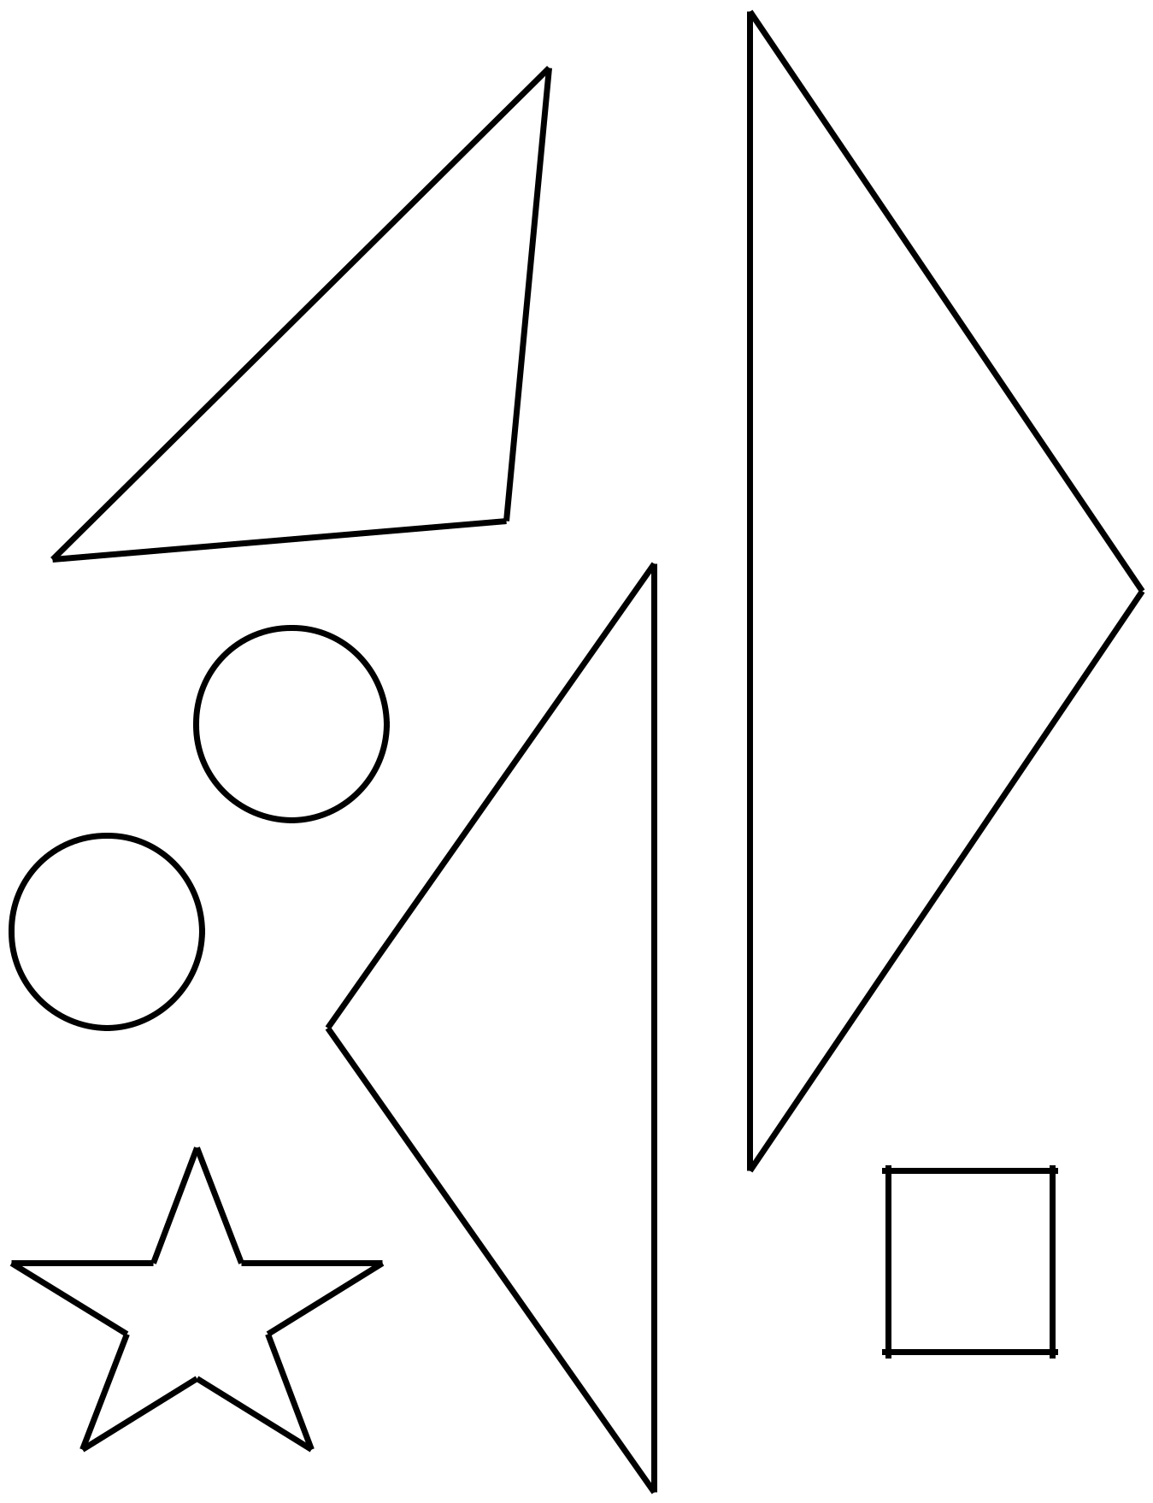

Cut out the Christmas tree shapes.

©2013 All Rights Reserved.
www.thisreadingmama.com

Cut it Out! Level 4- Shapes Christmas Tree Template
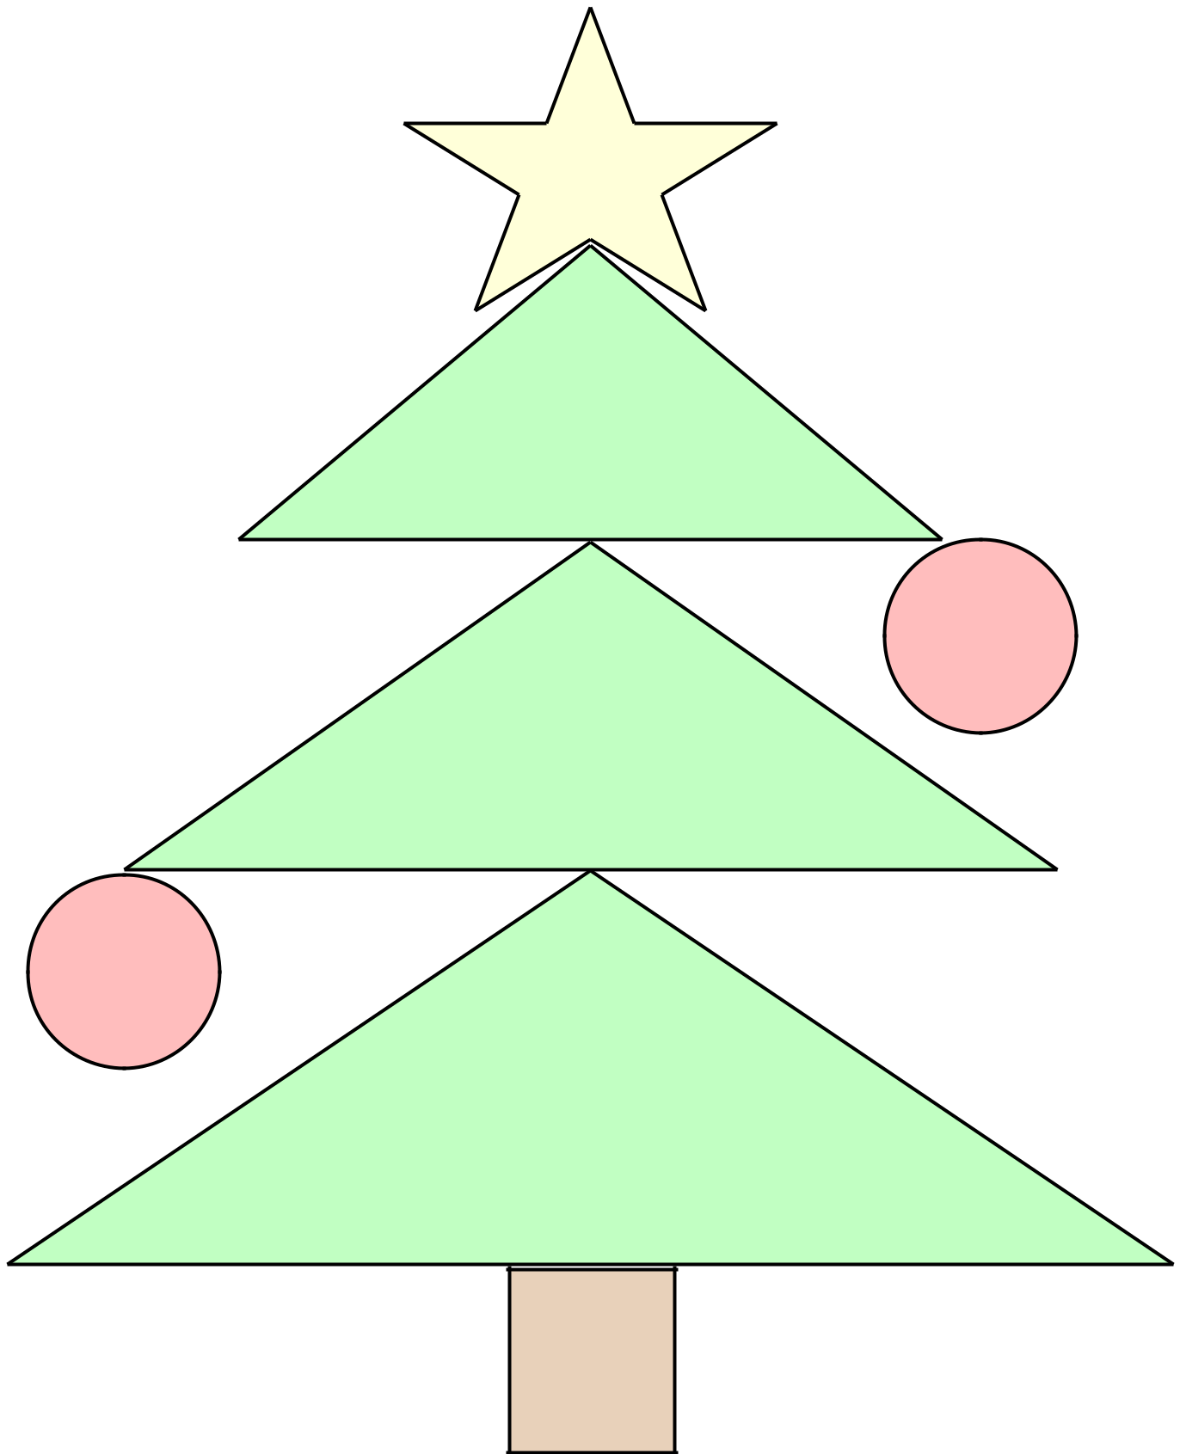

Glue shapes down to make a Christmas tree!

©2013 All Rights Reserved.
www.thisreadingmama.com

