Deck The Halls Christmas Tree Template

Original Design: Cori Dantini, Joy & Wonder fabric collection for Blend Fabrics

Adapted by: Allison Richter

This paper piecing template is in five rows with nine individual sections. Complete each individual paper pieced section (a – i). Connect all the individual sections to each other by row. Row 1: Sections a + b, Row 2: Sections c, d,e, f, Row 3: Section g, Row 4: Section h, Row 5: Section i. After the five rows are finished, sew together to complete the finished tree.
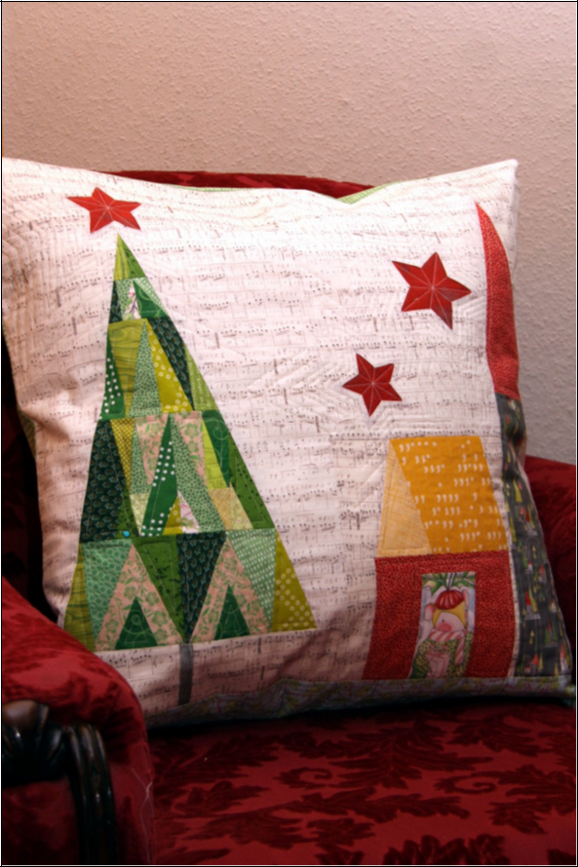

& %
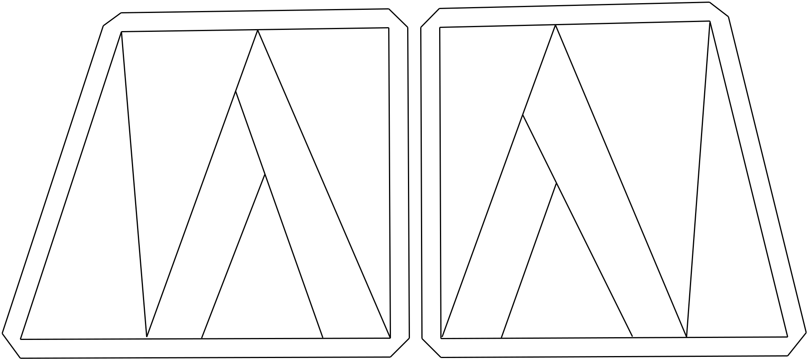

6S[§

 |  | § |  |  |  | §

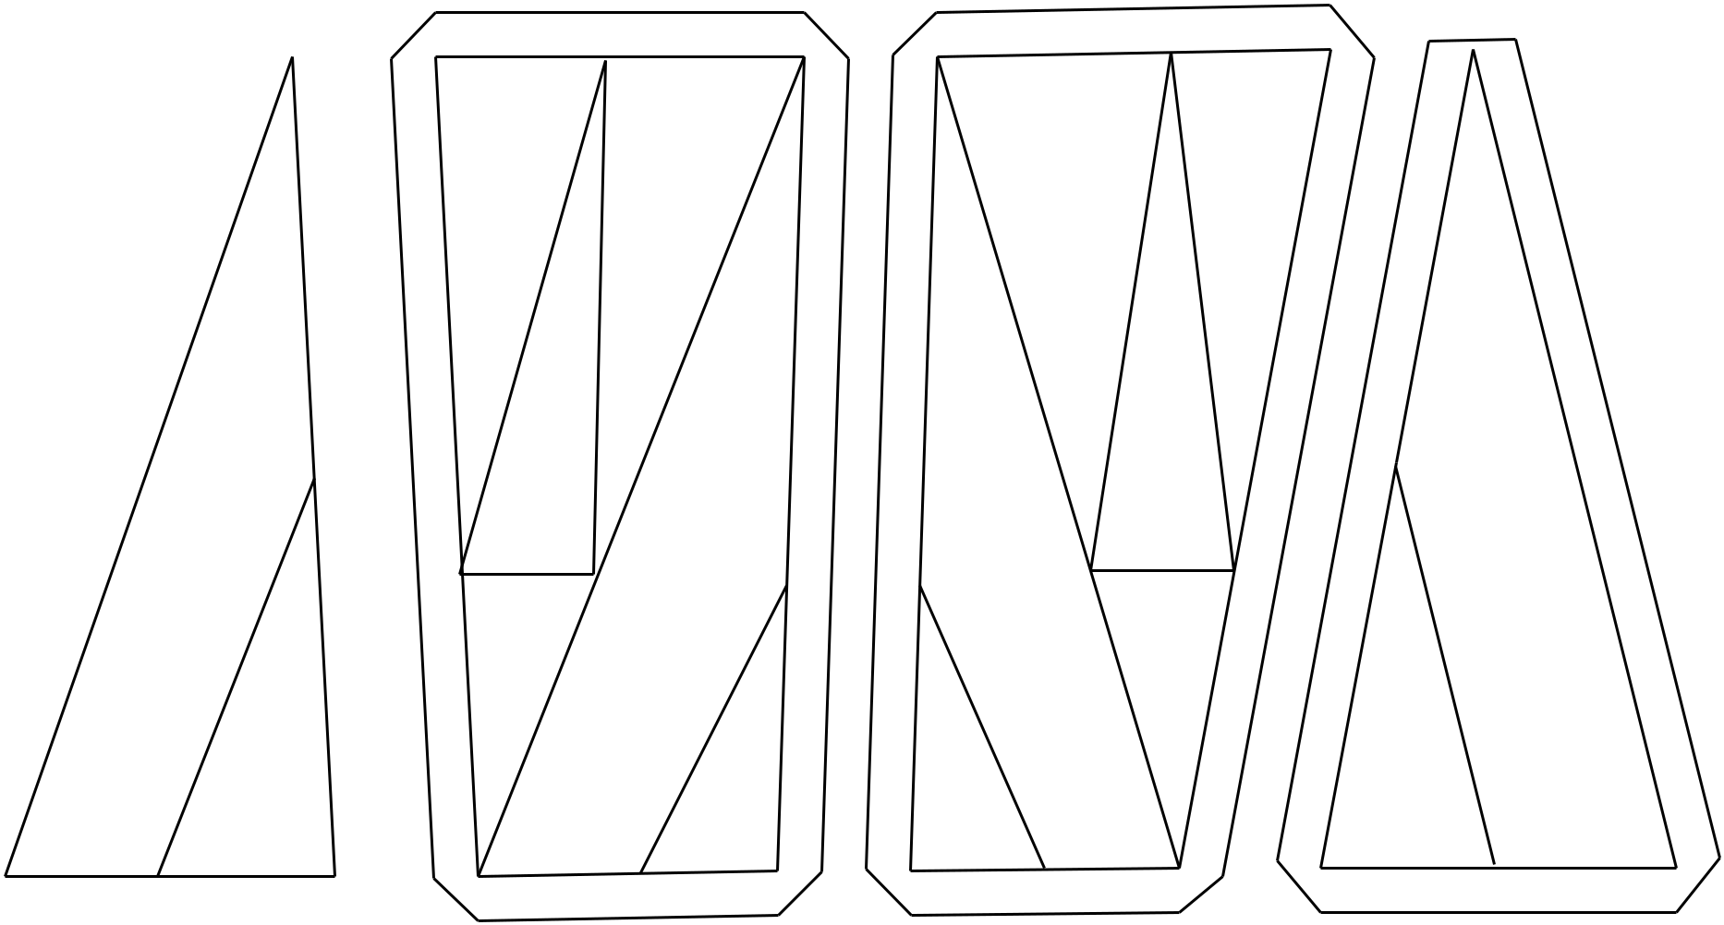

6S[

 | § |  | §

§

§

) * ( '

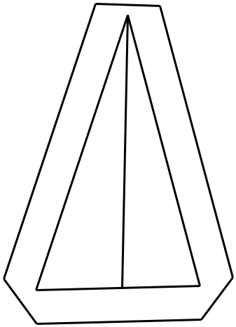

6S[

§

-
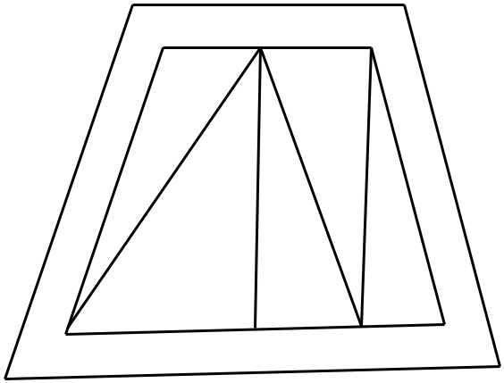

§

6S[

6S[

,






