

Game of Strength Board Game

Building your own board game is a fun and safe way to explore your own strengths and encourage your family, friends, and community to do the same!

Below are a couple steps to help you structure and personalize your own game:

- Use the templated version of the Sources Board Game (see below):

  - On the templated board, each square is correlated to a particular strength on the wheel. For Example: All yellow squares should be connected to Positive Friends, all orange squares connected to Family Support, etc.

- Create your own Board Game!

  - Personalize the templated board game with your own prompts or come up with your own design and ideas. If you are starting from scratch we recommend checking out Pinterest and Google for inspiration!

Sources of Strength Board Game Example
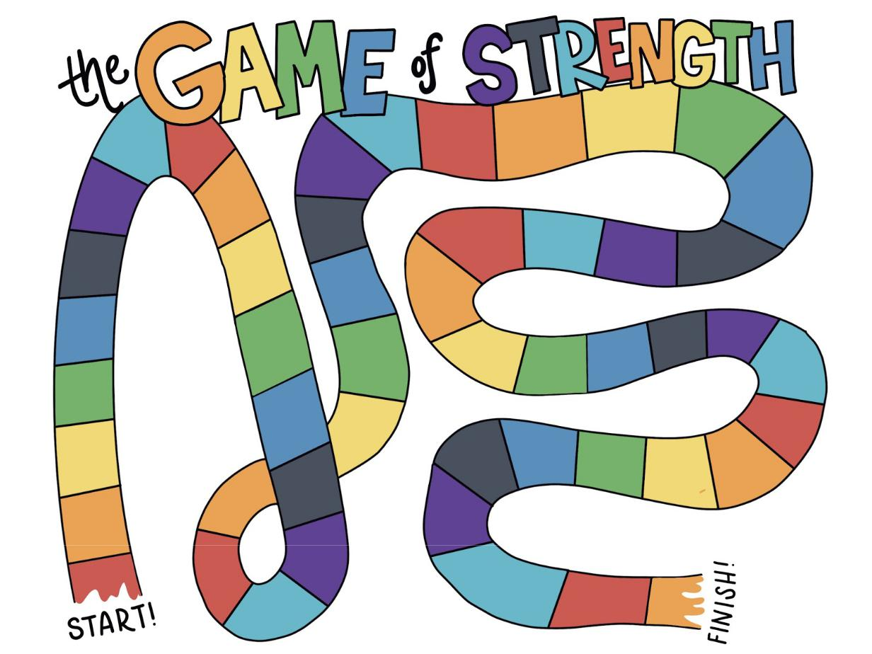

Sources of Strength Board Game Templated Prompts

Family | Positive | Mentors | Healthy | Generosity | Spirituality | Medical | Mental
Support | Friends |  | Activities |  |  | Access | Health
High five a | Name 3 | What do you | Run/walk/sk | Write a | Box | Find the | How do you
family | friends who | need in a | ip/slide a lap | thank you to | breathing. | nearest | make yourself
member | have the | mentor? | around the | someone. |  | first-aid kit or | feel calm?
(then wash | letter “S” in |  | house. |  |  | band-aid.
your hands.) | their name
Paint/Draw | Text a friend | Who has | Snap your | Do a chore | Spend 60 | What’s the fire | Describe your
a portrait of | “thank you!” | taught you | fingers or | around the | seconds in | escape route? | mood in 3
a family |  | something in | whistle for | house. | silence. |  | words.
member in |  | your life? | 60 seconds.
60 seconds.
Call a family | Draw a | Have you | Quick! 60 | How can you | Where is | Spend 60 | Tell us a joke!
member not | positive | been a | second | be generous | your favorite | seconds
in the room. | friend, other | mentor | talent show! | today? | place to go? | laughing (real
 | players | before? |  |  |  | or fake).
 | guess who | When?
 | you’ve
 | drawn.
Make a | What friend | Who’s the | Do an | When was | Who makes | Brush your | Take a
snack for a | did you talk | best fictional | interpretive | someone | you feel like | teeth! Full 2 | micro-nap
family | to last? | mentor? | dance based | generous to | you belong? | minutes! | until your
member. | What did | Books, | on the | you? |  |  | next turn.
 | you talk | movies, TV... | weather.
 | about?
Leave a | Randomly | Who is | Act out your | How can you | Sing/hum | Wipe down | Write a poem
secret note | select an | someone | favorite | be generous | until your | the 5 closest | about mental
for someone | Instagram | you look up | movie, other | without | next turn | doorknob.s | health.
in the house. | follower and | to? Why? | players | money?
 | DM them |  | guess the
 | something |  | title.
 | you love
 | about them.
Map out | Call a | Who’s your | Challenge a | Compliment | What are | Drink a whole | Who or what
your family | childhood | go-to team if | player and | another | you grateful | glass of water | helps when
tree. | friend and | you need | see who can | player. | for today? | (until your | you feel
 | reminisce on | help at home | hold plank |  |  | next turn). | stressed?
 | a fun | or at school? | longest.
 | childhood
 | memory.

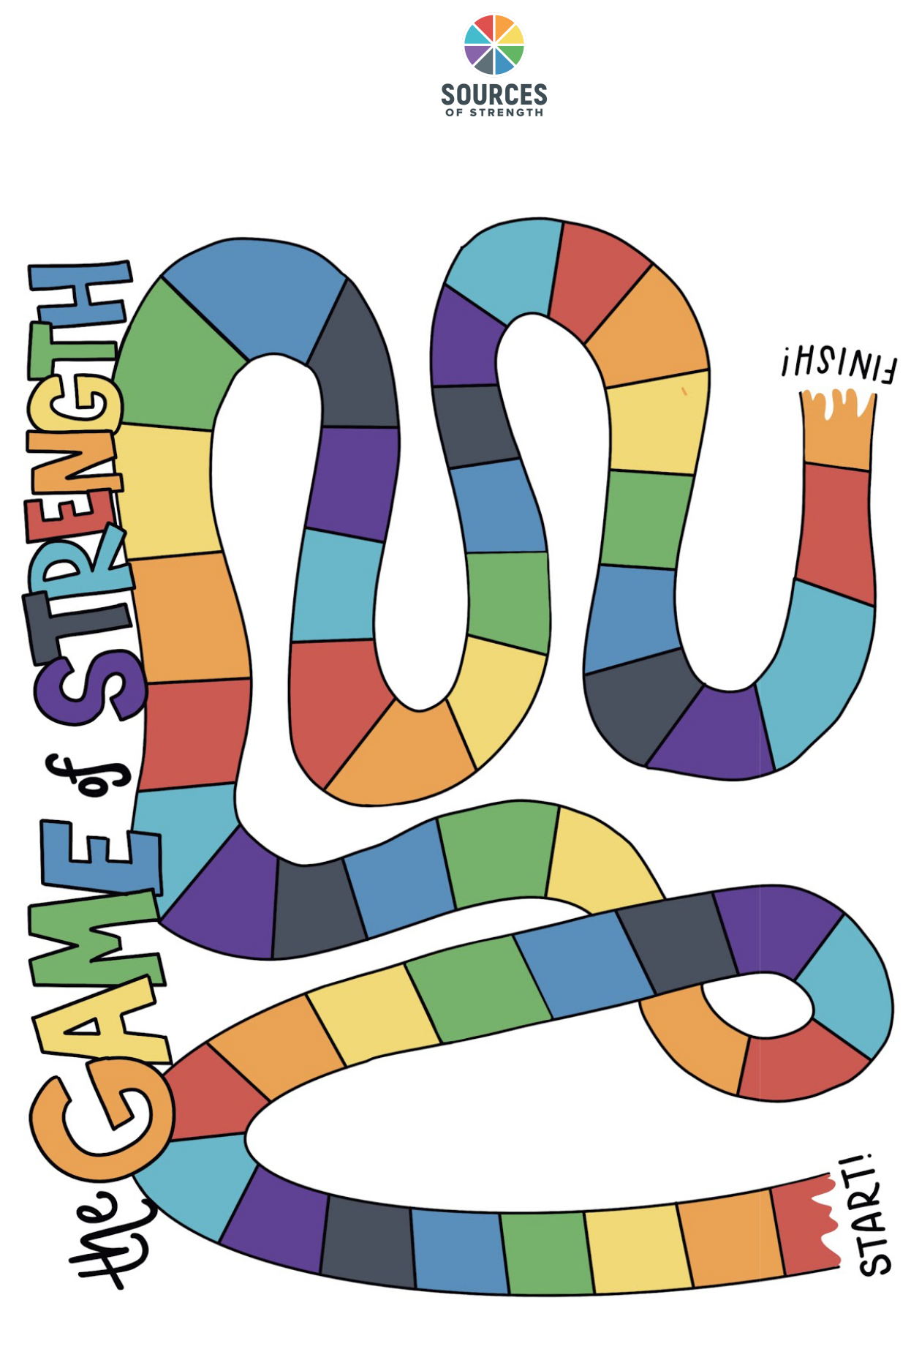

Sources of Strength Board Game Template (Printable)

Sources of Strength Board Game Templated Prompts

- Examples for filling in your board:

  - Purple (Spirituality):

    - Tell the person to your right something you love/appreciate about them

  - Red (Mental Health):

    - Journal how you are currently feeling until it is your turn again

  - Orange (Family Support):

    - Offer to do the dishes at your house

  - Yellow (Positive Friends):

    - Randomly select a friend on your contact list to call and say “hey” to

  - Green (Mentors):

    - Write a thank you note to someone you look up to, at the end call them to read it to them (you’d be surprised how happy this can make someone)

  - Blue (Healthy Activities):

    - Challenge anyone playing the game to a push up contest

  - Gray (Generosity):

    - Make an insta story telling a story of a time you witnessed an act of generosity (this will help shine light on good in the world)

NOTE: If after playing this board game, you feel it was fun and helpful as a source of strength, please share it with people around you. Also send our team pictures of you playing! We love pictures.

Love,

The Sources Team

