

Brownie Making Games

Badge Activity Plan 2

Purpose: When girls have earned this badge, they’ll know how to create new games and share them with others.

Planning Guides Link: Science, Technology, Engineering and Math

Fun Patch Link: Scavenger Hunt

Activity Plan Length: 1.5 hours

Resources

- This activity plan has been adapted from the Skill-Building Badge set for the It's Your Story—Tell It! Making Games Badge, which can be used for additional information and activities.

Activity #1: Going on a picnic

Badge Connection: Step 2—Make up a mystery game

Time Allotment: 10 minutes

Steps:

- First, sit in a circle. Inform the girls that you all are going on a picnic and everyone will need to bring something to share. Tell the girls that each person will take a turn introducing herself by saying her name and what she would like to bring to the picnic. After a girl states her name and what item she’d like to bring, you will tell each girl if she can or cannot bring the item.

- Tell the girls that there is a trick, or mystery, behind what each girl can or cannot bring to the picnic and it will be the girls’ job to figure out the mystery. For the first round, the trick is that the first letter of the item a girl chooses to bring to the picnic must start with the same letter as her first name.

- Start by giving an example of what you (the leader) are going to bring to the picnic.

- Give each girl a chance to say her name and what she would like to bring to the picnic, and tell her if she can or cannot bring that item. See if the girls catch on to to the trick. Tell the girls that if they figure out the mystery, they should keep it to themselves until everyone has figured it out.

- If girls struggle with figuring it out, try to make the clue more obvious.

- After the majority of girls have figured out the trick or solved the mystery, pick someone to share it aloud with the group.

- Ask the girls to think about other tricks they could use to play the same game. Test out the tricks by playing some additional rounds.

Activity #2: Bullfrog Game

Badge Connection: Step 2—Make up a mystery game

Time Allotment: 10 minutes

Steps:

- Tell the girls they are going to play a game called Bullfrog, which has three types of players: the
bullfrog (one person), the detective (one person) and the flies (everyone else). Tell the girls that this is a

mystery game where the detective will have to figure out the identity of the bullfrog.

- First, explain the job of each type of player:

  - The bullfrog sticks her tongue out at the flies sitting around the circle, trying to “eat” as many as she can. However, the bullfrog must be sneaky when sticking out her tongue, because she has to make sure the detective in the middle does not see her. The bullfrog’s goal is to “eat” all of the flies around the circle before the detective identifies her.

  - The flies must look around the circle for the bullfrog. If a fly sees the bullfrog stick her tongue out at her, she must stick her tongue out and lie down, as she has been “eaten” by the bullfrog. Once a fly sees the bullfrog and lies down, she is out for the rest of the game.

  - The detective turns around slowly in the middle of the circle, trying to find and catch the bullfrog in action. The detective has a maximum of three guesses to try and identify the bullfrog. The goal of the detective is to guess the identity of the bullfrog.

- Have the girls sit down in a circle, and choose one girl to be the detective. The detective will sit in the middle of the circle. The detective’s job is to try and figure out who the bullfrog is during the game.

- Tell the girls to close their eyes (including the detective in the middle) and that you will walk around the circle and choose one girl to be the bullfrog by tapping her on the top of the head. Tell the girls that only one girl will be tapped on the head, and if she is selected as the bullfrog, she shouldn’t tell anyone else. Anyone who is not tapped on the head is a fly.

- After selecting the bullfrog, tell everyone to open their eyes and begin the game. Remind the detective to turn slowly around in full circles in the middle, trying to find the bullfrog. Remind the bullfrog to stick her tongue out at the flies around the circle, but to not let the detective see her. Remind the flies to look around for the bullfrog, and if the bullfrog sticks out her tongue at them, to lie down and stick their tongues out.

- After playing a few rounds, ask the girls to think of a new twist that could be added to the game and try it out. Perhaps a different animal could be used (rather than a bullfrog and flies), or maybe there could be more than one bullfrog or detective.

Activity #3: Freeze Dance & Dancing Cows

Badge Connection: Step 3—Create a party game

Time Allotment: 10 minutes

Materials Needed:

- Music

Part I: Freeze Dance Steps:

- Tell the girls you are going to play a game called “Freeze Dance.” This is a game that can be done at birthday parties, at home with family or with people who enjoy dancing.
- When the music starts, everyone must dance and move around the room, performing any dance move or sequence of their choice. Everyone must keep dancing the entire time the music is playing.

- When you stop the music, everyone must freeze in the exact position they are in. This could mean their hands are up, one foot is off the ground, or they’re in the middle of a twirl! Girls are only allowed to do two things when they are frozen: breathe and blink.

- The last person to freeze and/or anyone who breaks their frozen position is eliminated from the game.

- Play the game a few times. For the first round, you will be in charge of starting and stopping the music. Later, you might consider having one of the girls be in charge of the music.

- After the girls get the hang of the game, ask them for specific rules to add to the game. For example, for one round, everyone might have to do a dance move that involves specific hand
motions. Other examples include:

- Performing a dance move that involves dancing only on one foot.

- Performing a dance move that involves moving around the room or one that involves standing in one spot the whole time.

Part II: Dancing Cow Game

Steps:

- This game has the exact same rules as “Freeze Dance;” however, when the music first starts, call out “Dancing Cow!” and tell the girls they must be dancing cows, dancing around the room in any manner they please. Tell the girls that when you stop the music and call out “Dead Cow!” everyone must lie on their backs with their arms and legs up in the air and freeze. The last person to reach this position is out.

- Each time the music restarts, you (the leader) will call out different kinds of cows the girls will become, and the girls will enact that type of cow. You can call out as many as you’d like as the music is playing in between freezes. Examples:

  - Surfing cow: Girls pretend they are surfing to the music

  - Spinning cow: Girls do some type of spinning movement to the music

  - Rockstar cow: Girls can play the guitar, pretend to sing or play the drums to the music

  - Skipping cow: Girls skip around the room to the music

- After playing the game once or twice, ask girls for examples of other kinds of cows and incorporate them into the next round.

- Tip: Allow the girls to be in charge of starting/stopping the music or giving out cow commands.

Activity #4: My Made-Up Board Game

Badge Connection: Step 3—Create a party game and Step 5—Create a whole new sport

Time Allotment: 20 minutes

Materials Needed:

- Board Game Template (one per small group)

- Board Game Spinners (one per small group)

- Sharpened pencils (one per small group)

- Large paper clips (one per small group)

- Writing and coloring utensils

- Board game objects, such as index cards, dice and game pieces (colored bits of paper or other place markers)

- Optional: Additional board game objects

Steps:

- Now that the girls have had a chance to experiment with a variety of games, they can become game masters and create their very own board games.

- Ask girls to brainstorm a variety of board games with which they are familiar, like Candy Land, Chutes and Ladders, and The Game of Life.

- Divide girls into small teams of three to four and distribute materials to each team, including game board spinners, game board templates, index cards, dice, and writing and coloring utensils.

- Each team is going to create a new board game. The basic rules of every board game are:

  - To begin play, all players place their game pieces at “Start.”

  - Players take turns rolling dice to move their game pieces forward along the designated path.
  - A player wins the game by reaching “Finish” first.

- A few of the rules will be chosen for teams at random by using the spinners. The spinners will determine the game theme and how game players move their pieces along the board. Each spinner also has a “team choice” space that lets the girls substitute their own rules for that category. More detailed instructions and examples are provided with the spinners.
- Have each team spin the spinners to get their rules (girls should take turns). To use the spinners:

    - Set the spinner card flat on a table.

    - Place a paper clip on top so that one of the looped ends goes around the center of the wheel on the spinner.

    - Hold a pencil straight up and down so the point is on the exact center of the wheel, with the paper clip free to move around it.

    - Give the free end of the paper clip a flick with your finger to get it to spin around the pencil.

- As girls are spinning for their team’s rules, you may need to give some examples to clarify some of the spinner choices.
- Set a time limit for teams to develop their games.
- If time allows, have each team meet with one other team. Teams should explain their games to each other and then try playing each other’s game. If you run out of time at this meeting, make plans to play at a future meeting.

Activity #5: Snack Chat

Badge Connection: Questions link to multiple badge steps

Time Allotment: 10 minutes

While enjoying a snack, here are some things for girls to discuss:

- What did you think of the picnic game we played today? Was it hard to catch on to the trick? What are some of your ideas for a different ‘trick’ we could use to play the same game?

- What did you think of the bullfrog game? What do you think could be added make this game different or more fun?

- What did you like most about the cow game? What didn’t you like as much? What rules would you add?

- If you had more time to develop your board games, what other rules/objects/themes would you add? How would those additions affect the way the game is played?

More to Explore

- Field Trip Ideas:

  - Attend a summer camp or recreational program to learn new games.

  - Visit a local park and plan your own scavenger hunt.

- Speaker Ideas:

  - Invite a camp counselor, physical education teacher or a children’s program facilitator to

your troop meeting to have some game-making fun.

- Host a troop “birthday party.” Plan some party games and invite another troop to come play them with you.

Customize It!: If your group wants to expand work on this badge or simply try different activities, go for it!

There are many ways to earn this award, including: Completing the activities as listed in the Brownie Skill-Building Badge set for It's Your Story—Tell It!, completing two of these activity plans, attending a council-sponsored event or customizing activities. Pick the one(s) that work best for your group. Girls will know they have earned the award if:
- They have explored and learned how to play a variety of games

- They have been responsible for devising the rules and goals for multiple games

- They have worked with others to revise and share games

Family Follow-Up Email

Use the email on the next page as a template to let families know what girls did at the meeting today. Feel free to add additional information, including:

- When and where you will be meeting next

- What activities you will do at the next meeting

- Family help or assistance that is needed

- Supplies or materials that girls will need to bring to the next meeting

- Reminders about important dates and upcoming activities


Hello Girl Scout Families:

We had a wonderful time today learning about games and earned the Making Games Badge.

We had fun:

- Learning and playing games where we had to solve a mystery.

- Learning and playing dance games that can be used at a party.

- Sharing our ideas to change and test new game rules.

- Creating our own board games.

Continue the fun at home:

- As a family, play a game that you already own or with which you are familiar. Let your Girl Scout change or create new rules to make the game more challenging, more fun or just different!

- Every week, help your Girl Scout hide a “mystery object” somewhere in your house and instruct your family members to try and find the object by the end of the week. Place the same object in a different hiding spot each week.

- Create a game with your Girl Scout using household objects and teach it to the rest of your family.

- Look through the Girl’s Guide to Girl Scouting with your Brownie to find other activities you can try at home.

Thank you for bringing your Brownie to Girl Scouts!

This activity plan was adapted from Girl Scouts River Valleys.
Board Game Spinner—Game Theme

- Based on the theme you spin, decide the object of your game. What is the point of the game? What do “Start” and “Finish” mean for game players? For example, if you spin “Fantasy and Imagination” you might decide that at the “Start” of the game, all game players are fairies who are lost in a forbidden forest. The point of the game is for the fairies to escape from the forbidden forest and find their way home. When they reach the “Finish” they have found their way out of the forest and back to their magical castle in the sky.

- When you decide the point of your game, think of an image to draw at the “Start” and “Finish” on your game board. Using the same example as above, you might draw a picture of a dark, scary-looking forest at the “Start” and a picture of a magical floating castle at the “Finish.”

- Next, decorate the rest of your game board with pictures and words that match the game theme. Using the same example, you might draw pictures of creatures of the forbidden forest along the path near the “Start” and pictures of sunshine, rainbows and other fairies along the path as you get closer to the “Finish.”
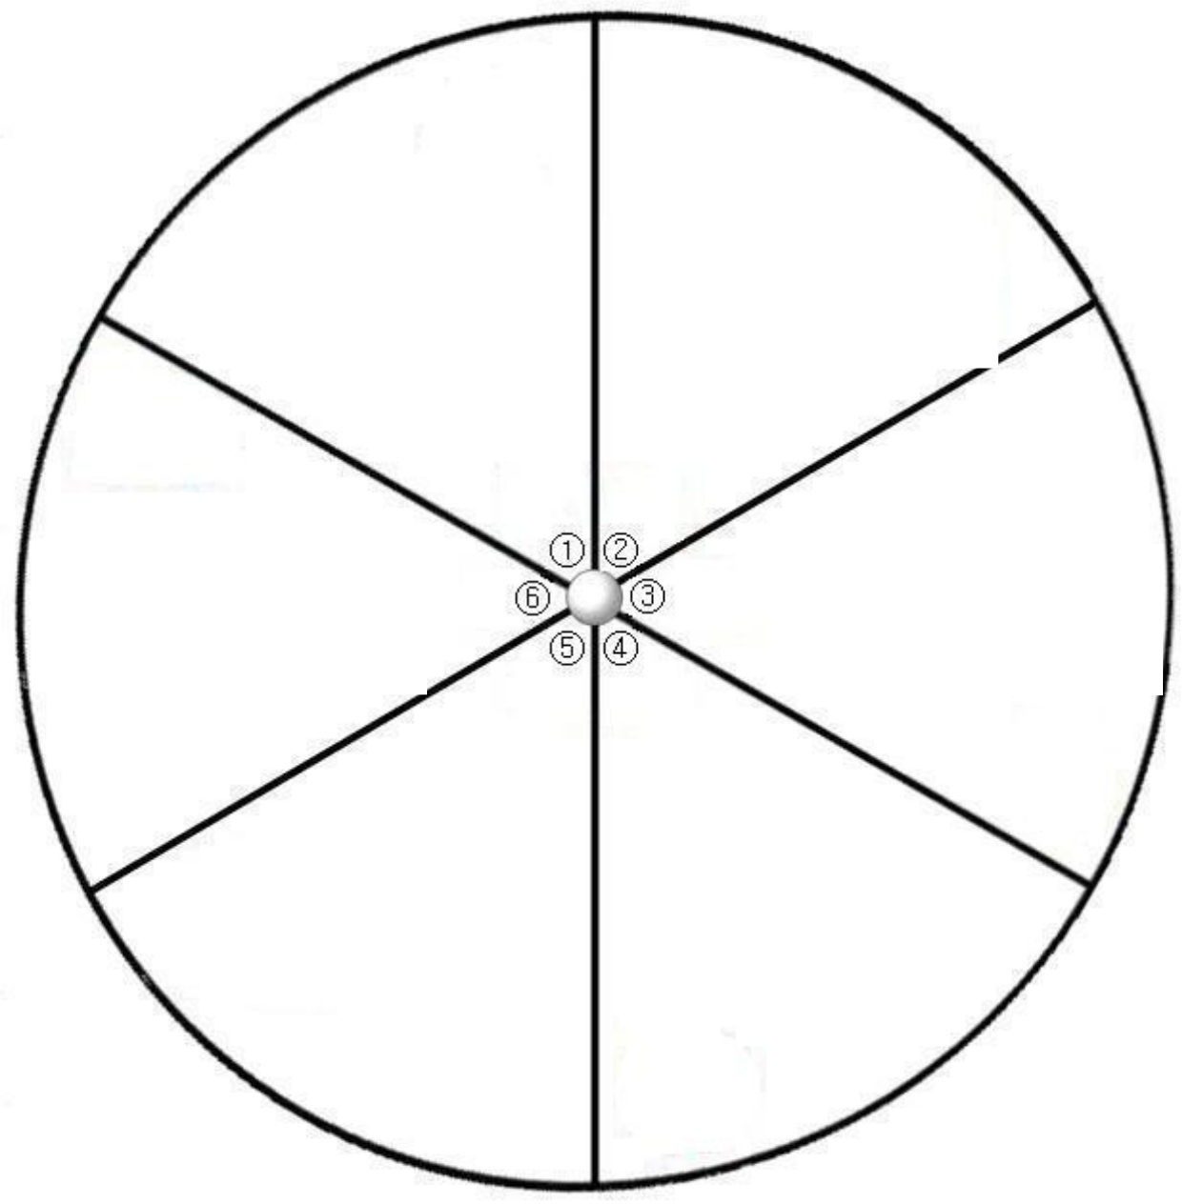

Animal Super

Adventures Sports

Team

Choice

World

Explorers

Fantasy & Imagination

Mystery &

Magic

Board Game Spinner—Game Cards

- Game players will roll dice to move their game pieces along the game board. They should move their game pieces forward as many spaces as the number they roll.

- To make things more interesting, select at least three spaces on your game board and write “Draw Card” in those spaces.

- Use the spinner below to create the index cards for players to draw if they land on one of those spaces

or come up with some of your own.

4. For example, if you spin “Jump Ahead Spaces” you should write that phrase on an index card and

fill in the blank with a number of your choosing. Spin a second time to create your second card, and so on.

- If you want, you can add a story to your card. Using the “Fantasy and Imagination” example from before, you might write the following on your card: “A magical unicorn gives you a ride towards the edge of the forbidden forest. Jump ahead three spaces.”
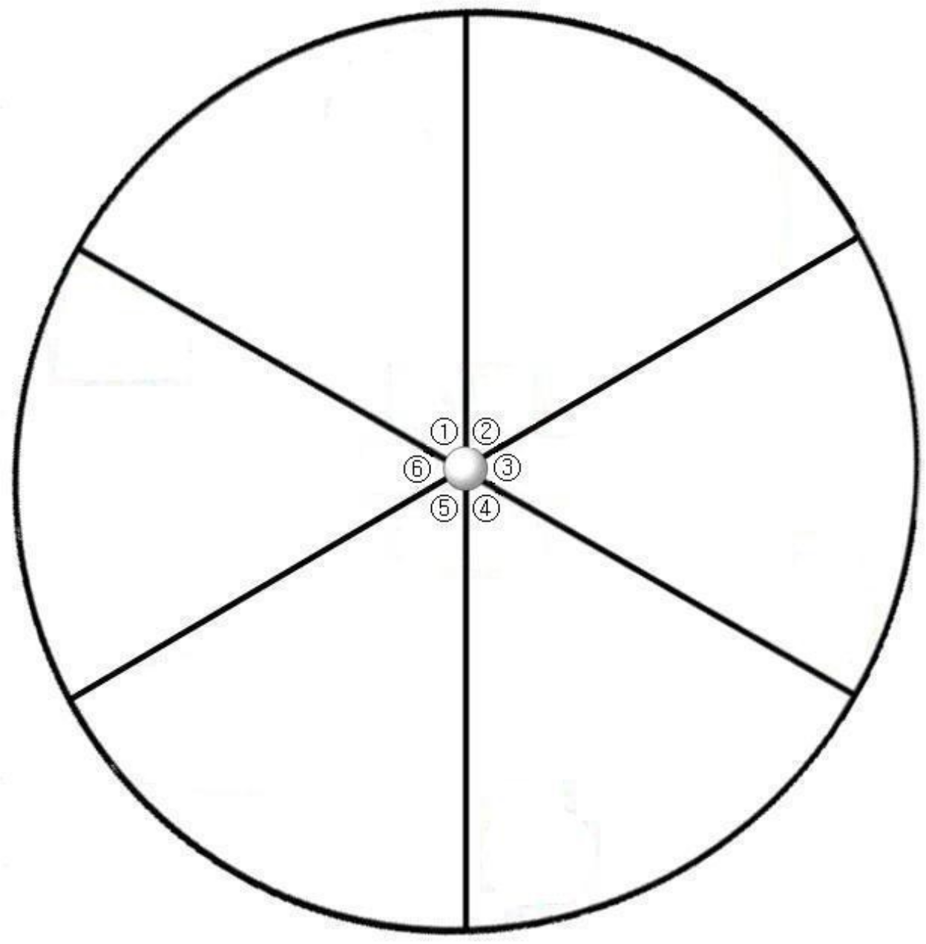

Jump ahead Move backward

_____ spaces _____ spaces

Team Choice Switch places with

an opponent

Take an extra Miss a turn

turn

©2013 Girl Scouts River 10

Board Game Spinner—Blank Template


