

Is Good Governance Possible in My Lifetime?

Looking Inward to Dismantle My Own Agenda

Catalyst Research Paper

Cordelia Snowdon, Jennifer Archer, Jeny Mathews-Thusoo, and Yasmin Dean


Mount Royal University is situated in an ancient and storied place within the hereditary lands of traditional territories of the Niitsitapi (Blackfoot) and the people of Treaty 7 which includes the Siksika, the Piikani, the Kainai, the Tsuut'ina, and the Îyârhe Nakoda. The City of Calgary is

also home to the Métis Nation (Region 3). It is a land steeped in ceremony and history that, until recently, was used and occupied exclusively by peoples indigenous to this place.

It is important to acknowledge the land and the legacy of colonization. Since this project is a part of a larger initiative to decolonize governance, recognizing where we are and where we have come from is especially significant. There has been the assumption that colonial ways of

being are the right way, with little regard for the practices of the people who have lived on this land for thousands of years. This is something we need to challenge.

Thank You

Thank you to the many individuals and organizations

that made this project possible. I am extremely grateful

for the hours others have given towards this project, and

the many talents that others have contributed in the

areas of governance, critical thinking, information design,

photography, and providing overall emotional support.

Catalyst Research Fellowship – Institute for

Community Prosperity at Mount Royal University

Barb Davies

James Stauch

Catalyst Research Fellows

Mount Royal University

Yasmin Dean

Resilient Calgary – The City of Calgary

Jeny Mathews-Thusoo

Jennifer Archer

Jennifer Isbister

Other Contributors

Nathan Lawley

Madison Snell

Peter Snowdon

Brian Jackson

Miriam Carey

Denin Lawley

Liv Brodowski

Community Conversation attendees

Cover photo by Benjamin Child from unsplash.com

Report design by Madison Snell @madison.sn

Community Conversation photos by Denin Lawley @denin.photo

3

Introduction

We assume that dominant decision-making models, such as the meeting conduct tool called Robert’s Rules of Order, are the best, the most equitable, or the most effective, but can we learn to be open to various forms of decision-making? Can we stop the feelings of frustration and disenfranchisement that are created for many community members, particularity those from equity-seeking communities, by the way we structure our meetings?

Rather than starting by disrupting the system, I looked at how to disrupt myself and find ways to bridge my identities as both a social worker and a policy maker. Using an autoethnographic process (Wisniewski, 2000; Adams, Holman Jones, & Ellis, 2015; Hughes & Pennington, 2018), I sought to define, dismantle, and decolonize my own understanding of governance and the Robert’s Rules of Order meeting framework. In order to answer the question, “Is Good Governance Possible in my Lifetime,” I needed to determine if it is possible to shift one’s own mindset and practice away from the norm. For the purpose of this paper, governance refers broadly to our decision-making frameworks used in a variety of settings, from organizational boards to community associations to government entities and others. Robert’s Rules represents one of the tools we use in the pursuit of good governance.

This research paper was created out of a partnership with the Institute for Community Prosperity and Resilient Calgary to address the community perception of institutions “not trusting the expertise and experiences that equity-seeking communities [bring] to the decision-making and leadership tables” (Resilient Calgary, 2019, p. 59). Equity-seeking communities are “groups of people who generally have less access to opportunities, resources, and systems of power because of their actual or perceived identity or identities” (p. 124). This project gave me the opportunity to go through a process of reflexivity to decolonize and dismantle my own agendas of what I thought I knew about governance, democracy, and macro-level decision-making. Understanding the current context and unpacking why we follow Robert’s Rules of Order as the dominant structure was my contribution to Resilient Calgary’s project of making governance more inclusive. Once we understand the framework that holds up the current mindset, we may be able to address the

structural problems that cause equity-seeking communities to feel distrusted and be disenfranchised with governance processes.

Social Context

At the start of this process, I was an advocate who thought I understood the issues of inclusion and governance best practices, but I knew it was possible to cause harm even with good intentions. If I assumed I knew the best policy solution, or at least the tools to use to arrive at the best solution, I was automatically ignoring the potential for better solutions to be found elsewhere.

I occur in the world as someone who experiences a certain amount of privilege and has had the support necessary to feel empowered. There has not been a need for me to disclose areas in which I experience less privilege in my participation in governance because they are not visible. However, these parts of me inevitably impact how I engage in decision-making processes. My childhood experiences, personal ideologies and values, and shifting identities over time all influence how I appear at the board table.

I have always wanted to be a social worker so I could “help people help themselves.” Since a young age, I have sought out avenues to achieve this. At nine years old, I ran for class Mayor (see Image 1). Though I did not win, the campaign platform still reflects my values today. 15 years later, after completing my Social Work Diploma, I ran a successful election to represent my peers as Vice-President Academic of the Students’ Association. I had returned to school as a policy studies student after working at a crisis centre and coming to know the systemic barriers experienced by clients. This shift in educational and occupational pursuits was to seek a better understanding of policy and fix barriers that prevented people from helping themselves. I later sought out tools to further shape my understanding, one of which was the course Being a Leader and the Effective Exercise of Leadership.

When I first became involved with committees and student governance, I was aware that there were challenges in making decisions, but had a tendency to explain difficulties in decision-making as being due to

4

the people at the table, not the rules of conduct. If only people were more student-friendly or understood the issues better, then they could come to the same conclusions I did and we could make smoother decisions. In the beginning, the content was new and there was limited training, so I looked for an area of governance I could become an expert in. Knowing the rules provided a sense of comfort; I may not be able to know the intricacies of each decision item, but knowing the rules – a skill many people struggled with – was something that I could latch on to. I became known for
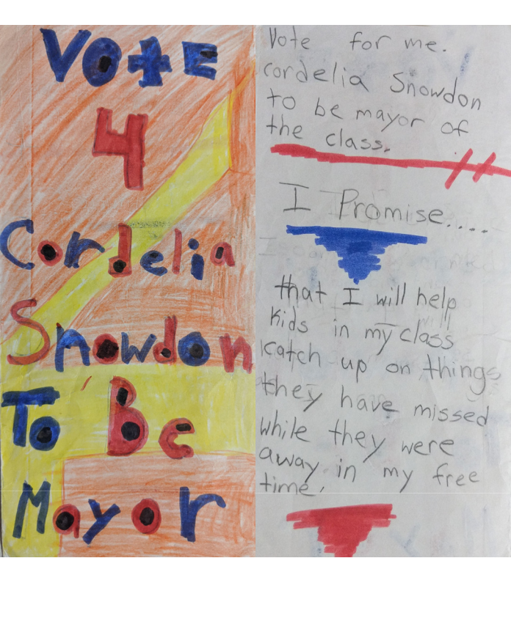

Image 1: Nine-year-old Cordelia’s campaign platform for class mayor.

Photos by Cordelia Snowdon.

carrying my pocket-version of Robert’s Rules and extras for the inevitable moment when someone got lost in the process of the meeting. Knowing the rules of the game allowed me to feel that I was qualified to be at the table. It allowed me to feel helpful.

Despite following a meeting framework that I was told was supposed to promote inclusion by giving everyone an opportunity to speak, members would disclose to me that they would often leave committee, council, or board meetings feeling frustrated and unheard. At

other times, members would identify gaps in representation and wonder if anyone had actually talked to the people impacted by the policy change. After being an advocate who was dedicated to following the rules, I had a negative experience while trying to do what I believed was right that caused me to feel betrayed by the governance process. I questioned if everything I had invested in learning about the rules and how to be an advocate had been wasted, and was wary about completing this research project when I learned it would be about improving governance.

I was not surprised to learn that the Resilient Calgary Report found that institutions struggle to show that they trust equity-seeking communities. My governance experience and the stories disclosed to me led me to believe that the issue of not feeling trusted by institu-tions is common among equity-seeking communities. Resilient Calgary (2019) made a commitment to the goal of “Institutions hav[ing] trusted and informed relation-ships with Calgary’s equity-seeking comm-unities” (p. 58), and this commitment encouraged me to pursue this topic despite my hesitation about being involved in governance again.

Process

An autoethnographic approach was selected for this project so I could look within to see if a mindset shift away from the norm is possible. If change is not possible for those who wish to do better, it seems unlikely that change will be initiated by those who think the model works well. There are claims that autoeth-nography is not “rigorous research” (Hughes & Pennington, 2017, p. 24), reflecting an assumption that alternative frameworks are not valid. Reading about the criticisms of autoethnography reaffirmed using this model to critique dominant governance methods because it deviates from dominant academic research methods. Additionally, since autoethnography was created as a “response to concerns about colonialism” (Adams, Holman Jones, & Ellis, 2015, p. 22), it felt like an appropriate choice to unpack my understanding of good governance.

Rather than interviewing equity-seeking community members and asking about their experience,

5

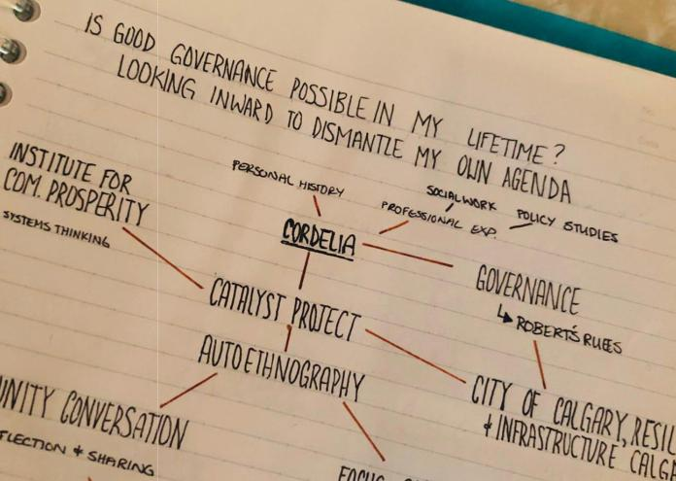

Image 2: Mind mapping the process of autoethnography as it relates to this project. Photo by Cordelia Snowdon.

contributing to the exploitative practice of using others as subjects and the distrust of researchers by taking something from community for their own benefit (Adams, Holman Jones, & Ellis, 2015, pp. 12-13), I chose to explore information that already existed while reflecting on my own history. I had limited experience in research, and did not wish to make equity-seeking community members re-share their stories. To guide my process of decolonizing my approach to gover-nance, I used Cull, Hancock, McKeown, Pidgeon, and Vedan’s (2018) definition of decolonization, which is “the process of deconstructing colonial ideologies of the superiority and privilege of Western thought and approaches” and, in particular, “weeding out settler biases or assumptions that have impacted Indigenous ways of being” (p. 7). Rather than imposing my way of being, which reflected colonial Western thought, I wanted to find a way to accept different ways of being and acting.

In addition to learning about Robert’s Rules, decolonization, and alternative models and perspectives on governance, I sought out a range of information from various perspectives and disciplines and reviewed resources that were recommended to me. This included content such as design thinking, feminist data visualization, intersectionality, economics, and gender disparity. I sought to include not just scholarly journals, but other forms of knowledge such as podcasts, videos, and guidebooks. Appendix A

includes some additional works consulted throughout my authoethnographic process. All of these resources and experiences contributed to my learning and reflection on my experiences through this autoeth-nography. I am grateful to the many individuals who had informal conversations with me to discuss what I found throughout the process.

Robert’s Rules Unpacked

Robert’s Rules of Order was developed in 1876 by Henry M. Robert (Robert, Honemann, & Balch, 2011, p. xxiii), who’s background as a “military man” and son of a Baptist preacher influenced the development of a manual with “systematic thoroughness” (Doyle, 1980,

- 6-7). Even though the processes described within Robert’s Rules are widely used, not much has been written about the author (Kelly, 2012, 6:35-6:48). Robert’s Rules was intended to provide a way to account for and address differences between participants (Doyle,

1980, p. 4), and to give “the least experienced member on the floor the skills necessary to participate fully in that meeting” (p. 18). The focus of Robert’s Rules is largely on running meetings with efficiency. According to Henry M. Robert himself, “It is difficult to find another branch of knowledge where a small amount of study produces such great results in increased efficiency”

(Robert, Honemann, & Balch, 2011, Epigraph).

The foundation of my unpacking of Robert’s Rules was questioning if our governance paradigms and rules serve us in the way that we think they do. Robert’s Rules was developed to “reconcil[e] ideals of democracy and efficiency” (Doyle, 1980, p. 4). Looking at literature and resources on Robert’s Rules, I found a range of opinions on its effectiveness. Despite the full version being 700 pages long, a Registered Parliamentarian stated “it’s not rocket science” (Turnbull, 2015, 8:10), yet another expert said that it “is not for the faint of heart” (Kelly, 2012, 5:37). Robert’s Rules has been described as intimidating and leading to nitpicking (Turnbull, 2015, 4:35-4:59) and “easy to mock” (Kelly, 2012, 1:08). Others have claimed that its “oddity effectively silences officeholders” (Reed, 1990, p. 139), that it is “convoluted political warfare” (Susskind, 2006, p. 355), and even if people are at the table, Robert’s Rules makes it so they still have “no voice” (Reed, 1990, p. 139).

6

The consensus from these widely varying assessments of Robert’s Rules is that its effectiveness is largely subjective. As the format of a meeting is the way by which we legitimize our decision-making as a fair process, the aim should be to ensure the model enhances decisions. Yet the use of Robert’s Rules persists. As Susskind (2006) asked, “why should we prize an outcome that displeases up to 49 percent of our community?” (p. 352). It appears Robert’s Rules persists because the people who hold power want it to, with little regard for how it impacts Indigenous ways of being or other decision-making frameworks.

Personally, being seen as an expert on Robert’s Rules gave me credibility and power, which is a noted criticism of Robert’s Rules (Susskind and Cruikshank, 2006, p. 13; Gunderman, 2017, p. 1052). Since this decision-making structure usually created outcomes I accepted or at least could live with, I saw no need to challenge the model until embarking on this project. However, I must be critical if I am going to be inclusive. In addition to the possibility of legal and other recourse options available to those who have been unjustly treated by the majority (Susskind and Cruikshank, 2006, p. 11), I would argue that assessing the effect of dominant structures is simply the right thing to do. As Curtin, Stewart, and Cole (2015) noted: “the onus for change and for being aware of inequalities should not fall to marginalized peoples but to everyone” (p. 525).

Reflections

Both of my professional domains of social work and policy studies influence how I understand Robert’s Rules as the dominant theory, and my experience from the Being a Leader course gave me a way to reconcile the two rather than limiting myself to a policy development or social work theory. Being a Leader focuses on “Being a Person of Integrity” (Erhard & Jensen, 2018, slide 43) which includes not only owning my word, but also knowing “What You Stand For” (Erhard & Jensen, 2018, slide 415). This course made me realize that if I say I am an advocate for access-ibility and inclusion, that advocacy needs to be woven throughout my being, not just something I talk about in certain settings.

When deciding on which tools to incorporate into our governance model, it is intuitive to look for a readily available solution, and not dig deeper by evaluating all options. If Robert’s Rules is available with dozens of versions and manuals easily accessible, it is easy to defer to that framework. The rules are intended to have ease of access, as the Robert’s Rules of Order: Newly Revised 11th Edition claimed, “in only twenty minutes, the average reader can learn the bare essentials, and with about an hour’s reading can cover all the basics” (Robert, Honemann, & Balch, 2011, p. xxiv). Previously, I accepted this as a reasonable expectation for participation, but now doubt that there is a ‘right’ size of manual that will lead to good governance.

Questioning the model is not obvious for decision-makers who are time-limited and potentially volun-teering in governance roles part-time, even though assuming the most popular model is the best is false. I had been so focused on learning the rules that I did not question whether the meeting could be structured to be more inclusive. I recognize a significant amount of cognitive dissonance in my advocacy work prior to this project. I pushed for course materials to be free, or at least affordable, to students and challenged the model of lecturing at students with a traditional textbook, but pushed for adherence to Robert’s Rules as the best way to run a meeting. Over the course of this project, I have had to reconcile that advocating for accessibility is not limited to one or a few settings.

While considering how to improve my practices, I realized that when faced with alternatives or criticisms of Robert’s Rules, many defend it without question. In fact, there were claims that the use of Robert’s Rules was the only possible choice. If I proposed alternative models, especially consensus-based decision-making, they were quickly discredited. Interestingly, proponents of consensus-based models can be just as critical of Robert’s Rules. This is not to suggest that consensus is the best alternative to Robert’s Rules as a full analysis of all the alternative models is beyond the scope of this paper. While the possibility of finding the ‘right’ model to create good governance came up throughout my research, as I reflected on my experiences I increasingly thought that there would be no solution.

7

In preparing a presentation on this research project, I used an analogy of board games as board meetings and ‘house rules.’ Like with board games, decision-makers can follow official rules or customize their own version to suit their needs. Everyone comes to a board game night with their own expectations of what rules will be followed, but are generally willing to consider playing by a set of house rules. Using this analogy, I sought out a way to challenge the assumption that the dominant rules were as efficient or inclusive as people expected them to be. This helped open up the possibility that there could be other ways to pursue good governance.

My team and I designed an event that we hoped would reflect my findings and determine how we might spread the impact to others. The Community Conversation, “Unpacking Governance and Decision-Making,” included two parts: a mock city council meeting and a debrief. The meeting of the fictional City Council of Uckbhi recreated my experiences and ensured participants had a shared governance experience and did not have to disclose their own, possibly confidential, stories. We hoped that combining all the frustrating, confusing, or strange examples together into one shared experience might lead participants to question what happens when we assume we are all playing by the same rules. I was also personally curious to see how others handled the challenging situations I had been put in, and the event provided an opportunity for me to unpack my assumptions about how I thought it would unfold.

Trying to transform my autoethnography into something that could be a shared learning opportunity required me to reframe my experiences and better understand how to invite others into a self-reflection process. The Community Conversation was designed intentionally to have the first half be structured and rigid, as Robert’s Rules tends to be, and the second half was more flexible with the room rearranged. Although I had intended to prepare in advance for many possible outcomes and ensure the event ran smoothly, I found additional areas I could work on to make this experience more inclusive. The city council meeting was intended to be ended abruptly, with the motion called or a motion to adjourn, but I had not anticipated how to wrap up the less formal debrief in a holistic way. I had assumed that based on my social work experience I would be able to naturally

Image 3: Structured seating arrangement for the Community Conversation.
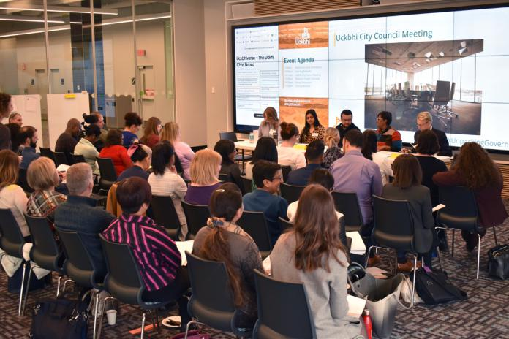
Photo by Denin Lawley.
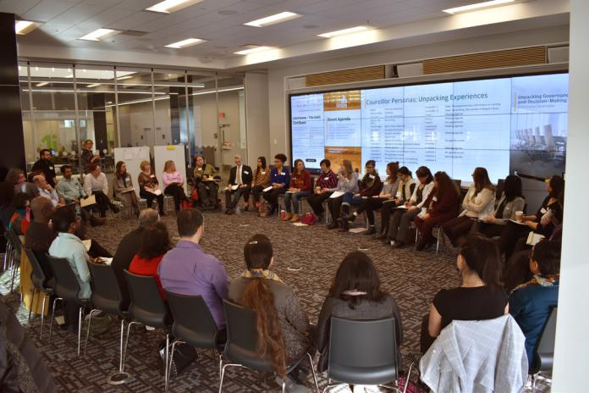

Image 4: Flexible seating arrangement for the Community Conversation.

Photo by Denin Lawley.

close the discussion, but I felt panic in the moment realizing that, despite my planning, I had not established the expectations about how we would wrap up and became focused on avoiding the abrupt end we had under Robert’s Rules. I gently notified the group that we were at the end of our time, but that we could add a few comments and people may leave as needed. This reiterated my conclusion that it was not about having the right rules because there were many ways it could have ended. It was more important to have a shared understanding of expectations.

From the Community Conversation, and other learning opportunities since starting this project, I realized that while there are benefits to Robert’s Rules, there are

8

significant factors that influence how decision-making is inclusive that are not contained in its 700 pages. Robert’s Rules does not address “volume, tone of voice, posture, and many other tools of dominance” (Gunder-man, 2017, p. 1052), or what happens before meetings (Susskind & Cruickshank, 2006, p. 10), or how members will feel about the decisions that were made. Relying on Robert’s Rules, or any manual for good governance, can make these relational pieces invisible. I became so focused on following the rules that I sometimes forgot the human part of decision-making. I assumed that improving governance was about bringing diverse perspectives to the table, and getting people to partic-ipate in the existing structures. Expecting people to conform and follow a colonized decision-making process without question will only perpetuate problems of inequality and a lack of trust. Just as the process of autoethnography represents a research method that “acknowledges and accommodates mess and chaos, uncertainty and emotion” (Adams, Holman,

- Ellis, 2015, p. 9), so too does our approach to the rules of governance need to reflect the complexity of human nature.

Since beginning this process eight months ago, and developing the visual representation of my journey (Appendix B), I have started noticing that governance is everywhere. Readings for professional development or entrepreneurship classes had references to expectations about rules and mindset shifts. Conversations seemingly unrelated to governance sparked realizations about how we assume decisions should be made. It has also impacted my life beyond my involvement in governance or high-level decision-making. My experiences on a micro-level have also been positively impacted because now I work to reflect beyond my first assumption of why something is a certain way.

Conclusion

The question “Is Good Governance Possible in my Lifetime?” is much more difficult to answer than I initially anticipated. While I believe it is possible, I have identified many disclaimers that accompany my response. Good governance is possible in my lifetime if I am willing to remain committed when I am challenged and if I have a strong support system to pull me

through the toughest days. Admitting where I have been wrong about governance and establishing rules, even when only admitting it to myself, is vulnerable work. Before I committed to this approach, I talked to the people I trust to help me identify where I can improve while still offering support. This was a vital part of how I was able to complete this project.

There are already many examples that demonstrate inclusive governance and alternatives to the dominant way of being. While examining alternatives and determining the best one was beyond what I could achieve in this project, and seems unlikely based on my findings, we can find inspiration and learn from those around us. By looking at a variety of sources including Indigenous governance practices (Honoring Nations, 2010), the decolonizing of post-secondary institutions and classrooms (Cull et al., 2018; Mullings, 2009), and a restaurant run completely cooperatively (Hunt, 2019), I have discovered that different can still be good or even better.

While this project included more than 160 hours of research and meetings, it is still just the beginning for me. I will continue to consult and engage in further research. Having started this work, I hope to add to my knowledge by speaking with Elders and other knowledge-keepers to continue to shift my expectations of what good governance looks like. I also plan to engage with both experts and the people who have too often been excluded from current governance processes.

There is no shortage of opportunities to engage in this practice of shifting our mindset to be more inclusive. Every meeting and any decision can present oppor-tunities to be more inclusive if we look for them. Rather than accepting that things have to be a specific way, I have realized that I am capable of both challenging the norm and challenging myself to be okay when process deviates from the norm. The hardest part of this work has been stopping myself from thinking something is wrong when it is different. Accepting that there is not one set of rules that are right has been a challenge, but it is the only way I will be able to make progress in making my approach to governance inclusive and accessible.

9

References

Adams, T., Holman Jones, S., & Ellis, C. (2015). Autoethnography. New York, New York: Oxford University Press. Retrieved from https://ebook central.proquest.com

Curtin, N., Stewart, A. J., & Cole, E. R. (2015). Challenging the Status Quo: The Role of Intersectional Awareness in Activism for Social Change and Pro-Social Intergroup Attitudes. Psychology of Women Quarterly, 39(4), 512– 529. https://doi.org/10.1177 /0361684315580439

Cull, I., Hancock, R. A., McKeown, S., Pidgeon, M., and Vedan, A. (2018). Pulling Together: A Guide for Front-Line Staff, Student Services, and Advisors. Victoria, BC: BCcampus. https://opentextbc.ca/ indigenizationfrontlineworkers/

Doyle, D. H. (1980). Rules of Order: Henry Martyn Robert and the Popularization of American Parliamentary Law. American Quarterly, 32(1), 3–18.

Erhard, W., & Jensen, M., Zaffron, S. & Echeverria, J. (2019). Being a leader and the effective exercise of leadership: An ontological/phenomenological model [PowerPoint slides].

Gunderman, R. B. (2017). Learning the Limits of Robert’s Rules. Academic Radiology, 24(8), 1052–1053. https://doi. org/10.1016/j.acra.2017.04.009

Honoring Nations. (2010). Constitutions and fundamental government reform: Lessons in excellence in the governance of American Indian Nations. Retrieved from https://hpaied.org/sites/default/files/publications/ web%20fundamental%20gov%20reform%20hn.pdf

Hughes, S., & Pennington, J. (2017). Autoethnography introduction and overview. In S. Hughes, & J. Pennington, (Eds.), Autoethnography: Process, product, and possibility for critical social research (pp. 4-33). Thousand Oaks, CA: SAGE Publications, Inc. https://doi. org /10.4135/9781483398594

Hunt, S. (2019, June 19) New Calgary restaurant where everyone you meet is the owner. CBC News. Retrieved from https://www.cbc.ca/

Kelly, P. (2012, December 11). Documents that changed the world: ‘Robert’s Rules of Order’. [Audio podcast]. Retrieved from https://ischool.uw.edu/podcasts/dtctw/ roberts -rules-order

Mullings, D.V. (2019, May). Dr. Delores V. Mullings: Decolonizing post-secondary classrooms to create room for rockstar learners [Video file]. Retrieved from https:// www.ted.com/talks/dr_delores_v_mullings_ decolonizing_post_secondary_classrooms_to_create_ room_for_rockstar_learners

Reed, R. R. (1990). Are Robert’s Rules of Order counterrevolutionary?: Rhetoric and the reconstruction of Portuguese politics.” Anthropological Quarterly, 63(3), 134-144. https://doi.org/10.2307/3317405

Resilient Calgary, City of Calgary. Resilient Calgary Strategy. Approved by Council on June 17, 2019. https://www.calgary.ca/CS/Documents/ResilientCalgary /ResilienceStrategyBooklet.PDF

Robert, H. M., III, Honemann, D. H., & Balch, T. J. (2011).

Robert’s rules of order newly revised (11th ed.).

Philadelphia, PA: Perseus Books.

Susskind, L., & Cruikshank, J. (2006). Breaking Robert’s rules: the new way to run your meeting, build consensus, and get results. Oxford, England: Oxford University Press.

Susskind, L. (2006). Breaking Robert’s Rules.

Negotiation Journal, 22(3). 351-355.

Turnbull, M. (2015, December 15). From our vantage point: What’s the Deal with Robert’s Rules? [Audio podcast]. Retrieved from https://www.thevantagepoint. ca/blog/our -vantage-point-episode-8-whats-deal-roberts-rules-order

Wisniewski, R. (2000). The averted gaze. Anthropology and Education Quarterly, 31(1), 5. https://doi-org. libproxy.mtroyal.ca/10.1525/aeq.2000.31.1.5

10

Appendix A – Recommended Resources


Videos

Mullings, D.V. (2019, May). Dr. Delores V. Mullings: Decolonizing post-secondary classrooms to create room for rockstar learners [Video file]. Retrieved from https://www.ted.com/talks/dr_delores_v_mullings_ decolonizing_post_secondary_classrooms_to_create_room_for_rockstar_learners

Labelle, R. S. (1999). Kanata: Legacy of the Children of Aataentsic [Motion picture]. https://www.nfb.ca/film/ kanata_legacy_of_the_children/


Podcasts

Turnbull, M. (2015, December 15). From our vantage point: What’s the Deal with Robert’s Rules? [Audio podcast]. Retrieved from https://www.thevantagepoint.ca/blog/our- vantage-point-episode-8-whats-deal-roberts-rules-order


Books

Adams, T., Holman Jones, S., & Ellis, C. (2015). Autoethnography. New York, New York: Oxford University Press.

Susskind, L., & Cruikshank, J. (2006). Breaking Robert’s rules: The new way to run your meeting,

build consensus, and get results. Oxford, England: Oxford University Press.


Articles and Other Readings

Ali, D. (2017). Safe Spaces and Brave Spaces: Historical Context and Recommendations for Student Affairs Professionals. Research and Policy Institute, National Association of Student Personnel Administrators. Retrieved from https://www.naspa.org/files/dmfile/Policy_and_Practice_No_2_Safe_Brave_Spaces.pdf

Harvard Project on American Indian Economic Development. (n.d.). Sovereignty matters. https://hpaied.org/

Hunt, S. (2019, June 19) New Calgary restaurant where everyone you meet is the owner. CBC News. Retrieved from https://www.cbc.ca/

Institute for the Future (2013). Governance Futures Lab: An Inventor's Toolkit. http://www.iftf.org/uploads/ media/GovFuturesLab_Toolkit.pdf

Johnson, A., Papi-Thornton, D., and Stauch, J. (2019). Student guide to mapping a system. Skoll Centre

for Social Entrepreneurship, Saïd Business School, University of Oxford. http://mapthesystem.sbs.ox.ac. uk/wp-content/uploads/2019/02/Student-Guide-to-Mapping-a-System-1.pdf

Guppy, N., & Luongo, N. (2015). The rise and stall of Canada’s gender-equity revolution. Canadian Review of Sociology, 52(3), 241-265. https://dx.doi.org/10.1111/cars.12076

Walby, S. (2018). The concept of inclusive economic growth. Soundings, 68, 138–154.

11

Appendix B – Discovery Snapshot

Is Good Governance Possible in My Lifetime?

Looking Inward to Dismantle My Own Agenda

Discovery Snapshot

Cordelia Snowdon, Jennifer Archer, Jeny Mathews-Thusoo, and Yasmin Dean

For my Catalyst fellowship project, I was partnered with members of the Resilient Calgary team at The City of Calgary. Under their guidance and assistance from my MRU faculty mentor, I set out to unpack my understanding of governance and democracy to see
if these systems of decision-making serve us in the way we think we do. This journey started long before the fellowship program. I have been involved in governance for many years. I used the classic board game of Snakes and Ladders as a visual reference to explain my journey. Ladders represent moments in my life where I felt uplifted by my academic and personal journey, and snakes represent moments where I encountered external setbacks or moments of personal pause and reflection. Included in this document is a do-it-yourself activity where one can illustrate their own professional journey as a Snakes and Ladders game board. As I move forward in my professional journey, I will continue to unpack and decolonize my understanding of governance, as it is a path with no end.


12

Looking Inward:

My Governance Journey

 |  | Represents an |  |  |  |  | Represents an
 |  | experience that |  |  |  |  | experience that
 |  | boosted me forward |  |  |  |  | provided me with a
 |  | and helped make my |  |  |  |  | moment of necessary
 |  | governance practice |  |  |  |  | reflection on what
 |  | more inclusive. |  |  |  |  | had come before.
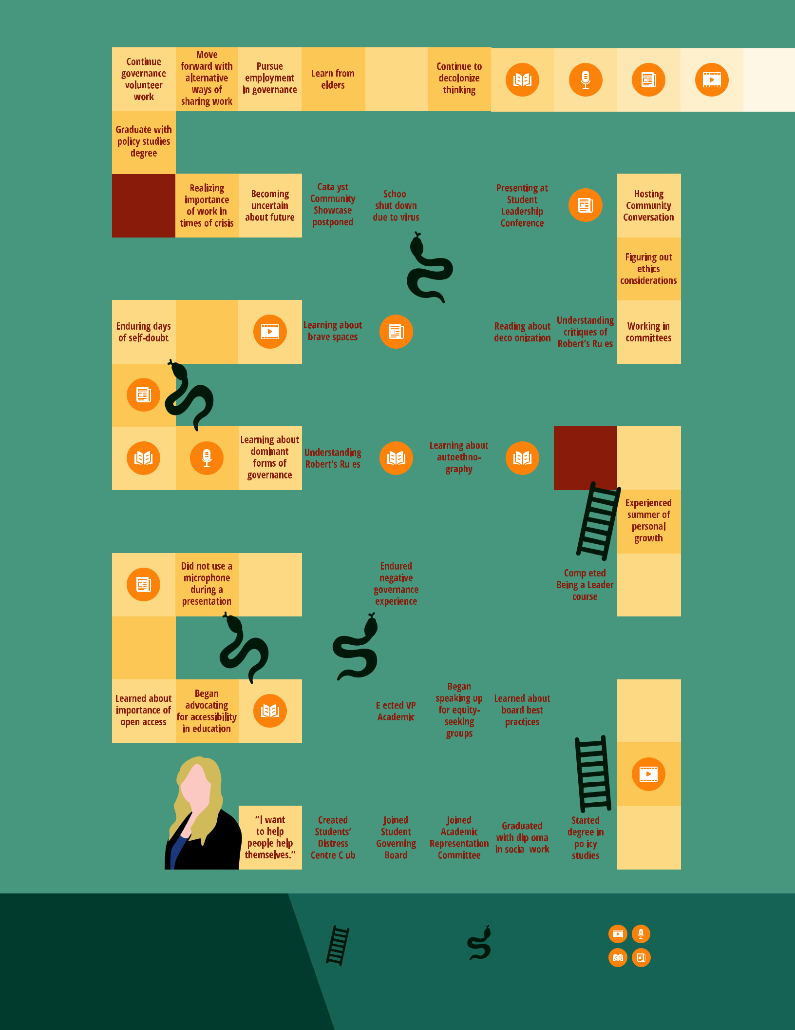

Represents key resources that influenced my journey. You can find these resources13 in Appendix A.
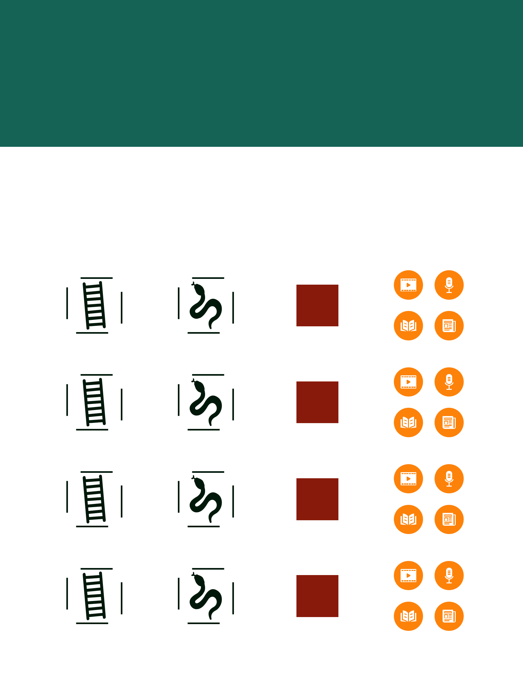
What does your journey look like?

Use the Snakes and Ladders board game template on the next

page to write out the highs and lows of your journey. Print and

cut out the ladders, snakes, significant events, and resource icons

on this page. Place them as necessary throughout the template
as you fill in your journey.

Ladder |  |  |  |  | Snake |  |  |  | Significant Event |  |  | Key Resource
Place the bottom of the ladder |  |  |  |  | Place the head of the snake at |  |  |  | Write out key moments on these |  |  | Place them throughout the board
at the top of a tile to indicate an |  |  |  |  | the bottom of a tile to indicate an |  |  |  | tiles to indicate events that were |  |  | game template as necessary to
event that boosted you forward |  |  |  |  | event that caused you to take a |  |  |  | the beginning of a new phase |  |  | indicate the discovery of videos,
or opened your eyes to something |  |  |  |  | moment of necessary reflection or |  |  |  | in your journey. |  |  | podcasts, books or articles that
new in your journey. |  |  |  |  | set you back in your journey. |  |  |  |  |  |  | influenced your learning and
 |  |  |  |  |  |  |  |  |  |  |  | your experience.

14

Place a photo

of yourself in

this space.

Looking Inward:

Your Journey

 | Represents an |  |  | Represents an |  | Represents key
 | experience that |  |  | experience that |  | videos, podcasts,
 | boosted you forward |  |  | provided you with a |  | books and articles
 | or opened your eyes |  |  | moment of necessary |  | that influenced |  | 15
 | to something new. |  |  | reflection on what |  | your journey.
 |  |  |  | had come before.


16

