Sea Ice Board Game

Overview:

Students review the types of sea ice and are introduced to the four stages of the sea ice cycle. Students enhance and demonstrate their knowledge by playing a sea ice board game.

(NOTE: This lesson may require more than one class period.)

Levels
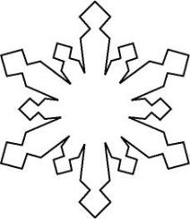

III-IV

Grades 5-8

Objectives:

The student will:

- identify the four stages of the sea ice cycle;

- identify the types of sea ice found in each stage of the sea ice cycle;

- identify the type and stage of sea ice by playing the sea ice board game;

- generate and answer a “critical thinking” question about sea ice.

GLEs Addressed:

Science

- [5-8] SA 1.1 The student demonstrates an understanding of the processes of science by asking questions, predicting, observing, describing, measuring, classifying, making generalizations, inferring, and communicating.

- [7] SD 1.2 The student demonstrates an understanding of geochemical cycles by explaining the water cycle’s connection to changes in the Earth’s surface.

- [8] SD 1.2 The student demonstrates an understanding of geochemical cycles by applying knowl-edge of the water cycle to explain changes in the Earth’s surface.

Whole Picture:

Sea ice grows and shrinks every year. In the far northern seas centered on the North Pole, sea ice covers the largest area at the end of the cold season, usually in March. Sea ice on top of the world is at its lowest amount in September. In between those times, sea ice is either growing or shrinking, never remaining the same. Scientists have monitored sea ice with satellites since the 1970s. With the overall view given by satellites, researchers now produce daily maps of sea ice. Recent years have shown smaller amounts of sea ice, making some people think the Arctic Ocean may be totally without ice in summer sometime later this century, although ice will continue to form on the Arctic Ocean in winter.

Materials:

- TEACHER OVERVIEW

- SEA ICE BOARD GAME TEMPLATE

- SEA ICE BOARD GAME CARDS

- Standard 6-sided die (one per group)

- Playing pieces, various colors (one per student)

- Glue, tape, or staples and stapler

- Scissors

- OVERHEAD: “Stages of Sea Ice Development”

- OVERHEAD: “Sea Ice Cycle: Types of New Ice”

- OVERHEAD: “Sea Ice Cycle: Formation Stage”

- OVERHEAD: “Sea Ice Cycle: Growth Stage”

- OVERHEAD: “Sea Ice Cycle: Deformation Stage”

ACMP ©2006-2008 UAF Geophysical Institute B-1 Sea Ice Board Game

- OVERHEAD: “Sea Ice Cycle: Disintegration Stage”

- STUDENT INFORMATION SHEET: “Sea Ice Board Game Instructions”

- STUDENT WORKSHEET: “Sea Ice Cycle”

Activity Preparation

- Prepare the Sea Ice Board Game by making one copy of the SEA ICE BOARD GAME TEMPLATE for each group of four students. Cut out the bottom line and sides of each box on Page 1 and 2 of each board to create a flap. Glue, staple or tape page 1 and 2 over page 3 and 4 to form the board for the Sea Ice Board Game. Students may do this themselves if time allows.

Teacher’s Note: Students may enjoy thinking of themselves as polar bears swimming in the ocean and walking on the ice while playing the Sea Ice Board Game. If desired, students can make game pieces by cutting out small polar bear shapes of various colors, taping them to a toothpick, and insert-ing the toothpick into a small piece of foam or cork.

Activity Procedure:

Critical Thinking Concept: K-W-L Method. Create a three-column chart to be filled in during student discussion. The first column should be labeled “K (What I KNOW),” the second column “W (What I WANT to Know),” and the third column “L (What I LEARNED).” Fill in the first two columns of the chart by asking students what they know about sea ice development and what they want to know. At the end of the lesson, fill in the third column of the chart.

How Does Sea Ice Affect Global Climate?

- Explain sea ice in the Arctic and Antarctic cools our planet. One of the most reflective substances on Earth, sea ice reflects heat from the sun back into the atmosphere. As sea ice decreases, Earth’s temperature rises, as the ocean absorbs more heat. Use the TEACHER OVERVIEW and tools from the ACMP website Sea Ice Curriculum page (http://www.arcticclimatemodeling.org/lessons/index. html) to emphasize this point; the Sea Ice Curriculum page includes segments about sea ice from the ACMP DVD, a clip of an Alaska Native Elder describing local changes in sea ice, and a section from the ACMP Scientist Lecture Climate Change, presented by University of Alaska President’s Professor of Climate Change John Walsh.

Foundational Sea Ice Concepts

(NOTE: Below is a narrative for six overheads, which serve to illustrate foundational sea ice concepts as they relate to the sea ice cycle of formation, growth, deformation, and disintegration. More in depth infor-mation about the stages of the sea ice cycle and content of the overheads can be found in the TEACHER OVERVIEW.)

- Review the stages of sea ice development by displaying OVERHEAD: “Stages of Sea Ice Develop-ment.” Explain that sea ice forms, grows, deforms, and disintegrates in a cycle called the sea ice cycle. Each type of sea ice fits into either the formation or growth state of the sea ice cycle.

- Display OVERHEAD: “Sea Ice Cycle: Types of New Ice.” Explain that the first sign of freezing on the sea is an oily appearance of the water caused by the formation of needle-like crystals called frazil ice. These crystals increase in number until the sea is covered by a slush of a thick, soup consistency, called grease ice. In turbulent conditions when there is snowfall, frazil ice may combine with snow to form slush on the surface of the water. Strong waves will push slush or grease ice together forming pancake ice.

ACMP ©2006-2008 UAF Geophysical Institute B-2 Sea Ice Board Game

- Display OVERHEAD: “Sea Ice Cycle: Formation State.” Explain that once a thin elastic crust of ice is formed on the surface of the ocean, it is called Nilas. If the ocean is calm, the ice may freeze into a brittle, shiny crust, instead of a thin, elastic crust. This brittle, shiny sheet of ice is called ice rind. Ice rind is easily broken by wind or swell.

- Display OVERHEAD: “Sea Ice Cycle: Growth Stage.” Explain that once a sheet of ice has formed, it will increase in thickness by the freezing of water on its lower surface. This period is called the growth stage. First-year ice, old ice, second-year ice, and multi-year ice all exhibit a growth stage.

- Display OVERHEAD: “Sea Ice Cycle: Deformation Stage.” Explain that once the ice is thick enough, it will be deformed through various processes. One type of deformation of the ice is called a pressure ridge. Pressure ridges are formed when pressure is exerted on the ice by wind or tide. Another type of deformation is hummocks, which are small hills of broken ice that are forced upward. Over time hummocks can become weathered by snow drifting over them or by summer thawing and solar ra-diation. Cracking occurs where ice sheets break into ice floes, a further manifestation of deformation. Ice floes are broken ice sheets. Lastly, rafting is yet another display of deformation, where sheets are pushed together so that one is above the other, with a minimum of breaking.

- Display OVERHEAD: “Sea Ice Cycle: Disintegration Stage.” Explain that the disintegration of ice usu-ally occurs when the ice melts. Melting occurs when the temperature of the ice is raised above its freezing point. Generally this occurs when the ice absorbs solar radiation or from conduction of heat from the surrounding air or water. As ice floes drift toward the equator, the melting is enhanced by the increased temperature of the water and atmosphere.

Play the Sea Ice Board Game

- Divide students into groups of four or less. Distribute a prepared Sea Ice Board Game (see Activity Preparation), and set of SEA ICE BOARD GAME CARDS to each group. Go over the game instruc-tions with the class.

- Direct students to cut out the SEA ICE BOARD GAME CARDS and play the Sea Ice Board Game using the instructions provided on the STUDENT INFORMATION SHEET: “Sea Ice Board Game In-structions.” (NOTE: SEA ICE BOARD GAME CARDS can also be photocopied for use with Avery® business cards 5881, 8373, or 8869.)

Critical Thinking Activity: Question Exchange Method. Ask students to complete the L (“what I LEARNED”) column of the K-W-L chart individually, and then share one thing they learn with the class. After each student has shared at least one thing they have learned, invite students to write a question they still have about the lesson. Student questions may involve the broader picture (how does sea ice affect global climate?), the local environment (why is sea ice important to my commu-nity?), specific sea ice processes (does the sea ice cycle always go in the order of formation, growth, deformation, disintegration?), etc. Students may also use the Sea Ice Board Game Cards as prompts for questions.

Ask students to complete a fast write in answer to their questions, or collect student questions and distribute them among the class, so that students are answering each other’s questions. This activity can also be extended into an essay, research paper, science fair project, etc. Invite students to share their responses.

Teacher’s Note: Questions developed from the Critical Thinking Activity: Question Exchange Method can be used as quiz questions or study questions.

ACMP ©2006-2008 UAF Geophysical Institute B-3 Sea Ice Board Game

Answers:

1. A. Formation | 2. A. Formation | 3. A. | Pressure ridges
B. Growth | B. Growth | B. | Ice floes
C. Deformation | C. Growth | C. | Cracks
D. Disintegration | D. Formation | D. | Rafting
 |  | E. | Hummocks

Rubric:

Objective | Below Proficient | Proficient | Above Proficient
The student identifies the | The student correctly | The student correctly | The student correctly
four stages of the sea ice | identifies one or two | identifies three stages of | identifies all four stages of
cycle on the student | stages of the sea ice | the sea ice cycle. | the sea ice cycle.
worksheet. | cycle.
The student identifies the | The student incorrectly | The student correctly | The student correctly
types of ice found in each | classifies the types of sea | classifies some, but not | classifies each type of sea
stage of the sea ice cycle | ice into the stages of the | all, types of sea ice into | ice into the appropriate
on the student worksheet. | sea ice cycle. | the appropriate stages of | stages of the sea ice cycle.
 |  | the sea ice cycle.
The student identifies the | The student is unable to | The student completes the | The student completes the
type and stage of sea ice | complete the Sea Ice | Sea Ice Board Game, | Sea Ice Board Game,
based on a description by | Board Game, due to the | correctly identifying most | correctly identifying all of
playing the Sea Ice Board | inability to identify the | of the types and stages of | the types and stages of sea
Game. | types and stages of sea | sea ice based on descrip- | ice based on descriptions.
 | ice based on descriptions. | tions.
The student generates | The student generates a | The student generates a | The student generates a
and answers a question | question about sea ice. | question about sea ice. | question about sea ice that
about sea ice during the | The student answers a | The student answers a | takes a broad picture into
Critical Thinking Activity: | question about sea ice | question about sea ice | account. The student
Question Exchange | incorrectly and/or incom- | completely and accurately. | answers a question about
Method. | pletely. |  | sea ice accurately and
 |  |  | completely.

ACMP ©2006-2008 UAF Geophysical Institute B-4 Sea Ice Board Game

Teacher Overview
ACMP DVD

 |  |  |  |  |  | How Does Sea Ice Affect Global Climate?
 | Visit the Arctic Climate Model-
 |  |  |  |  |  | Sea ice in the Arctic and the Antarctic cools our planet. One of the
 | ing Program (ACMP) Sea Ice |  |  |  |  | most reflective substances on Earth, sea ice reflects heat from
 | Curriculum page (http://www. |  |  |  |  | the sun back into the atmosphere. When the Arctic Ocean is cov-
 | arcticclimatemodeling.org/les- |  |  |  |  | ered with ice, roughly three-quarters of the heat from the sun is
 | sons/index.html) for the fol- |  |  |  |  | reflected back into the atmosphere. When sea ice decreases,
 | lowing: |  |  |  |  | heat from the sun is absorbed by the ocean.
 | • segments about sea ice |  |  |  |  |  |  |  |  |  | In 2007, Arctic sea ice
 |  | and sea ice changes from |  |  |  |  |  |  |  |  | plummeted to the low-
 |  | the ACMP DVD; |  |  |  |  |  |  |  |  | est levels since satellite
 | • | a clip of an Alaska Native |  |  |  |  |  |  |  |  | measurements began
 | • |  |  |  |  |  |  |  |  |  | in 1979. Arctic sea ice
 |  | Elder | describing | local
 |  | Elder | describing | local |  |  |  |  |  |  | receded so much that
 |  | changes in sea ice from the
 |  |  |  |  |  |  |  |  |  |  | the fabled | Northwest
 |  | documentary Wales, Alaska |  |  |  |  |  |  |  |  | the fabled | Northwest
 |  |  |  |  |  |  |  |  |  |  | Passage | completely
 |  | Survival in a Changing Cli- |  |  |  |  |  |  |  |  | Passage | completely
 |  |  |  |  |  |  |  |  |  |  | opened for the first time
 |  | mate;
 |  | mate; |  |  |  |  |  |  |  |  | in human memory. Over
 | • | a section from the ACMP
 | • |  |  |  |  |  |  |  |  |  | the past 30 years, sci-
 | • |  |  |  |  |  |  |  |  | ACMP DVD
 |  | Scientist | Lecture: | Climate |  |  |  |  |  | ACMP DVD
 |  | Scientist | Lecture: | Climate |  |  |  |  |  | ACMP DVD | entists have observed
 |  | Change; and
 |  |  |  |  |  | an 8% loss in arctic sea ice area (that’s about 1 million square
 | • | access to additional ACMP |  |  |  | kilometers). Current sea ice is 40% thinner than in the past.
 |  | classroom lessons |  | related |  | “Decreasing sea ice in
 |  | to sea ice.
 |  |  |  |  |  | the |  | Arctic affects | the
 |  |  |  |  |  | heat |  | budget for | the
 |  |  |  |  |  | whole planet,” said Geo-
 |  | physical Institute Professor Hajo Eichen, with the University
 |  | of Alaska Fairbanks. “The amount of warming our planet
 |  | gets from having sea ice retreat is roughly equivalent to the
 |  | amount of warming it gets from doubling carbon dioxide.
 |  | Most people know about greenhouse gases, but few are
 |  | aware of the global impact of receding sea ice.”
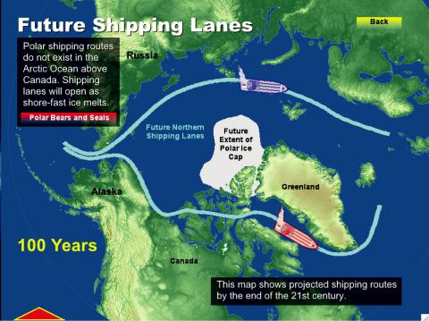
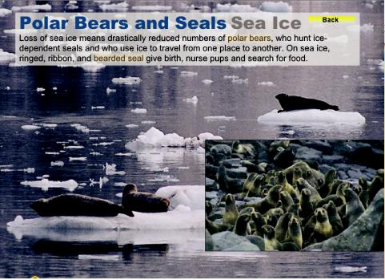

The ACMP interactive, multimedia Global Climate DVD pro-

vides an overview of how sea ice fits into the broader picture of climate. The Global Climate DVD presents complex scientific concepts about Earth’s weather and climate in an engaging visual, and interactive format. Two units, “Earth’s Systems” and “Climate Change Impacts” are especially relevant to sea ice. “Earth’s Systems” contains a section on ocean circulation and a section on the cryosphere. “Climate Change Impacts” discusses the impact of reduced sea ice on Arctic mammals, such as polar bears. These segments of the DVD are available on the ACMP Web site.

The Sea Ice Board Game and Observing Sea Ice

The Sea Ice Board Game provides an overview of the types of sea ice found in each stage of the sea ice cycle. The sea ice cycle is comprised of four stages: formation, growth, deformation, and disinte-gration. During this lesson students play a game to enhance, demonstrate, and hone their knowledge of sea ice. A variety of ACMP resources are used in conjunction with this lesson and can be explored in more depth as time and interest allows.

Working through the Observing Sea Ice lesson will help students appreciate the variety of sea ice by introducing them to the Student Network for Observing Weather (http://www.arcticclimatemodeling.

ACMP ©2006-2008 UAF Geophysical Institute B-5 Sea Ice Board Game

org/son/index.html). On the network, students can see thumbnail sketches of 14 different types of sea ice displayed on the Sea Ice Board Game Overhead “Stages of Sea Ice Development.”

In the Observing Sea Ice lesson, students use chapter one of the Manual of Standard Procedures for Observing and Reporting Ice Conditions to define each type of sea ice. This manual, published by the Canadian Ice Service, includes terminology, methods of ice observation, and directions for the prepa-ration and analyzing of ice charts (discussed in more detail in the Arctic Climate Modeling Program lesson The Egg Code).

Sea Ice Board Game Overheads

Six overheads provide students with background information on sea ice.

- “Stages of Sea Ice Development”

- “Sea Ice Cycle: Types of New Ice”

- “Sea Ice Cycle: Formation Stage”

- “Sea Ice Cycle: Growth Stage”

- “Sea Ice Cycle: Deformation Stage”

- “Sea Ice Cycle: Disintegration Stage”

Additional Overhead Information

The “Activity Procedure” section of the Sea Ice Board Game contains text that can be used to talk to the class about each overhead. Below is more comprehensive background information for each over-head.

- The “Stages of Sea Ice Development” overhead reviews 14 different types of sea ice and associ-ates them with either the formation or growth stages of sea ice development. Please note that these are broad categories of sea ice, used in shipboard observations. Within these categories, there are many types of sea ice; University of Alaska Fairbanks Geophysical Institute scientists are currently working with Alaska Native Elders to compile a comprehensive sea ice dictionary of more than 100 different terms for sea ice.
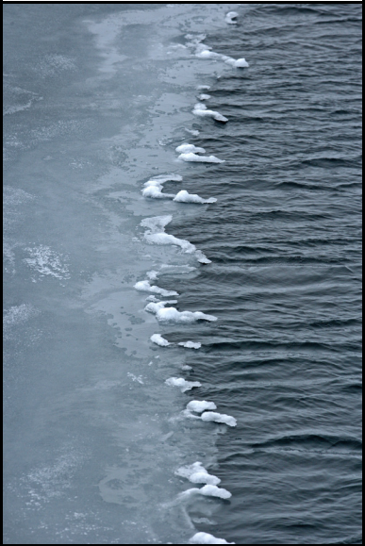

(2) The “Types of New Ice” overhead presents the first signs of | grease ice
freezing and the various types of ice classified as “new ice.” The first
sign of freezing on the sea is an oily appearance of the water caused
by the formation of needle-like crystals called “frazil ice.” These crys-
tals increase in number until the sea is covered by a slush of thick,
soup consistency, called “grease ice.” In turbulent conditions, where
there is snowfall, frazil ice may combine with snow to form slush on
the surface of the water. Strong waves will push slush or grease ice
together to form “pancake ice.” All of these types of ice – frazil, slush,
grease, and pancake – are types of new ice.

- The “Formation Stage” overheadpresents the two parts of the formation stage of the sea ice cycle: new ice and “young ice.” The next stage of sea ice development after the initial signs of freezing is known as “nilas” or “ice rind.” Nilas and ice rind are the same thick-ness and stage of ice development, but are distinguished by the con-ditions under which they freeze. Ice rind forms on a calm ocean; nilas forms on an ocean with swells.

NOAA

The third stage of sea ice development, and the final stage of the formation stage of the sea ice cycle is young ice. Young ice is divided into two categories: “grey ice” and “grey-white ice.” The two types of ice differ in thickness. When observing and recording observations of sea ice, young ice may be de-scribed as “grey ice,” “grey-white ice,” or the more general term, “young ice.”

- The “Growth Stage” overhead presents the fact that once a sheet of sea ice has formed, it grows in thickness from its bottom surface; not from the addition of ice forming on top. The types of ice in the

ACMP ©2006-2008 UAF Geophysical Institute B-6 Sea Ice Board Game

growth stage are distinguished by their thickness and how long they have been present on the ocean. There are two types of ice in the growth stage of a cycle: “first-year ice” and “old ice.” These two types of ice are divided into subcategories.
Student Network for Observing Weather Data Entry Page

First-year ice is divided into three categories: thin first-year ice (30-70 centimeters), medium first-year ice (70-120 centimeters), and thick first-year ice (more than 120 centimeters). Thin first-year ice is further divided into a first stage (30-50 centimeters) and second stage (50-70 centimeters).

Old ice is any ice that has survived at least one summer’s melt. Old ice is divided up into “second-year ice” and “multi-year ice.” Second-year ice is old ice that has survived only one summer’s melt. Multi-year ice is ice that has survived at least two summer’s melt.

Surface observations can be used to help distinguish between types of ice in the growth stage. For example, old ice is generally smoother than first-year ice.

- The “Deformation Stage” overhead reviews the variety of processes that occur to deform ice. “Crack-ing,” or “fracturing,” occurs when ice sheets break and separate into floes. “Pressure ridges” form when pressure is exerted on the ice by the wind or water currents. “Hummocks” are small hills of broken ice that have been forced upward by pressure. “Rafting” occurs when one ice floe is pushed over or under another one with a minimum of cracking or breaking.
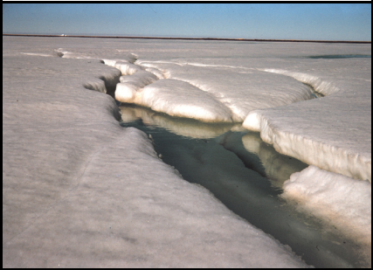
(6) The “Disintegration Stage” overhead explains that the disin- | melting sea ice
tegration stage of ice usually occurs when ice melts. Melting oc-
curs when the temperature of the ice is raised above its freezing
point. Generally, this occurs when the ice absorbs solar radiation
or from conduction of heat from surrounding air or water. Sea ice
can melt partially, forming puddles on top of the ice, without melt-
ing completely.

NOAA

Lesson Resources

Student Network for Observing Weather (http://www.arcticclimatemodeling.org/son/index.html)

The Student Network for Observing Weather (SON) is a database of weather data collected from automated weather stations at the 15 schools in the Bering Strait School District and weather and sea ice observations made by local observers (students and teachers) in the Bering Strait region. The sea ice index visible from the SON Weather Data Entry page. The sea ice index dis-plays 14 common types of sea ice, so that students can view and enter the types of ice present in their village.
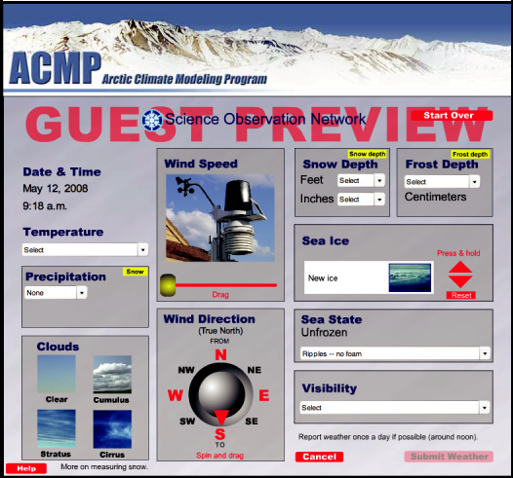

Geographic Information Network of Alaska (GINA)

The University of Alaska’s Web-based Geographic In-formation Network of Alaska (GINA) is an extensive geo-graphic and technologic database for Alaska and the Arc-tic. GINA uses satellite images, an advanced geographic information system (GIS), and topographic imaging to

study many events affecting the Arctic. GINA can be used to display near-real-time satellite images of sea ice in the Bering Strait. ACMP classroom lessons that demonstrate how to use GINA include: Sat-ellite Sense, GINA Over Alaska, and Viewing Sea Ice with GINA.

Scientist Lectures

ACMP Scientist Lectures are available on a variety of topics. In “Climate Change,” President’s Professor of Climate Change John Walsh lectures on climate change in Alaska and how it influences overall global climate change. Walsh gives a brief overview of climate and why changes in climate are

ACMP ©2006-2008 UAF Geophysical Institute B-7 Sea Ice Board Game

important in understanding current global issues. Walsh also touches on receding sea ice and what types of problems it could create for marine mammals like polar bears and seals, as well as how the loss of sea ice could potentially effect humans, specifically those in arctic regions. Contributing factors to sea ice melt and climate change over the past 50 years, such as the Greenhouse Effect, also are discussed.

Scientist Mentor Network

The ACMP Scientist Mentor Network is a means of contacting scientists for additional information. ACMP Scientist Mentors are Geophysical Institute, International Arctic Research Center, University of Alaska Fairbanks, and National Weather Station scientists involved in weather, climate, and related fields of study. To ask a scientist a question, visit the ACMP Ask a Scientist page at http://www.arctic-climatemodeling.org/ask.html.

Additional ACMP Lessons

Additional ACMP lessons about sea ice are accessible from the ACMP Web site (http://www.arcticcli-matemodeling.org/lessons/seaIceLessons.html). ACMP curriculum includes lessons on a variety of weather and climate themes beyond sea ice. Themes include: climate change; clouds and precipita-tion; energy transfer; permafrost; remote sensing; temperature; the water cycle; weather and climate; and wind. Lessons also can be viewed by grade level. Alaska State Grade Level Expectations (GLEs) are identified for each lesson.

Other Resources

Listed below are a few sources for additional information on sea ice.

National Snow and Ice Data Center (http://nsidc.org/index.html)

National Oceanic and Atmospheric Administration (NOAA) Arctic theme page (http://www.arctic.noaa.gov/index.shtml)

Canadian Ice Service (http://ice-glaces.ec.gc.ca/)

ACMP ©2006-2008 UAF Geophysical Institute B-8 Sea Ice Board Game

Sea Ice Board Game Template (page 1 of 4)
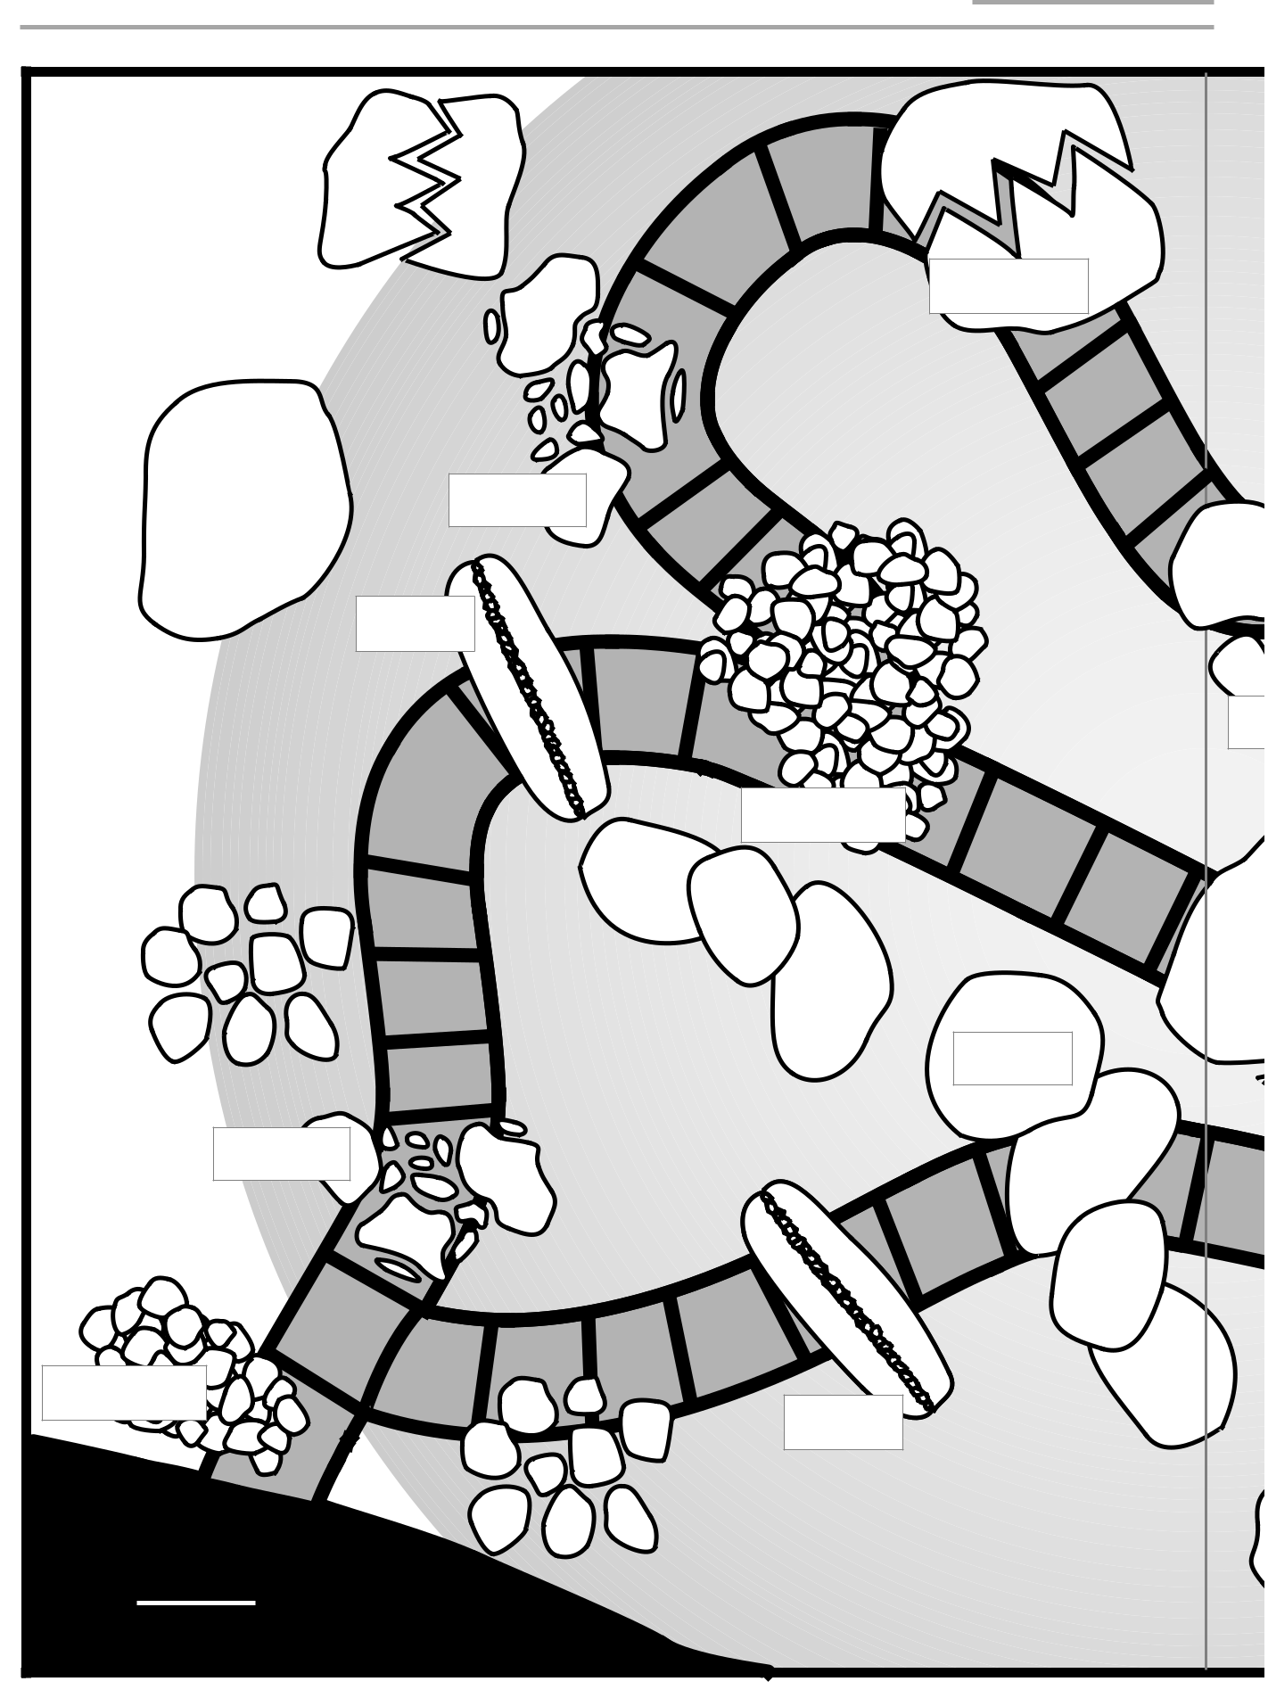

LAND
START
ACMP ©2006-2008 UAF Geophysical Institute | B-9 | Sea Ice Board Game

Sea Ice Board Game Template (page 2 of 4)
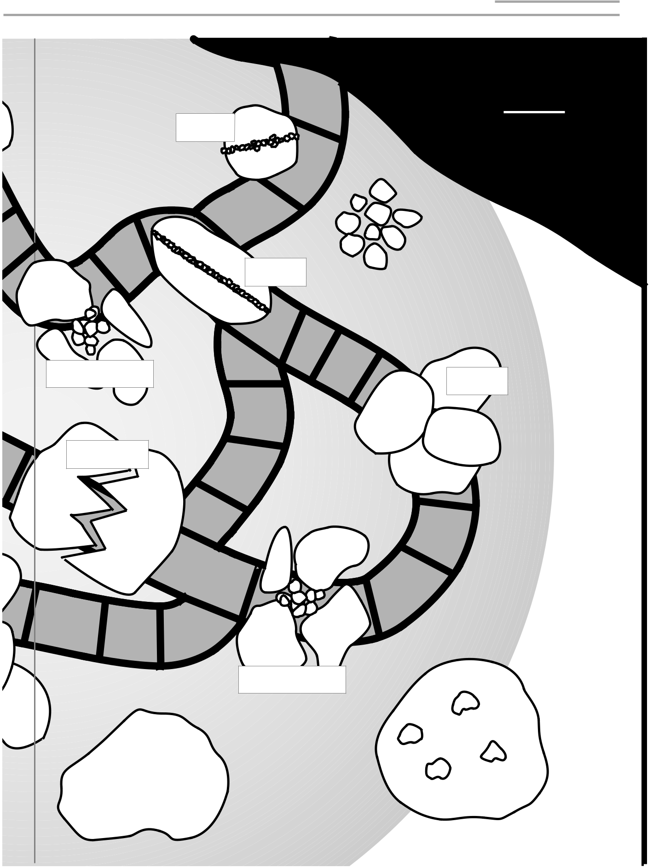

LAND

FINISH

ACMP ©2006-2008 UAF Geophysical Institute B-10 Sea Ice Board Game

Sea Ice Board Game Template (page 3 of 4)


cracking

ice floe

ridges

h

pancake

rafting

ice floe

pancake
ridges

ACMP ©2006-2008 UAF Geophysical Institute B-11 Sea Ice Board Game

Sea Ice Board Game Template (page 4 of 4)


ridges

ridges

hummocks | rafting

cracking

hummocks

ACMP ©2006-2008 UAF Geophysical Institute B-12 Sea Ice Board Game

Name:____________________________________

Sea Ice Cycle

Student Worksheet

Directions: Answer the questions as directed.

- List the four stages of the sea ice cycle.

  - _________________________________________________

  - _________________________________________________

  - _________________________________________________

  - _________________________________________________

- For each stage of sea ice development listed, circle the stage of the sea ice cycle.

Sea Ice | Stage of Sea Ice Cycle
A. Nilas | Formation | Growth
B. Thick First-year Ice | Formation | Growth
C. Old Ice | Formation | Growth
D. Grey Ice | Formation | Growth

- Match the picture below with the type of deformation.

A.  Hummocks
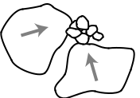

Levels

III-IV

B. Cracks


C. |  | Ice Floes

D. Pressure Ridges
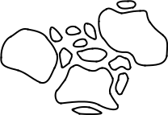


E. Rafting

ACMP ©2006-2008 UAF Geophysical Institute B-13 Sea Ice Board Game

Sea Ice Board Game Instructions

Student Information Sheet

STEP 1 Each player picks a game piece and places it on the START space on the game board.

Levels

III-IV

STEP 2 Each player rolls the die to determine who goes first. The player with the highest number begins. Play then passes to the left.

STEP 3 Each player rolls the die to determine how many spaces to move. Players may move any direction.

STEP 4 If a player reaches a square with sea ice, he or she will be required to correctly answer a question to continue. Another player at the table should draw a card and read the question aloud. The player on the sea ice should answer the question. The reader should state if the player answered correctly or incorrectly.

STEP 5 If the player answers incorrectly, the reader should return the card to the bottom of the pile without revealing the answer and draw another card. The player has three chances to answer correctly. If the player does not answer correctly within three tries in one round, he or she must return to the start.

STEP 6 If the player answers correctly, he or she may identify aloud the type of deformation present in the sea ice he is standing on or pass. If the player chooses to identify the deformation, he should state his answer aloud, and then lift the flap on the board to verify the answer. If the player answers correctly he may roll again and move the number of spaces shown on the die in any direction. If he answers incorrectly, he must roll the die and move backward the number of space shown on his die.

STEP 7 The winner is the first person to reach the finish.

ACMP ©2006-2008 UAF Geophysical Institute B-14 Sea Ice Board Game

Sea Ice Board Game Cards
Student Information Sheet (page 1 of 3)
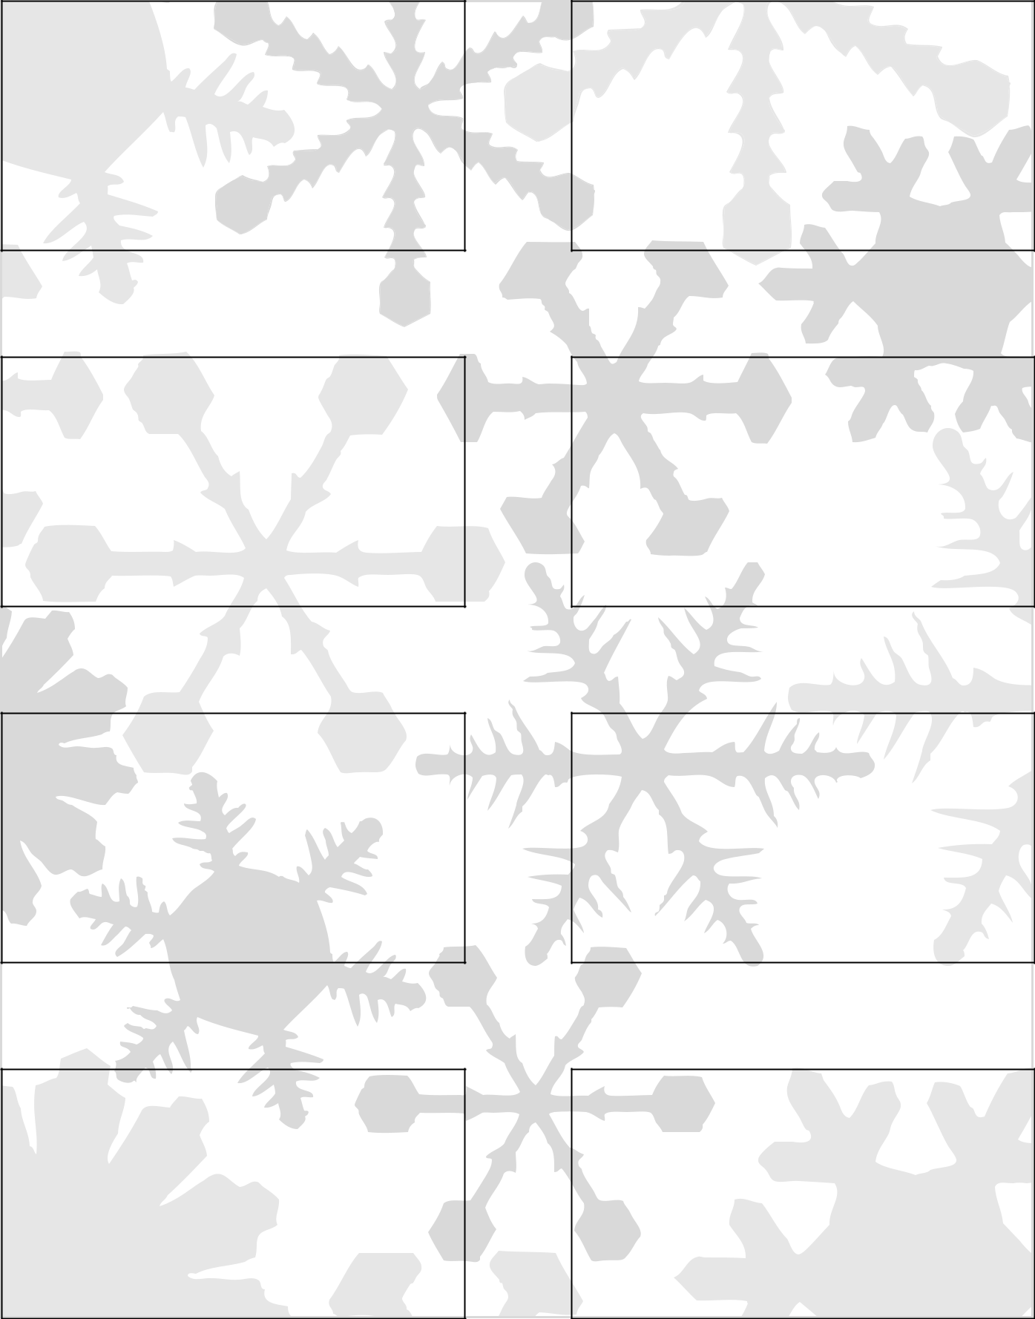

- What type of sea ice is composed of thin round sheets?

- Pancake Ice

- Which type of Nilas is thicker, dark or light?

- Dark Nilas

These cards can be copied onto cardstock and cut out

or photocopied for use with Avery business cards 5881, 8373, or 8869.

- What type of sea ice is a mixture of frazil ice and snow?

- Slush

- What causes pressure ridges?

- The pressure against the ice from wind or water currents

- Which ice is generally smoother,

Young Ice or Old Ice?

- Old ice

- Multi-year ice is ice that has survived at least how many years?

- Two

- What type of sea ice is 50-70 centimeters thick?

- Thin first-year ice, second stage

- Which stage of the sea ice cycle contains puddles?

- Disintegration

ACMP ©2006-2008 UAF Geophysical Institute B-15 Sea Ice Board Game

Sea Ice Board Game Cards
Student Information Sheet (page 2 of 3)
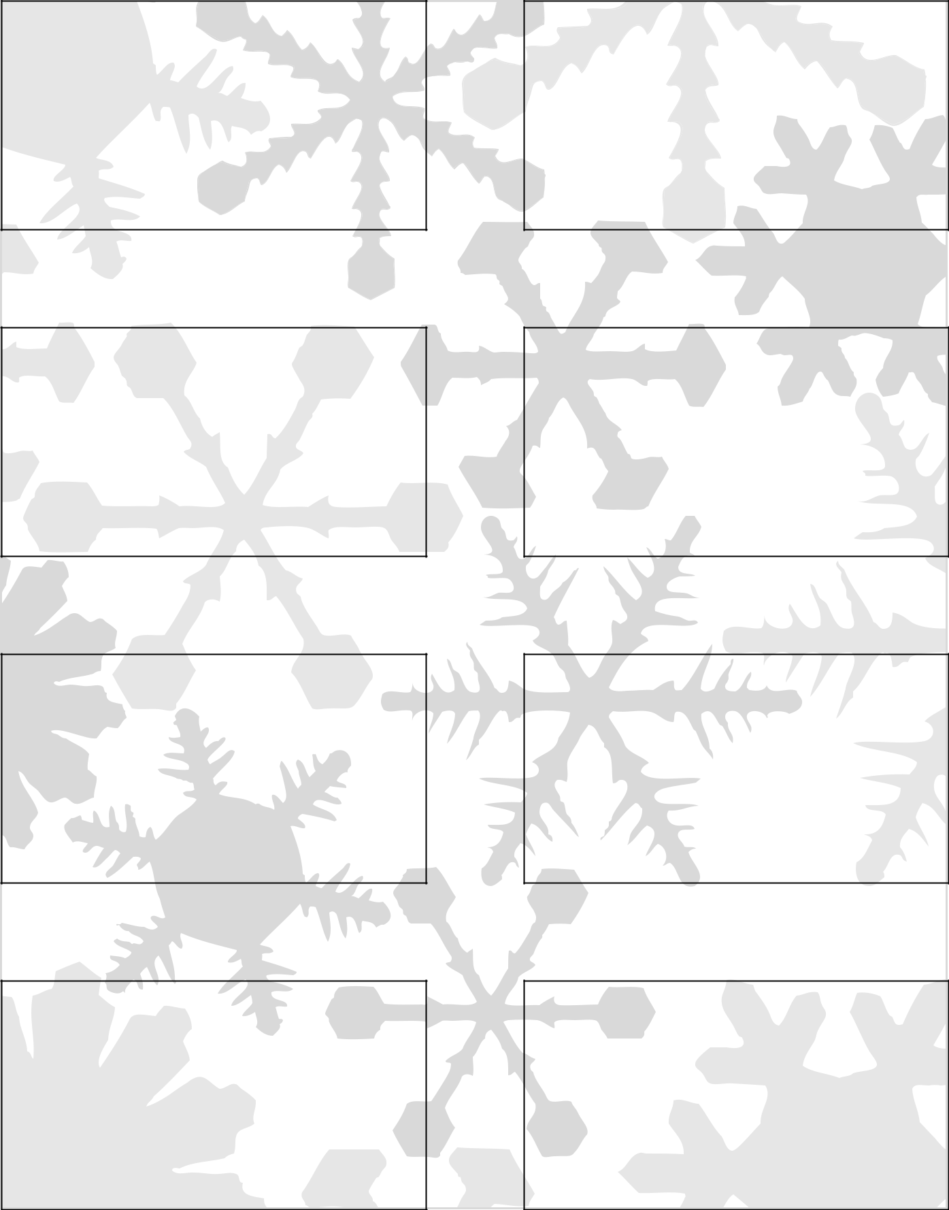

- What type of deformation is caused by pressure forcing the ice upward?

- Hummocks

- Which type of ice is older? Multi-year or second-year ice?

- Multi-year ice

- What type of deformation is caused by one piece of ice overriding another?

- Rafting

- Which stage of sea ice development occurs first? Grease Ice or Frazil Ice?

- Frazil Ice

- True or False: In the growth stage of the sea ice cycle, new ice forms on the top.

- False

- True or False: The Arctic Ocean only contains one type of ice at a time.

- False

- Grey ice and grey-white ice are what ice type?

- Young ice

- Which of the following is not a stage of the sea ice cycle: formation, disintegration, growth, or ridging?

- Ridging

ACMP ©2006-2008 UAF Geophysical Institute B-16 Sea Ice Board Game

Sea Ice Board Game Cards
Student Information Sheet (page 3 of 3)

- What are ice sheets called after they break into pieces?

- Ice floes

- Melting sea ice is part of what stage of the sea ice cycle?

- Disintegration

- True or False: Sea ice can be shaped or changed by weathering.

- True

- True or False: Nilas forms on a calm ocean.

- False

- Which of the following is not a type of deformation: rafting, hummocks, pressure ridges, or melting?

- Melting

- True or False: Second-year ice is typically smoother than first-year ice.

- True

- Ice crystals that have formed a soupy layer are called?

- Grease ice

- Melting of sea ice results from the conduction of heat from which two sources?

- Ocean and atmosphere (air)

ACMP ©2006-2008 UAF Geophysical Institute B-17 Sea Ice Board Game

Stages of Sea Ice Development

Overhead


 | DESCRIPTION
FORMATION | New ice
FORMATION | Nilas; Ice rind
STAGE | Young ice
STAGE | Grey ice
 | Grey-white ice
 | First year ice
 | Thin first-year ice
GROWTH | Thin first-year ice, first stage
GROWTH | Thin first-year ice, second stage
STAGE | Medium first-year ice
STAGE | Thick first-year ice
 | Old ice
 | Second-year ice
 | Multi-year ice


from the Science Observation Network

IMAGE | THICKNESS |  | CODE
 | 0 | - 10 cm | 1
 | 0 | - 10 cm | 2
 | 10 - 30 cm |  | 3
 | 10 - 15 cm |  | 4
 | 15 - 30 cm |  | 5
 | = or > 30 cm |  | 6
 | 30 - 70 cm |  | 7
 | 30 - 50 cm |  | 8
 | 50 - 70 cm |  | 9
 | 70 | - 120 cm | 1 .
 |  | >120 | 4 .
 |  |  | 7 .
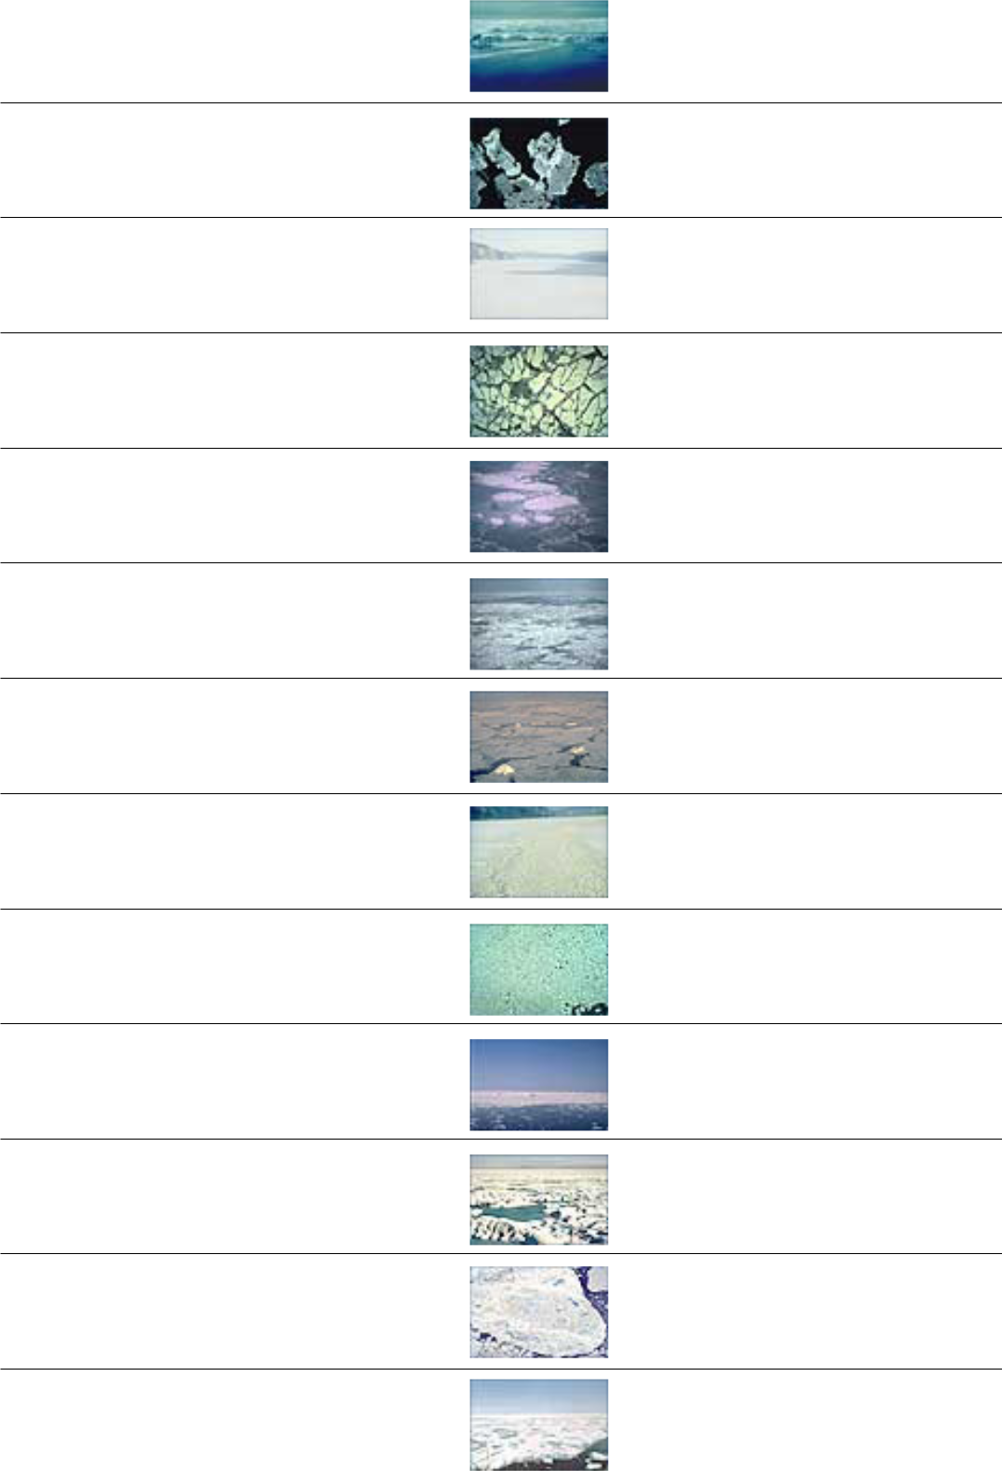

8 .
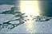

9.

ACMP ©2006-2008 UAF Geophysical Institute Sea Ice Board Game

Sea Ice Cycle: Types of New Ice

Overhead

Frazil Ice
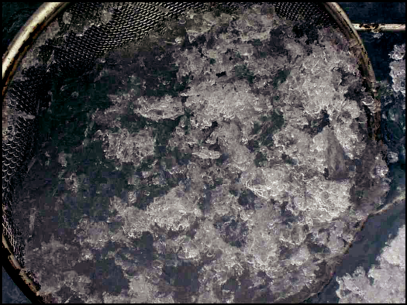
Fine plates of ice suspended in water.

H. Eicken, Geophysical Institute

Grease Ice
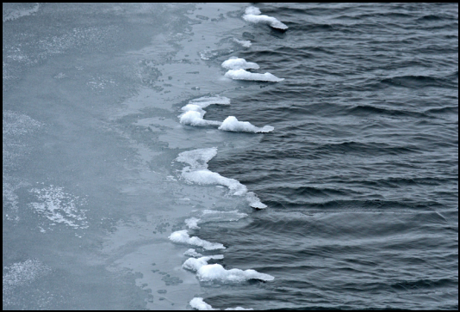

A later stage of freezing than frazil ice, when ice crystals have formed a soupy layer, called grease ice.

NOAA photo

Slush Ice
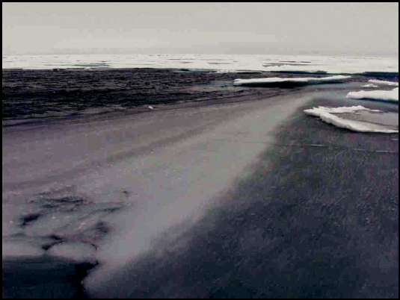
An accumulation of frazil ice and snow.

H. Eicken, Geophysical Institute

Pancake Ice
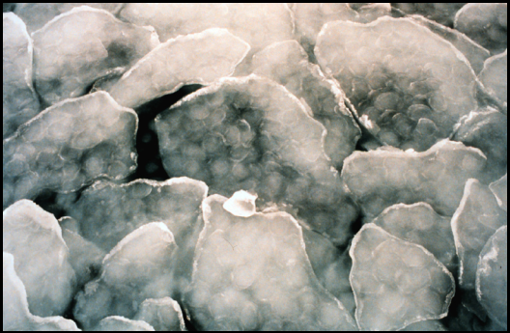

Slush and grease ice that is pushed together by waves to form rounded sheets of ice.

NOAA photo

ACMP ©2006-2008 UAF Geophysical Institute Sea Ice Board Game

Sea Ice Cycle: Formation Stage

Overhead

New Ice
New Ice | NOAA
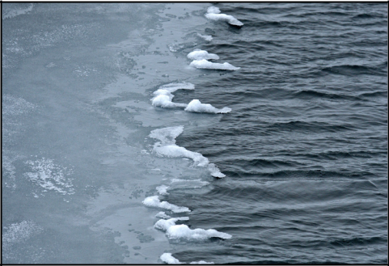
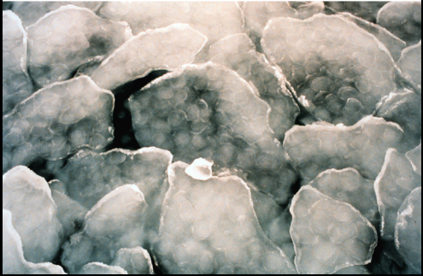

Recently formed ice, which includes frazil ice, grease ice (shown at left), slush ice, and pancake ice (shown at right).

NOAA
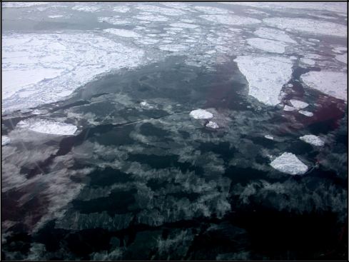

Nilas

A thin, elastic crust of ice, easily bending on waves and swell and under pressure.

H. Eicken, Geophysical Institute

Ice Rind

A brittle, shiny crust of ice formed on a quiet surface by direct freezing from grease ice.

Young Ice

Ice in the transition stage between nilas & first-year ice. May be subdivided into grey ice and grey-white ice.

 | Grey Ice
 | Young ice (shown at left) that is 10-15 centimeters
 | thick. Grey ice is less elastic than nilas and breaks on
 | swell.
 | Grey-white Ice
 | Young ice that is 15-30 centimeters thick. Grey-white
H. Eicken, Geophysical Institute | ice is more likely to ridge than raft under pressure.
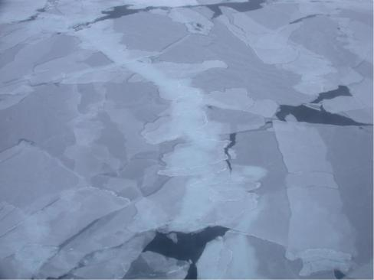

ACMP ©2006-2008 UAF Geophysical Institute Sea Ice Board Game

Sea Ice Cycle: Growth Stage

Overhead

NOAA |  | courtesy NASA/JPL-Caltech
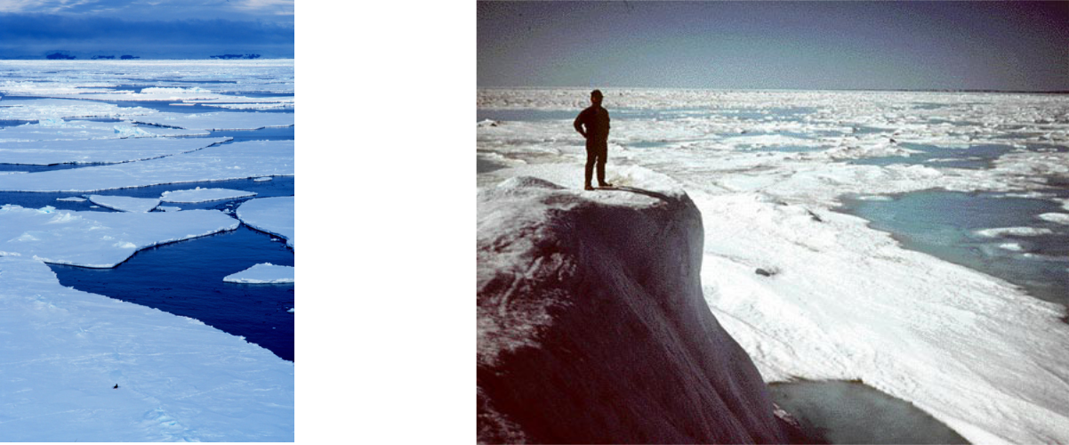
First-year ice This man is standing on multi-year ice next to first-year ice.
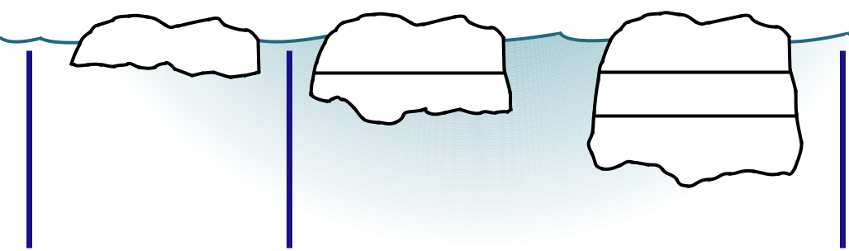

 1 DAY 1 WEEK 

Once a sheet of ice has formed, it increases in thickness by the freezing of water on its lower surface.

ACMP ©2006-2008 UAF Geophysical Institute Sea Ice Board Game

Sea Ice Cycle: Deformation Stage

Overhead

Pressure Ridges
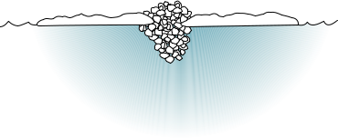

Pressure ridges form when pressure is exerted on the ice by the wind or water currents.
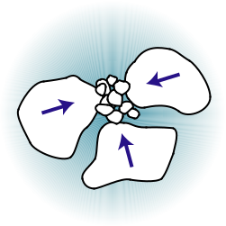

Hummocks

Hummocks are small hills of broken ice that have been forced upward by pressure. Over time, hummocks may become weathered by snow drifting over them or by summer thawing and solar radiation.
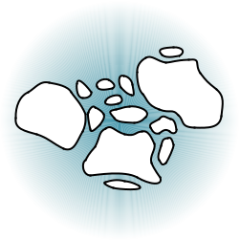

A. X. Meyer, NOAA (ret.)
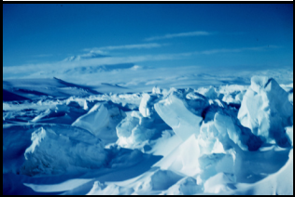
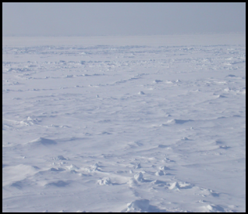

H. Eicken, Geophysical Institute

Ice Floes
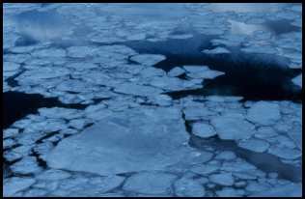

Ice floes are ice sheets that have be-come broken and cracked.

M. Van Woert, NOAA, NESDIS, ORA

Rafting
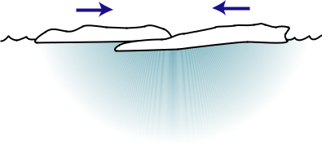
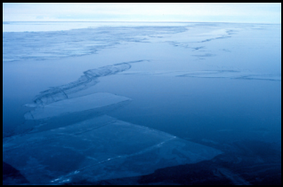

Rafting occurs when one floe is pushed over or under another one with a minimum of cracking or braking.

M. Van Woert, NOAA, NESDIS, ORA


Cracks
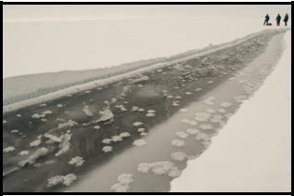

Cracks are formed in the ice where

an ice sheet breaks and the floes

separate.

J. Hutchings, IARC

ACMP ©2006-2008 UAF Geophysical Institute Sea Ice Board Game

Sea Ice Cycle: Disintegration Stage

Overhead
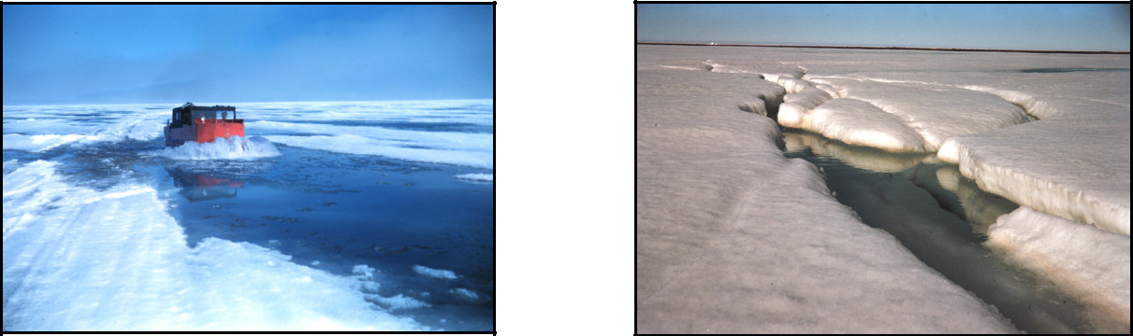

Rear Admiral H. D. Nygren, NOAA Corps (ret.)

Melted snow and ice during spring melt at Brownlow, Alaska.

Rear Admiral H. D. Nygren, NOAA Corps (ret.)

The first sign of spring melt (disintegration stage) - a stream is seen flowing on the ice.

Disintegration of ice usually takes place when ice melts. Melting occurs when the temperature of the ice is raised above its freezing point. Generally this occurs when the ice absorbs solar radiation or from conduction of heat from the sur-rounding air, water, or land.
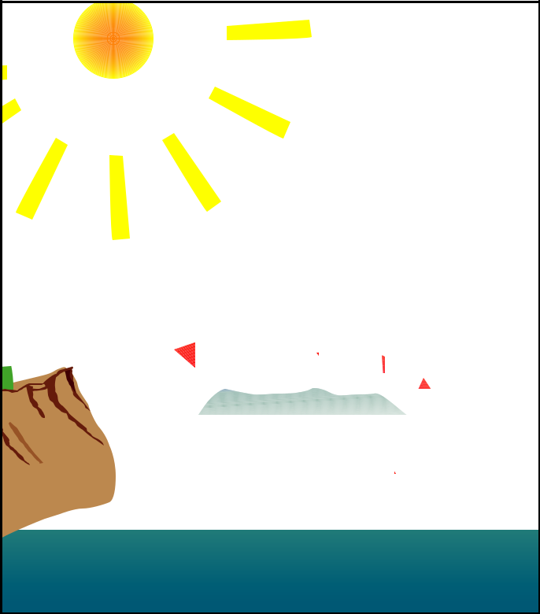

SUN

Radiation

Conduction from
Atmosphere

SEA ICE

LAND

Conduction
OCEAN

ACMP ©2006-2008 UAF Geophysical Institute Sea Ice Board Game

