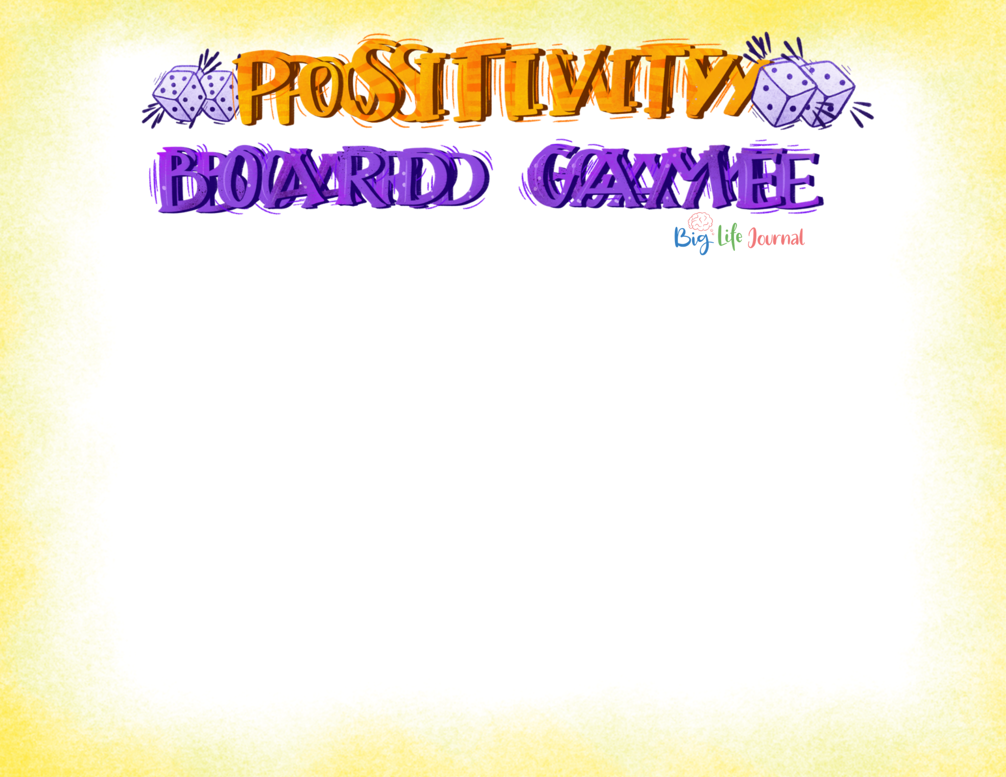

HOW TO ASSEM BLE

- Print both pages of the game. To assemble, cut out the bottom white part of page 1 on the solid line and tape to the top of page 2 to form the board.

- Get a game die from another board game or print and assemble the paper die on page 3.

- Choose small items as your game board pieces such as small rocks, figurines, or small blocks.

HOW TO PLAY

- Roll the die and move the correct number of spaces on the board. For example, if you roll a 2, move two spaces on the board.

- Do the activity or answer the question in the square you landed on. If there is no activity, it's the next player's turn.

- If you land on a square with a ladder, move your game piece up the ladder to a new square. If you land on a square with the snake, slide down the snake to the lower square.

- The game is over when all players reach the “Finish” square!

Copyright by Big Life Journal - biglifejournal.com

36

Say your favorite affirmation or quote.

Tell ³⁵ someone what you like about

them.
37

What is something you can't wait to try?

34

What do you enjoy learning about?
38
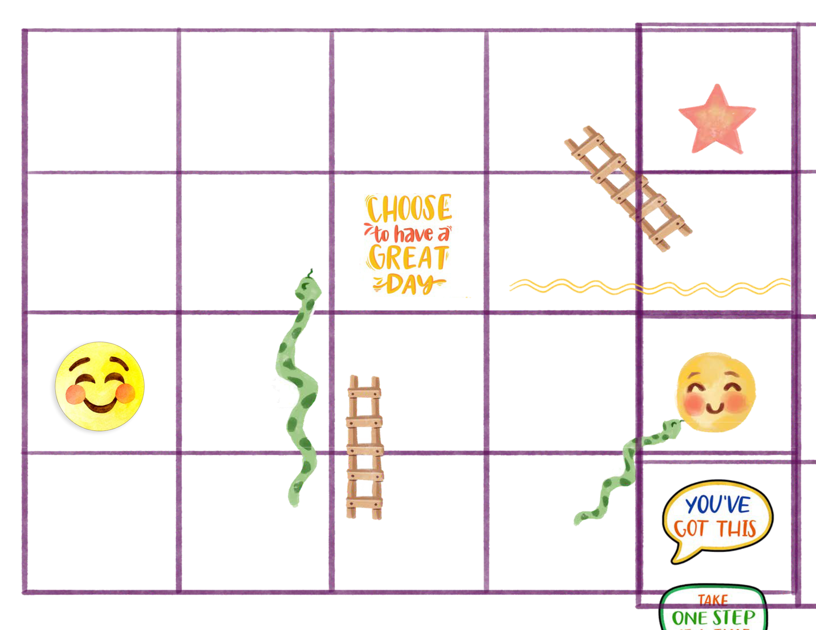

What is something you feel proud about?

33
39

Name your biggest strength.

32

What's the

coolest

thing

you've ever

seen?
FINISH⁴⁰

31

Do 5

squats.

26

What do you like about

27

28

Stretch

or do a

yoga

What's your favorite

29

30

What's

your

favorite

25

Sing and dance to your favorite song.

yourself?

24

Give

someone

- high five!

pose.

23

Who did

you help

recently?

thing to

wear?

22

Make your silliest face.

food?

21

Copyright by Big Life Journal - biglifejournal.com Page 1

16 | 17
Which sound
makes you
laugh?
15 | 14
 | What are
 | you
 | grateful
 | for?
6 | Hop on one ⁷
Tell a | leg for
joke. | 30
 | seconds.
5 | 4
 | What made
 | you laugh
 | today?
18 19
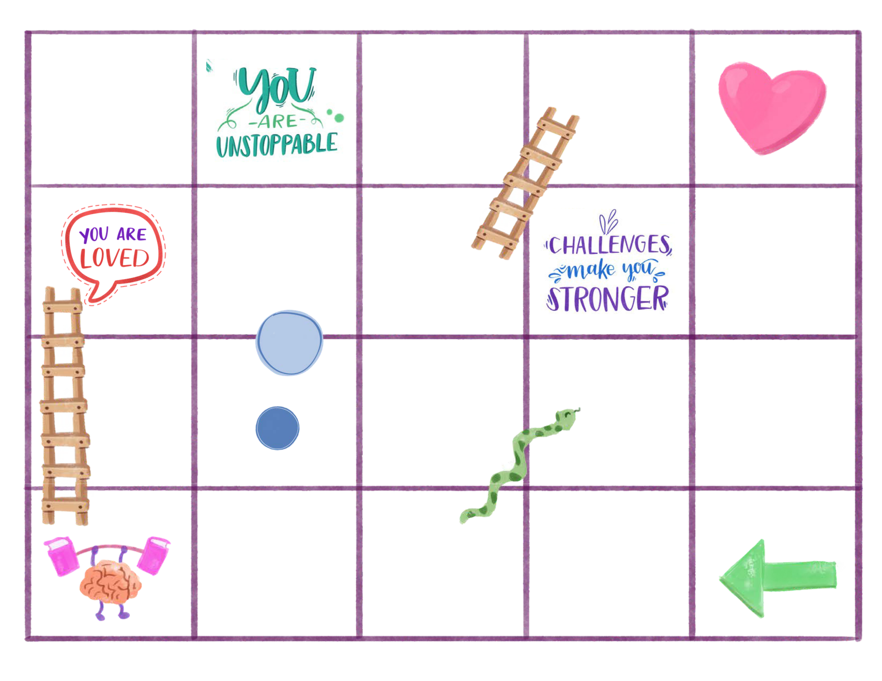

Give Say

yourself a something

big hug for kind to

20 seconds. yourself.

13 12

Take 3

deep

breaths.

When do ⁸ | 9
you feel | Who do
you feel | you
the | you
the | admire?
happiest? | admire?

3 | 2
What did | What's your
you learn | favorite part
today? | of the day?
20

YOU ARE

KIND

11

What

would you like to get better at?

10

What place do you want to visit?

START ¹

Copyright by Big Life Journal - biglifejournal.com Page 2

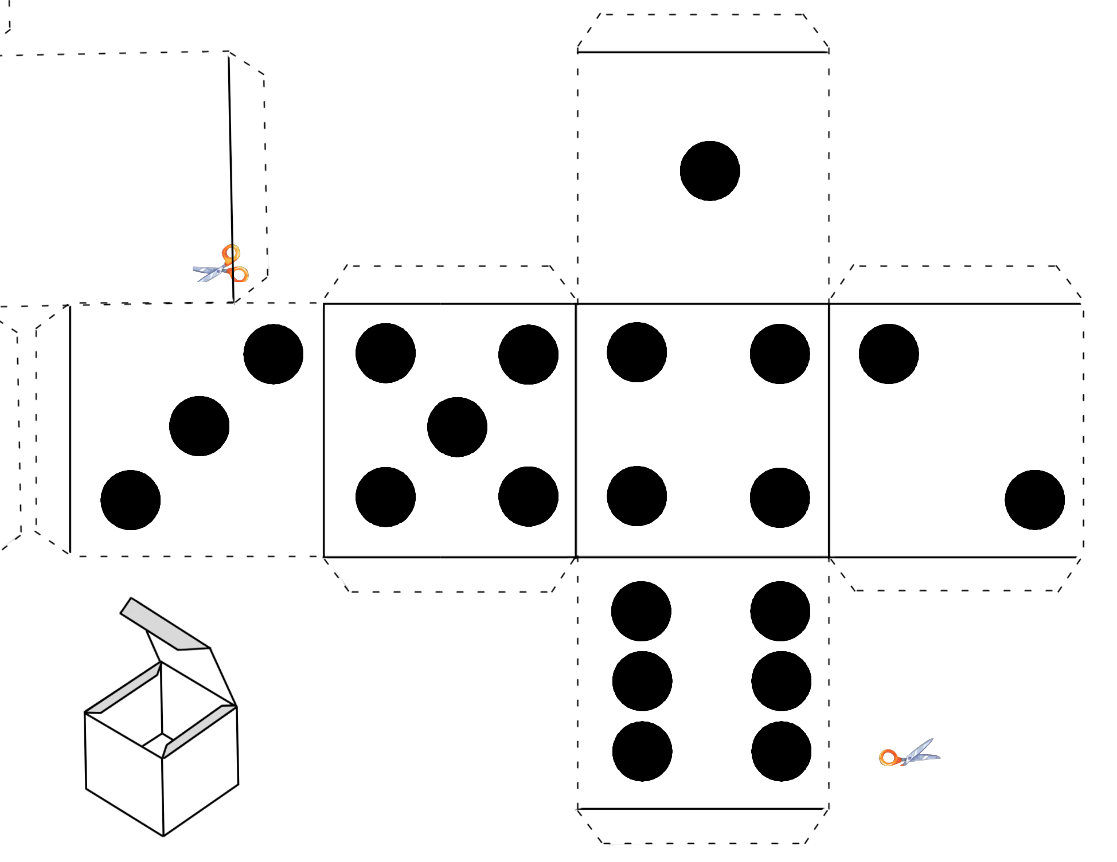  Copyright by Big Life Journal - biglifejournal.com | glue or tape

glue or tape glue or tape

glue or tape

glue or tape glue or tape

glue or tape

Page 3
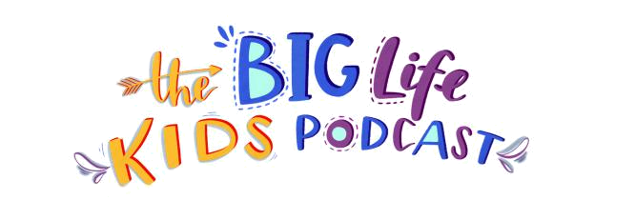
EPISODE 23 GUIDE

INdiscoverTHISEPISODE,howtofocusCHILDRENonthepositivesW ILL
travel to Hong Kong

be inspired by Dr. Jamie Chiu, psychologist and founder of The Brightly Project

discussionWhatkindofbridgesquestionswouldyou like to build in your brain? (positivity bridge, kindness bridge, gratitude bridge, etc.)
How do you make the positivity bridges in your brain stronger? (by using it more often and finding positive things in any situation)
Who is the most positive person you’ve ever met? What qualities did you appreciate about them? What can you do to be more like them?

1Try.CompletetheseWeeksactivities25&26"Be Positive" in the Big Life Journal - 1st Edition. In this chapter, children will practice being positive about a situation, a person, and their life. They will learn that when you’re positive, you look for good things in any circumstance.

- Use the 7-Day Positivity Challenge (in our Challenges Kit) to encourage a more positive attitude in your child. Each activity takes only a few minutes and helps rewire your child’s brain to be more positive.

- Use our printable 10 Uplifting Ways to Go About Your Day (in the Positivity & Connection Kit) to share uplifting moments throughout the day.

- Repeat Growth Mindset Affirmations (in our Growth Mindset Printables Kit) with your children to increase self-esteem, promote positive thinking, and change negative self-talk.

- Check out the Podcast Activity Kit for Seasons 1 & 2. The kit includes engaging activities to boost self-esteem, teach the importance of learning from mistakes, encourage resilience and more!

The Big Life Kids Podcast is produced by Big Life Journal and is available FREE on Apple Podcasts, Spotify, Google Play, and other platforms. Listen to Episode 23 on Apple Podcast (also available on other platforms). All kits can be found on biglifejournal.com.


biglifejournal.com/podcast

Enjoy Your Free Printable!

By downloading this file, you are agreeing to the

"Terms of Use".

Reselling of Big Life Journal printables is strictly prohibited. Posting Big Life Journal files or download links on websites, on social media, inside forums, in virtual classrooms, on personal or organization storage sites (Google Drive, Dropbox, etc.), inside chats, inside Facebook groups, and the like is strictly prohibited.

Forwarding our newsletter with the printables to your friends, colleagues, family, etc. is permitted.

You may only print Big Life Journal printables for your personal or classroom use. No other use is authorized. Please email hello@biglifejournal.com to request specific use for our printables.

You many not use Big Life Journal printables (free or purchased) in your professional practice with clients (coaching, therapy, private classes, and the like) without purchasing a professional license. For more information about professional licenses, please contact support@biglifejournal.com

It is illegal to reproduce or distribute copyrighted material without the permission of the copyright owner.

https://biglifejournal.com/pages/terms

