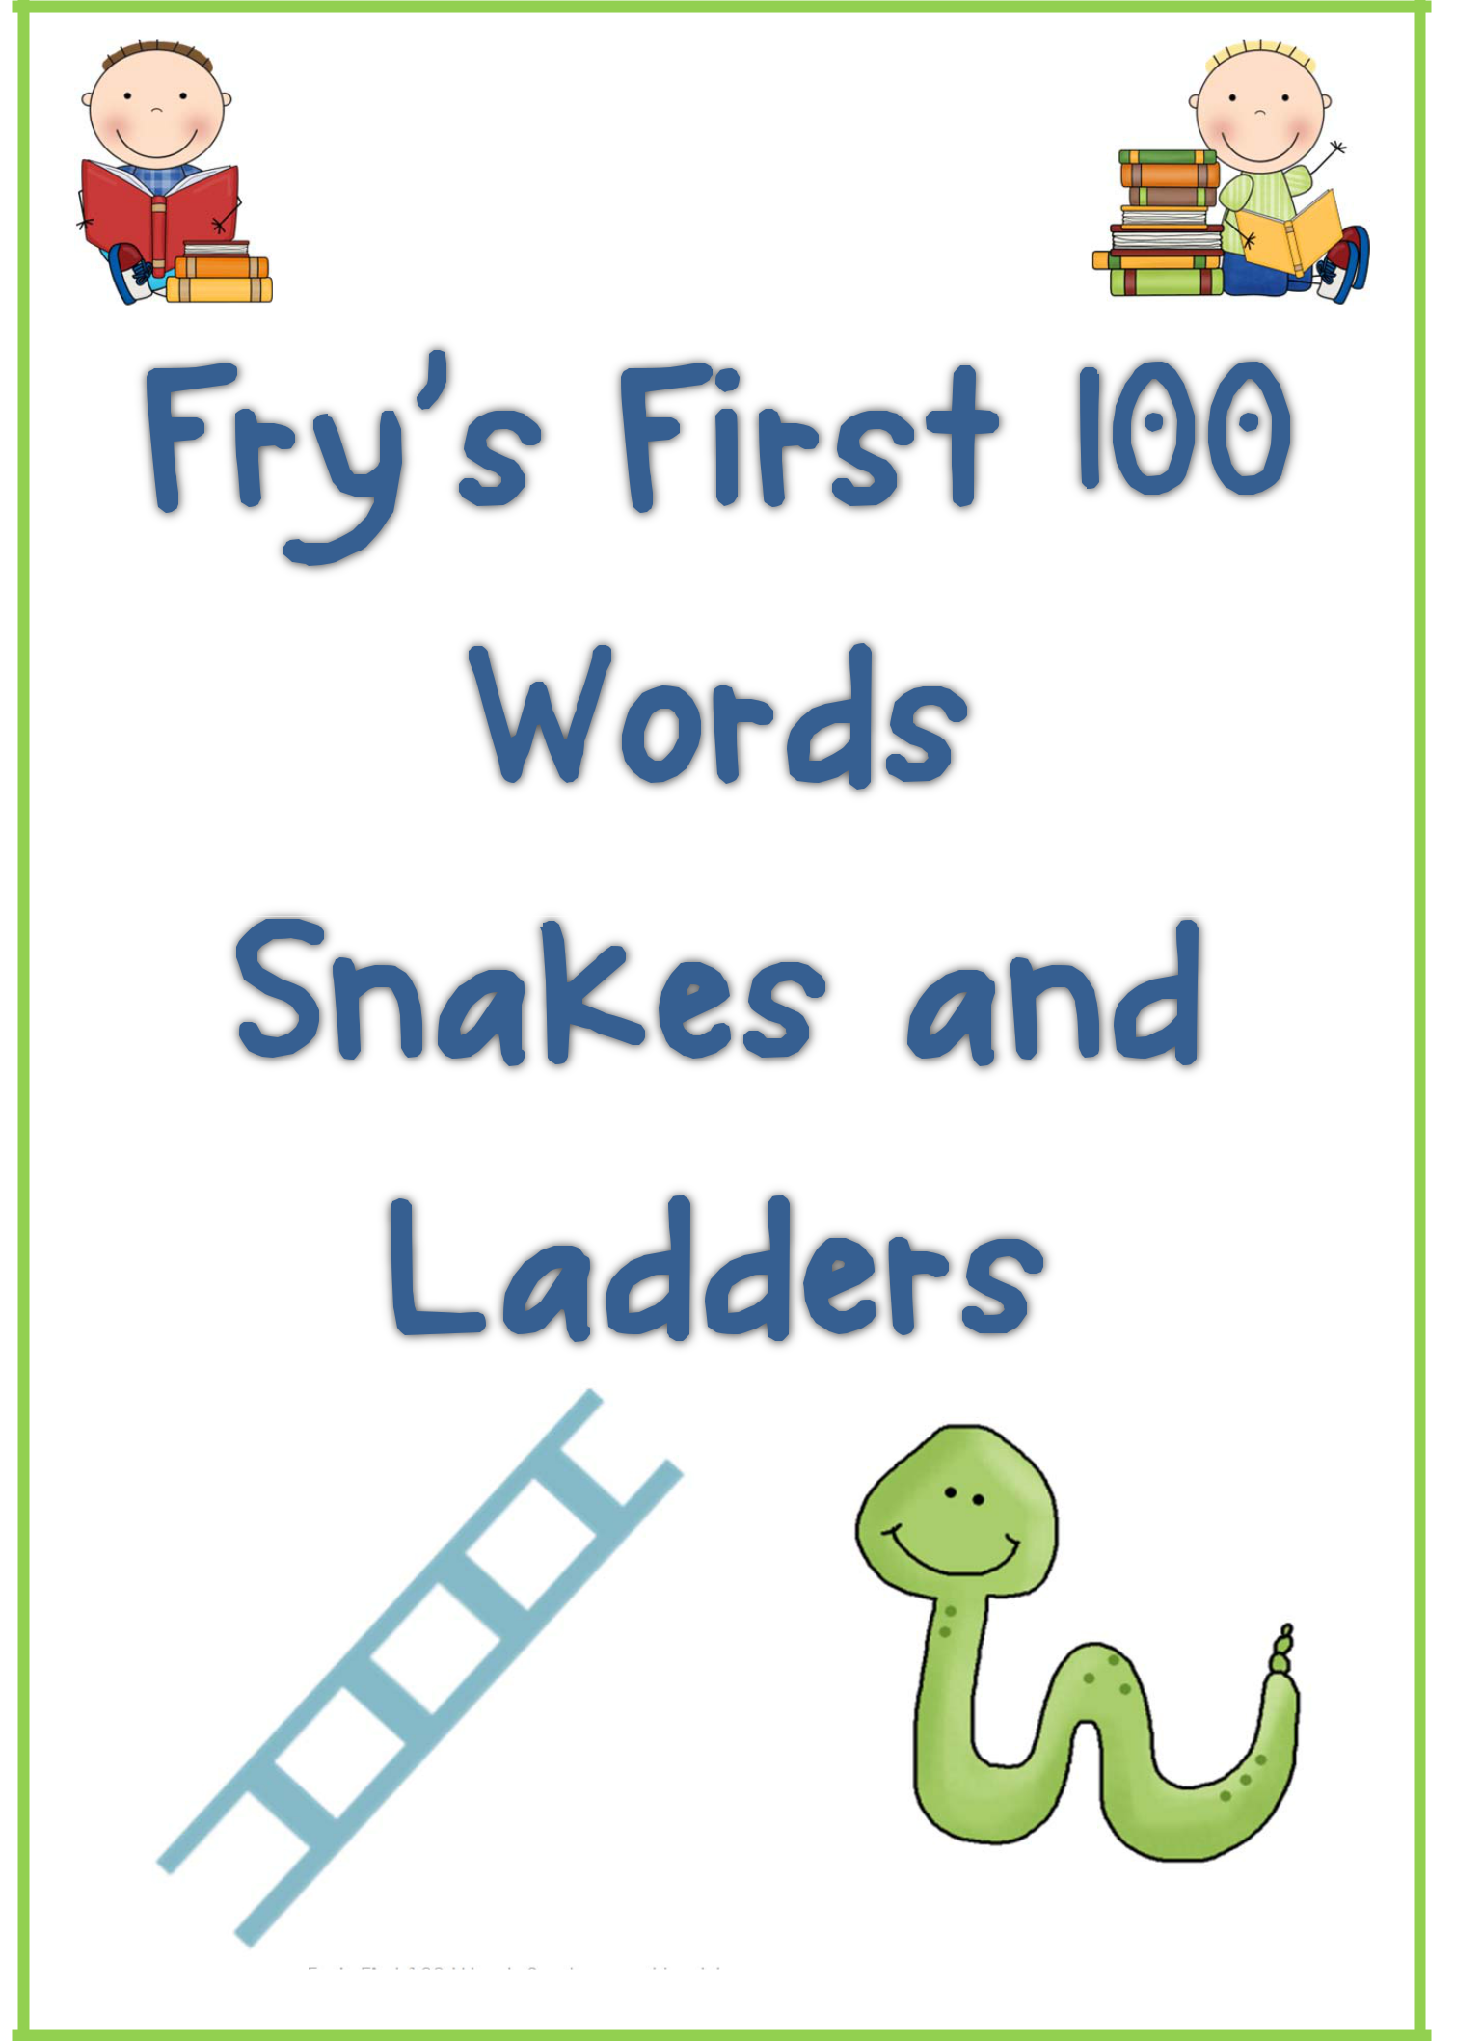

Fry’s First 100 Words Snakes and Ladders Games - Clever Classroom TpT ©

http://www.teacherspayteachers.com/Store/Clever-Classroom
Fry’s First 100 Words Snakes and Ladders Games Guide for Teachers



 Statement of Purpose: This resource gives elementary aged students the opportunity to revise and learn the first set of Fry’s most used words. Children will interact with peers whilst using known reading strategies to demonstrate reading skills.

How to use this resource: Print and laminate your set of 6 snakes and ladders games for students to play in small groups of between 2 and 6 players. You must demonstrate how to play the game and how to apply known reading strategies such as: Does it look right? Does it sound right? Can you sound it out? Have a go and so on.

The first player rolls one die and moves their object to the appropriate box. They must read each word they move over as they go. If the player doesn’t read each word, they must go back to where they started and the next player takes their turn. If a player doesn’t know a word, what strategies can you they use to find out Children can ask other players for help. Each player must find their way to the ‘finish’ box at the top of the game by reading the words correctly. Avoid landing on the snakes head and sliding down and try to climb ahead by moving up the ladders.

Variation: When landing on the final word of their turn, players can put that word into a sentence as well as reading it.
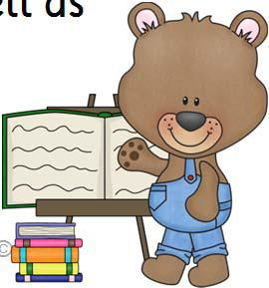

Clip art by: Scrappin Doodles.



Fry’s First 100 Words Snakes and Ladders Games - Clever Classroom TpT ©

http://www.teacherspayteachers.com/Store/Clever-Classroom
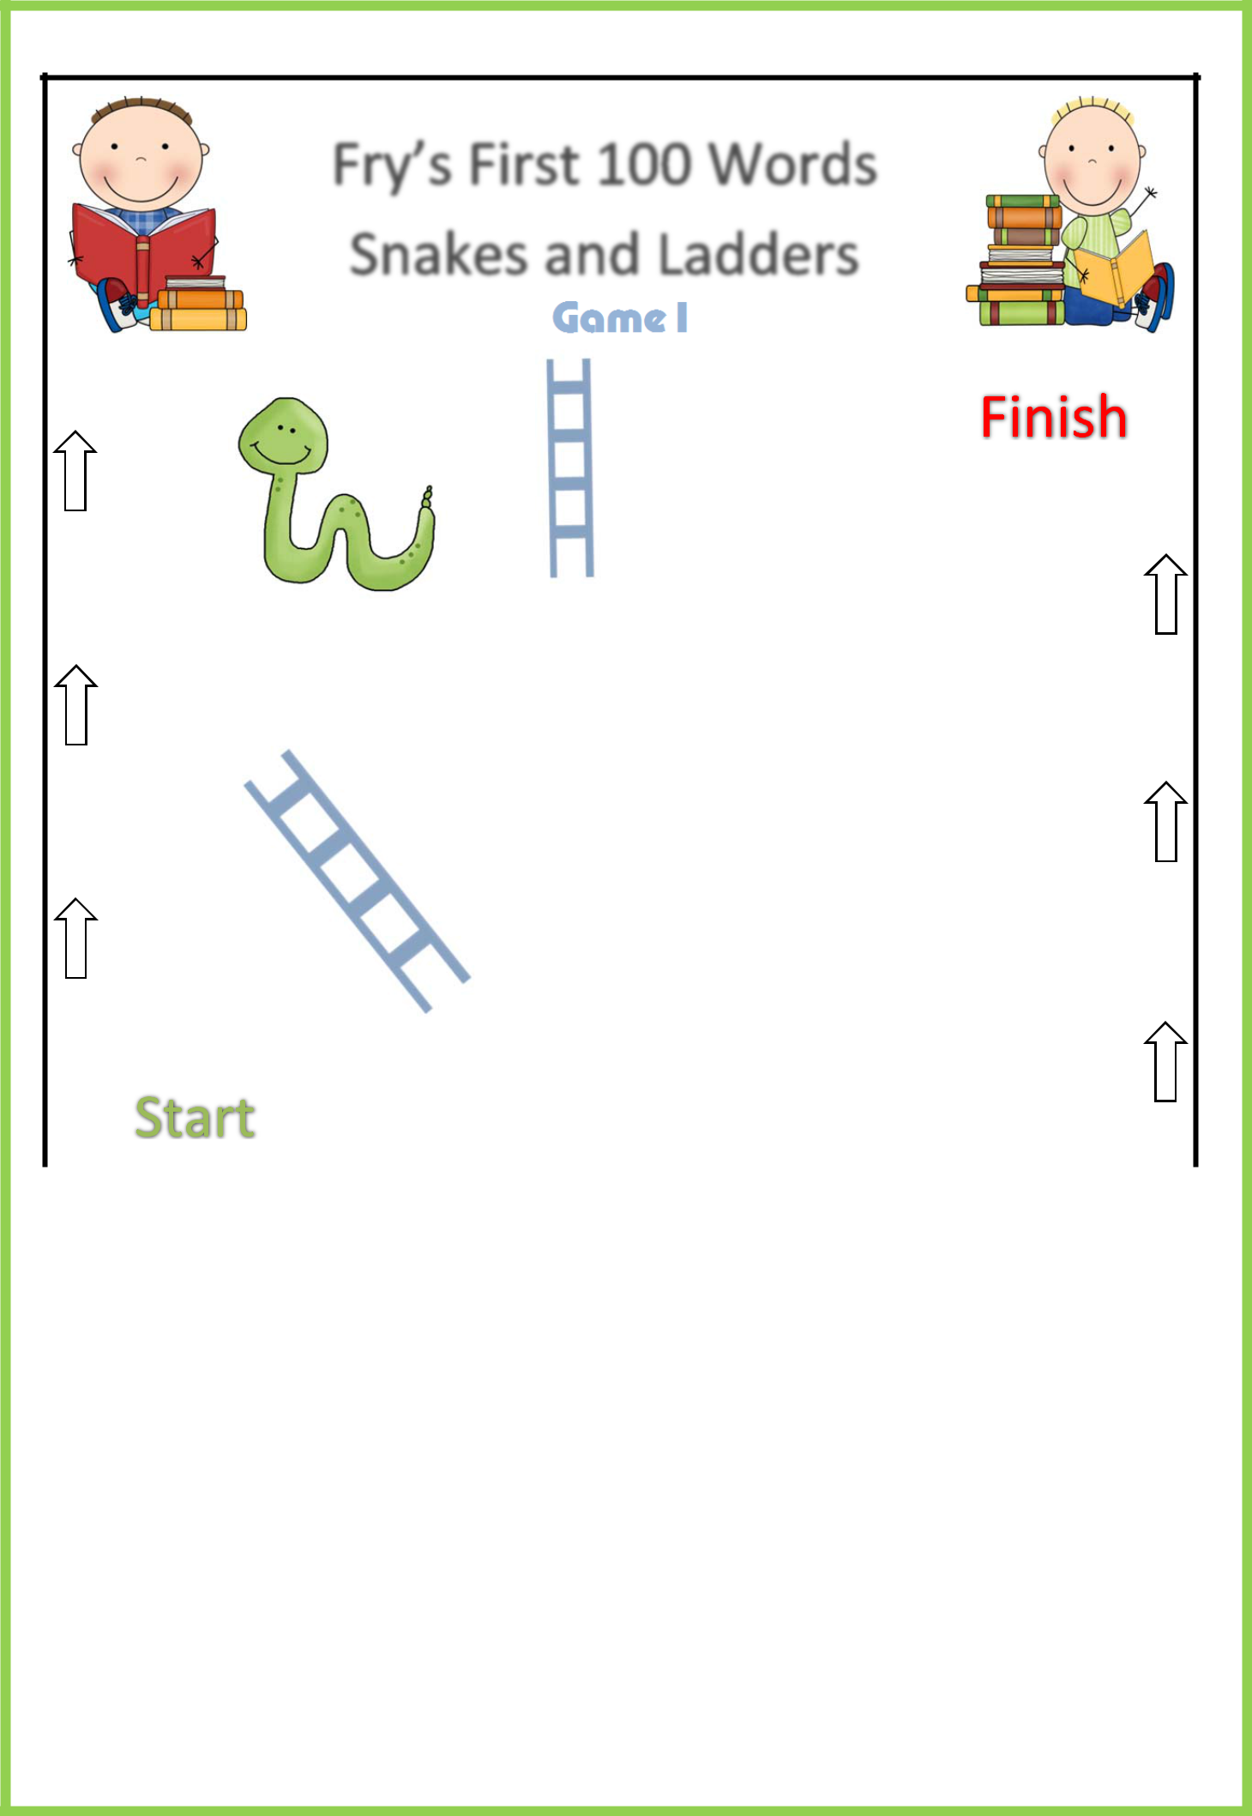

Game 1

a | or | and
to | in | is | you
that | it | he | was
for | on | are | as
with | his | they | I
at | be | this | have
 | or | one | had
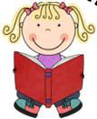

Players: 2-6

Instructions: All players begin on the ‘start’ box at the bottom of the game.

Roll one die and move your object to the appropriate box. Read each word you move over as you go. If you don’t read each word, you must go back to where you started and the next player takes their turn. If a player doesn’t know a word he should use his reading strategies. Players can ask other players for help. Each player must find their way to the ‘finish’ box at the top of the game by reading the words correctly. Avoid landing on the snake heads and sliding down and try to climb ahead by moving up the ladders.

Variation: When landing on a word, players can put that word into a sentence as well as reading it.

Fry’s First 100 Words Snakes and Ladders Games - Clever Classroom TpT ©

http://www.teacherspayteachers.com/Store/Clever-Classroom
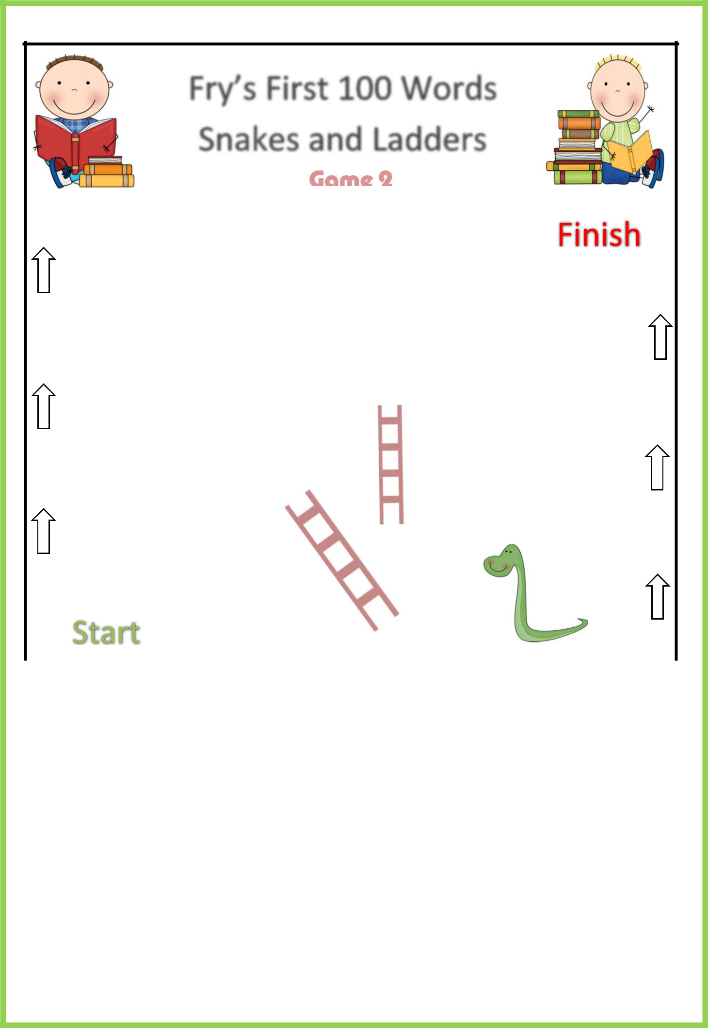

Game 2

not | word | but
what | all | were | we
when | your | can | said
there | use | an | each
which | she | do | how
their | if | will | up
 | about | out | many
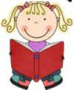

Players: 2-6

Instructions: All players begin on the ‘start’ box at the bottom of the game.

Roll one die and move your object to the appropriate box. Read each word you move over as you go. If you don’t read each word, you must go back to where you started and the next player takes their turn. If a player doesn’t know a word he should use his reading strategies. Players can ask other players for help. Each player must find their way to the ‘finish’ box at the top of the game by reading the words correctly. Avoid landing on the snake heads and sliding down and try to climb ahead by moving up the ladders.

Variation: When landing on a word, players can put that word into a sentence as well as reading it.

Fry’s First 100 Words Snakes and Ladders Games - Clever Classroom TpT ©

http://www.teacherspayteachers.com/Store/Clever-Classroom
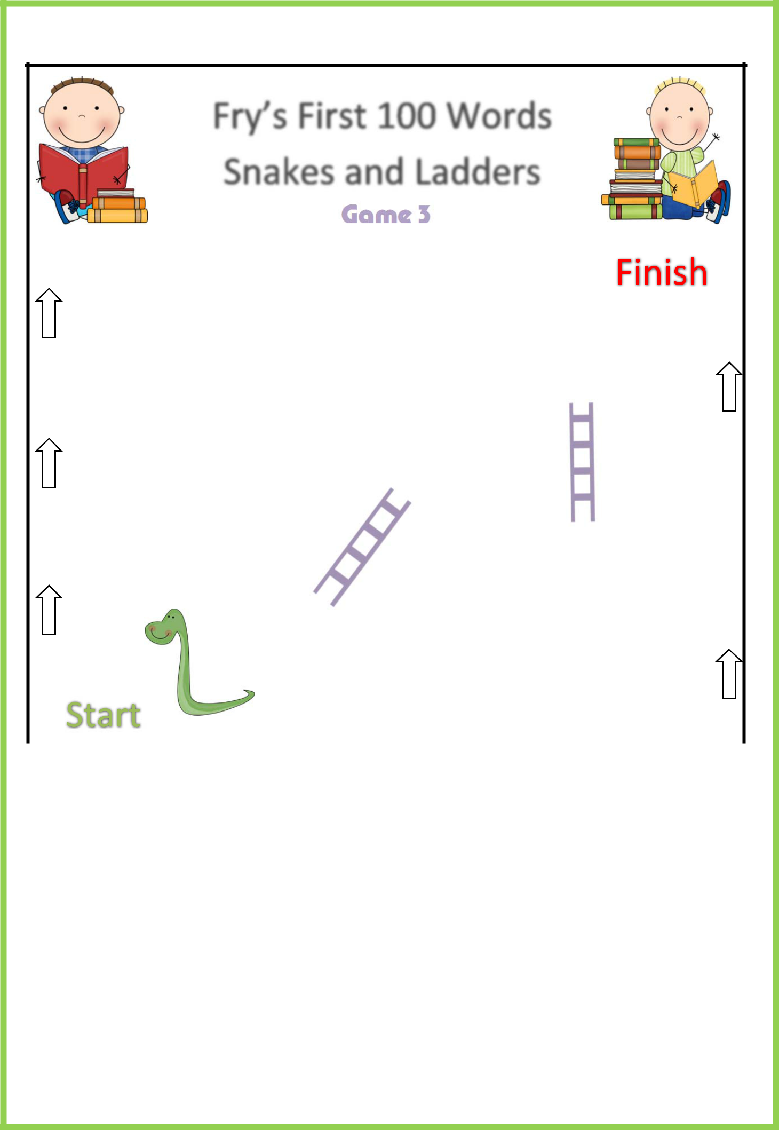

Game 3

so | them | these
some | her | would | make
like | him | into | time
has | look | two | more
write | go | see | number
no | way | could | people
 | than | first | water
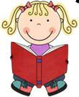

Players: 2-6

Instructions: All players begin on the ‘start’ box at the bottom of the game.

Roll one die and move your object to the appropriate box. Read each word you move over as you go. If you don’t read each word, you must go back to where you started and the next player takes their turn. If a player doesn’t know a word he should use his reading strategies. Players can ask other players for help. Each player must find their way to the ‘finish’ box at the top of the game by reading the words correctly. Avoid landing on the snake heads and sliding down and try to climb ahead by moving up the ladders.

Variation: When landing on a word, players can put that word into a sentence as well as reading it.

Fry’s First 100 Words Snakes and Ladders Games - Clever Classroom TpT ©

http://www.teacherspayteachers.com/Store/Clever-Classroom
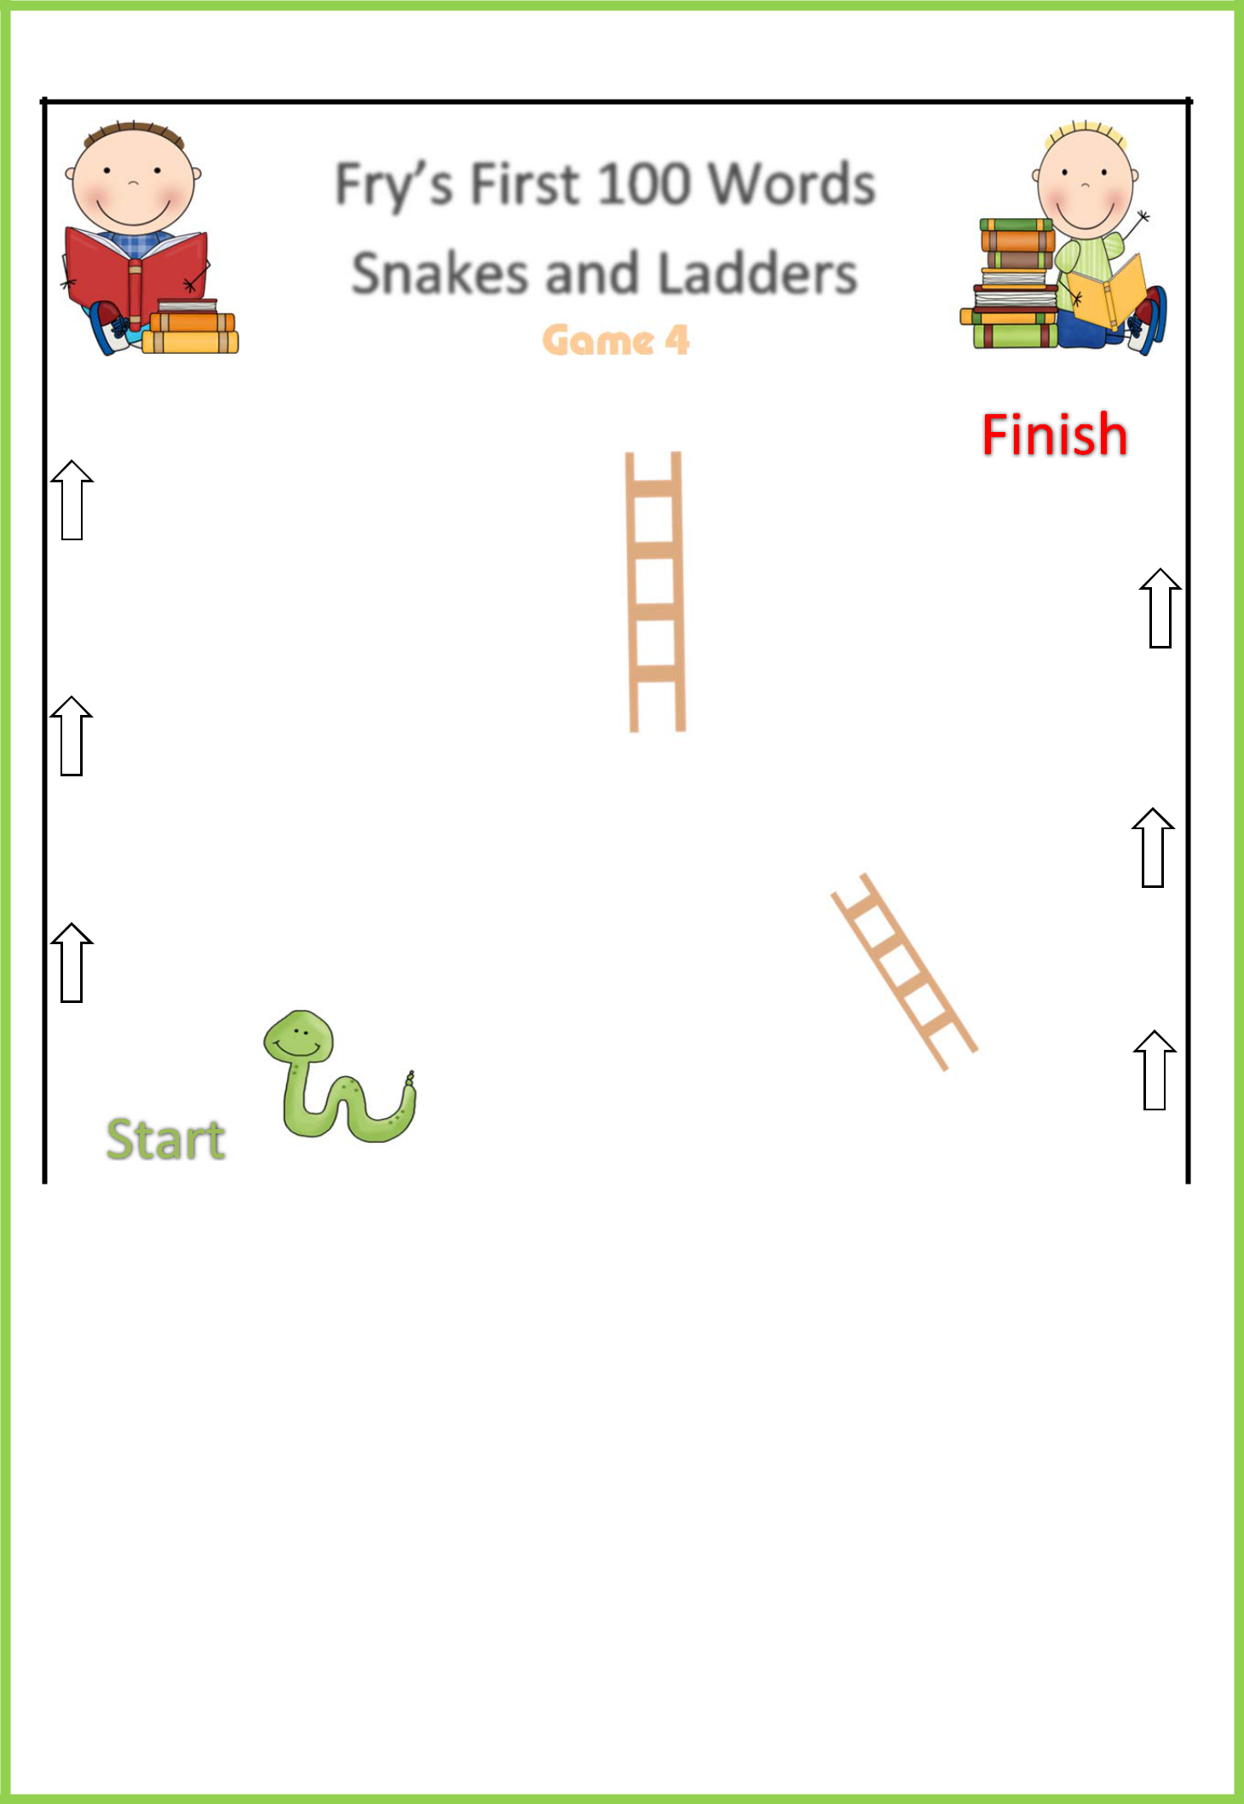

Game 4

am | call | who
its | now | find | long
down | day | did | get
come | made | may | part
the | from | by | other
then | my | been | on
 | at | with | were
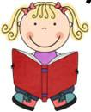

Players: 2-6

Instructions: All players begin on the ‘start’ box at the bottom of the game.

Roll one die and move your object to the appropriate box. Read each word you move over as you go. If you don’t read each word, you must go back to where you started and the next player takes their turn. If a player doesn’t know a word he should use his reading strategies. Players can ask other players for help. Each player must find their way to the ‘finish’ box at the top of the game by reading the words correctly. Avoid landing on the snake heads and sliding down and try to climb ahead by moving up the ladders.

Variation: When landing on a word, players can put that word into a sentence as well as reading it.

Fry’s First 100 Words Snakes and Ladders Games - Clever Classroom TpT ©

http://www.teacherspayteachers.com/Store/Clever-Classroom
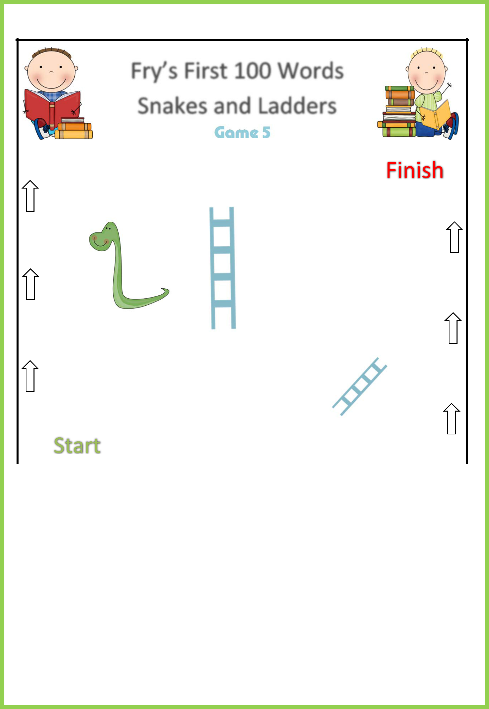

Game 5

has | they | each
day | I | which | look
did | at | she | two
get | be | do | more
come | this | how | write
made | have | their | go
 | may | from | if
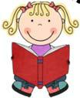

Players: 2-6

Instructions: All players begin on the ‘start’ box at the bottom of the game.

Roll one die and move your object to the appropriate box. Read each word you move over as you go. If you don’t read each word, you must go back to where you started and the next player takes their turn. If a player doesn’t know a word he should use his reading strategies. Players can ask other players for help. Each player must find their way to the ‘finish’ box at the top of the game by reading the words correctly. Avoid landing on the snake heads and sliding down and try to climb ahead by moving up the ladders.

Variation: When landing on a word, players can put that word into a sentence as well as reading it.

Fry’s First 100 Words Snakes and Ladders Games - Clever Classroom TpT ©

http://www.teacherspayteachers.com/Store/Clever-Classroom
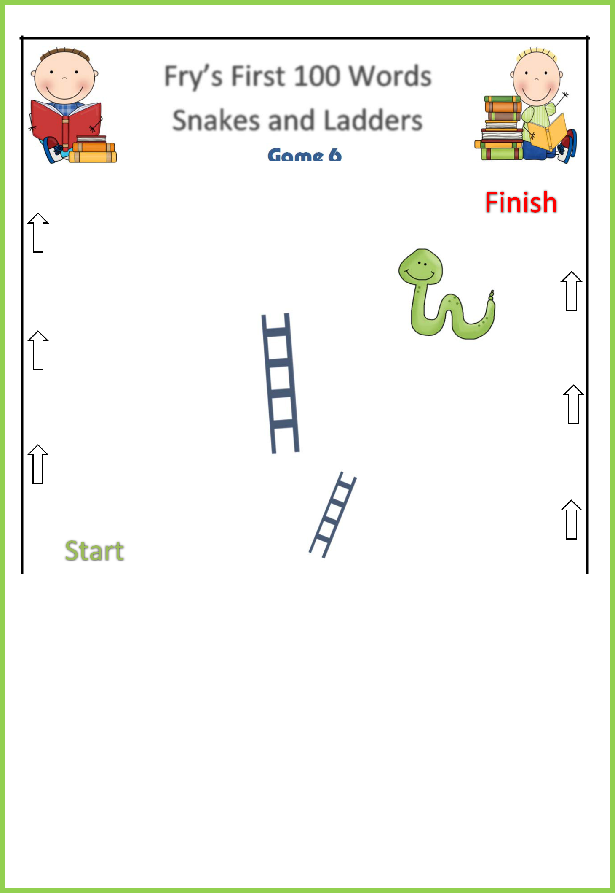

Game 6

the | see | of
or | one | up | no
a | by | to | but
out | all | her | who
its | did | get | we
for | his | an | she
 | about | not | your
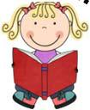

Players: 2-6

Instructions: All players begin on the ‘start’ box at the bottom of the game.

Roll one die and move your object to the appropriate box. Read each word you move over as you go. If you don’t read each word, you must go back to where you started and the next player takes their turn. If a player doesn’t know a word he should use his reading strategies. Players can ask other players for help. Each player must find their way to the ‘finish’ box at the top of the game by reading the words correctly. Avoid landing on the snake heads and sliding down and try to climb ahead by moving up the ladders.

Variation: When landing on a word, players can put that word into a sentence as well as reading it.

Fry’s First 100 Words Snakes and Ladders Games - Clever Classroom TpT ©

http://www.teacherspayteachers.com/Store/Clever-Classroom
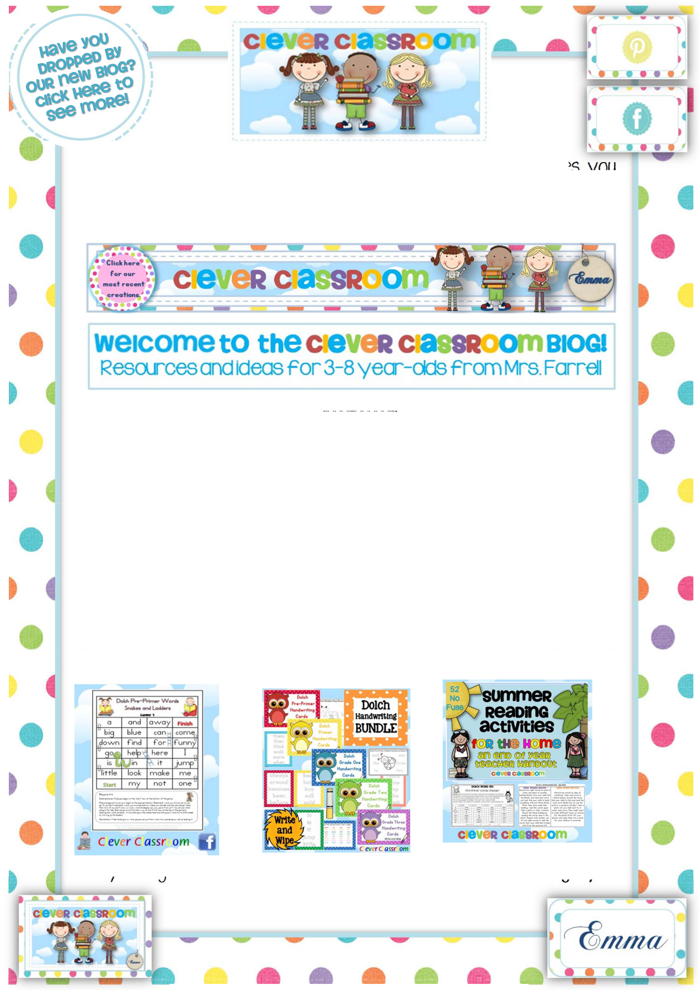

Thank you for downloading our resource! I hope it saves you

some time and energy! If you have any questions about any of our resources, please contact me (Emma) via my TpT store.

- Copyright

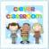 The material provided in our Teachers Pay Teachers store is copyright protected and is to be used for single classroom use only. Resources are not to be reproduced or sold in any capacity. Files cannot be modified in any way by the user as all files are protected by PDF format to sustain the design and protect any clip art used, as requested by clip art sellers. Please email emma@cleverclassroom.com.au if you have any further questions.

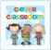 Multiple user Licenses: TpT has now introduced an option to purchase more than one license for each TpT purchase that you make. If you would like a colleague to have a copy of one of our resources please select the multiple user license option in checkout or log back in and you can add it from the ‘My Purchases’ tab. Most of our multiple user licenses are priced at 50% of the original.

- Similar resources that you might like:

or you might like to visit our Literacy Games and Activities category in

our TpT store for more ideas to save you time.

