Creating a Game Board in Microsoft Word

- Open Microsoft Word. To create a game

board, you will probably want to use more space on the page than is allowed by the standard margin settings. Therefore, the first thing you need to do is change the margins.

- Pull down the File menu and click on Page Setup.

  - Notice that the Margins tab is in front and that the number in the Top margin box is highlighted. Simply type your new margin over it. We'll use a 1/2 inch margin, so type .5 in the Top margin box.

  - Change each margin to .5 inches. (You can just hit the Tab key to go to the next box.)

  - Before you click OK, while you're in the Page Setup window, decide whether you want your game board to appear vertically or horizontally on the
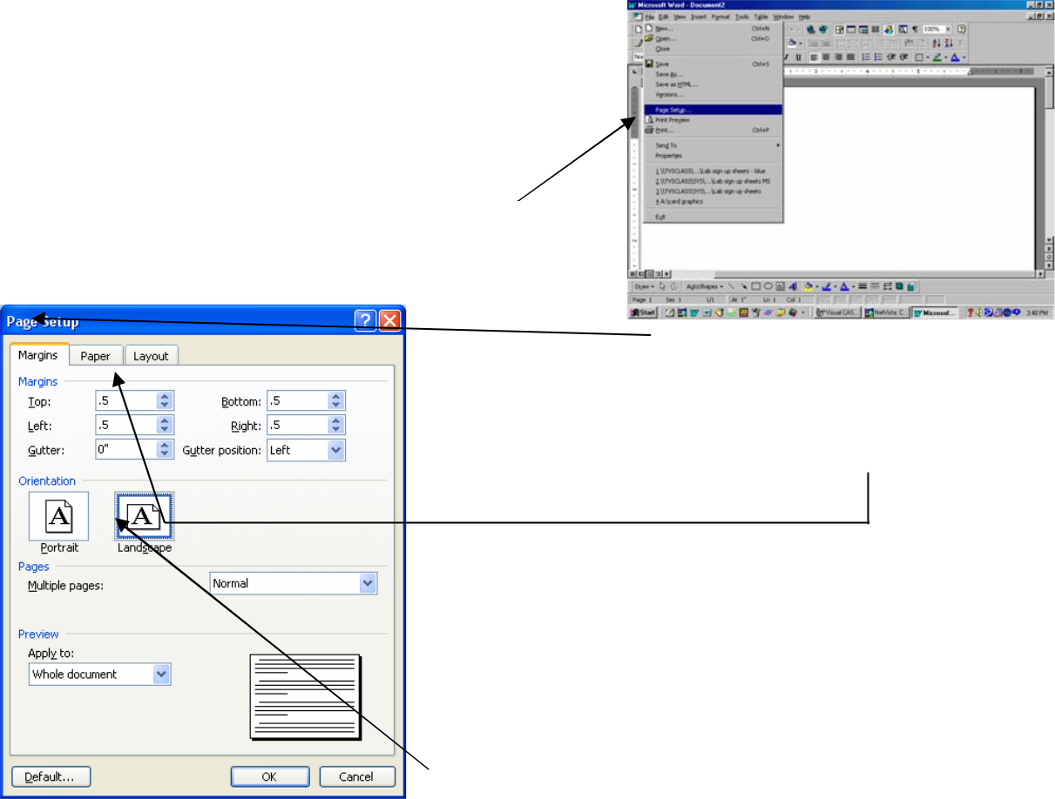
page. If you want it to appear horizontally, click on the Landscape button. When you've finished, click
OK.

- You'll be using a table to create your game board. Whenever you are working with tables, it's a good idea to start your table on the second line of the page. That way, you can always go back and add text or graphics above the table if you need to. So before we make the table, hit the Enter key once.

  - Now pull down the Table menu and click on Insert Table.
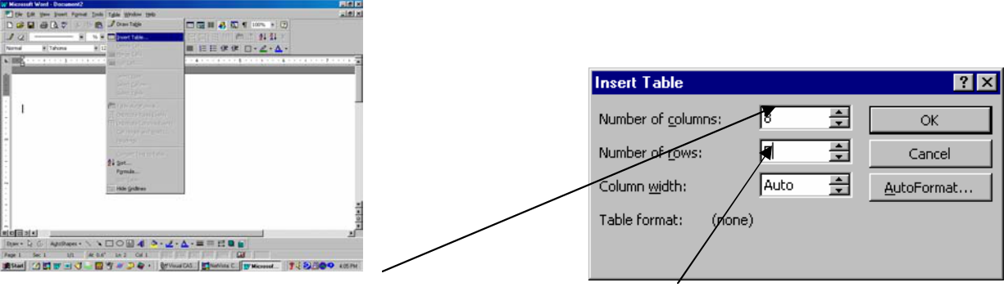

- For Number of columns, put 8. For Number of rows, put 5. Click OK.

2

- You should now have a table that looks like this:

- Take some time to practice selecting one or more cells, columns, rows, and the entire table.

- To select a cell, click inside the cell and drag your mouse to the right.

- To select more cells, keep dragging the mouse to the right and/or down until you’ve selected the cells you want.
- To select a row, hold your pointer to the left of the row (outside the border) until it changes into an arrow and click the mouse.

- To select more rows, hold the mouse button down and drag up or down until you’ve selected the rows you want.
- To select a column, hold your pointer at the top of the column (on the border) until it changes into a downward-pointing arrow and click the mouse.
- To select more columns, hold the mouse button down and drag to the left or right until you’ve selected the columns you want.
- To select the entire table, use either the method for selecting an entire row or an entire column and click and drag until all the rows or all the columns are selected. Or click this symbol at the top left corner of the table.
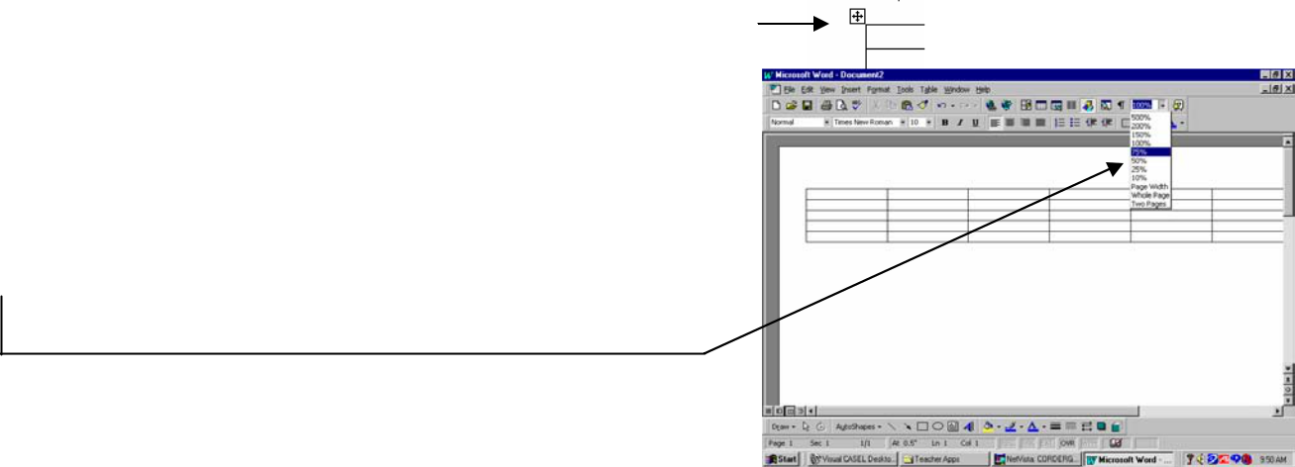

- If you are working in Landscape (horizontal) orientation, you cannot see the whole table at once. To make your table easier to work with, it is helpful to be able to see the entire page as you work. To do this, click on the small downward arrow next to the 100% in the top right-hand corner of your screen. Click on either 75% or 50%, whichever you are more comfortable with.

- Now select the entire table using one of the methods listed above. With the entire table selected, pull down the Table menu and click on Table Properties.
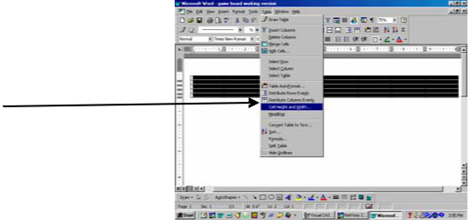
3
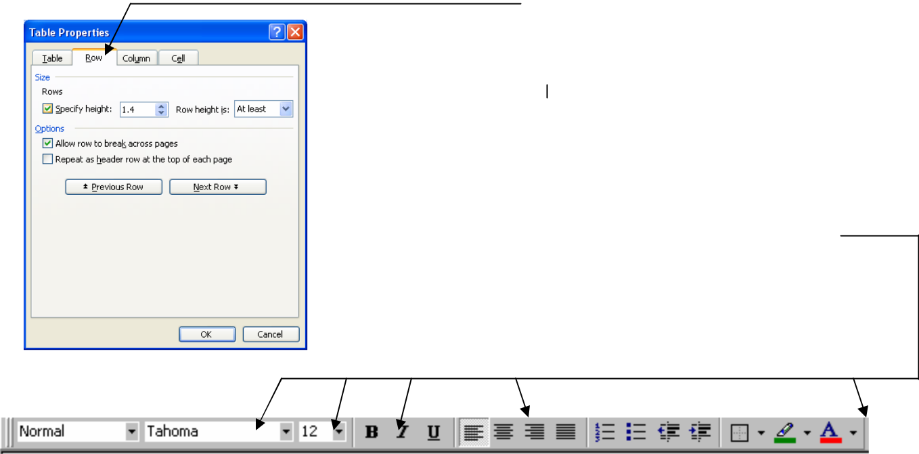

14) Click on the Row tab.

- Check the box next to Specify height and type in

1.4". This will make all your rows 1.4" high. Click
OK.

  - While your table is still selected, you can choose your font, your font size and color, bold, italics, centering, etc using the buttons on the Formatting toolbar at the top of your screen. Doing this while the entire table is selected will apply those settings to the whole table. (A font size of 14, bold works well for this table.)

- Notice that in its current form, this table has many
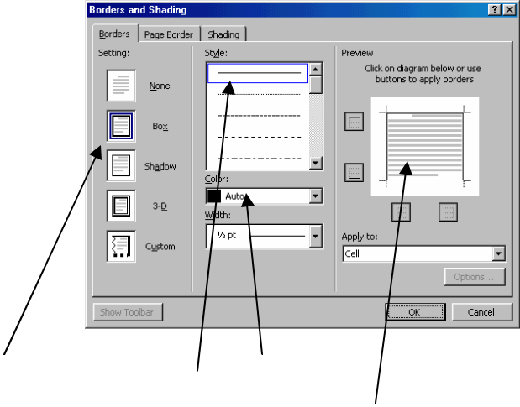
uses. To create the game board, however, you will need to remove some of the lines surrounding the cells. These lines are called borders.

- Select the first cell in the second row. Now click in that cell with your right mouse button. Click (with the left button) on Borders and Shading. (An alternative is to pull down the Format menu, with the cell selected, and click on Borders and Shading.)

- Notice that the current border setting is a Box, the current line style is a thin solid black line, and that the preview shows that the cell has borders on all four sides. All of these settings can be changed to create different looks. Now look at the game board you want to create. In the second row, the first 6 cells have no left or right border. To remove these borders for a selected cell, simply click on the line in the preview box of the Borders and Shading window. (Clicking the line again will replace it.)

  - Now remove the left and right borders from each of the first 6 cells in the second row. Do the same for the 3rd through 8th cells in the fourth row. Notice that there are still visible (faded) lines around the cells. Don't worry. These will not print out. They are simply there to indicate the boundaries of the cells.
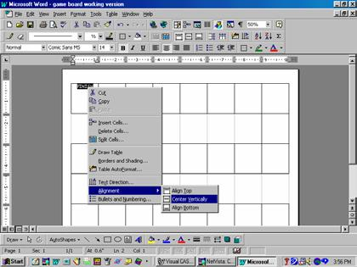
4

- Your table should now start to look more like a game board. Your next step will be to type text in the cells. Click in the first cell on the first row. If you centered your text in Step 16, your cursor will be in the middle of the cell. Type the word FINISH.

Notice that the text appears at the top of the cell. If you would like your text to appear in the middle of the cell, you have two options:

- You can click your cursor to the left of the word and hit the Enter key a couple of times OR
- You can right-click anywhere within the cell and click on Cell Alignment. Click on the icon which shows text centered vertically and horizontally.

- Type text in several more cells and practice centering the text vertically. You may select several cells at once and center them all vertically at once.

- Your game board is almost finished. You're
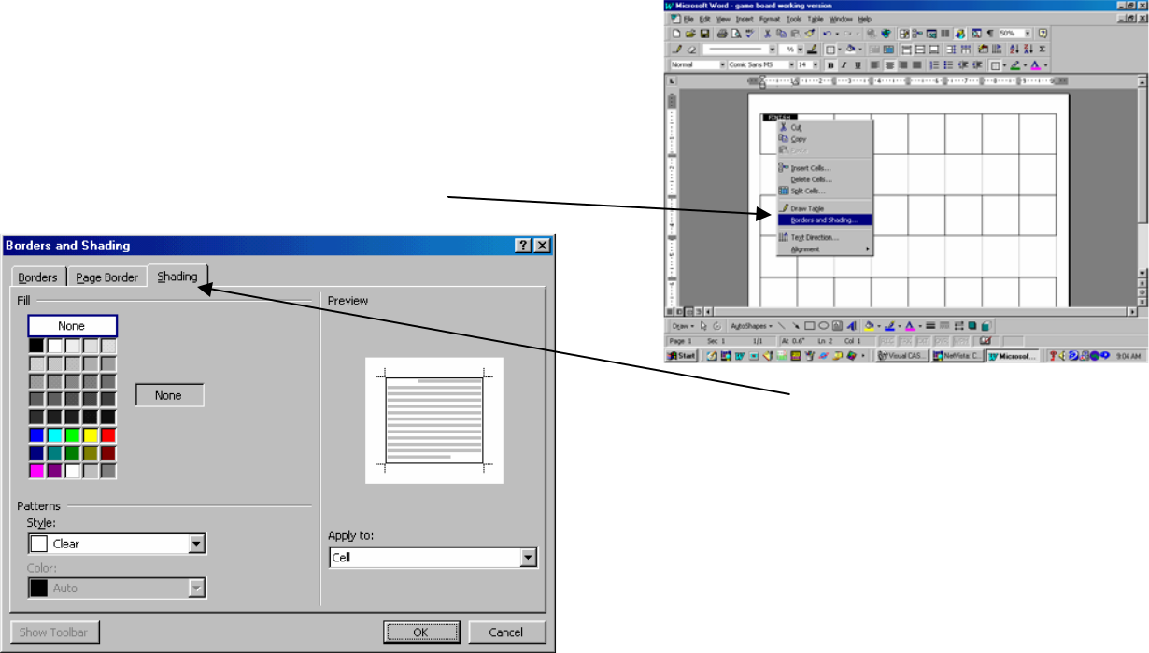
now ready to make it more colorful by filling some of the cells with color. Select a cell you would like to fill with a color and right-click in it. Click on Borders and Shading.

24) Click on the Shading tab.

25) Choose a color from the palette and click OK.

26) Apply color to several other cells for practice. You may wish to add WordArt titles and clip art to enhance the

appearance of your game board.
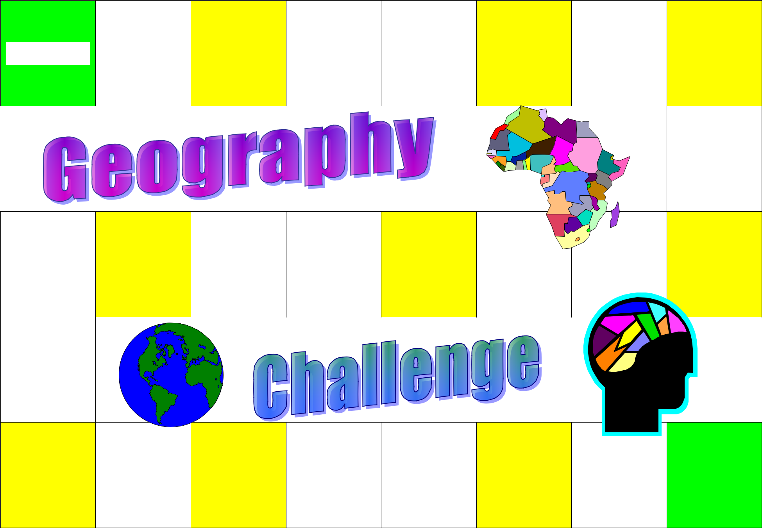  FINISH | LOSE A | MOVE | TAKE AN
 | LOSE A | AHEAD 2 | EXTRA
 | TURN | AHEAD 2 | EXTRA
 | TURN | SPACES | TURN
 |  | CHANGE
MOVE |  | PLACES | GO BACK 2
AHEAD 2 |  | WITH | GO BACK 2
AHEAD 2 |  | WITH | SPACES
SPACES |  | ANOTHER | SPACES
 |  | PLAYER
RETURN | GO BACK 1 | MOVE | START
RETURN | GO BACK 1 | AHEAD 3 | START
TO START | SPACE | AHEAD 3 | START
TO START | SPACE | SPACES

