12


GCSE LATIN
FOR TEACHING FROM 2016

CPD AUTUMN 2019

PREPARING CANDIDATES WITH LIMITED TEACHING TIME

CPD 2019 LT Page 1


Table of Contents:

p. 2 Hand-out: 1st/2nd declension adjectives by topic

p. 3 Hand-out: 1st/2nd declension adjectives vocab test

pp. 4-5 Hand-out: “The cheeky monkey”

p. 6 “The Golden Fleece” board game template

- 7 “The Golden Fleece” board game cards samples p. 8 “The Honeycomb” game template

- 9 “The Honeycomb” game sample: 1st conj. perfect tense pp. 10-11 Shared translation sample (Team 1)

pp. 12-13 Shared translation sample (Team 2)

pp. 14-15 “Two for One” comprehension sample (Team A) pp. 16-17 “Two for One” comprehension sample (Team B)

- 18-19 Grammar Book sample: 3rd declension nouns p. 20 List of useful publications

GCSE Vocab: Adjectives by “topic”

Character:
 |  |  | -a, -um |  |  | kind, generous
benignus,
bonus, -a, -um |  |  |  |  |  | good
dirus, -a, -um |  |  |  |  |  | dreadful
durus, -a, -um |  |  |  |  |  | hard, harsh
malus, -a, -um |  |  |  |  |  | bad
audax, -is |  |  |  |  |  | bold, daring
fortis, -e |  |  |  |  |  | brave
crudelis, -e |  |  |  |  |  | cruel
saevus, -a, -um |  |  |  |  |  | savage, cruel
ferox, -ocis |  |  |  |  |  | fierce, ferocious
gravis, -e |  |  |  |  |  | heavy, serious
Quality:
 | -e? |  |  |  |  | what sort of?
qualis, |  |  |  |  |  | what sort of?
talis, -e |  |  |  |  |  | such
pulcher, -chra, -chrum |  |  |  |  |  | beautiful, handsome
celer, -is, -e |  |  |  |  |  | quick, fast
stultus, -a, -um |  |  |  |  |  | stupid
dives, -itis |  |  |  |  |  | rich
facilis, -e |  |  |  |  |  | easy
difficilis, -e |  |  |  |  |  | difficult
iuvenis, -e |  |  |  |  |  | young
senex, -is |  |  |  |  |  | old; old man
novus, -a, -um |  |  |  |  |  | new
carus, -a, -um |  |  |  |  |  | dear
sacer, -cra, -crum |  |  |  |  |  | sacred
verus, -a, -um |  |  |  |  |  | true, real
vivus, -a, -um |  |  |  |  |  | alive, living
Position: |  |  |  |  |  | first
primus, -a, -um |  |  |  |  |  | first
medius, -a, -um |  |  |  |  |  | middle, middle of
proximus, -a, -um |  |  |  |  |  | nearest, next to
summus, -a, -um |  |  |  |  |  | highest, top of, greatest

Size:
 |  |  |  |  | how big? |  |  |  | CPD
quantus,* -a, -um?
tantus,* -a, -um |  |  |  |  | so great, such a great |  |  |  | 2019
altus, -a, -um |  |  |  |  | high, deep |  |  |  | 2019
 |  |  |  |  |  |  |  |  | LT
latus, -a, -um |  |  |  |  | wide |  |  |  | LT
 |  |  |  |  |  |  |  |  | 2Page
longus, -a, -um |  |  |  |  | long
brevis, -e |  |  |  |  | short, brief
magnus, -a, -um |  |  |  |  | big, large, great
ingens, -entis |  |  |  |  | huge
parvus, -a, -um |  |  |  |  | small
Quantity: |  |  |  |  | how many?
quot?
tot |  |  |  |  | so many
quantus,* -a, -um? |  |  |  |  | much?
tantus,* -a, -um |  |  |  |  | so much
multus, -a, -um |  |  |  |  | much, many
nullus, -a, -um |  |  |  |  | not any, no
pauci, -ae, -a |  |  |  |  | few, a few
omnis, -e |  |  |  |  | all, every
plenus, -a, -um |  |  |  |  | full
ceteri, -ae, -a |  |  |  |  | the rest, the others
Feelings: |  |  |  |  | angry
iratus, -a, -um
laetus, -a, -um |  |  |  |  | happy
infelix, -icis |  |  |  |  | unhappy, unlucky
miser, -a, -um |  |  |  |  | miserable, wretched, sad
tristis, -e |  |  |  |  | sad
solus, -a, -um |  |  |  |  | alone, lonely, only, on one’s own
perterritus, -a, -um |  |  |  |  | terrified
tutus, -a, -um |  |  |  |  | safe
Possessive: |  |  |  |  | my; mine
meus, -a, -um
tuus, -a, -um |  |  |  |  | your (sg.); yours
noster, -stra, -strum |  |  |  |  | our; ours
vester, -stra, -strum |  |  |  |  | your (pl.); yours
suus, -a, -um |  |  |  |  | his/her/its/their own



CPD 2019 LT Page 3

Example of a vocabulary test / learning tool. Anything that would engage your students can be used instead of the butterflies.

It is also useful when practising comparative and superlative degrees.

(GCSE) ADJECTIVES: 1st/2nd declension: Vocab test

TASK 1:

Write down the meaning of the adjectives in the space provided (on the opposite wing of each butterfly):
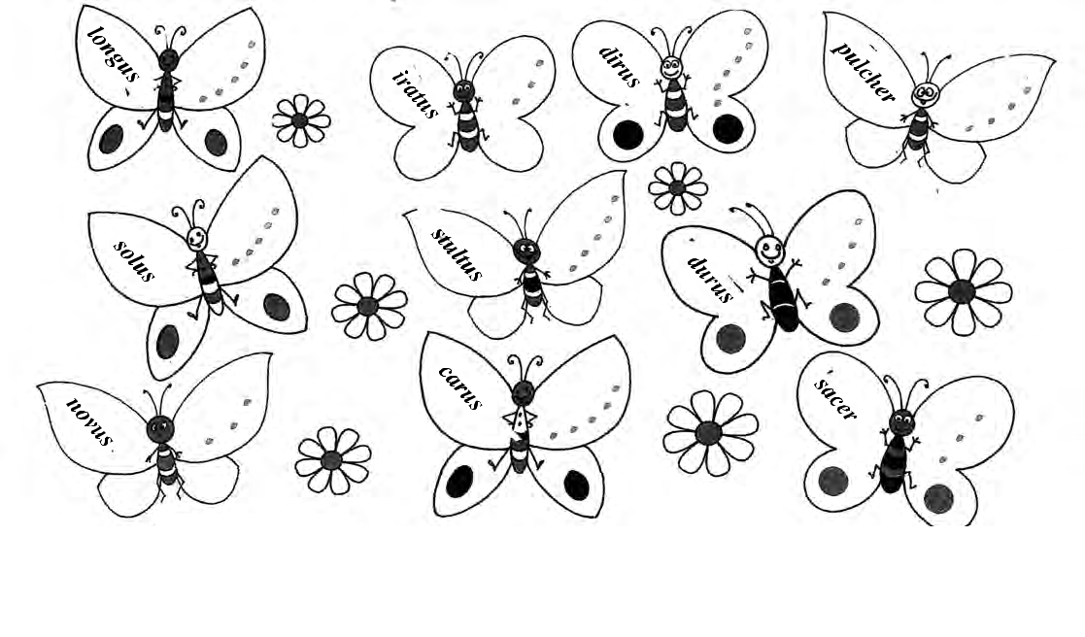

TASK 2:

Write down the opposites of the adjectives in the space provided (on the opposite wing of each butterfly).
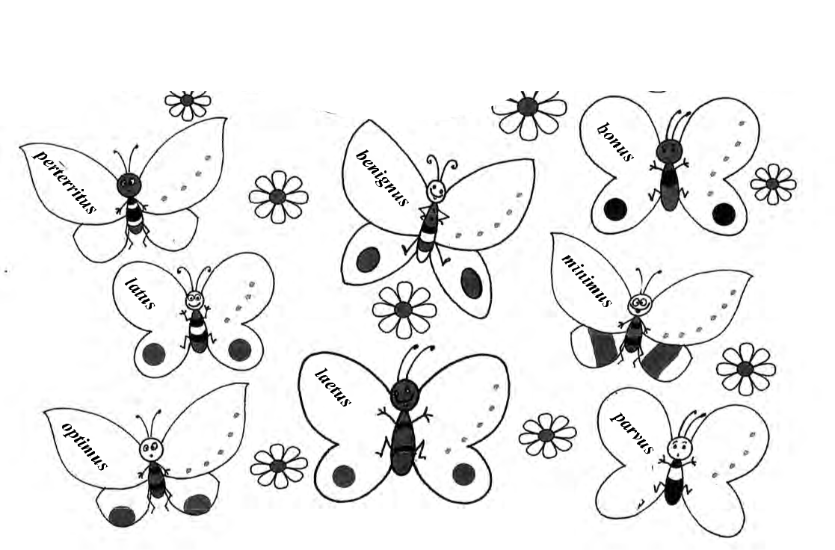

Choose from the pool provided:

magnus miser altus malus saevus maximus pessimus tutus

Idea borrow from “Playing English” by Sylvie Doladkova, INFOA 2006


CPD 2019 LT Page 4

SIMIA BUCCULENTA (the cheeky monkey): 1st/2nd declension adjectives

 | Here are some animals
 |  |  |  | Character:
 | & their Latin names.
 |  |  |  | benignus, -a, -um
 | We will learn how to
 | describe them correctly |  |  | bonus, -a, -um
 | in Latin.
 |  |  |  | dirus, -a, -um
 | TASK 1:
 | TASK 1: |  |  | durus, -a, -um
 | Fill in the meanings |  |  | malus, -a, -um
 | of the adjectives ➢
 |  |  |  | saevus, -a, -um
 | TASK 2: |  |  | Quality:
 | In pairs ask & answer
 |  |  |  | pulcher, -chra, -chrum
 | questions about each ani-
 |  |  |  | stultus, -a, -um
 | mal: e.g.
 |  |  |  | novus, -a, -um
 | “Quis est magnus?”
 |  |  |  | carus, -a, -um
 | “Elephantus magnus est.”
 |  |  |  | sacer, -cra, -crum
 |  | zebra |  | Size:
 |  | zebra |  | altus, -a, -um
 |  |  |  | latus, -a, -um
 |  |  |  | longus, -a, -um
 |  |  |  | magnus, -a, -um
 |  |  |  | parvus, -a, -um
 | Sg. cameopardalis (m/f)
 |  |  |  | Feelings:
 | Pl. cameopardales
 |  |  |  | iratus, -a, -um
 | catta |  |  | laetus, -a, -um
 |  |  |  | miser, -a, -um
 |  |  |  | solus, -a, -um
Sg. avis (f) |  |  |  | perterritus, -a, -um
Pl. aves
 |  |  |  |  |  |  |  | porcus | camelus (m/f) | Sg. lepus (m)
 |  | Sg. leo (m) |  |  |  |  |  |  |  | Pl. lepores
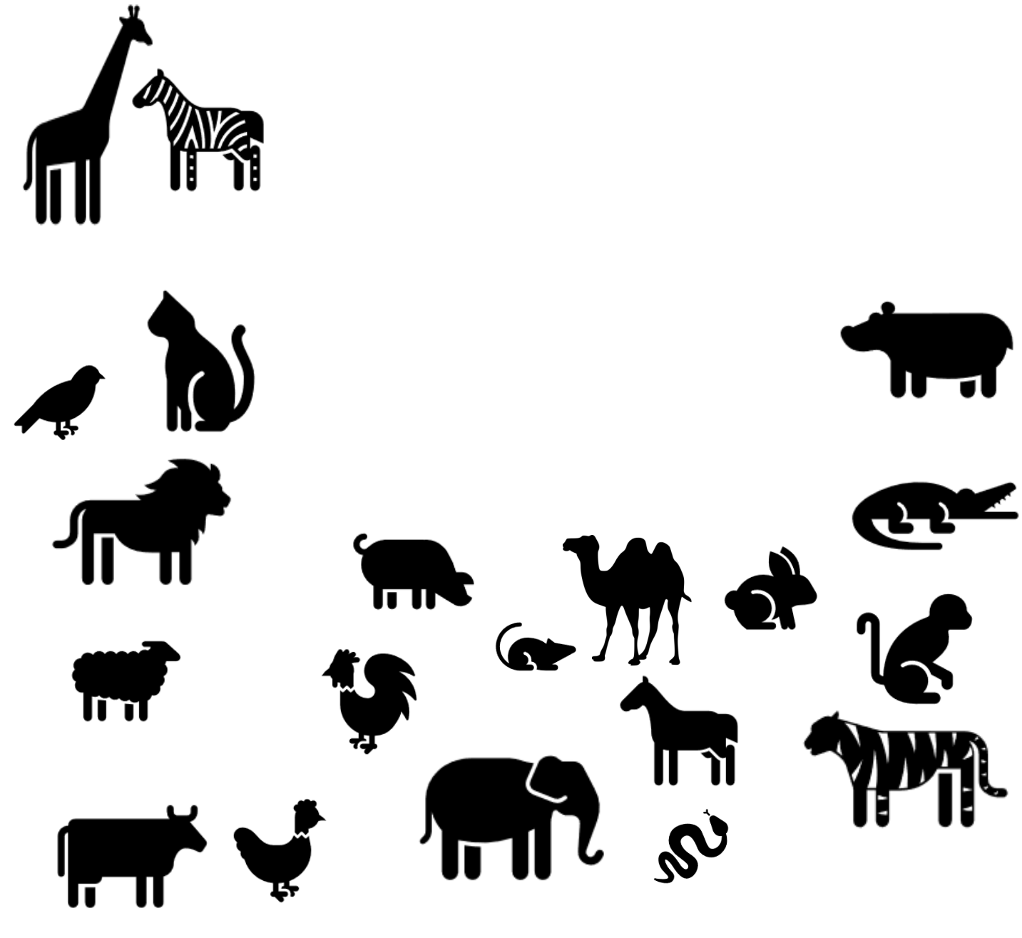

Pl. leones

Sg. ovis (f) | Sg. mus (m/f)
Pl. oves | Pl. mures
 | gallus
vacca |  | equus
 | gallina
 |  | Sg. serpens (m/f)
 | elephantus (m/f) | Pl. serpentes

That little bit

EXTRA:

Not all animals follow the 1st/2nd declension pattern!

I.e. Noun & adjec-tive will not always have the same ending!



Sg. anas (f)

Pl. anates

Sg. canis

(m/f)

Pl. canes

Sg. piscis _{Pl. pisces} (m/f)

hippopotamus

crocodilus

simia

Sg. tigris (m/f)

Pl. tigrides

Simia bucculenta: page 1


CPD 2019 LT Page 5

TASK 3: Choose the correct form of the adjectives provided, then translate as in the example.

E.g. Porcus magnus / | magna | / | magnum | est. | The pig is large.
a) Camelus benignus / benigna / benignum est. |  |  |  |  | …………………………………………………………………………………………..
b) Simia stultus / stulta / stultum est. |  |  |  |  | …………………………………………………………………………………………..
c) Mus parvus / parva / parvum est. |  |  |  |  | …………………………………………………………………………………………..
d) Zebra saevus / saeva / saevum non est. |  |  |  |  | …………………………………………………………………………………………..
e) Ovis perterritus / perterrita / perterritum est. |  |  |  |  | …………………………………………………………………………………………..


TASK 4: Now create as many descriptions of your own as you can.

Use Task 2 as a model. Make sure you use the correct gender form.


TASK 5: Let’s not forget the neuters: How would you describe these?

- Caelum (the sky) ……………………….…….. est.

- Templum (the temple) ………...….……………... est.

- Periculum (the danger) …………….……………..... est.

- Praemium (the prize) ……………….……..…… est.

- Vinum (the wine) …………………….… est.

TASK 6: Choose the correct form of the adjectives provided, then translate as in the example.

E.g. Porci magni / | magnae | / | magna | sunt. | The pigs are large.
a) Cameli benigni / benignae / benigna sunt. |  |  |  |  | …………………………………………………………………………………………..
b) Simiae stulti / stultae / stulta sunt. |  |  |  |  | …………………………………………………………………………………………..
c) Equi parvi / parvae / parva non sunt. |  |  |  |  | …………………………………………………………………………………………..
d) Zebrae saevi / saevae / saeva non sunt. |  |  |  |  | …………………………………………………………………………………………..
e) Oves perterriti / perterritae / perterrita sunt. |  |  |  |  | …………………………………………………………………………………………..


TASK 7: Now create as many plural descriptions of your own as you can.

Use Task 5 as a model. Make sure you use the correct gender and number form.

TASK 7: Yet again, let’s not forget the neuters: How would you translate these?

a) Verba nova sunt. ……………………………………………………………………………………..

- Templa pulchra sunt. ……………………………………………………………………………………..

- Pericula magna sunt. ……………………………………………………………………………………..

- Praemia bona sunt. ……………………………………………………………………………………..

e) Bella mala sunt. …………………………………………………………………………………….

Vocab extra: bellum, i, n = war periculum, i, n = danger praemium, i, n = prize verbum, i, n = word

Simia bucculenta: page 2

Graded card questions GOLDEN FLEECE game: easy (2), medium (4), hard (6), 
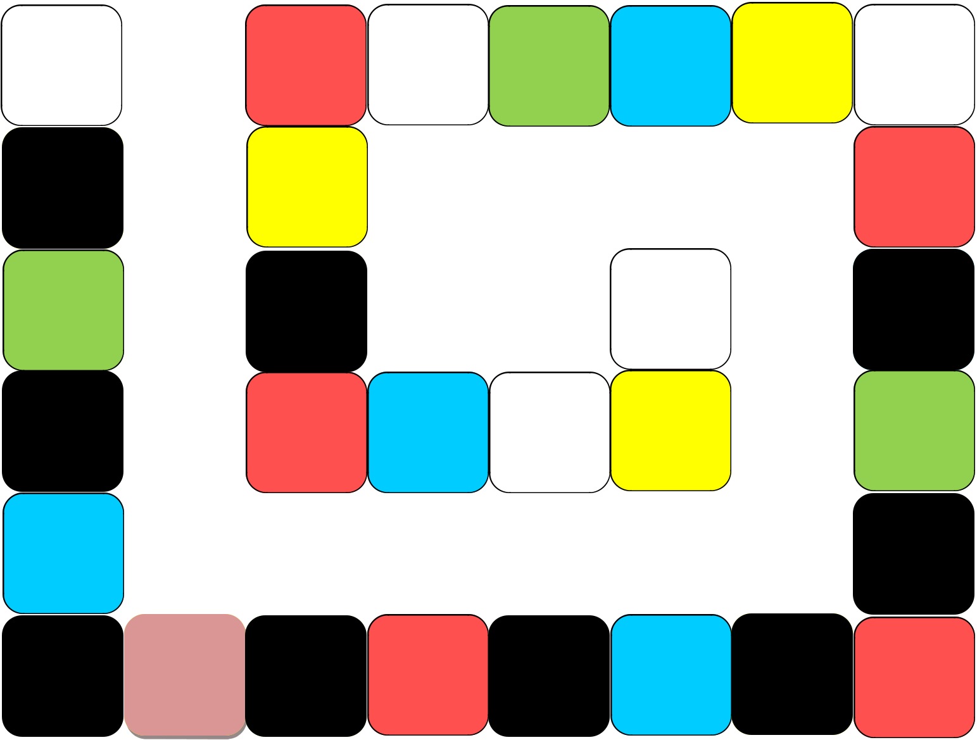
The GOLDEN fleece

game

CPD 2019 LT


START

1.

2.

3.

Move back

two spaces

4.

5. Move | 6.

forward

three spaces

22. | 21. Move | 20. | 19. | 18. | 17.
 | forward |  |  |  | Take an
 | four space |  |  |  | extra turn
23. |  |  |  |  | 16.

24. 15.

Miss a turn |  |  | FINISH
25. | 26. | 27. | 28. | 14.

Move back

two spaces

13.

Move back

two spaces

7. | 8. | 9. | 10. | 11. | 12.

Miss a turn

Play in pairs or groups of three to four.

Take turns to throw the dice and move round the board from the start square.

Each time you land on a col-oured square, pick a card of that colour and carry out the task.

If you land on a square with words, follow the instruc-tions.

One person should note down the score.

If a player cannot give an an-

swer, they miss a turn.

The winner is the first player to throw the number that takes them exactly to the finish square.

The group with most correct answers written down is the winning group.


Page 6


CPD 2019 LT Page 7

The Golden Fleece board game: sample cards: 2nd declension

1. | The GREEN cards: best suited to vocabulary or morphology:
 | legatus | praemium | vestimenta
 | signum | nuntius | dominus
2. | The BLUE cards: best suited to short phrases / sentences:
 | dominus servi | dunum legato | ira deorum
 | gladio pugnavit | templum video | dominos non amo
3. | The RED cards: best suited to translation:
4. Servi vinum amant. |  | 5. Legatus consilium | 25. Dei bellum viris
 |  | laudat. | parant. +1
7. Liberti dominos |  | 19. Templa deorum in | 28. Libertus servum
 | adiuvant. | foro sunt. +1 | gladio superat. +2

N.B. The above are sample sentences that normally would be numbered sequentially. It is a good idea to provide a translation key, so the teams can self-correct, e.g.:

4. Slaves love wine. | 5. The commander | 25. The gods prepare
 | praises the plan. | war for the men. +1
7. The freedmen help | 19. The temples of the | 28. The freedman
7. The freedmen help | 19. The temples of the | overcomes the slave with
the masters. | gods are in the forum. +1 | a sword. +2

N.B. Should you be short of time, you don’t need to pre-prepare cards. Just agree which pages of the vocab list / which exercises of a textbook will equate to which colour.


CPD 2019 LT Page 8

The Honeycomb Race

…………………………………………………………………….
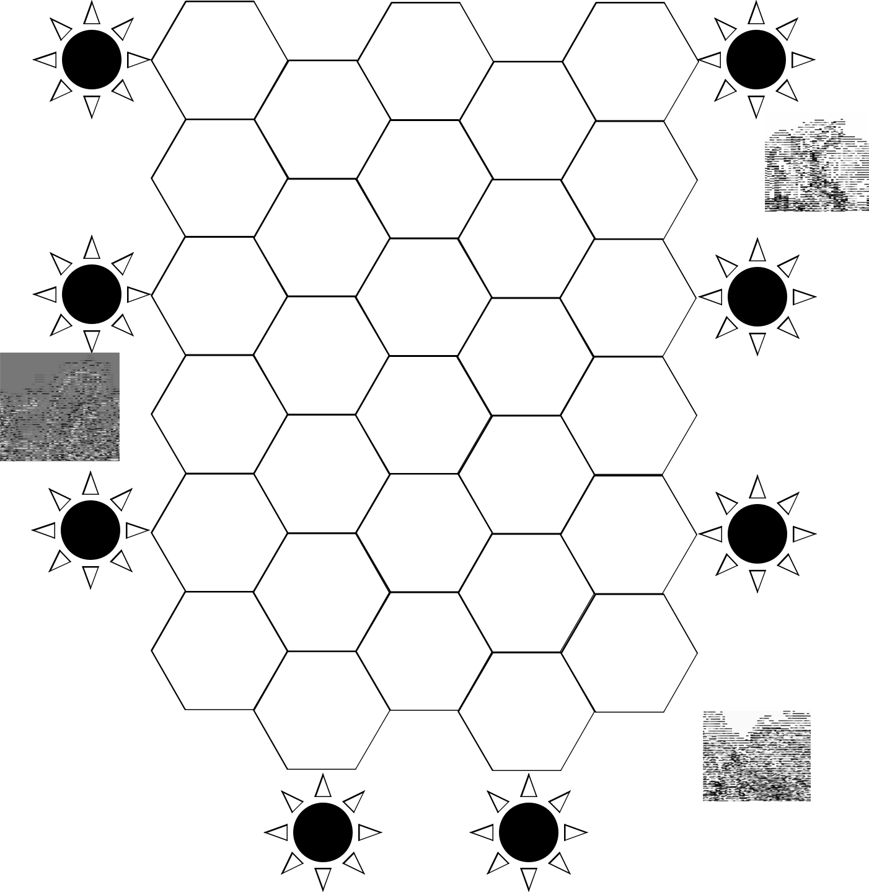

A
start

B
start

C
finish

C
start

D
start

A
finish

D | B
finish | finish

Play in pairs or groups of three or four.

Place your counters on one of the letter suns marked ‘start’.

The aim of the game is to move across the board to reach the same letter sun marked ‘finish’.

The first player begins by choosing the hexagon nearest to their letter sun.

Players take turns to play. They may move in any direction, but may not move to a hexagon if another player is there. If a player cannot give an answer, they miss a turn.

The first player to reach the finish for their letter wins.


CPD 2019 LT Page 9

The Honeycomb Race
1st conjugation verbs, perfect tense:
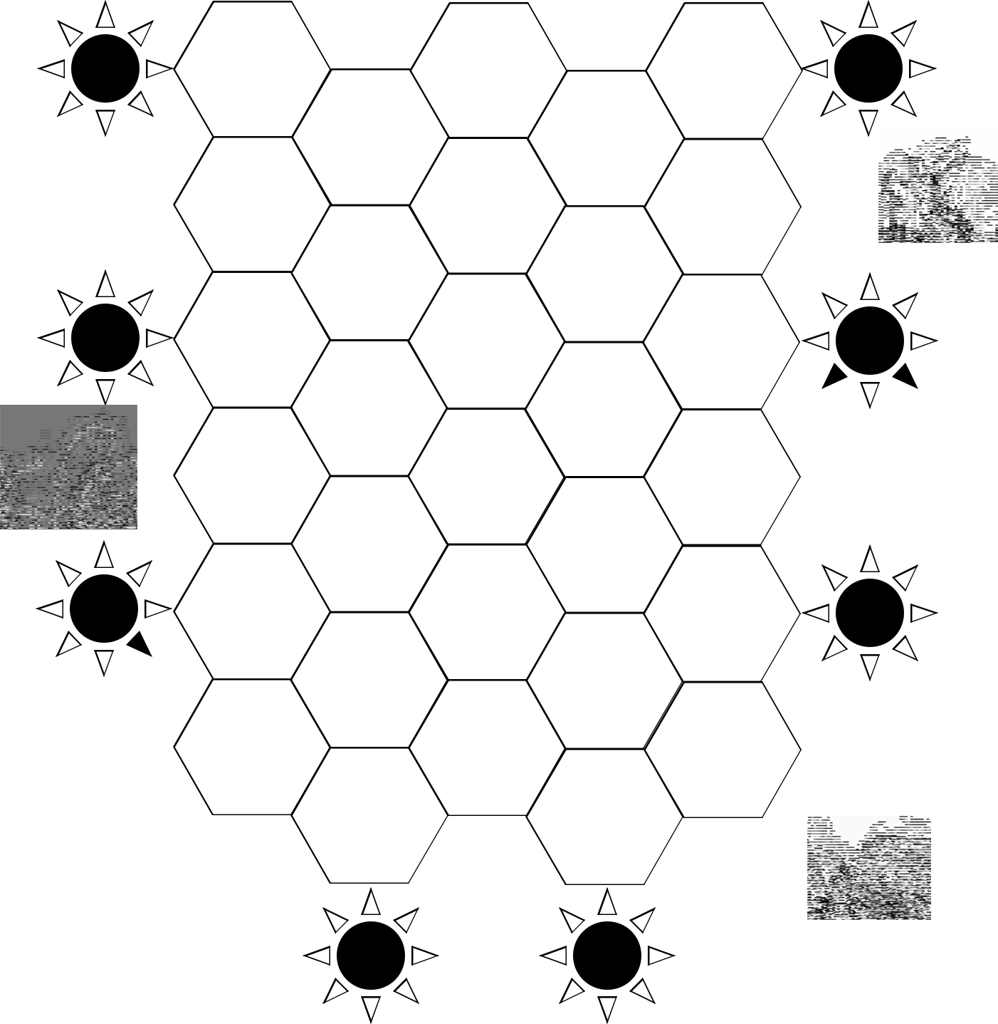

A | laboravi | pugnvistis | amavisti | C
start | laboravi | pugnvistis | amavisti | start
 |  | aedificavit | festinavimus
 | necavi | paraverunt | rogaverunt
 |  | exspecta- | spectavisti
 |  | vistis
B | superavit | navigavi- | narravistis | D
start |  | mus |  | start
 |  | vocaverunt | cantavistis
 | navigavistis | necavit | aedificavi
 |  | amaverunt | paravimus
C | spectavistis | lacrima- | navigavit | A
finish |  | verunt |  | finish
 |  | festinav- | superavistis
 |  | erunt
 | paravistis | cantavimus | navigavi
 |  | pugnavit | laboravisti

D | B
finish | finish

Play in pairs or groups of three or four.

Place your counters on one of the letter suns marked ‘start’.

The aim of the game is to move across the board to reach the same letter sun marked ‘finish’.

The first player begins by choosing the hexagon nearest to their letter sun.

Players take turns to play. They may move in any direction, but may not move to a hexagon if another player is there. If a player cannot give an answer, they miss a turn.

The first player to reach the finish for their letter wins.

CPD 2019 LT Page 10

“De Bello Troiano”: Shared translation: Team 1:

TASK A: Translate sentences 1-9 (Use the extra vocab provided at the end.)

- Romani ita narrabant: Roma antiqua erat colonia Troianorum.

…………………………………………………………………………………………………..………..

- Olim Graeci Troiam oppugnabant.

…………………………………………………………………………………………………………..

- Diu Graeci muros Troae oppugnabant.

……………………………………………………………………………………………………………

- Diu Troiani Graecos a muris Troae arcebant.

………………………………………………………………………………………….………………..

- Nam Hector cum amicis Troiam constantia defendebat.

………………………………………………………………………………………….………………..

………………………………………………………………………………………….………………..

- Graeci autem Troiam non audacia, sed dolo superaverunt.

………………………………………………………………………………………….………………..

………………………………………………………………………………………….………………..

- Nam Odysseus equum magnum ligneum aedificavit.

……………………………………………………………………………..

……………………………………………………………………………..

- Troiani equum in Troiam traxerunt.

……………………………………………………………………………..

……………………………………………………………………………..

- Graeci ex equo in vias cucurrerunt et multos Troianos necaverunt.

………………………………………………………………………………………….………………..

………………………………………………………………………………………….………………..
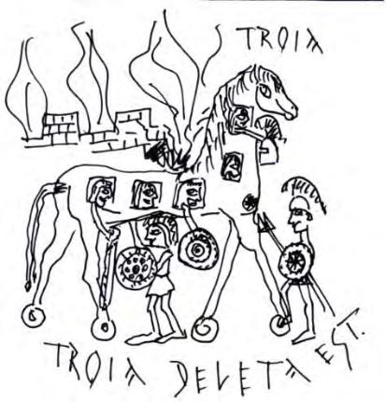

1


CPD 2019 LT Page 11

“De Bello Troiano”: Shared translation: Team 1:

TASK B: Read the rest of the story in English below.

- The women of Troy were calling (on) the gods and goddesses.

- But the gods did not hear the women.

12.At length, the Greeks destroyed Troy with flames.

- Aeneas with his son and other Trojans fled from Troy.

- They sailed from the shore of Troy to many lands.

- At length the Trojan sailors approached the shore of Italy.

- The gods gave the Trojans a new country.

- Ancient Rome was a colony of the Trojans.

- And so, the Trojans were the ancestors of the Romans.

TASK C: Share your translation of sentences 1-9 with Team 2: take any constructive criticism on board and make corrections.

TASK D: Team 2 will share their translation of sentences 10-18 with you: discuss any inaccuracies in their translation and work out the reasons behind them.

Extra vocabulary:

ab = from

ad = to(wards)

aedifico, 1 = I build

alius, -a, -um = other

antiquus, -a, -um = old, ancient

appropinquo, 1 = I approach

arceo, 2 = I prevent, stop from

audacia, ae, f = courage

audio, 4 = I hear

autem = however

avus, i, m = grandfather, ancestor

colonia, ae, f = colony

constantia, ae, f = perseverance

cum = with

deleo, 2 = I destry

diu = for a long time

do, dedi, 1 = I give

dolum, i, n = deceit

e(x) = out of curro, cucurri, 3 = I run eqqus, i, n = horse erat = was

flamma, ae, f = flame, fire Graecus, -a, -um = (a) Greek Hector= Hector (Trojan hero) ita = in this way, thus itaque = and so

ligneus, -a, -um = wooden nam = for
narrow, 1 = I tell (a story)

navigo, 1 = I sail neco, 1 = I kill novus, -a, -um = new olim = once upon a time oppugno, 1 = I attack

ora, ae, f = shore

patria, ae, f = fatherland / country sed = but
servo, 1 = I save tandem = at last traho, traxi, 3 = I drag Troia, ae, f = Troy Troianus, -a, -um = (a) Trojan voco, 1 = I call

Story based on a story in ‘The Latin Language’ by Nedyalka Georgieva (SUP)

2


CPD 2019 LT Page 12

“De Bello Troiano”: Shared translation: Team 2:

TASK A: Read the beginning of the story in English below.

- The Romans used to tell a story in this way: ancient Rome was a colony of the Trojans.

- Once upon a time the Greeks were attacking Troy.

- The Greeks were attacking the walls of Troy for a long time.

- For a long time the Trojans were preventing the Greeks from the walls of Troy.

- For Hector with his friends was defending Troy with perseverance.

- The Greeks, however, overcame Troy not with courage, but with a trick.

- For Odysseus built a large wooden horse.

- The Trojans dragged the horse into Troy.

- The Greeks ran out of the horse into the streets of Troy and killed many Trojans.

TASK B: Translate sentences 10-18 (Use the extra vocab provided at the end.)

- Feminae Troianae deos deasque vocaverunt.

………………………………………………………………………………………….………………..

- Sed dei feminas non audiverunt.

………………………………………………………………………………………….………………..

………………………………………………………………………………………….………………..

12.Tandem Graeci Troiam flammis deleverunt.

………………………………………………………………………………………….………………..

………………………………………………………………………………………….………………..

- Aeneas cum filio et aliis Troianis e Troia fugerunt.

………………………………………………………………………………………….………………..

………………………………………………………………………………………….………………..

- Ab ora Troiae ad multas terras navigaverunt.

………………………………………………………………………………………….………………..

………………………………………………………………………………………….………………..

1


CPD 2019 LT Page 13

“De Bello Troiano”: Shared translation: Team 2:

- Tandem nautae Troiani orae Italiae appropinquaverunt.

………………………………………………………………………………………….………………..

………………………………………………………………………………………….………………..

- Dei Troianis in Italia novam patriam dederunt.

………………………………………………………………………………………….………………..

………………………………………………………………………………………….………………..

- Roma antiqua colonia Troianorum erat.

………………………………………………………………………………………….………………..

………………………………………………………………………………………….………………..

- Itaque, Troiani erant avi Romanorum.

………………………………………………………………………………………….………………..

TASK C: Team 2 will share their translation of sentences 1 -9 with you: discuss any inaccuracies in their translation and work out the reasons behind them.

TASK D: Share your translation of sentences 10-18 with Team 2: take any constructive criticism on board and make corrections.

Extra vocabulary:

ab = from | dolum, i, n = deceit | ora, ae, f = shore
ad = to(wards) | e(x) = out of curro, cucurri, 3 = I run | patria, ae, f = fatherland / country
aedifico, 1 = I build | eqqus, i, n = horse | sed = but
alius, -a, -um = other | erat = was | servo, 1 = I save
antiquus, -a, -um = old, ancient | flamma, ae, f = flame, fire | tandem = at last
appropinquo, 1 = I approach | Graecus, -a, -um = (a) Greek | traho, traxi, 3 = I drag
arceo, 2 = I prevent, stop from | Hector= Hector (Trojan hero) | Troia, ae, f = Troy
audacia, ae, f = courage | ita = in this way, thus | Troianus, -a, -um = (a) Trojan
audio, 4 = I hear | itaque = and so | voco, 1 = I call
autem = however | ligneus, -a, -um = wooden
avus, i, m = grandfather, ancestor | nam = for
colonia, ae, f = colony | narrow, 1 = I tell (a story)
constantia, ae, f = perseverance | navigo, 1 = I sail
cum = with | neco, 1 = I kill
deleo, 2 = I destry | novus, -a, -um = new

Story based on a story in ‘The Latin Language’ by Nedyalka Georgieva (SUP)

2


CPD 2019 LT Page 14

“Two for One” Comprehension: Cicero vs. Catilina & Young Paris: TEAM A

TASK 1: WRITE UP comprehension questions for each sentence & give to Team B.

  - Translation and vocabulary are provided to help you.

- Cicero consul Romanorum erat. Cicero was a consul of the Romans.

- Cicero Romanos amabat. Cicero loved the Romans.

- Catilina vir malus erat: Ciceronem necare volebat!

Catilina was a bad man: he wanted to kill Cicero!

- Itaque, Catilina amicos vocavit et clamavit: And so, Catilina called his friends and shouted:

- “Amici, Ciceronem non amamus et necare debemus!” “Friends, we do not like Cicero and we ought to kill him!”
- Sed Cicero Catilinam non timebat. But Cicero did not fear Catilina

- Ubi amici Catilinae ad villam conculis ambulaverunt, servi villam custodiebant. When Catilina and his friends walked to the house of the consul, slaves were guarding the house.

- Servi cum amicis Catilinae diu pugnabant.

The slaves fought with the friends of Catilina for a long time.

- Tandem servi vitam domini magna audacia servaverunt.

At length the slaves saved the life of their master with great bravery.
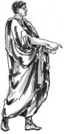

- Dominus servos laudavit. The master praised the slaves.
- Catilina e Roma fugit. Catilina ran away from Rome.

Story based on a story in ‘Latin Stories: A GCSE

reader’ by H. Cullen, M. Dormandy and J. Taylor

 | Vocab: “Cicero & Catilina”
 | audacia, ae, f = bravery |  | laudo, 1 = I praise
 | Ciceronem = Accusative form of Cicero |  | malus, -a, -um = bad
 | consul, -is, m = consul |  | servo, 1 = I save
 | consulis = of the consul |  | tandem = at last, at length
 | custodio, 4 = I guard |  | timeo, 2 = I fear
 | debeo, 2 = I ought (to) |  | ubi = when
 | diu = for a long time |  | volebat = he wanted / wished
 | fugio, fugi, 3 = I run away, I flee |  | volo, volui = I wish, I want

1


CPD 2019 LT Page 15

“Two for One” Comprehension: Cicero vs. Catilina & Young Paris: TEAM A

TASK 2: Answer Team B’s comprehension questions on this story.

- Troia erat oppidum in Asia.

……………………………………………………………………

- Priamus Troiam regnabat.

……………………………………………………………………

- Hecuba erat femina Priami: liberos multos habuerunt.

…………………………………………………………………………………………..……………

- Sed dei ex caelo clamaverunt:

…………………………………………………………………………………………..……………

- “Priame, filius tuus Alexander Troianis erit periculosus.

…………………………………………………………………………………………..……………


6. Itaque Alexandrum e Troia expellere debes.” |  |  | Vocabulary:
 |  |  | agricola, ae, m = farmer
 | …………………………………………………………………………………………..……………
 | …………………………………………………………………………………………..…………… |  | cura, ae, f = care
7. Verba deorum Priamum terruerunt. |  |  | curo, 1 = I look after
 |  |  | desertus, -a, -um = deserted
 | …………………………………………………………………………………………..…………… |  | domum = (to) home
8. | Hecuba diu lacrimabat. |  | erit = he will be
8. | Hecuba diu lacrimabat. |  | expello, 3 = I expel
 | …………………………………………………………………………………………..……………
 | …………………………………………………………………………………………..…………… |  | habeo, 2 = I have
9. | Tandem servus Priami puerum Alexandrum ex oppido |  | invenio, 4 = I find
9. | Tandem servus Priami puerum Alexandrum ex oppido |  | itaque = and so
 | portavit et in loco deserto reliquit. |  | iubeo, 2 = I order
 | portavit et in loco deserto reliquit. |  | lacrimo, 1 = I cry
 | …………………………………………………………………………………………..…………… |  | oppidum, i, n = town
 | …………………………………………………………………………………………..…………… |  | periculosus, -a, -um = dangerous
 | …………………………………………………………………………………………..…………… |  | regno, 1 = I rule
10. Agricola Alexandrum invenit et domum portavit. |  |  | relinquo, reliqui, 3 = I leave
 | …………………………………………………………………………………………..…………… |  | tandem = at last, at length
 | …………………………………………………………………………………………..…………… |  | terreo, 2 = I terrify, scare
11. Femina agricolae puerum magna cura curavit. |  |  | Story based on ‘Latin Reading Course:
 |  |  | Part 1’ by James Alexander Harrison

………………………………………………………………………………………………………………

TASK 3: Share answers with Team B:

- Discuss their answers to your Task 1 & help out make corrections.

- Take any constructive criticism of your answers to Task 2 & make corrections.

2


CPD 2019 LT Page 16

“Two for One” Comprehension: Cicero vs. Catilina & Young Paris: TEAM B

TASK 1: Answer Team A’s comprehension questions on this story:

- Cicero consul Romanorum erat.

………………………………………………………………………………………

- Cicero Romanos amabat.

……………………………………………………………………………………….

- Catilina vir malus erat: Ciceronem necare volebat!

………………………………………………………………………………………

- Itaque, Catilina amicos vocavit et clamavit:

………………………………………………………………………………………

- “Amici, Ciceronem non amamus et necare debemus!”
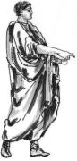

………………………………………………………………………………………

- Sed Cicero Catilinam non timebat.

………………………………………………………………………………………

- Ubi amici Catilinae ad villam conculis ambulaverunt, servi villam custodiebant.

………………………………………………………………………………………

………………………………………………………………………………………

- Servi cum amicis Catilinae diu pugnabant.

………………………………………………………………………………………

- Tandem servi vitam domini magna audacia servaverunt.

………………………………………………………………………………………

- Dominus servos laudavit.

……………………………………..

- Catilina e Roma fugit.

……………………………………..

Story based on a story in ‘Latin Stories: A GCSE

reader’ by H. Cullen, M. Dormandy and J. Taylor

 | Vocab: “Cicero & Catilina”
 | Ciceronem = Accusative form of Cicero |  | laudo, 1 = I praise
 | consul, -is, m = consul |  | malus, -a, -um = bad
 | consulis = of the consul |  | servo, 1 = I save
 | cum = with |  | tandem = at last, at length
 | custodio, 4 = I guard |  | timeo, 2 = I fear
 | debeo, 2 = I ought (to) |  | ubi = when
 | diu = for a long time |  | volebat = he wanted / wished
 | fugio, fugi, 3 = I run away, I flee |  | volo, volui = I wish, I want

1


CPD 2019 LT Page 17

“Two for One” Comprehension: Cicero vs. Catilina & Young Paris: TEAM B

TASK 2: WRITE UP comprehension questions for each sentence & give to Team A.

- Translation and vocabulary are provided to help you.

- Troia erat oppidum in Asia. Troy was a town in Asia.

- Priamus Troiam regnabat. Priam ruled Troy.

- Hecuba erat femina Priami: liberos multos habuerunt.

Hecuba was Priam’s wife: they had many children.

- Sed dei ex caelo clamaverunt: But the gods shouted from the sky:

- “Priame, filius tuus Alexander Troianis erit periculosus. Priam, your son Alexander will be dangerous to the Trojans.

- Itaque Alexandrum e Troia expellere debes.” And so, you must expel him from Troy.

- Verba deorum Priamum terruerunt. The words of the gods terrified Priam.

- Hecuba diu lacrimabat.

Hecuba was in tears for a long time.

- Tandem servus Priami puerum Alexandrum ex oppido portavit et in loco deserto reliquit.
At length, a slave of Priam’s carried the boy Alexander away from the town and left him in a deserted place.

- Agricola Alexandrum invenit et domum portavit. A farmer found Alexander and carried him home.
- Femina agricolae puerum magna cura curavit.

The wife of the farmer looked after the boy with great care.

Vocabulary:


agricola, ae, m = farmer cura, ae, f = care curo, 1 = I look after desertus, -a, -um = deserted domum = (to) home erit = he will be

expello, 3 = I expel

habeo, 2 = I have

invenio, 4 = I find

itaque = and so

iubeo, 2 = I order

lacrimo, 1 = I cry

oppidum, i, n = town

periculosus, -a, -um = dangerous

regno, 1 = I rule

relinquo, reliqui, 3 = I leave tandem = at last, at length terreo, 2 = I terrify, scare
Story based on ‘Latin Reading Course:

Part 1’ by James Alexander Harrison

TASK 3: Share answers with Team A:

- Take any constructive criticism of your answers to Task 1 & make corrections.

- Discuss their answers to your Task 1 & help out make corrections.

2

CPD 2019 LT Page 18

3rd declension nouns (consonant / -i)


- Here belong nouns of all genders, with a range of endings in the Nom. sg. (rex, m; navis, f; caput, n).

- Often the stem can’t be seen in the Nominative sg.

- The STEM = Gen. sg. minus –is : e.g. Nom. rex, Gen. regis →stem reg-

- There are some patterns + English derivatives which help remembering the stems.

- The Vocative is always the same as the Nominative

- Some nouns have ending –ium in Gen. pl. instead of –um

 |  | amor (m) ‘love’ | dux (m) ‘leader’ | nomen (n) ‘name’ | civis (m/f) ‘citizen’ | mare (n) ‘sea’
Sg. | Nom. | amor | dux | nomen | civis | mare
obj | Acc. | amorem | ducem | nomen | civem | mare
of | Gen. | amoris | ducis | nominis | civis | maris
to | Dat. | amori | duci | nomini | civi | mari
with | Abl. | amore | duce | nomine | cive (i) | mari
Pl. | Nom. | amores | duces | nomina | cives | maria
obj | Acc. | amores | duces | nomina | cives (is) | maria
of | Gen. | amorum | ducum | nominum | civium | marium
to | Dat. | amoribus | ducibus | nominibus | civibus | maribus
with | Abl. | amoribus | ducibus | nominibus | civibus | maribus

PATTERNS of 3rd declension nouns in our vocabulary list: find English cognates which keep the Latin stem!

- Nominative sg. = stem: mainly masculine with the odd feminine:

amor, amoris, m = love [amorous]

clamor, clamoris, m = shout(ing), noise [clamorous]

imperator, imperatoris, m = general [imperatorial]

labor, laboris, m = work [laborious]

uxor, uxoris, f = wife [uxorial]

2. Nom. sg. ending in –x, STEM ending in -c- / -g-: masculine or feminine

dux, ducis, m = leader [conductor]

lux, lucis, f = light [lucid; elucidate; blond Lucius in ‘Harry Potter’; Lucifer] pax, pacis, f = peace [pacifist; Pacific] vox, vocis, f = voice [vocal]

rex, regis, m = king [regal]

3. Nom. sg. ending in –s, STEM ending in -t- / -d-: masculine or feminine

custos, custodis, m/f = guard [custody]

comes, comitis, m/f = companion, comrade [comity (e.g. of nations)] miles, militis, m = soldier [military]

pes, pedis, m = foot [pedicure, pedal, pedestrian]

N.B.: caput, capitis, n = head [decapitated, capital]


CPD 2019 LT Page 19

  - STEM ending in -n-:

- Usually Nom. sg. ending in –o: masculine or feminine homo, hominis, m = man [hominid]

legio, legionis, f = legion

sanguis, sanguinis, f = blood [sanguine]

- Nom. sg. ending in –en: neuter
flumen, fluminis, n = river [fluminous ☺]
nomen, nominis, n = name [nomination]

  - Stem ending in -r-:

- Nom. sg. ending in –er: masculine and feminine frater, fratris, m = brother [fratricide]

mater, matris, f = mother [matricide] pater, patris, m = father [patricide]

- Usually Nom. sg. ending in –us: neuter

corpus, corporis, n = body [corporeal]

tempus, temporis, n = time [temporal]

vulnus, vulneris, n = wound [vulnerable]

iter, itineris, n = road, journey [itinerary]

  - With ending –ium in Gen. pl.;

- Nom. sg. ending in –s: mainly feminine & some masculine ars, artis, f = art, skill [artist, artisan, artificial]

mons, montis, m = mountain [Mont Blanc]

mors, mortis, f = death [mortal, mortuary, post mortem] nox, noctis, f = night [nocturnal]

pars, partis, f = part

princeps, principis, m = leader [principal] urbs, urbis, f = city [urban]

- Nom. sg. ending in –is: masculine and feminine

civis, civis, m/f = citizen [civilisation]

hostis, hostis, m/f = enemy [hostile]

navis, navis, f = ship [navigate]

- Nom. sg. ending in –e / -al: neuter mare, maris, n = sea [marine, marina] animal, animalis, n = animal [animalistic]

CPD 2019 LT Page 20

Eduqas CPD November 2019: preparing candidates on limited time

“Text-harvesting” publications:

‘Latin Reading Course: Part 1’ by James Alexander Harrison (Collins Educational 1970)

‘Latin Reading Course: Part 2’ by James Alexander Harrison (Collins Educational 1971)

‘Latin for Today: Book 1’ by Mason D. Gray and Thornton Jenkins (GINN 1934) [innumerable editions]

‘Latin for Today: Book 2’ by Mason D. Gray and Thornton Jenkins (GINN 1934) [innumerable editions]

‘Principia: A Beginner’s Latin Course’ by C.W.E. Peckett and A.R. Munday (Wilding & Son 1949) lots of fun

‘Latin Unseens’ by Rev. A.E. Hillard and C.G. Botting (Rivingtons 1958)

‘Elementary Latin Translation Book’ by Rev. A.E. Hillard and C.G. Botting (Rivingtons 1947)

‘Ritchie’s Fabulae Faciles: Latin Text with Facing Vocabulary and Commentry’ by Geoffrey

Steadman (2012) free Pdf download here: https://geoffreysteadman.com/ritchies-fabulae-faciles/ ‘Ritchie’s First Steps in Latin’ by Francis Ritchie (Longmans, Green & Co 1909) ‘Ritchie’s Second Steps in Latin’ by Francis Ritchie (Longmans, Green & Co 1924)

‘Short Latin Stories’ by Philip Dunlop (CUP 1987)

‘Lingua Magistra: Corso di Latino’ by Angelo Diotti (Bruno Mondadori 2008)

‘Lingua Viva: lezioni di latino 1’ by Angelo Diotti (Bruno Mondadori 2010)

‘Cotidie discere: Corso di Latino’ by Giuseppe De Micheli (HOEPLI 2011)

‘Ex Novo: Lingua e cultura latina’ by Sergio Nicola & Franca Nicco (Petrini 2011)

Old Prescription Texts (so will need to gloss some vocab., Abl. Abs., gerundive, verbs of fearing, qui + subj., infinitives other than pres. etc.):

‘Latin Language Tests for Levels 1,2 & GCSE’ by Ashley Carter (Bristol Classical Press 2011)

‘Momentum Tests for GCSE’ by Ashley Carter (Bristol Classical Press 2003)

‘Latin Stories: A GCSE Reader’ by H. Cullen, M. Dormandy and J. Taylor (Bloomsbury 2011)

‘Essential GCSE Latin’ by John Taylor (Bloomsbury 2006 [old edition ], 2014 [revised edition])

‘Latin to GCSE’ Parts 1 & 2, by Henry Cullen and John Taylor (Bloomsbury 2016)

Past Papers Levels 1 & 2 here: https://www.wjec.co.uk/qualifications/qualification-resources.html?subject=latin&level=Level12Certificate&pastpaper=true

Fast-track start & progress with grammar: ‘So You Really Want To Learn Latin’ Books 1 & 2 by N.R.R. Oulton (Galore Park Publishing Ltd.)

