

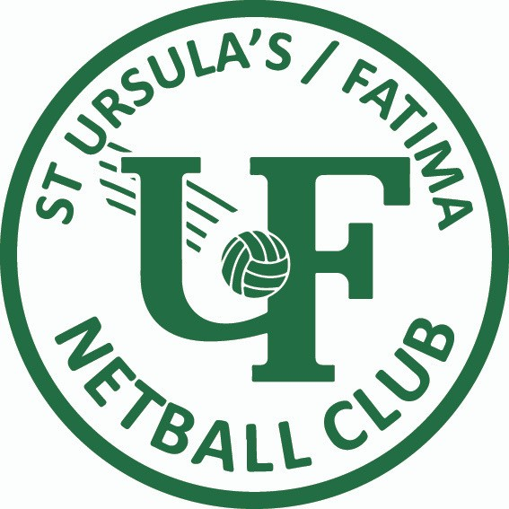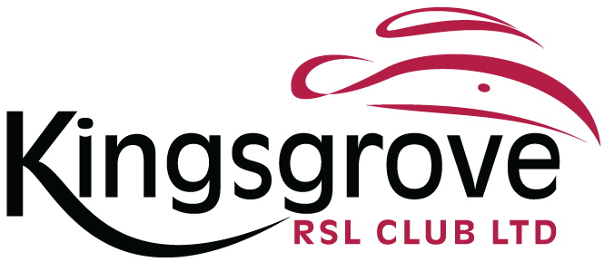

BLOCK PARTY

Saturday

May

26th

6:30pm to 9pm

Kingsgrove RSL Club

**$15** PER PERSON OR **$35** FAMILY TICKET

(three or more children from the same family)

DJ.

FOOD.

DRINKS.

GAMES.

PRIZES.

RSVP & Payment by May 19th to your team manager.

Supervision provided by the **SUFNC** Committee!

Limited chaperone spots for NetSetGo parents.

Contact our Social Coordinator, via [**sufncsocial@outlook.com**](mailto:sufncsocial@outlook.com)

if interested!