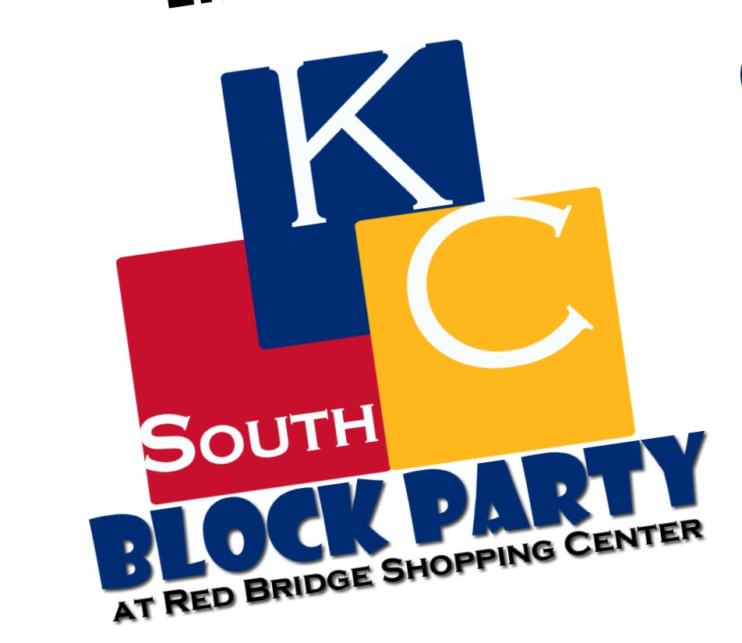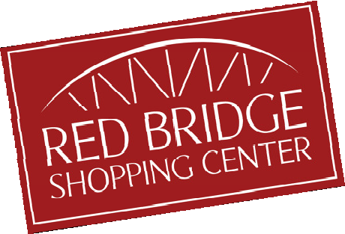

**Inaugural**

**October 14,**

**2017**

**10 am - 3 pm**

Red Bridge Shopping Center

*453 E Red Bridge Road,*

*Kansas City, MO*

■

■

■

■

■

Live Entertainment Craft & Vendor Booths Local Food Trucks Carnival Games

Kids Activities provided by Wonderscope and Mid-Continent Public Libraries

And More...

For regular updates visit

[**www.southkcchamber.com**](http://www.southkcchamber.com/)

For more information call 816.761.7660 o

email [vwolgast@southkcchamber.co](mailto:vwolgast@southkcchamber.co)