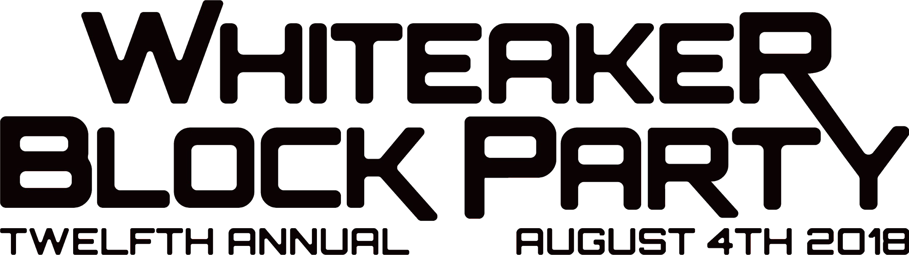

WHITEAKER BLOCK PARTY 2018 AUGUST 4TH 2O18 12-1OPM GENERAL SPONSORSHIP PACKET

1O5O W 3RD AVE EUGENE OREGON 974O2

CONTACT: CHRIS GADSDBY 541.255.6343 [SPONSORSHIP@WHITEAKERBLOCKPARTY.COM](mailto:SPONSORSHIP@WHITEAKERBLOCKPARTY.COM)

How would you like your business to be associated with Eugene’s biggest annual event? Last year the Whiteaker Block Party had over 12,000 patrons and we continue to grow larger every year. The Whiteaker Block Party is 100% volunteer ran and with help from over 350 volunteers and our sponsors we have been able to keep this an entirely free event.

All extra funds at the end of the block party are donated to local charities. The best part is that your sponsorship is completely tax deductible. Join us this year and get involved with your community whether it’s a vending booth, sponsorship, volunteer position, or a donation. After you experience the Whiteaker Block Party you will understand why we say “Cheers” everytime we see each other.

*We accept cash, check & credit cards please make checks payable to the Whiteaker Block Party. If you will be filing this donation as a tax deduction please make checks payable to Whiteaker Community Council. Tax ID# 51-0175444

**GENERAL SPONSORSHIP - WHITEAKER BLOCK PARTY 2O18**