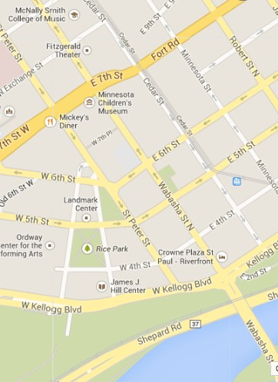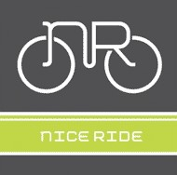

**#wanderwabasha**

**JOIN US!**

**WABASHA STREET BLOCK PARTY**

**THURSDAY,**

**JULY 24**

**10 AM - 2 PM**

LOCATED BETWEEN KELLOGG BOULEVARD & EXCHANGE STREET

COME EXPERIENCE A

VISION FOR A BIKEABLE & WALKABLE WABASHA WITH:

•

•

•

•

•

•

PERFORMANCES

VENDORS FOOD MUSIC

ARTS ACTIVITIES AND MORE

HOSTED BY WABASHA PARTNERS, ST. PAUL SMART TRIPS

A MUSICANT GROUP PRODUCTION

FUNDING FOR THIS PROJECT IS PROVIDED IN PART BY THE CENTER

FOR PREVENTION AT BLUE CROSS AND BLUE SHIELD OF MINNESOTA.