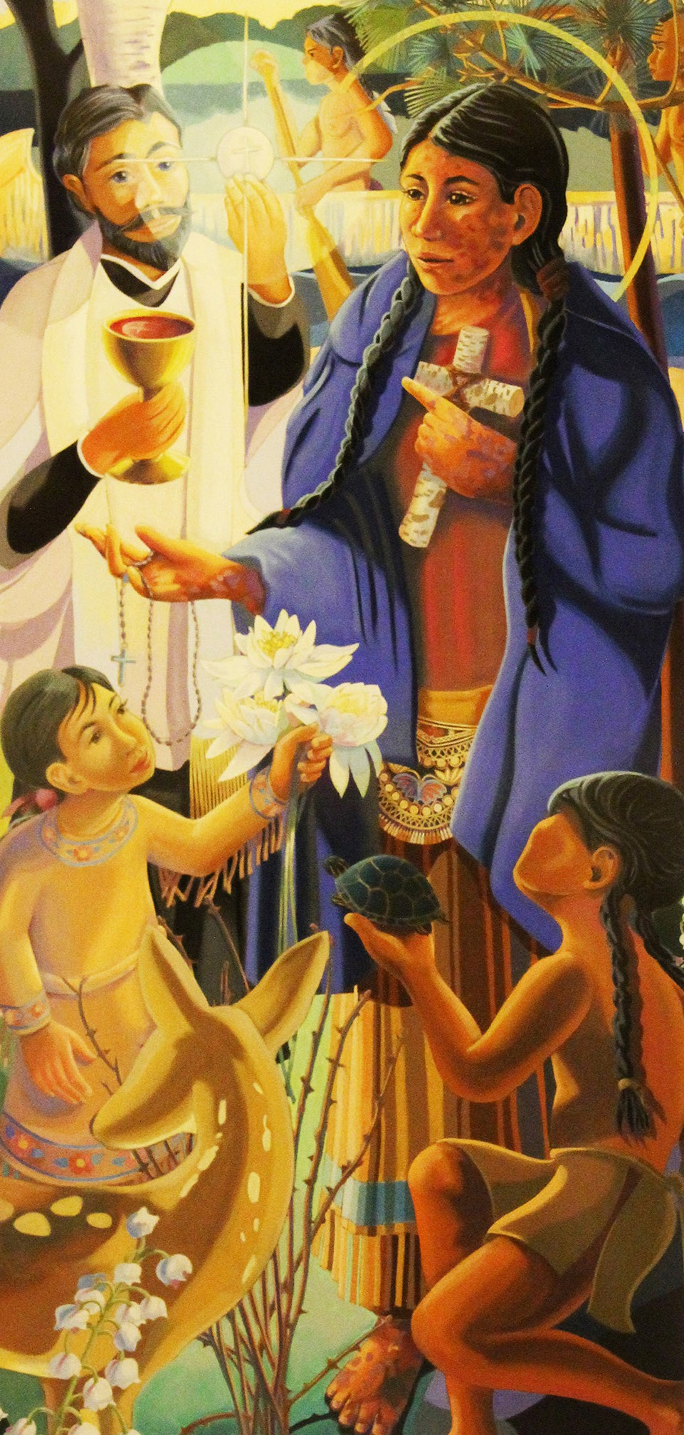

St. Kateri Family

Block

Party

Saturday, Sept. 7th,

6-10

p.m.

Spirit

of

Life

Church

801

1st

St. SE, Mandan

701-663-1660

myspiritoflife.com

Burgers,

will be

Brats

&

Indian Tacos

served free

of charge

There will be entertainment for the children, fun and

games for all!

Music

provided

by

the

band

Dirty Word 7-10 p.m.

Bring

a

non-perishable

food

item to donate

for

those

in

need.

Mark your

calendars

and

join

us

for

this community-wide celebration!