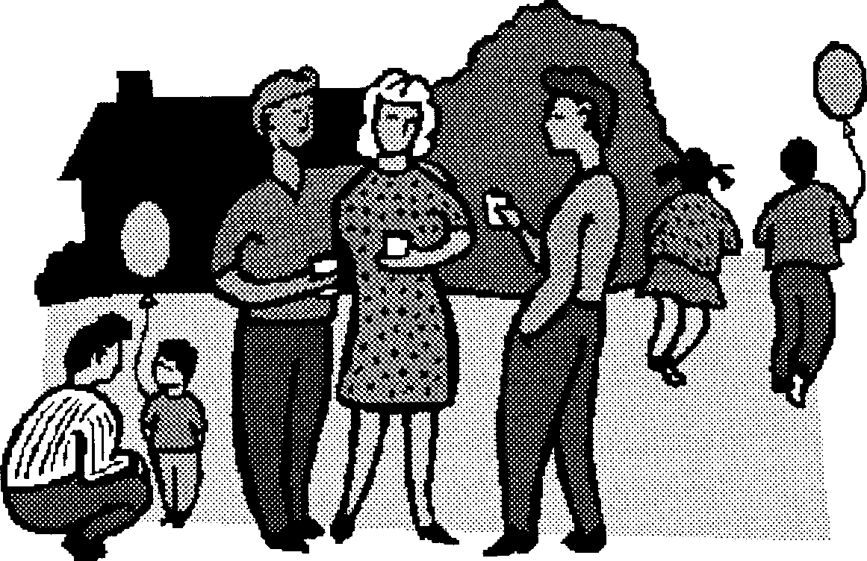

***YOU ARE INVITED TO***

***A BLOCK PARTY On National Night Out!***

DATE:

TIME:

PLACE:

THEME/EVENT:

To RSVP, or to help out, please phone:

at , or

at

8



**Block Party Details**

We are glad you can join us for National Night Out:

On at

(date)

(time)

We are asking each family to bring:

* chairs to sit on
* your own meats or vegetarian food to barbecue
* 1 salad and 1 desert to share (make enough for people)
* your own beverages or coffee and tea will be provided
* your own non-breakable plates, cups and cutlery
* other

In addition, do you have the following that could be used:

A barbecue

A table

A cooler

Do you have a talent that you would like to share with us?

Suggestions for activities you could organize?

Please return this form by (date) to:

Name Phone

Address

9

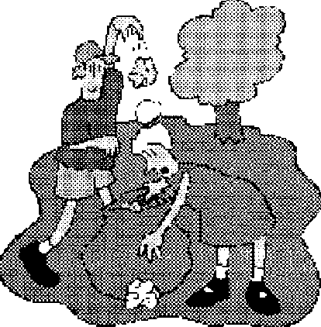

**National Night Out** E**valuation Form**

**To help us plan future block parties, your feedback is appreciated.**

What were the 3 best things about this block party?

1.

2.

3.

What 3 things would you change for next time?

1.

2.

3.

How would you like the neighborhood connections gained at the block party to be maintained during the year?

1.

2.

3.

Are you willing to help with the planning of future neighborhood events? yes no

if yes, please leave your name and phone number

with at Please leave this form at (address) at

*Thank You*

10