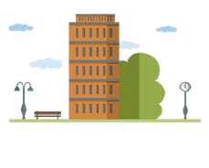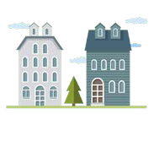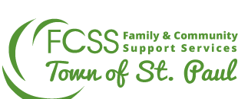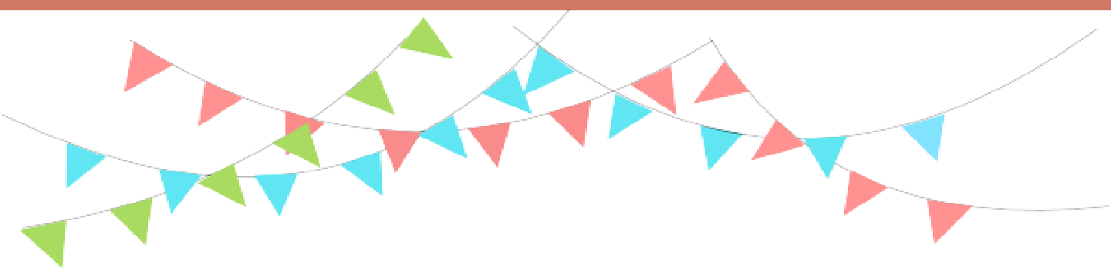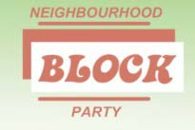

10 Reasons to **HOST** a Block Party:

“Building a community one

**BLOCK** at a time!”

1.

2.

To have FUN!

To get to KNOW your neighbours!

To BUILD friendships! To CREATE a sense of belonging!

To CELEBRATE your great neighbourhood!

To INCREASE sense of safety/security by knowing your neighbours! To MEET others that you could help out or help you out in the future!

To DISCUSS events happening in your neighbourhood!

To CREATE a welcoming environment!

To FORM a group to plan more fun events!

3.

4.

Through the Neighbourhood Block Party Program, individuals, on behalf of their neighbourhood, can apply for funding of up to $150.00 per year to conduct activities designated in their

5.

6.

7.

neighbourhood.

8.

To apply for the Block Party Rebate Program, please call FCSS at **780-645-5311** or visit [**www.stpaulfcss.ca**](http://www.stpaulfcss.ca/) to download your own toolkit.

9.

10.