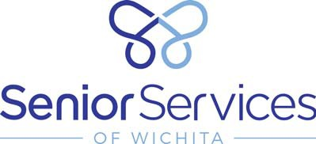

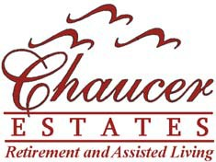

Thursday, September 15, 2016

1 to 4 p.m.

Featuring Douglas Lockett, DJ, KSUN Station Manager

Celebrating National Senior Center Month

“Find A Balance At Your Center”

200 S. Walnut

Wichita, KS 67213

Sponsored By:

T & S Eldercare