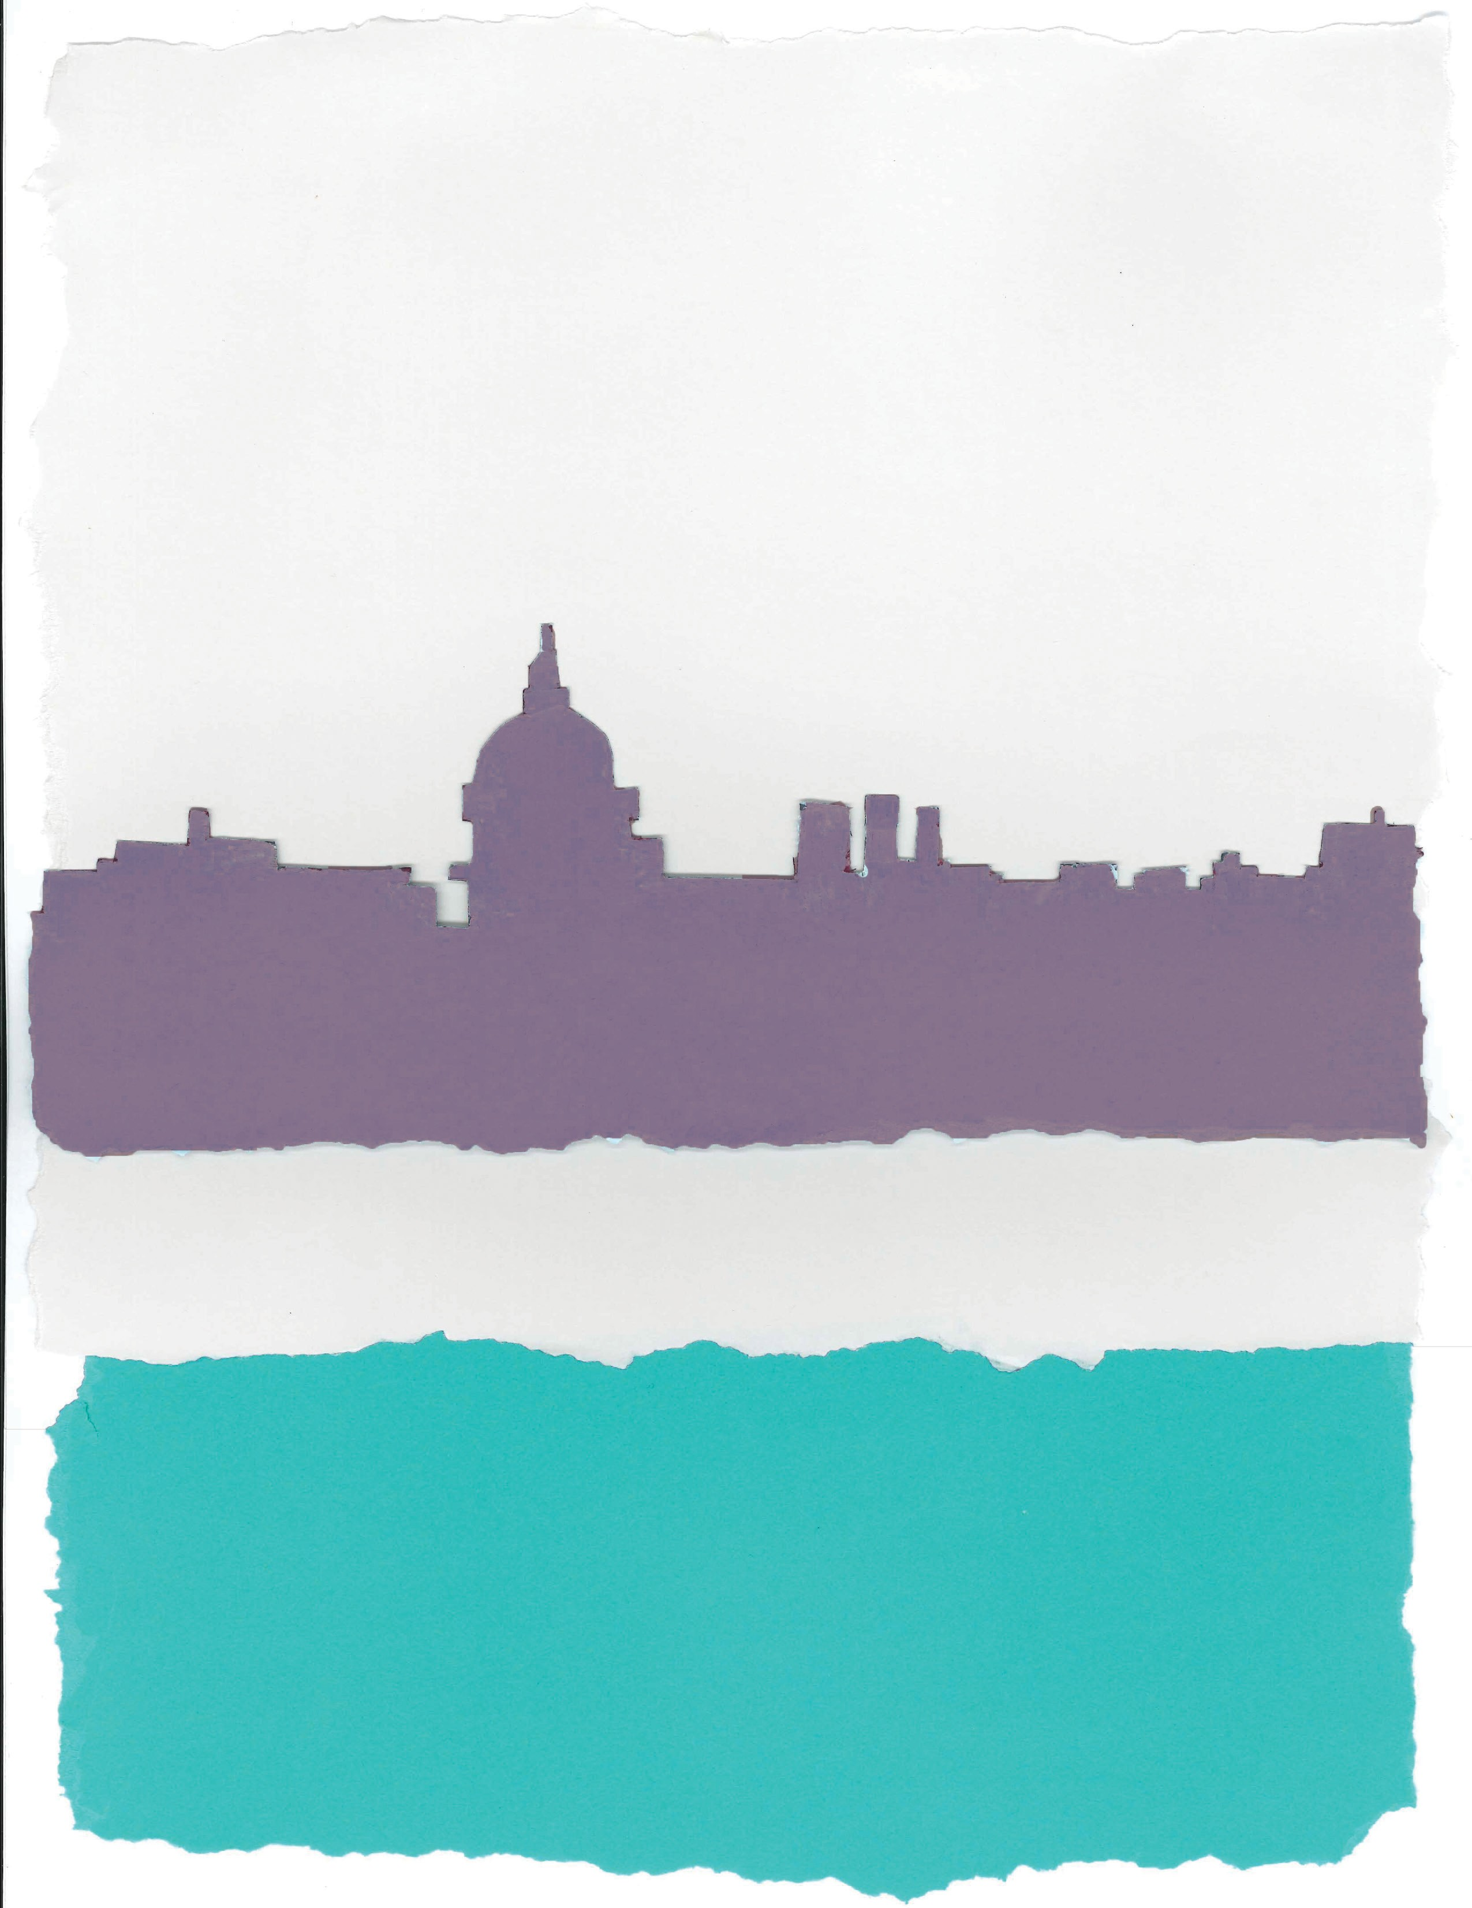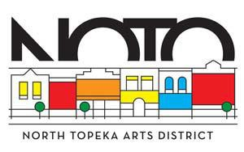

*Block Party*

Saturday May 30 • 1-4pm

FFFrrreeeeee EEEvvveeeennnnttt • OOOpppeeennnn tttooo ttthhheeee PPPuuubbbblllliiiicccc

Bus Tour • Kids Bike Rodeo Win A Kids Bike • Live Music

Food Trucks • Bookmobile • TMB Demo Helen Hocker One-Act Plays