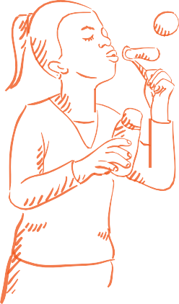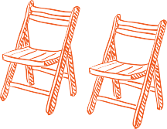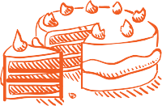



DATE:

TIME:

BLOCK/LOCATION:

We look forward to seeing you!

This family-friendly event will include games, food, and new friends!

YOU CAN HELP

Volunteer to share a talent, organize an activity, or loan a BBQ, table, or cooler.

Let me know what you’d be interested in.

IF YOU CAN, BRING ALONG:

Chairs to sit on

A food item to share Beverages for yourself and your family

Your own plates, cups, and cutlery

TO CONTACT YOUR HOST:

NAME: ADDRESS: EMAIL: PHONE:

For more on block parties

Visit: vancouver.ca/blockparty

Phone: 3-1-1 TTY: 7-1-1

Share: #VanBlockParty