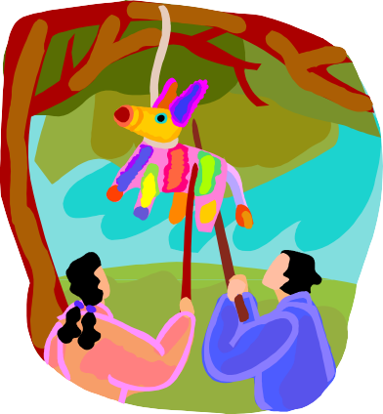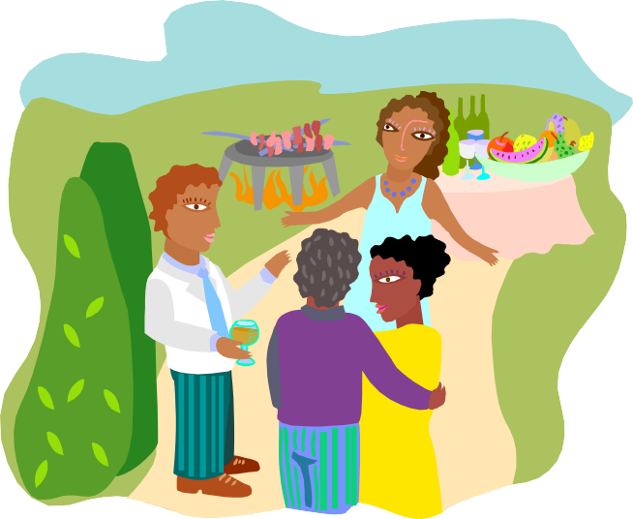

**You Are Invited To A:**

**Date: .**

**Time: .**

**Place: .**

**To RSVP, Or To**

**Help Out, Call/E-Mail**

**At**

**Or**

**At**



**We’re Happy You Can Join Us!**

**At**

**On**

**For the Block Party!**

We are asking each family to bring:

* chairs to sit on
* your own meats or vegetarian food to barbecue
* a desert to share (make enough for people)
* beverages
* your own non-breakable plates, cups and cutlery

In addition, do you have the following that could be used:

A barbecue

A table

A cooler

Do you have a talent that you would like to share with us? Suggestions for activities you could organize?

Please return this form by _ (date) to: Name _ Phone Address _