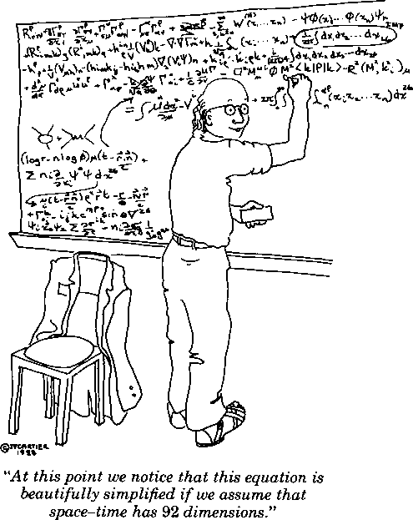

PHYSICS BLOCK PARTY

Friday, 5 September 3:00 PM

2nd Floor Nicholson (halls and rooms near library)

⬇Welcome for new people in Department

⬇Free pizza and sodas

**Pizza arrives at 3:20**

⬇LN2 Ice Cream Social

⬇Ping Pong Tournament

**Arrive promptly at 3:00 PM Tournament Director Prof. H. Lee**

⬇LSU-Physics Scavenger Hunt

**Starting at 3:45; teams of three Hint: one item is “Bring a neutrino.”**

⬇Minimum-Acceleration Duels

**Mano-a-Mano duels and group melees**

**⬇Othello Tournament - starts at 3:00 PM Tournament Director Zach Edwards**

⬇Book exchange, Jacob’s Ladder...