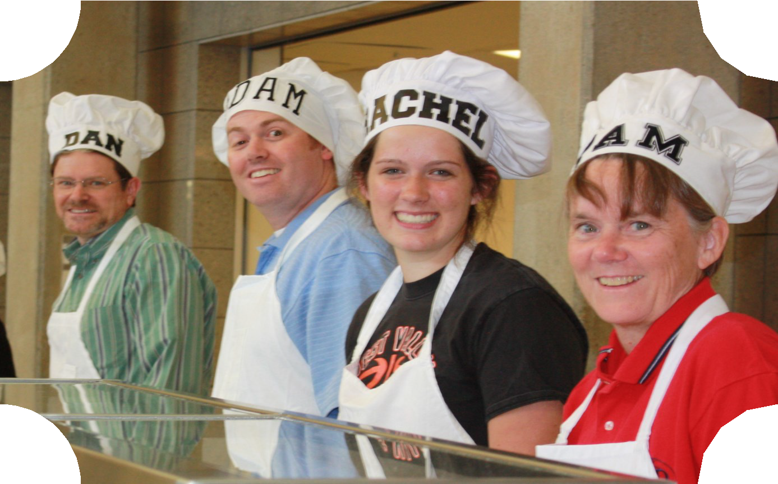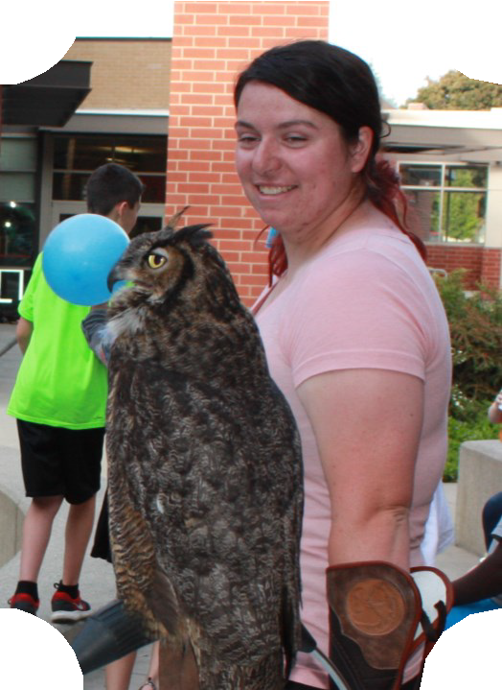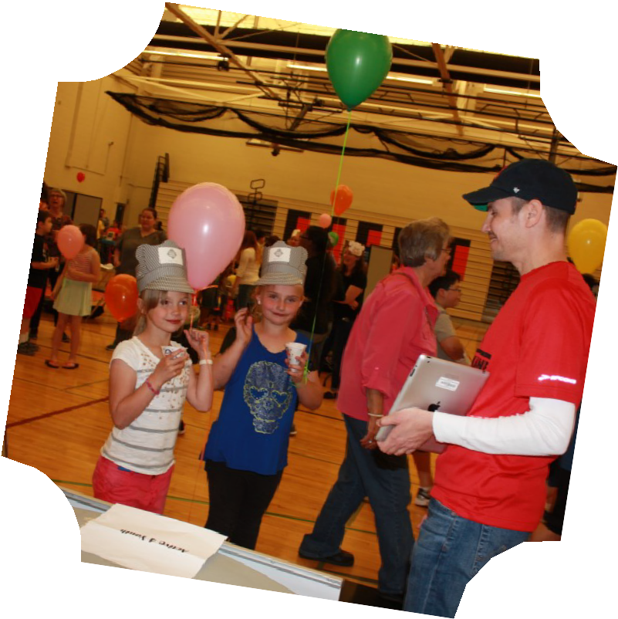

**West Valley’s 16th Annual Community Appreciation**

Block Party

**May 18, 2017**

**5:00 - 8:00 p.m.**

**West Valley High School 8301 E. Buckeye**

FREE

Spaghetti Dinner Popcorn, Balloons Sno cones

Kids Crafts Dunk tank

Door Prizes

**CTE and STEM Activities & Robotics Display**

Student Displays

and Performances

**Hoot Show**

**presented by West Valley’s Outdoor**

**Learning Center**

**It’s all FREE - Don’t miss the FUN!**