Emergency contact form

Date received | <office use only>
Date entered in HiiP | <office use only>
Received by | <office use only>

Tenant details
Service ID | <fill in service ID>
Tenant 1 name | <fill in tenant 1 name>
Tenant 2 name | <fill in tenant 2 name>
Tenant 3 name | <fill in tenant 3 name>
Address | <fill in address>
Suburb/Town | <fill in suburb or town> | Postcode | <fill in postcode>
Contact number | <fill in contact number>

Emergency contact details
Contact name(s) | <fill in contact name(s)>
Address | <fill in address>
Suburb/Town | <fill in suburb or town> |  | Postcode | <fill in postcode>
Telephone landline | <fill in landline telephone> | Mobile | <fill in mobile number>
Work number | <fill in work number>
Email address | <fill in email address>
Relationship to tenant(s) | <Fill in the relationship to the tenant (Example: son/friend/legal representative)>

Authorisation
I/We hereby authorise the Director of Housing, or officers acting on behalf of the Director of Housing, to contact the above nominated person in any event deemed an emergency, and I/we am/are not contactable.
Full name of Tenant 1 | <fill in full name of tenant 1>
Signature | <signature of tenant 1>
Date | <fill in the date>
Full name of Tenant 2 | <fill in full name of tenant 2>
Signature | <signature of tenant 2>
Date | <fill in the date>
Full name of Tenant 3 | <fill in full name of tenant 3>
Signature | <signature of tenant 3>
Date | <fill in the date>

Information privacy
The Department of Health and Human Services is committed to protecting the privacy of your personal information. Personal information is information which directly or indirectly identifies a person. We need to collect and handle your personal information in order to be able to process your application. All the information you give us will be handled in accordance with the Privacy and Data Protection Act 2014 and the Health Records Act 2001.
If you are using other department programs we may share some of your information with them to help us coordinate better services for you. We will not use your information for any other purpose other than those listed on this form to provide services to you, or without your consent, unless the law requires us to do so.
You can access your information through the Freedom of Information Act 1982 or through the Privacy and Data Protection Act 2014. For information about Freedom of Information requests, call 1300 650 172 or apply online at www.foi.vic.gov.au. For further information about privacy, call: 1300 884 706 or email: privacy@dhhs.vic.gov.au
To receive this publication in another accessible format, contact your local office using the National Relay Service 13 36 77 if required.
Authorised and published by the Victorian Government, 1 Treasury Place, Melbourne.
© State of Victoria, Department of Health and Human Services January 2017.
Available at <www.housing.vic.gov.au>

LanguageLink
This publication is about housing. If you have difficulty reading English, you can get help with this publication. Please contact your local office or call Language Link on (03) 9328 0799 for an interpreter.
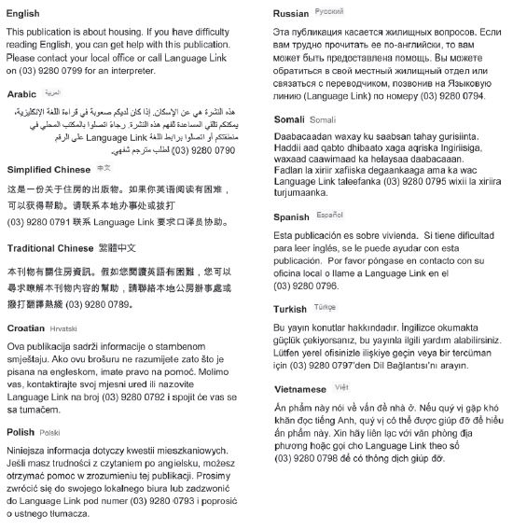For other languages, an interpreter is available through your local office.

