Miss Tooth Fairy Pearly White Palace Tooth Fairy Town
Fairyland

Dear
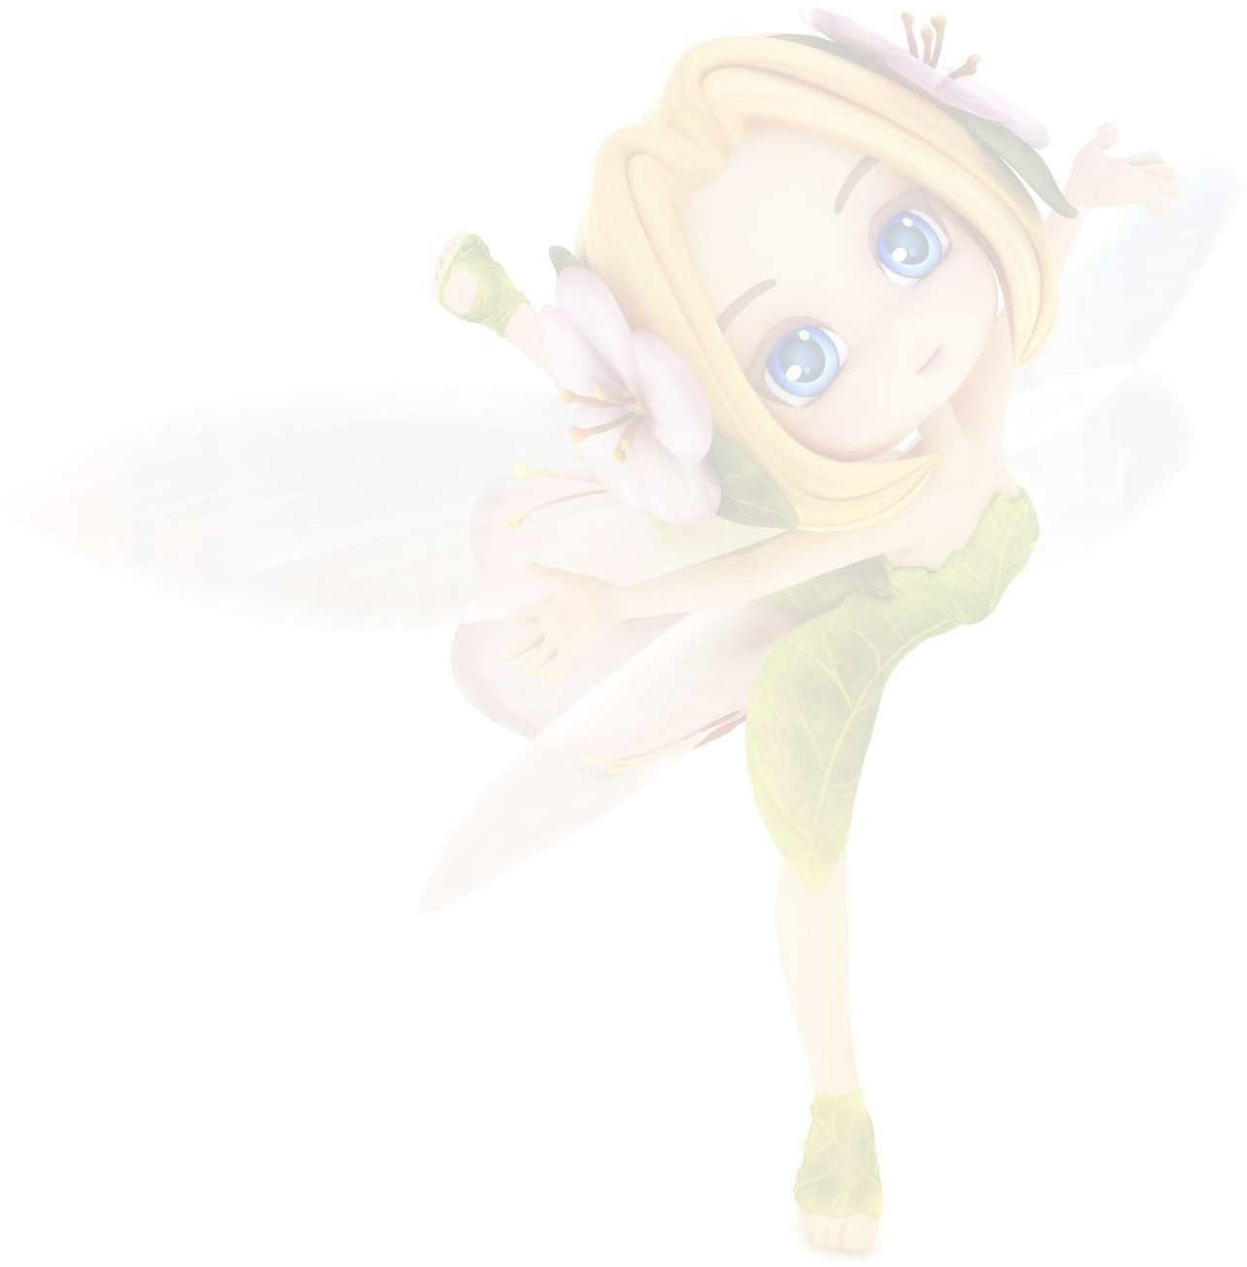
Thank you so much for leaving that shiny white tooth under your pillow. It took a little while to find because it was quite dark in your bedroom, but when I shone my magic fairy torch I could see it quite clearly, nestling in the corner.
I’m sorry I couldn’t stop to say hello but I’m a rather shy fairy and not really allowed to meet little girls or boys, or indeed any kind of human. I do occasionally flap my wings at cats and dogs but as they can’t speak, it’s OK, and they normally just blink at me anyway.
You really are very kind to leave me such a lovely tooth. It’s not often I receive one that’s so well looked after - your dentist must be very pleased with you!
As you know I‘m a very busy fairy and you’re probably wondering what I do with all the teeth I collect. Well, when I get back to Tooth Fairy Town, I take them to the sorting office where the good teeth are separated from the not so good by my team of tooth fairy helpers. The best ones are then used for building fairy palaces or making furniture such as tables and chairs -
you’d be surprised how comfy a molar can be!
As your tooth is in such good condition, it’s sure to have pride of place in my palace – I might even use it to build a new throne!
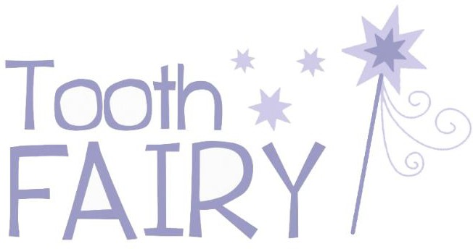
Well done for having such a terrific tooth and keep on brushing! Love from

