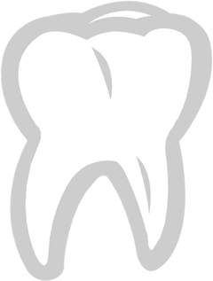From the desk of the Tooth Fairy
Dear Alora,
I am so sorry that I missed your house yesterday. I know you left your tooth for me last night, I was so excited to come get it.
Unfortunately, I just did not make it to your house before morning. I had so many teeth to pick up that by the time I got to your neighborhood the sun was already coming up. The Tooth Fairy
can only come at night and only while you are sleeping. I felt so bad that I came to your house FIRST tonight.
Thank you so much for being patient! I left a little bit extra this time to help make up for the tardiness. Thank you for such a nice tooth. It will be a wonderful addition to my collection. I have a very special place to put it.
Remember to brush your teeth in the morning after breakfast and at night before you go to bed.
Hope your day is full of sparkles and smiles!
Love,
Tooth Fairy

